MITIGATING PUBLIC TRANSIT UNRELIABILITY THROUGH DEEP LEARNING ANALYTICS AND RIDERSHIP FORECASTING

YIP ZI XIAN

RESEARCH REPORT SUBMITTED TO THE FACULTY OF EDUCATION, UNIVERSITY OF MALAYA, IN PARTIAL FULFILMENT OF THE REQUIREMENTS FOR THE DEGREE OF MASTER IN ARTIFICIAL INTELLIGENCE

2026

UNIVERSITI MALAYA

Original Literacy Work Declaration
Name of Candidate: Yip Zi Xian (I.C/Passport No: 020709-08-1513)
Registration/Matric No: 24202141
Name of Degree: Master of Artificial Intelligence (MAI)
Title of Project Paper/Research Report/Dissertation/Thesis (“this Work”):
Mitigating Public Transit Unreliability through Deep Learning Analytics and Ridership Forecasting

Field of Study: Artificial Intelligence
I do solemnly and sincerely declare that:
- I am the sole author/writer of this Work;
- This Work is original;
- Any use of any work in which copyright exists was done by way of fair dealing and for permitted purposes and any excerpt of extract from, or reference to or reproduction of any copyright work has been disclosed expressly and sufficiently, and the title of this Work and its authorship have been acknowledged in this Work;
- I do not have any actual knowledge, nor do I ought reasonably to know that the making of this Work constitutes an infringement of any copyright work;
- I hereby assign all and every rights in the copyright to this Work to the University of Malaya (“UM”), who henceforth shall be owner of the copyright in this Work and that any reproduction or use in any form or by any means whatsoever is prohibited without the written consent of UM having been first had and obtained;
- I am fully aware that if in the course of making this Work I have infringed any copyright whether intentionally or otherwise, I may be subject to legal action or any other action as may be determined by UM.

Candidate’s Signature Date: 22nd June 2026

Subscribed and solemnly declared before,

Witness’s Signature Date:
Name: Prof. Ts. Dr. Rafidah binti Md Noor
Designation: Professor

Abstract
Keywords
Public Transit Reliability, Deep Learning Analytics, Ridership Forecasting, Urban Mobility Pattern Analysis
The prediction of daily public transport ridership in Malaysia becomes extremely difficult owing to the inherent challenges related to spatiotemporal variables such as population density, weather, and socio-economic activities. These complexities often lead to operational bottlenecks in scheduling and routing, which undermine system reliability and passenger satisfaction. Furthermore, extreme data anomalies – specifically during Malaysia’s Movement Control Order (MCO) – introduce significant predictive bias, as conventional models struggle to distinguish between pandemic-driven noise and normal urban mobility patterns. The primary objectives of this research are to: (1) identify and categorize the key spatiotemporal factors influencing Malaysia public transit ridership; (2) develop a robust predictive model, the Hybrid Multi-scale Temporal Spatio Feature (HMT-TSF) Forecaster, to estimate future trends; (3) benchmark this proposed model against a wide range of baseline, graph-based, and attention-based deep learning (DL) architectures; and (4) evaluate the impact of MCO period on model accuracy by comparing performance across datasets with and without MCO period. The current research adopts a robust DL framework that uses several datasets – General Transit Feed Specification (GTFS) data, historical weather patterns, and Points of Interest (POIs). The research compares the proposed HMT-TSF against several state-of-the-art architectures, such as LSTM, BiLSTM, STGCN, and Informer. The analysis is conducted across two distinct dataset segmentations: a “With MCO” period (2019 – 2025) and a “Without MCO” period (2022 – 2025). Performance is evaluated using metrics including MAE, RMSE, and R². The study shows that the incorporation of exogenous variables such as weather and POIs greatly improves the prediction power of DL models in comparison to statistical methods like ARIMA. It suggests that the proposed HMT-TSF outperforms existing baseline models across various lookback windows and both datasets. Critically, the study finds that training models on datasets including the MCO period introduces substantial bias, by contrast, segmenting the dataset and removing the anomalies enables the model to properly identify the peaks and standardize the mobility patterns. The study concludes that advanced DL methodologies are essential for managing the spatiotemporal complexities of Malaysia’s public transit networks. With the help of proposing the HMT-TSF and proving the importance of data segmentation, the paper offers an effective way for transportation authorities to optimize scheduling and routing. Such optimization is necessary for making up for the gap between expansion of the infrastructure and ridership.

Abstrak
Kata Kunci
Kebolehpercayaan Transit Awam, Analitis Pembelajaran Mendalam, Ramalan Jumlah Penumpang, Analisis Corak Mobiliti Bandar
Ramalan jumlah penumpang harian pengangkutan awam di Malaysia sukar dilakukan disebabkan cabaran pemboleh ubah ruang-masa (spatiotemporal) seperti kepadatan penduduk, cuaca, dan aktiviti sosioekonomi. Kerumitan ini sering mencetuskan kesesakan operasi dalam penjadualan dan penentuan laluan, sekali gus menjejaskan kebolehpercayaan sistem serta kepuasan penumpang. Tambahan pula, anomali data ekstrem semasa Perintah Kawalan Pergerakan (PKP) memperkenalkan bias ramalan yang ketara kerana model konvensional sukar membezakan antara gangguan (noise) pandemik dan corak mobiliti bandar yang normal.. Objektif utama kajian ini adalah untuk: (1) mengenal pasti dan mengkategorikan faktor ruang-masa utama yang mempengaruhi jumlah penumpang transit awam di Malaysia; (2) membangunkan satu model ramalan yang teguh, iaitu Hybrid Multi-scale Temporal Spatio Feature (HMT-TSF) Forecaster, untuk menganggar trend masa hadapan; (3) menanda aras model yang dicadangkan ini terhadap pelbagai seni bina pembelajaran mendalam (DL) berasaskan garis dasar (baseline), graf, dan perhatian (attention-based); dan (4) menilai kesan tempoh PKP terhadap ketepatan model dengan membandingkan prestasi merentasi set data yang mengandungi tempoh PKP dan tanpa tempoh PKP. Kajian ini menggunakan rangka kerja DL yang teguh dengan memanfaatkan set data General Transit Feed Specification (GTFS), corak cuaca sejarah, dan Tempat Menarik (POIs). Model HMT-TSF yang dicadangkan dibandingkan dengan beberapa seni bina terkini seperti LSTM, BiLSTM, STGCN, dan Informer. Analisis dijalankan merentasi dua segmentasi set data: tempoh "Dengan PKP" (2019–2025) dan tempoh "Tanpa PKP" (2022–2025). Prestasi dinilai menggunakan metrik termasuk MAE, RMSE, dan R². Kajian menunjukkan bahawa penggabungan pemboleh ubah eksogenus seperti cuaca dan POI meningkatkan kuasa ramalan model DL secara signifikan berbanding kaedah statistik seperti ARIMA. Model HMT-TSF yang dicadangkan juga mengatasi prestasi model garis dasar sedia ada merentasi pelbagai tetingkap imbas kembali (lookback windows) dan kedua-dua set data. Secara kritikal, latihan model menggunakan set data yang merangkumi tempoh PKP memperkenalkan bias yang besar. Sebaliknya, membahagikan set data dan mengeluarkan anomali tersebut membolehkan model mengenal pasti waktu puncak dengan betul dan menyeragamkan corak mobiliti. Kajian ini merumuskan bahawa metodologi DL maju amat penting untuk mengurus kerumitan ruang-masa rangkaian transit awam di Malaysia. Melalui model HMT-TSF dan bukti kepentingan segmentasi data, makalah ini menawarkan penyelesaian berkesan bagi membantu pihak berkuasa pengangkutan mengoptimumkan penjadualan dan penentuan laluan demi merapatkan jurang antara peluasan infrastruktur dan jumlah penumpang.

Acknowledgments
Above all, I wish to extend my most sincere thanks to my highly respected supervisor, Prof. Ts. Dr. Rafidah binti Md Noor, for her excellent guidance, endless support, and boundless patience in the entire process of conducting this research. The extensive knowledge she possesses regarding smart transport systems, coupled with her continuous support and encouragement, was pivotal in completing this thesis work.
I would like to extend my immense gratitude towards my family members who loved me unconditionally and helped me in every possible way by making huge sacrifices. It was only because of their caring nature and belief in my capabilities that I could fully concentrate on my studies without any hindrance especially during the tough times of this research process.
To my fellow friends and mates, thank you very much for all the support and fun activities that made me feel relaxed in the middle of my tough academic life.
Lastly, to my partner who supported me throughout with her moral strength and patience, thank you very much for all the efforts.
To everyone who contributed directly or indirectly to the completion of this milestone, your kindness and support will always be remembered.

Table of Contents
Original Literacy Work Declaration 1
Abstract 2
Abstrak 4
Acknowledgments 6
Table of Contents 7
List of Figures 11
LIst of tables 13
Chapter 1 INTRODUCTION 15
1.1 Research Background 15
1.2 Problem Statement 16
1.3 Research Questions 17
1.4 Research Objectives 17
1.5 Research Scope 18
1.6 Research Scope 19
Chapter 2 LITERATURE REVIEW 20
2.1 Public Transport Reliability and Demand Dynamics 20
2.1.1 Defining Reliability: Metrics and User Perception 20
2.1.2 The Relationship between Ridership and Service Unreliability 21
2.1.3 The Landscape of Public Transit in Malaysia 23
2.2 Transit Data Ecosystems and Anomalies 23
2.2.1 Sources of Transit Data 23
2.2.2 Data Quality, Noise and Preprocessing Challenges 25
2.2.3 Extreme Anomalies in Spatiotemporal Data 26
2.3 Evolution from Traditional to DL Models 27
2.3.1 Traditional Architectures 27
2.3.2 Deep Learning Approaches in Spatiotemporal Transit Data 28
2.3.3 Benchmarking Methodologies and Evaluation Metrics 29
2.4 AI-Driven Operational Strategies and Sustainability 30
2.4.1 Proactive Scheduling and Resource Allocation 30
2.4.2 Deployment Challenges of AI in Transit Management 31
2.4.3 Sustainable Urban Mobility and Environmental Impact 32
2.5 Research Gap 33
Chapter 3 METHODOLOGY 34
3.1 Data Collection and Understanding 34
3.1.1 Primary Transit and Network Data 34
3.1.2 Administrative Geography and Spatial Connectivity 34
3.1.3 Economic and Temporal Indicators 35
3.1.4 Environmental and Geospatial Features 35
3.1.5 Data Segmentation and MCO Considerations 36
3.2 Feature Engineering 38
3.2.1 Data Cleaning 38
3.2.2 Feature Alignment 39
3.2.3 Sequence Building 41
3.3 Explanatory Data Analysis 41
3.3.1 MCO Collapse and Unequal Recovery 41
3.3.2 Northeast Monsoon Rainfall Pattern 42
3.3.3 Weather-Induced Ridership Surge under Heavy Rainfall 45
3.3.4 Fuel Price Elasticity and Modal Substitution 47
3.3.5 Holiday Anticipation and Return-Surge Effect 50
3.3.6 Lag Dominance and Static Near-Zero Signal 53
3.4 Baseline & Comparative Models 55
3.4.1 Spatiotemporal Models 55
3.4.1.1 LSTM 55
3.4.1.2 BiLSTM 55
3.4.1.3 TPA-LSTM 56
3.4.1.4 CNN-LSTM 56
3.4.1.5 CNN-BiLSTM 56
3.4.1.6 ST-LSTM 57
3.4.2 Graph Models 57
3.4.2.1 STGCN 57
3.4.2.2 ASTGCN 58
3.4.2.3 PDR-STGCN 58
3.4.2.4 STSGCN 58
3.4.2.5 STFGNN 59
3.4.2.6 MTGNN 59
3.4.3 Attention Models 60
3.4.3.1 Autoformer 60
3.4.3.2 Informer 60
3.5 Hybrid Multi-scale Temporal Spatio Feature (HMT-TSF) – Proposed Model 61
3.5.1 Feature Selection 61
3.5.2 Key Architecture Components 62
3.5.2.1 Reversible Instance Normalisation (RevIN) 62
3.5.2.2 Multi-scale Temporal Convolution Network (TCN) – Temporal Encoder 63
3.5.2.3 Spatial Graph Encoder 63
3.5.2.4 Regime Gating Embedding 63
3.5.2.5 Gated Fusion 64
3.5.2.6 Dual Forecast Heads and Custom Loss 64
3.5.2.7 Future Temporal Projection – Known-Future Calendar Conditioning 65
3.5.3 Architecture Diagram 65
3.5.4 Strengths 66
3.5.5 Weaknesses 66
3.6 Evaluation Metrics 67
3.6.1 Combined Accuracy Percentage (Combined %) 67
3.6.2 Mean Absolute Percentage Error (MAPE%) 67
3.6.3 Mean Absolute Error (MAE%) 68
3.6.4 Root Mean Squared Error (RMSE%) 68
3.6.5 Coefficient of Determination (R²) 69
REFERENCES 70
APPENDICES 76
Appendix A1 – Hardware Specification 76
Appendix A2 – Data Configuration 76
Appendix B1 – Baseline Models Hyperparameters 76
Appendix B2 – Baseline Models Training Optimization 77
Appendix C1 – Spatiotemporal Models 77
Appendix C2 – Graph Models 80
Appendix C3 – Attention Models 84
Appendix C4 – HMT-TSF Training Configurations 85

List of Figures
Figure 2.1 Vicious Cycle of Public Bus and Rail Transit Unreliability and Ridership Uncertainty 22
Figure 2.2 Cause-and-effect illustration after Deployment Challenges of AI in Public Transit Systems are Solved 31
Figure 3.1 Total Daily Transit Volume from 2019 to mid-2026, featuring 6 Vertical Red Dashed Lines pinpointing Specific Structural Shifts/Transition Points over Time 42
Figure 3.2 Average Daily Usage Numbers across Various Rail and Bus Lines Segmented into 3 Distinct Phases: Pre-MCO (blue), MCO (orange), and Post-MCO (green) 42
Figure 3.3 Comparison of Total Counts of Wet Days (≥10mm), Very Wet Days (≥30mm), and Extreme Days (≥50mm) across Various States with Terengganu consistently showing the Highest Counts 43
Figure 3.4 Dashboard visualizing the Trend and Breakdown of Extreme Rainfall Events over Time, including Month/Annual Frequency Percentages, Annual Wet Day Counts by Category, and Extreme Event Frequency aggregated by Month 43
Figure 3.5 Dashboard outlining General Rainfall Trends, including Average Daily Rainfall by Month, Monthly Rainfall Anomalies, a 7-day Rolling Average Timeline, and Total Annual Rainfall from 2019 to 2026 44
Figure 3.6 Advanced Behavourial Analysis focusing on Weather-driven Modal Shifts, Constrasting Heavy Rain Days against Normal Conditions through a Correlation Matrix, Monthly Trend Comparisons, and a Daily Percentage Change Surge Analysis 45
Figure 3.7 Monthly Averages for Daily Rainfall against Total Ridership with Monthly Breakdown of Correlation Coefficients, r, with Corresponding Statistical Significance (p-values) 46
Figure 3.8 Dashboard Analysis on Direct Impact of Wet Weather with Rainfall-vs-Ridership Scatterplot (r = 0.1444), Average Daily Ridership Comparison Bars, Total Rainy Day Sample Count (n = 197), and Historical Rainfall Time Series from 2019 to 2026 46
Figure 3.9 Fuel Price Levels (RON95, RON97, Diesel) in MYR/Litre (top) and Weekly Price Changes for RON95 and Diesel (bottom), both from late 2018 to mid-2026 48
Figure 3.10 Dashboard Analysis on Direct Relationship between Fuel Prices and Public Transit Ridership with Scatterplot with Trend Lines and Weekly Percentage Changes, and Bar Chart of Average Daily Ridership by Price Level 48
Figure 3.11 Lagged correlation (from 0 to 7 days) between Changes in Fuel Prices (RON95 and Diesel) and Subsequent Changes in Transit Ridership 49
Figure 3.12 Broad Seasonal and Weekly Overview Displaying Average Daily Ridership across Day Types, Monthly Distribution of Public Holidays (peaking in May), Daily Breakdown by Day of the Week, General Ridership Fluctuations across the Months of the Year 50
Figure 3.13 Assessing How the Length of Holiday Influences Travel Patterns showing that Short Holidays (less than 3 days) Experience the Most Severe Percentage Dip in Ridership from Normal Levels with Frequency Distribution and Day-of-Week Profile broken down by Holiday Duration 50
Figure 3.14 Ridership Trends between Academic and Public Holidays highlighting Public Holidays see Sharp Drops in Both Overall Mean Volume and Daily Percentage Change with Breakdown of Mean Ridership across Dozens of Individual Malaysian Calendar Events 51
Figure 3.15 Dashboard tracking Transit Demand around Holiday Periods, showing Overall Mean Total Ridership Drops on Holidays, Day-of-Week Demand Dips (Most Pronounced on Tuesdays and Wednesdays), Distinct Weekday vs Weekend Response Gaps, and Percentage of Daily Ridership Change by Holiday Regime 52
Figure 3.16 Detailed 6 x 6 Correlation Matrix of Key Demand Forecasting Inputs (left) with Standardized Coefficients of the Dominant Predictors of Ridership (right) 53
Figure 3.17 Large-scale, Lower-triangular Heatmap visualizing Complex Feature Correlation Matrix (79 x 79) for Full Demand Model 54
Figure 3.18 HMT-TSF Architectural Flow Diagram 65

LIst of tables
Table 1.1 Baseline, Comparative and Proposed Models, Evaluation Metrics, Geographical Focus, and Dataset Segmentation for Malaysia’s MCO period used in this Research 17
Table 2.1 Comparison of Technical Reliability Metrics and Subjective User Perception Factors based on Multiple Sources 20
Table 2.2 Detailed table of endogenous data sources with examples, applications, and characteristics 24
Table 2.3 Detailed table of exogenous data sources with examples, applications, and characteristics 24
Table 2.4 Brief Comparison of Different Aspects between Traditional and DL models 27
Table 2.5 Common Evaluation Metrics and its Focus (Jiang et al., 2021; S.K.B et al., 2024; Mystakidis et al., 2025) 29
Table 3.1 Independent Raw Data Sources and its Coverage, Content, and Usage for this Study 36
Table 3.2 Primary Cleaning Operations applied to Each Sources 38
Table 3.3 Merge Strategy and Null Handling 39
Table 3.4 79 Features across 5 Semantic Groups 39

INTRODUCTION

Research Background
By enhancing urban mobility where citizens prioritize public transports over private vehicles, countries can improve their economies while promoting environmental sustainability (Lu et al., 2020), aligning with Sustainable Development Goals (SDG) adopted by the United Nations. Malaysia, as a developing nation undergoing urbanisation, establishing an efficient public transit system is essential to achieve developed-country status (Wang et al., 2025). However, some suggested that citizens revert to private vehicles due to unreliable public transit predictions in public transit systems caused by uncertainties – weather conditions, socio-economic activities, and geopolitical events – thereby accelerates traffic congestion and air/sound pollution (Amir et al., 2025). Reliable public transit systems directly address the environmental and social challenges, enhancing residents’ quality of life and mobility across metropolitan and rural areas (Wang et al., 2025).
Despite Malaysian government investments in major transit infrastructure such as mass rapid transit (MRT) Putrajaya, Shah Alam, and planned MRT Circle Line, ridership remains below average due to the uncertainties and service quality flaws (Amir et al., 2025). Both studies from Shen et al. (2016) and Borhan et al. (2019) identified that prolonged travel times, untimely delays, and limited accessibility are primary causes of passenger dissatisfaction (Mee et al., 2022). These service deficiencies increase spatiotemporal complexity – traffic, weathers, how people move around – which conventional statistical models like AutoRegressive Integrated Moving Average (ARIMA) fails to predict accurately. This emphasizes the important need for advanced predictive model to accurately, consistently, and reliably forecast public transit ridership.
The development of big data analytics and deep learning (DL) methodologies shows high promise for modelling intricate spatiotemporal relationships within public transit networks (Chen et al., 2022). Unlike traditional models like ARIMA, DL approaches such as Long Short-Term Memory (LSTM) and Graph Convolutional Networks (GCN) integrate multiple data sources – General Transit Feed Specification (GTFS) data, historical weather patterns, Points of Interest (POIs) – to fully capture multidimensional relationships (Ge et al., 2021; Chen et al., 2022). Implementing state-of-the-art (SOTA) DL architectures addresses Malaysia’s current reliance on conventional models, enabling accurate ridership predictions for complex spatiotemporal data.

Problem Statement
One of the major issues with Malaysia’s transit management system is predicting daily ridership accurately due to the complex relationships existing between spatiotemporal factors affecting public transport services – including population density, weather, station/stop accessibility and socio-economic activities (Amir et al., 2025). Consequently, transit authorities face critical bottlenecks in terms of scheduling, routing, and service intervals during peak hours and holidays, undermining system reliability and passenger satisfaction. Addressing this requires a dual approach: (1) identify spatiotemporal factors influencing Malaysia’s ridership trends; (2) develop a robust predictive model capable of forecasting daily ridership based on these identified features.
Traditional statistical models struggle with highly fluctuating data compared to DL approaches. A critical barrier exists in historical ridership data: extreme anomalies from Malaysia’s Movement Control Order (MCO) enforcement (18th March 2020 to 31st December 2021) produced an 85-90% passenger drop, creating highly noisy patterns unrepresentative of normal operations (Amir et al., 2025). Training AI models on such extreme outlier data introduces significant predictive bias, as pandemic-driven behaviour differs fundamentally from typical urban mobility patterns (Zhao & Lan, 2025). Models trained on contaminated datasets often struggle to recognize true ridership peaks once daily life normalizes (Lv et al., 2021). Therefore, this researcher strategically compare two datasets – one including and one excluding the MCO period – to determine whether this anomaly should be treated as noise before model training.

Research Questions
- What are the primary spatiotemporal factors (e.g. weather, POIs, population density) that heavily affect public transit ridership trends in Malaysia?
- How accurately and consistently can existing DL architectures (spatiotemporal-based, graph-based, and attention-based) compare against each other and proposed model in predicting Malaysia’s public transit ridership?
- How does the inclusion of extreme data anomalies, specifically the Malaysia’s MCO period, impact the predictive accuracy and bias of existing DL models and proposed model?

Research Objectives
- To identify and categorize the primary spatiotemporal factors affecting Malaysian public transit ridership through a systematic analysis of historical performance data.
- To develop and propose Hybrid Multi-scale Temporal Spatio Feature (HMT-TSF) Forecaster that integrates Malaysia’s spatiotemporal data to estimate future ridership trends with a combined score (Mean Absolute Error (MAE), Root Mean Squared Error (RMSE) and Mean Absolute Percentage Error (MAPE)) of 75% with R² (Coefficient of Determination) of 0.7.
- To benchmark the proposed model against existing baseline, spatiotemporal-based, graph-based and attention-based models using combined score and R².
- To evaluate and compare model performance across two distinct dataset segmentations (with and without MCO period) to determine the impact of extreme outlier data on predictive bias.

Research Scope
Table 1.1
Baseline, Comparative and Proposed Models, Evaluation Metrics, Geographical Focus, and Dataset Segmentation for Malaysia’s MCO period used in this Research
Aspect | Description
Models* | Baseline | LSTM
 | Spatiotemporal | BiLSTM, ST-LSTM, CNN-LSTM, CNN-BiLSTM, TPA-LSTM
 | Graph | STGCN, ASTGCN, PDR-STGCN, STSGCN, STFGNN, MTGNN
 | Attention | Autoformer, Informer
 | Proposed | Hybrid Multi-scale Temporal Spatio Feature (HMT-TSF) Forecaster
Evaluation Metrics | Combined MAE, RMSE and MAPE, and R²
Geographical Focus | Bus, urban rail, commuter transit networks with available data throughout whole Malaysia.
MCO Period Segmentation | Without MCO | 1st Jan 2022 to 31st Dec 2025
 | With MCO | 1st Jan 2019 to 31st Dec 2025
Note. *. Models full form refer to Appendix.

Research Scope
- Provide a detailed comparative analysis evaluating multiple deep learning models across distinct lookback windows, explicitly segmented by MCO periods.
- Introduce a predictive model that outperforms baseline SOTAs across all lookback windows and MCO inclusion/exclusion, accompanied by a reduced-feature variant based on SHAP-based feature importance ranking, to evaluate the removal of near-zero important spatiotemporal features toward ridership prediction.
- Develop a command-line interface (CLI) inference to predict 7-day ridership for 12 distinct transit networks based on historical distribution percentages with the proposed model.

Thesis Organization
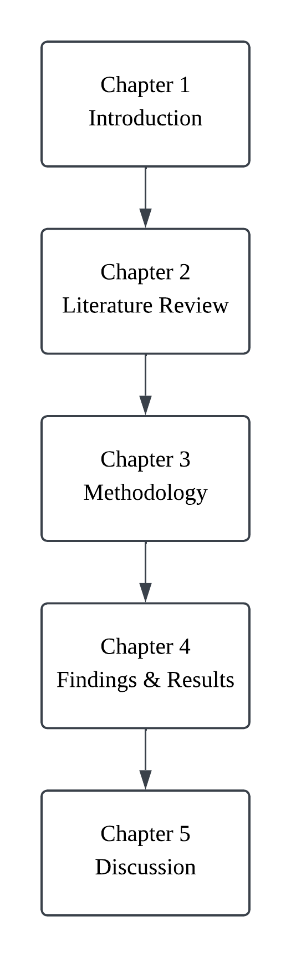

LITERATURE REVIEW

Public Transport Reliability and Demand Dynamics

Defining Reliability: Metrics and User Perception
Public transport reliability is a multi-dimensional construct that integrates objective operational performance indicators with subjective passenger experience. A study defines travel time reliability as the calculated time gap between expected and actual travel times, citing route length, signalized intersections, and departure delays as primary structural causes of network unreliability (Mohamed et al., 2021). Conversely, some researchers also demonstrate that user satisfaction within the Klang Valley Light Rail Transit (LRT) system is heavily mediated by “soft” reliability factors – the provision of accurate real-time information and the quality of station amenities (Ibrahim et al., 2022).
This divergence indicates that while transit agencies like RapidKL traditionally prioritize “hard” technical metrics such as headway adherence and on-time performance, the passenger’s psychological perception of reliability is shaped by the immediate physical environment and the mitigating effect of transparent communication. For instance, structural breakdowns and delays on the LRT Kelana Jaya line, alongside extreme disruptions like the derailment near Chan Sow Lin station on LRT Ampang-Sri Petaling line, highlight that operational unpredictable execution converts directly into acute user stress and anxiety.
Consequently, understanding the intersection of technical metrics and subjective factors is vital for establishing standardized evaluation criteria, as mapped in the comprehensive breakdown of operational, informational, and service quality parameters detailed in Table 2.1.
Table 2.1
Comparison of Technical Reliability Metrics and Subjective User Perception Factors based on Multiple Sources
Metric Category | Technicalª | Subjective^{b}
Temporal  (Mohamed et al., 2021) | Headway adherence, Travel time variability | Punctuality, Wait time anxiety
Informational  (Rezapour & Ferraro, 2021) | PIS accuracy, Real-time data latency | Certainty, Reduced stress
Service Quality  (Ibrahim et al., 2022) | Vehicle cleanliness, Amenity availability | Comfort, Perceived safety
Operational  (Sogbe et al., 2024) | Frequency, Route coverage | Accessibility, Convenience
Note. a. Operational Indicator.
b. User Perception

The Relationship between Ridership and Service Unreliability
Chronic service unreliability generates a sever demand-erosion cycle that fundamentally undermines public transit ridership. The absence of reliable predictions regarding traffic and weather variations causes citizens to abandon public transit in favour of private vehicles (Amir et al., 2025), supported with another finding which identify prolonged travel times and untimely delays as the leading causes of passenger dissatisfaction in metropolitan areas like Kuala Lumpur and Manila (Mee et al., 2022).
When operational variance grows, passengers are forced to allocate substantial “buffer time” into their personal schedules to insure against systemic delays. For most commuters, this continuous temporal penalty quickly outweighs the financial savings of public transport, causing stagnant or declining model shares even during periods of rising fuel costs or high private vehicle ownership penalties, as observed in decentralized urban sectors such as Kota Samarahan. This behavioural shift establishes a self-reinforcing loop where transit unreliability drives private vehicular growth, thereby intensifying the road congestion that further degrades transit schedule adherence, as visually conceptualized in the behavioural cycle shown in Figure 2.1.
Figure 2.1
Vicious Cycle of Public Bus and Rail Transit Unreliability and Ridership Uncertainty
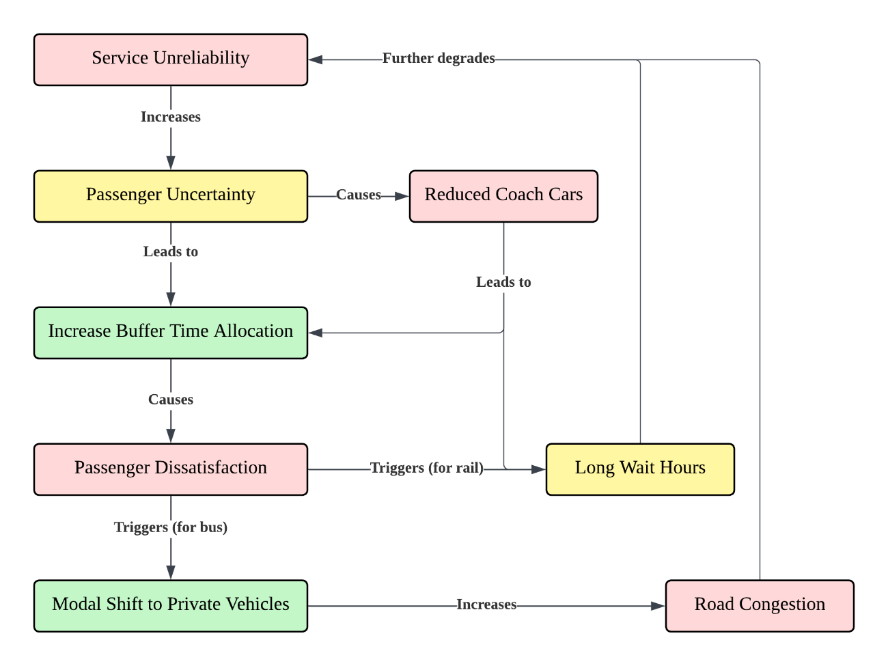

The Landscape of Public Transit in Malaysia
The Malaysian public transportation sector is currently defined by a sharp mismatch between extensive capital infrastructure investments and persistently low commuter modal shares. Despite massive government-funded transit expansions – including the Mass Rapid Transit (MRT) Putrajaya line, Shah Alam line, and the upcoming MRT3 Circle line – national public transport usage remains stagnant at approximately 20%, falling significantly short of the 40% target established by the National Transport Policy (NTP) 2019 – 2030. Research highlights that in regions like Sarawak, private vehicle ownership remains exceptionally high due to the perceived inadequacy of bus service quality regarding tangibility and operational responsiveness (Ubaidillah et al., 2022).
This disparity proves that physical network expansion is sufficient on its own to shift commuter habits; infrastructure must be supported by localized reliability and data-driven operational optimizations to resolve localized service gaps. While programs like the MyBas initiative in Johor Bahru and Penang have successfully leveraged GTFS data to optimize networks and capture over 14.5 million trips, systemic barriers like the “first-mile-last-mile” (FMLM) connectivity gap continue to limit the efficacy of the broader national network. Resolving these localized structural inefficiencies requires transit management to pivot away from purely physical expansion toward DL methodologies capable of accurately forecasting spatiotemporal ridership to mitigate daily unreliability.

Transit Data Ecosystems and Anomalies

Sources of Transit Data
Modern transit data ecosystems combine diverse endogenous operational streams and exogenous environmental inputs to form a comprehensive foundation for urban mobility analysis. Two studies founded to classify core endogenous sources as Automated Fare Collection (AFC) systems for ridership tracking, Automated Vehicle Location (AVL) systems for real-time GPS tracking, Automated Passenger Counting (APC) sensors, and static GTFS schedules (Ge et al., 2021; Liu et al., 2025). Concurrently, another study also defines critical exogenous variables as real-time weather metrics, road network traffic data, POIs extracted via land-use profiles, and regional socio-economic demographics (Amir et al., 2025).
Endogenous data provides a direct, high-volume reflection of internal transit supply and passenger throughput, but it lacks the contextual capacity to explain sudden demand fluctuations on its own. By integrating exogenous streams like gridded population distributions or localized weather anomalies, analytical models can successfully map the external drivers that directly govern passenger mode selection and spatial destination choices. Synthesizing these multi-source streams into an integrated matrix – as categorized by the operational features, collection frequencies, and specific analytical applications outlined in Table 2.2 and 2.3 for endogenous and exogenous data, respectively – is a vital prerequisite for advanced predictive modeling.
Table 2.2
Detailed table of endogenous data sources with examples, applications, and characteristics
Specific Examples | Typical Applications | Key Characteristics
AFC Systems | Ridership analysis, origin-destination, revenue tracking | Transactional, passenger-centric
AVL Systems | Real-time tracking, schedule adherence, fleet management | Spatiotemporal, vehicle-centric
APC Systems | Occupancy rates, detailed ridership statistics | Discrete counts, vehicle-centric
Vehicle Sensors | Maintenance, operational efficiency | Real-time, diagnostic
GTFS Data | Route planning, schedule information, app development | Static, foundational
Table 2.3
Detailed table of exogenous data sources with examples, applications, and characteristics
Specific Examples | Typical Applications | Key Characteristics
Weather Data | Demand forecasting, operational adjustments | Environmental, dynamic
Traffic Data | Travel time prediction, congestion management | Real-time, network-wide
POIs | Demand modeling, urban planning | Static/dynamic, location-based
Demographic/Socio-economic | Long-term planning, demand forecasting | Static/slow-changing, population-centric

Data Quality, Noise and Preprocessing Challenges
Raw transit data ecosystems are highly vulnerable to fragmented quality issues and severe noise, demanding extensive preprocessing before deployment in DL models. One research points out that public transport agencies frequently collect disjointed and fragmented data streams that impede comprehensive system interpretation (Keller et al., 2022), while another identifies pervasive data quality threats such as sensor omissions, localized GPS telemetry errors, formatting inconsistencies across legacy systems, and extreme outliers (S.K.B et al., 2024).
These imperfections introduce major challenges during data cleaning, multimodal integration, feature transformation, and data reduction stages. For example, a missing data gap caused by an IoT network outage could generate significant downstream predictive bias if it left unaddressed, while the lack of alignment across spatial resolutions creates high noise that obscures actual demand signals. Because raw transit data is rarely usable in its initial state, implementing rigorous, automated preprocessing and feature engineering pipelines is essential to ensure data integrity and unleash the full potential of advanced analytics.

Extreme Anomalies in Spatiotemporal Data
Spatiotemporal transit profiles are highly sensitive to extreme, non-typical anomalies that degrade the reliability and generalization capabilities of predictive models. Extreme anomalies deviate drastically from standard mobility baselines, exemplified by Malaysia’s MCO during the COVID-19 pandemic, which caused an abrupt 85-90% ridership drop across all transit networks (Maria-Arribas et al., 2026). Training predictive models directly on these contaminated datasets introduces severe predictive bias because pandemic-era containment behaviours differ fundamentally from normal urban mobility patterns (Zhao & Lan, 2025).
When neural network architectures ingest uncorrected outlier sequences, they risk overfitting to anomalous troughs, confusing regular seasonal patterns, and failing to recognize normal ridership peaks once standard daily operations resume. Traditional anomaly detection methods relying on basic statistical thresholds often fail when applied to high-dimensional spatiotemporal data, driving the need for advanced techniques like ensemble DL or strategic dataset segmentation. This structural vulnerability underlines the necessity of this study’s approach: splitting the time-series data into distinct MCO-inclusive and MCO-exclusive segments to empirically evaluate and isolate the impact of extreme noise on DL architectures.

Evolution from Traditional to DL Models

Traditional Architectures
Traditional statistical and machine learning architectures offer strong model interpretability but are fundamentally limited by their inability to capture the non-linear, multi-dimensional complexities of modern transit data. Historically, forecasting models have relied on classical frameworks like ARIMA, Historical Average (HA), Vector AutoRegressive (VAR) models, Support Vector Regression (SVR), and Random Forest Regression (RFR). These traditional statistical architectures demand strict data stationary and rigid distribution assumptions, which directly conflict with highly fluctuating, time-varying traffic data (Yin et al., 2022).
Traditional models assume fixed functional forms and linear mathematical relationships, rendering them ineffective when tasked with modelling the intricate space-time interactions that define urban transit networks. Even established rule-based systems reach their operational limits in complex spatiotemporal scenarios like railway delay propagation because they cannot adapt to volatile, real-world variations (Sobrie et al., 2023). The structural limitations detailed in the comparative breakdown of data handling, assumptions, and scalability metrics in Table 4 emphasize the clear need to transition away from rigid classical models toward highly flexible DL frameworks.
Table 2.4
Brief Comparison of Different Aspects between Traditional and DL models
Aspect | Traditional Models | DL Models
Data Handling | Small-scale, structured | Large-scale, multi-source
Dependencies | Linear, short-term | Non-linear, long-term
Complexity | Low (functional forms) | High (hierarchical features)
Assumptions | Strict (Stationarity, normality) | Minimal (Data-driven)
Interpretability | High | Lower (Black-box nature)
Scalability | Limited | High

Deep Learning Approaches in Spatiotemporal Transit Data
The main advantage of using DL architectures is that they can circumvent many restrictions posed by the conventional models by means of automatically capturing hierarchies of non-linear spatiotemporal features from transit multi-source data. The most efficient modern DL frameworks incorporate specially designed neural building blocks – Convolutional Neural Networks (CNNs) capture spatial correlations from grid structures, Recurrent Neural Networks (RNNs) like LSTMs track sequential temporal dependencies, Graph Convolutional Networks (GCNs) model non-Euclidean network topologies, and attention mechanisms dynamically weigh feature significance. For instance, multi-model GeoSpatial-Temporal LSTM (GT-LSTM) that achieved a 15% reduction in MAPE and a 20% reduction in RMSE over traditional methods and standard DL baselines (S.K.B et al., 2024).
These architectures eliminate the necessity for explicit feature engineering through the learning of multi-dimensional interactions directly from the data. The use of transportation networks as connected graph nodes and environmental variables as dynamic weights, models like STGCN, ASTGCN, and TPA-LSTM can simultaneously process structured data (such as GTFS) and unstructured covariates (such as weather and POIs). Successful deployment of these diverse DL architectures requires establishing an equally rigorous benchmarking methodology to benchmark their respective accuracy and error.

Benchmarking Methodologies and Evaluation Metrics
Rigorous, standardized benchmarking methodologies and multi-metric validation frameworks are essential to verify the accuracy, consistency, and operational reliability of predictive models. In comprehensive DL surveys, some studies utilize MAE, RMSE, and MAPE as primary evaluation metrics (Jiang et al., 2021), while others emphasize the importance of pairing relative and absolute indices to validate SOTA results on benchmark datasets (Mystakidis et al., 2025).
Evaluating models through a single metric can mask critical performance flaws. As shown in Table 5, MAE provides an outlier-robust measure of average error, RMSE penalizes severe individual forecast failures through squaring, MAPE normalizes errors for intuitive scale-independent interpretation, and R² captures the model’s overall goodness-of-fit. A comprehensive benchmarking framework must combine comparative analysis against established baselines, sensitivity analysis under varying data densities, and robustness testing across distinct geographical and anomalous contexts. Adhering to these structured metrics ensures a fair comparison between 14 baseline architectures evaluated in this study, providing a clear path to validating the performance gains of the proposed HMT-TSF forecaster.
Table 2.5
Common Evaluation Metrics and its Focus (Jiang et al., 2021; S.K.B et al., 2024; Mystakidis et al., 2025)
Metric | Focus
MAE | Treats all errors equally and highly robust to outliers
RMSE | Heavily penalized large errors and sensitive to outliers
MAPE | Measures error relative to actual values, easy to understand
R² | Explanatory power, how well model predict based on given data

AI-Driven Operational Strategies and Sustainability

Proactive Scheduling and Resource Allocation
Transitioning from reactive transit management to AI-driven predictive modelling enables transit agencies to implement proactive scheduling and highly optimized resource allocation. Public transport networks are evolving through AI’s capacity for data-driven optimization (Jevinger et al., 2024). A study proved that LSTM encoder-decoder architecture outperforms traditional rule-based business systems by 18% to 23% in real-time delay forecasting (Sobrie et al., 2023). Furthermore, reports also show that AI-powered planning platforms maximize bus schedule efficiency and fleet deployment by anticipating changing user demands (Levner, 2025; CCS Global Tech, 2026).
Traditional dispatch scheduling is reactionary in nature; changes in service frequencies are made only after delays or disruptions have occurred in the system due to over-crowding or other reasons. On the contrary, DL models can predict passenger surges and bottleneck formations well in advance, which allows for dynamic changes in service intervals as well as coach allocation based on future passenger demand. Their successful deployment depends on overcoming several technical and organizational barriers within transit agencies.

Deployment Challenges of AI in Transit Management
AI solution adoption into public transportation system framework is hampered by multiple obstacles including data quality, infrastructure scale, and organizational resistance. Fragmented corporate data structures and internal organizational silos frequently block the adoption of advanced data science methods (Keller et al., 2022), whereas two evidence shows that high upfront implementation costs, strict data privacy compliance, and stakeholder resistance to operational changes as major adoption barriers (Suwaidi et al., 2022; Hashimzai & Mohammadi, 2024).
DL approaches need large-scale, clean datasets, meaning there must be considerable long-term commitment in data governance and scalable computing infrastructure. Without clear data integration strategies and collaborative pipelines connecting software developers with transit operators, such complex predictive systems will just be theoretical endeavours. It is crucial to overcome these multifaceted organizational obstacles since addressing them will allow transit agencies to unlock the significant environmental benefits associated with such AI-based optimizations, as depicted in the cause-and-effect flow in Figure 2.2.
Figure 2.2
Cause-and-effect illustration after Deployment Challenges of AI in Public Transit Systems are Solved
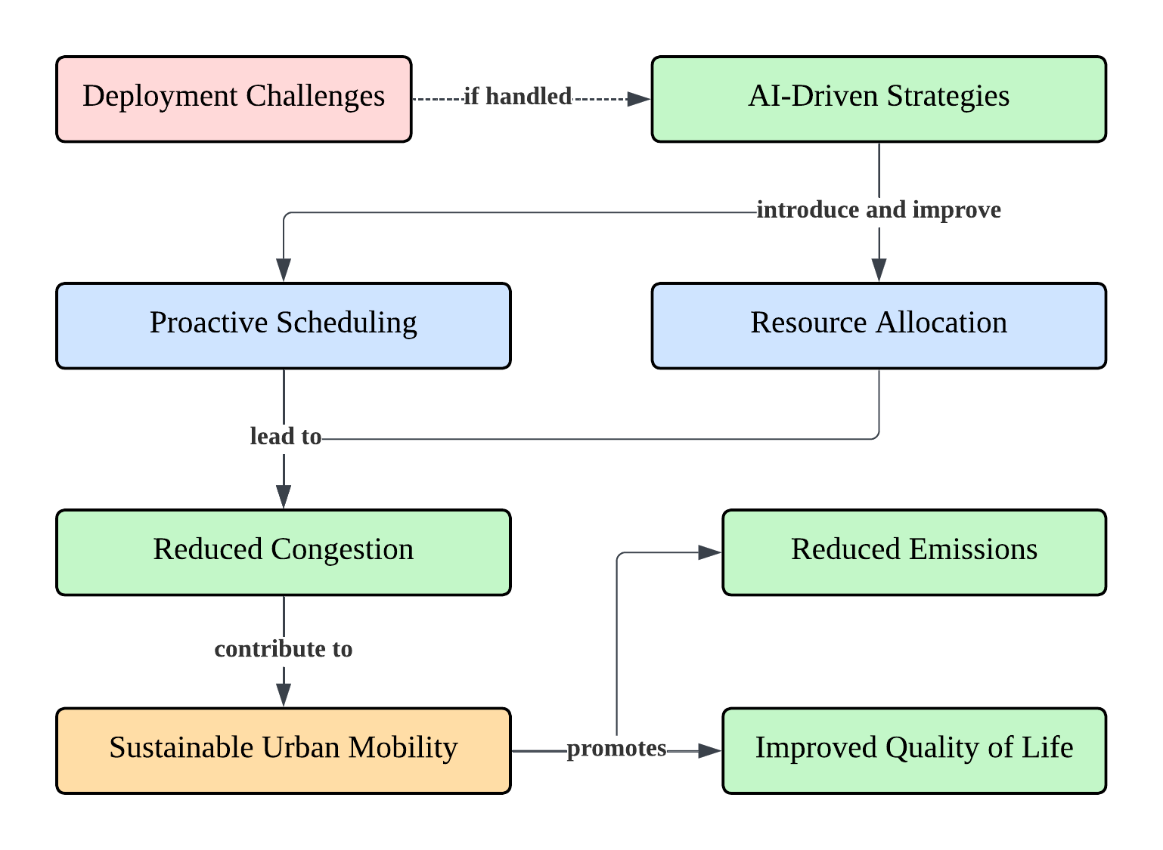

Sustainable Urban Mobility and Environmental Impact
Implementing AI optimizations within public transit networks directly supports sustainable urban mobility gaols by reducing operational waste and mitigating environmental degradation. Transforming urban mobility is vital for lowering global transportation emissions (Son et al., 2025) whereas AI-driven regularizations of headways and schedule adherence minimize fuel waste, emergency maintenance costs, and operational inefficiencies (Vujadinovic et al., 2024).
If predictive models prove successful in improving transit efficiency and reducing waiting time, they will help expedite the modal shift that involves choosing public transits over private vehicles. The combination of this modal shift along with the improvement of bus idling and rail routes directly lowers urban emission rates and improves overall air quality (CCS Global Tech, 2026). The optimization of transit operations through AI-powered forecasts serves as a vital tool for advancing comprehensive urban sustainability and improving the long-term quality of life for citizens.

Research Gap
Existing literature lacks hybrid forecasting models that can integrate multi-scale spatiotemporal features while isolating the predictive biases caused by severe historical data anomalies like the MCO period. Although contemporary studies have applied baseline DL techniques to predict public transport ridership (Farahmand et al., 2023; Amir et al., 2025), these models rely on standard architectures that cannot process complex interactions across multi-scale time and multi-dimensional space. Furthermore, the highly confounding nature of pandemic-era data anomalies, yet there is a lack of empirical research in Malaysia quantifying how these non-typical patterns distort graph-based and attention-based SOTA models (Zhao & Lan, 2025).
Simply removing the MCO period creates a structural gap that breaks the continuity of time-series data, whereas leaving it uncorrected introduces significant predictive bias that degrades forecasting accuracy. This lack of systematic benchmark across diverse sequential, graph, and attention architectures leaves transit operators without a clear path to identifying the most robust forecasting systems for Malaysia’s unique urban landscape. To resolve these gaps, this study develops and proposes the Hybrid Multi-scale Temporal Spatio-Feature (HMT-TSF) Forecaster, transitioning Malaysia transit management from a reactive framework to a proactive, data-driven paradigm.

METHODOLOGY

Data Collection and Understanding

Primary Transit and Network Data
Accurate public transit ridership forecasting requires integrating primary multi-source data to model the structural supply and baseline passenger demand of the transit network. Daily ridership counts for 12 Malaysian service lines (including LRT, MRT, Monorail, Keretapi Tanah Melaya (KTM), and RapidBus lines) and static GTFS data were obtained from data.gov.my, alongside secondary spatial layers used for connectivity modelling. Combining GTFS static data with secondary spatial layers allows for a granular assessment of network efficiency and accessibility (Hassan et al., 2025).
Processing these files establishes a high-resolution representation of network topology and volume. However, real-time GTFS streams are excluded because the data portal only provides real-time offerings to vehicle positions as of early 2026; calculating metrics from raw coordinates dynamically would degrade inference efficiency. This foundational transit matrix must be supplemented with geographic boundary parameters to accurately account for spatial interactions across the network.

Administrative Geography and Spatial Connectivity
Incorporating macro-level administrative boundaries allows the predictive model to capture regional transit dynamics and spatial dependencies. Data of Global Administrative Areas (GADM) level-1 boundaries for Malaysia were standardized to WGS-84 coordinate reference system to construct binary and border-length-weighted $N×N$ adjacency matrices. Representing transit networks through graph-based structures like adjacency matrices is important for capturing spatial heterogeneity (Jin et al., 2022).
Spatial modelling prevents the omission of the “neighbour effect”, where regional ridership patterns at specific nodes are influenced by surrounding administrative and functional territories. While these matrices define the spatial structure, macroeconomic and temporal indicators must be integrated to capture changing demand over time.

Economic and Temporal Indicators
Socio-economic fluctuations and calendar-based events serve as major drivers of temporal variations in public transport demand. Weekly retail fuel prices (RON95, RON97, and diesel) from data.gov.my were forward filled to a daily index, while Malaysian public and school holiday ranges from 2019 to 2026 were extracted from timeanddate.com as binary flags. A significant positive correlation between fuel price hikes and increased ridership in developing countries (Ahmad et al., 2024).
Fuel price increases naturally trigger short-run model substitution as commuters shift from private vehicles to cost-effective public transit, while holiday markers distinguish normal commuting baselines from festive demand drops. Evaluating these economic and temporal shifts requires pairing them with localized environmental and geospatial datasets.

Environmental and Geospatial Features
Localized land-use configurations and adverse weather patterns impose critical environmental constraints on transit accessibility. Gridded population density data from worldpop.org and 7-category POI counts from the OpenStreetMap (OSM) Overpass API were extracted within a 500m stop radius, alongside sub-national daily rainfall data from data.gov.my. Capturing non-linear relationships in ridership prediction requires integrating semantic and spatial factors (Shi et al., 2024).
Integrating population density maps latent demand, POI catchments describe the urban activity generating trips, and daily precipitation totals simulate the structural impacts of weather on system reliability. The resulting multi-dimensional feature matrix must be segmented systematically to account for historical data anomalies.

Data Segmentation and MCO Considerations
Strategically bisecting the time-series data is necessary to isolate and evaluate the predictive bias introduced by extreme historical anomalies. The raw multi-source dataset spanning 1st January 2019 to 31st December 2025 was divided into two distinct configurations: an MCO-inclusive segment and an MCO-exclusive segment. Segmenting the dataset allows the researcher to empirically measure how highly noisy, non-typical operational periods distort the generalization capabilities of DL models. This data segmentation strategy underpins the comprehensive, multi-source feature engineering pipeline detailed in Table 3.1.
Table 3.1
Independent Raw Data Sources and its Coverage, Content, and Usage for this Study
Source (Coverage) | Content | Usage
Ridership (2019-01-01 – present) | Daily passenger counts for 12 transit services + total | Primary forecast target; provides the 13 output variables (12 service lines + total)
Fuel Price (2017-03-30 – present) | Weekly retail prices for 6 fuel types (level + weekly change) | Demand driver; capturing modal substitution behaviour
GTFS Static (Snapshot) | Standard GTFS files for Rapid Rail KL, RapidBus KL, RapidBus Penang, KTMB | Network topology; stop counts, route density and travel-time edges quantify transit supply
Rainfall (2019-01-01 – present) | Daily precipitation at state level; 9 metrics including accumulation and anomaly indices | Weather covariate; state-level daily precipitation captures external signals
GADM (2020) | GeoJSON polygons for 16 Malaysian states (Level 1 admin divisions) | Spatial structure; used to derive inter-state adjacency weights
POIs (Snapshot) | OSM POI extract; 7 categories (transport, food, retail, education, healthcare, leisure, other) | Land-use context within a 500m catchment of each stop
Population Density (2020) | ~1km² gridded raster of population density across Malaysia | Spatial context; static proxy for transit catchment potential
Holidays (2019 – 2026) | Date-range calendar of public holiday and academic break periods | Demand modifier; lead/lag features capture anticipation dips and post-holiday return surges

Feature Engineering

Data Cleaning
Automated preprocessing pipelines must transform heterogeneous raw data formats into a standardized, contiguous daily format to prevent downstream gradient corruption. Eight independent preprocessing scripts were executed to clean structural nulls, reindex weekly streams, and project original features as shown in Table 3.2. A study utilizes stationary percent-change features alongside non-stationary levels to capture short-run economic responses (Pour et al., 2026). Circular encoding via sine and cosine projections prevents the ordinal discontinuities that disrupt gradient-based models during calendar updates (Casolaro et al., 2023).
$$\text{dow_sin}=\sin{!}\left(\frac{2π⋅\text{dow}}{7}\right), \text{dow_cos}=\cos{!}\left(\frac{2π⋅\text{dow}}{7}\right)$$
$$\text{month_sin}=\sin{!}\left(\frac{2π⋅\text{month}}{12}\right), \text{month_cos}=\cos{!}\left(\frac{2π⋅\text{month}}{12}\right)$$
Retaining missing values as structural NaNs before launch dates prevents zero-demand distortions, forward filling fuel levels preserves economic equilibrium context, and computing cyclic transformations prevents models from treating sequential temporal boundaries as distant parameters. Once individual data sources are cleaned and structured, they must be merged using unified alignment rules.
Table 3.2
Primary Cleaning Operations applied to Each Sources
Source | Cleaning Operations
Ridership | Date parsing, MCO binary flag, pre-/post-launch null handling, total_ridership derivation
Fuel price | Daily forward-fill reindex, percent-change derivation, back-fill of leading nulls
Holidays | Expansion to daily rows, lead/lag proximity features, cyclic DOW/month encoding
Rainfall | Version filter (final only), wide pivot (date * state), 7-day linear interpolation, bfill/ffill
GTFS | Referential integrity verification, coordinate validation, directed edge extraction, static scalars
OSM POI | Element deduplication, 7-category taxonomy, 500m catchment counts, per-stop log transforms
Population Density | Bounding-box filter, log1p transform, state aggregation, national median scalars
GADM Boundaries | Property cleaning, centroid extraction, shared-border adjacency matrix

Feature Alignment
The development of a master matrix demands that all processed variables be aligned to a common index per day across the designated research periods. The features were linked to consecutive indexes spanning 1st January 2019 to 31st December 2025 and 1st January 2022 to 31st December 2025 using the specific merge and null-handling actions defined in Table 3.3. Three autoregressive indicators (lags 7, 14, and 28) were generated from the historical ridership series prior to merging, following established transit demand paradigms (Wu et al., 2023; Yusuf et al., 2025).
Computing autoregressive lags from the complete historical series preserves early matrix continuity, while broadcasting static network and demographic scalars provides a rich multivariate representation across 79 distinct features (Table 3.4). The finalized, aligned feature matrix serves as the direct baseline input for the sequence assembly phase.
Table 3.3
Merge Strategy and Null Handling
Source | Join Method | Null Handling
Ridership (Targets) | reindex | Pre-launch nulls retained; filled to 0.0 in sequence assembly
Fuel Price | reindex + ffill | No gaps after forward-fill
Holiday / Cyclical | reindex + fillna(0) | Non-holiday days default to 0
Rainfall | reindex + interpolate(limit=7) + bfill/ffill | Contiguous after interpolation
Static Features | Scalar broadcast | No nulls across population density, GTFS, POI, or GADM streams

Table 3.4
79 Features across 5 Semantic Groups
Group | Count | Description
Targets | 13 | 12 service-line ridership counts + total_ridership
Temporal | 16 | Holiday flags, lead/lag proximity days, cyclic DOW/month, year, day_of_year, is_weekend
External | 30 | Fuel price levels and percent-changes (15) + per-state rainfall (15)
Lag | 3 | ridership_lag_7, ridership_lag_14, and ridership_lag_28
Static | 17 | Population density, GTFS network counts, OSM POI means, GADM boundary stats
TOTAL | 79 | Finalized aligned multivariate input matrix

Sequence Building
It is necessary to transform the continuous feature matrix into discrete sliding window tensors for constructing valid input-output sequences for DL models. Overlapping input windows ($T_{in}$) and prediction horizons ($T_{out}$) were extracted in strict chronological order, partitioned into a 70%/15%/15% chronological split, and normalized using a MinMaxScalar fit exclusively on training data. Avoiding data shuffling and fitting scalers solely on the training partition prevents future information leakage (Casolaro et al., 2023).
Chronological partitioning preserves the temporal properties required for valid time-series cross-validation, while isolating the scaling parameters guarantees that model evaluation metrics remain uninflated. Segregating these model-ready tensors allows for an empirical exploration of the data via explanatory data analysis.

Explanatory Data Analysis

MCO Collapse and Unequal Recovery
The COVID-19 MCO introduced a non-stationary structural break that significantly altered ridership volumes and post-crisis recovery trajectories across transit modes. Operational metrics reveal an abrupt 85-90% drop in ridership during the lock-down period (affecting ~25% of the 2019 – 2025 series), with a change-point detection identifying four distinct phases as illustrated in Figures 3.1 and 3.2.
Rail-heavy services experienced prolonged recovery delays due to rigid network topologies, whereas bus services adapted more quickly due to route-level flexibility. Retaining these rows with a dedicated binary flag ensures sequence continuity for sliding windows while explicitly exposing the structural break to the neural architecture. Beyond these mobility shocks, seasonal monsoon patterns create distinct spatial variations in the environmental features.
Figure 3.1
Total Daily Transit Volume from 2019 to mid-2026, featuring 6 Vertical Red Dashed Lines pinpointing Specific Structural Shifts/Transition Points over Time
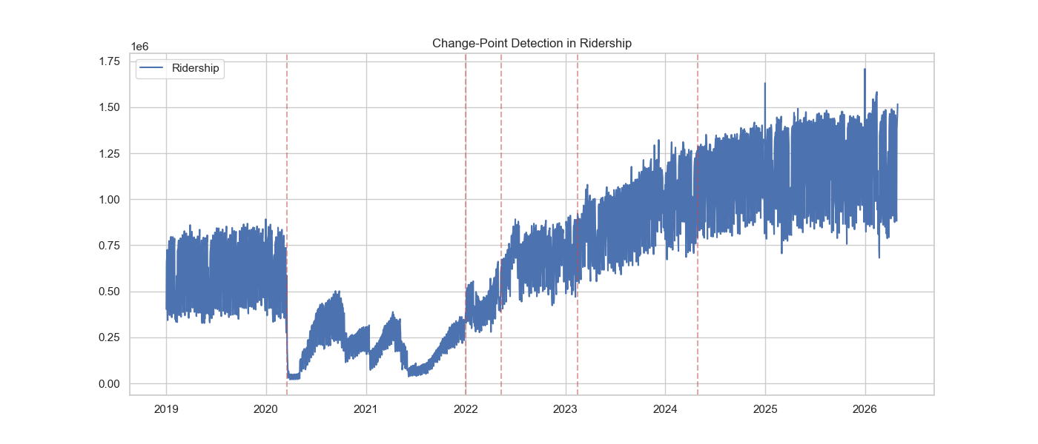
Figure 3.2
Average Daily Usage Numbers across Various Rail and Bus Lines Segmented into 3 Distinct Phases: Pre-MCO (blue), MCO (orange), and Post-MCO (green)
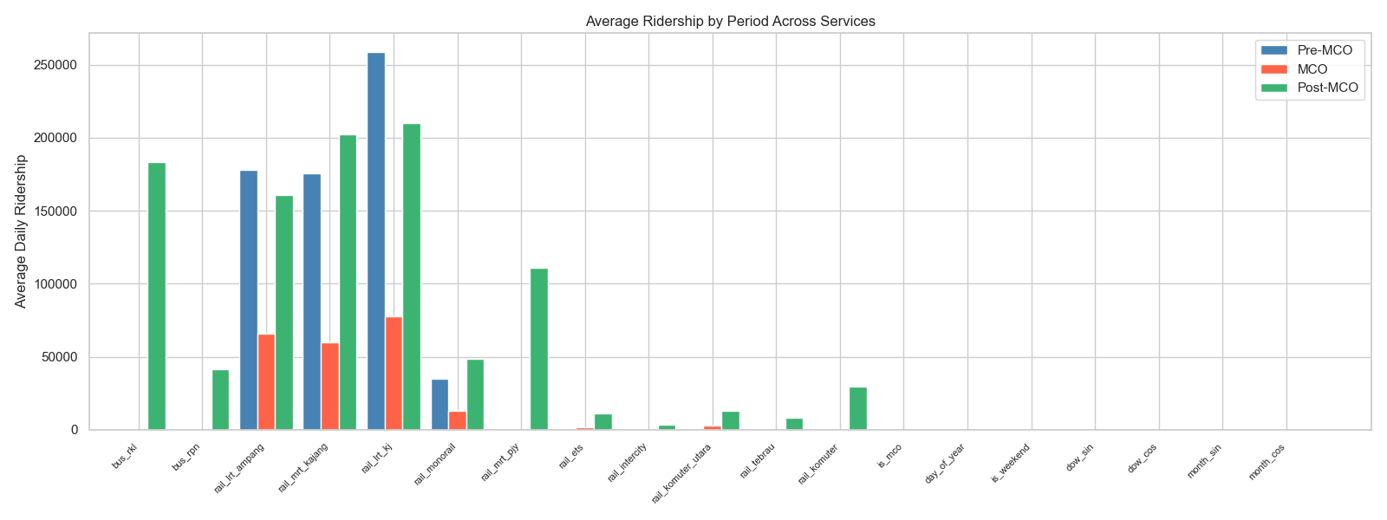

Northeast Monsoon Rainfall Pattern
The Northeast Monsoon introduces significant geographic and seasonal variations in daily precipitation across Malaysian administrative states. Sub-national data shows that extreme rainfall events (>50 mm/day) and wet-day ratios peak between November and January, with east-coast states recording higher annual frequencies than west-coast territories (Figures 3.3, 3.4, and 3.5). A research states that aggregating regional weather patterns into a single national average masks critical regional variations that drive mode-specific transit choices (Ngo & Bashar, 2024).
15 state-level rainfall variables are kept individually to preserve the spatial differences needed to model localized weather impacts, while a 7-day interpolation limit prevents over-smoothing during typical monsoon cycles. These localized rainfall patterns directly influence short-term commuter behaviour and transport modal shifts.
Figure 3.3
Comparison of Total Counts of Wet Days (≥10mm), Very Wet Days (≥30mm), and Extreme Days (≥50mm) across Various States with Terengganu consistently showing the Highest Counts
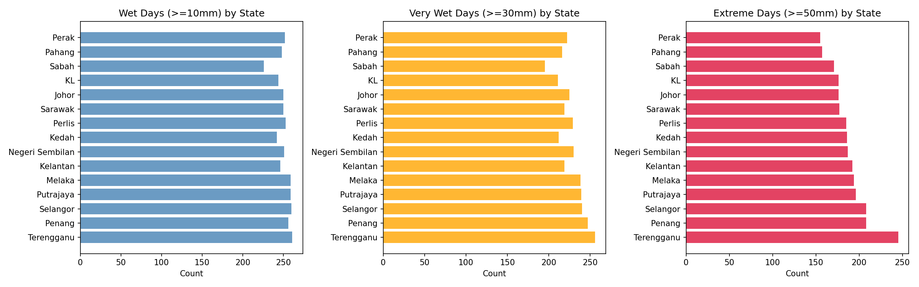
Figure 3.4
Dashboard visualizing the Trend and Breakdown of Extreme Rainfall Events over Time, including Month/Annual Frequency Percentages, Annual Wet Day Counts by Category, and Extreme Event Frequency aggregated by Month
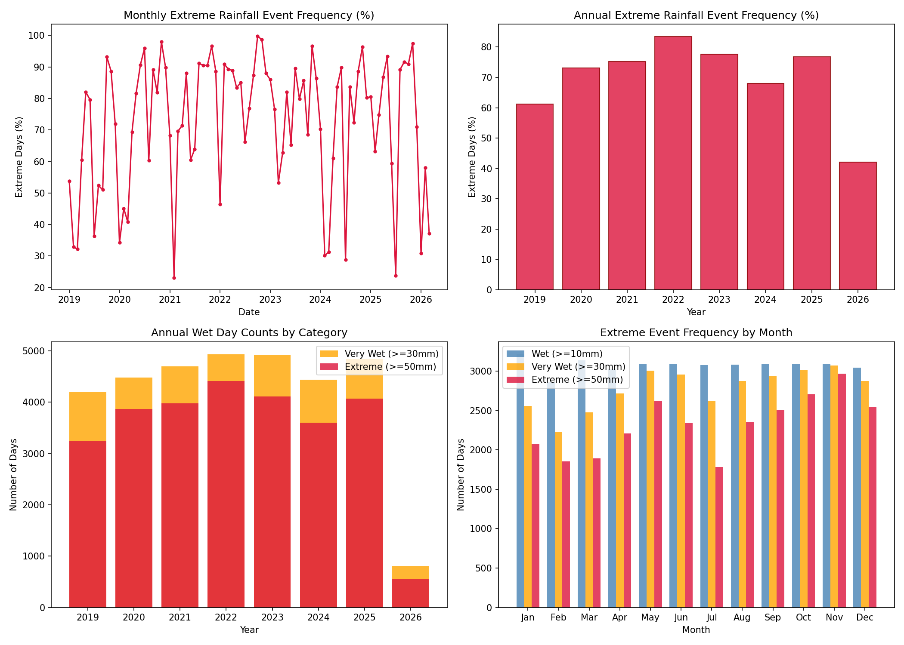
Figure 3.5
Dashboard outlining General Rainfall Trends, including Average Daily Rainfall by Month, Monthly Rainfall Anomalies, a 7-day Rolling Average Timeline, and Total Annual Rainfall from 2019 to 2026
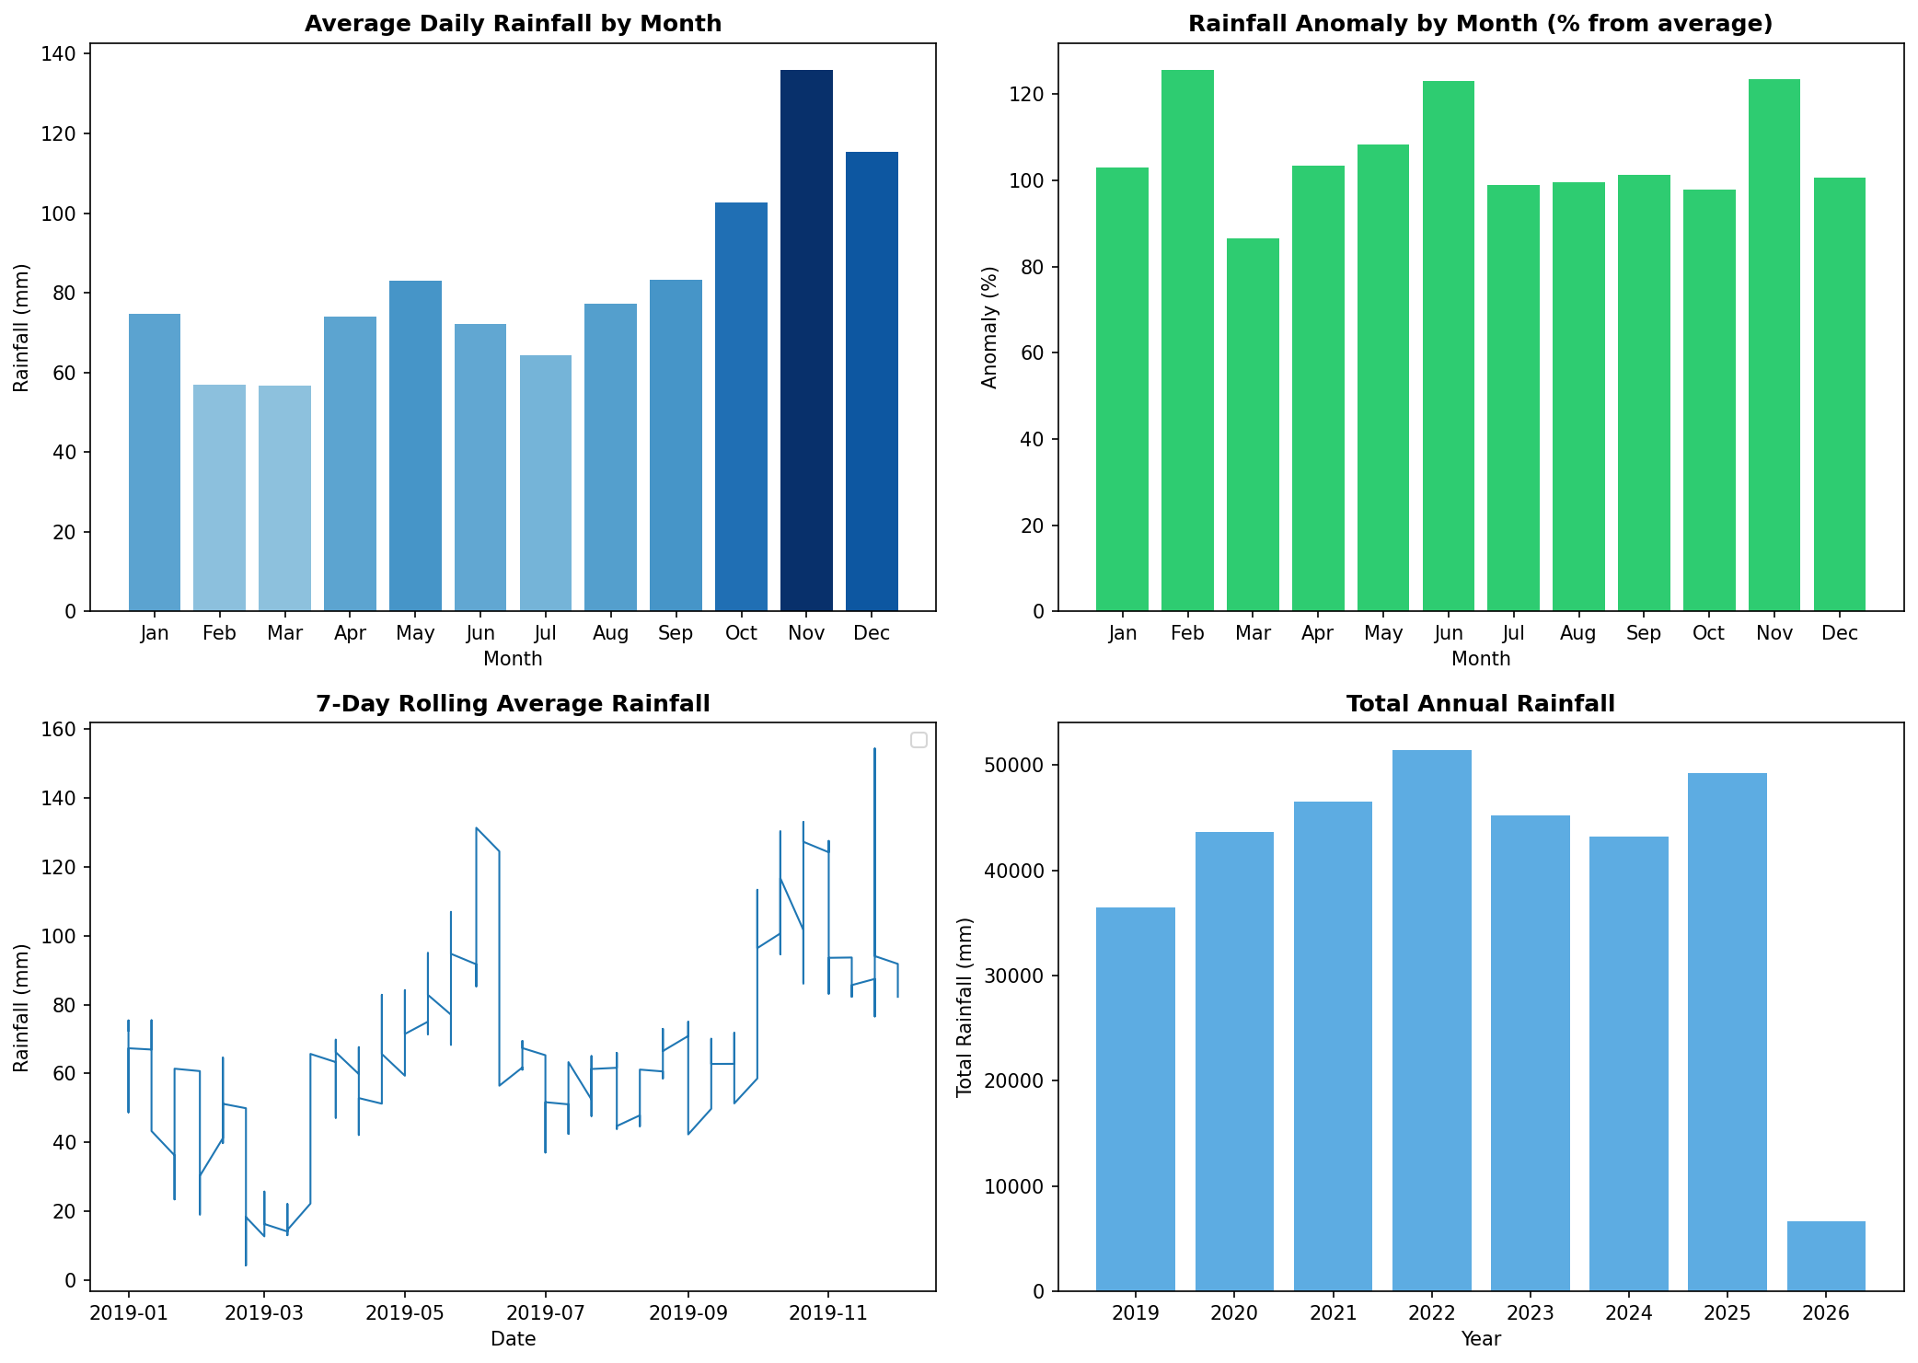

Weather-Induced Ridership Surge under Heavy Rainfall
Severe precipitation events trigger non-monotone behavioural adaptations, driving a weather-induced ridership surge via modal substitution. Correlation matrices and intensity-bin analyses (Figures 3.6, 3.7, and 3.8) demonstrate that while light rain slightly suppresses travel, heavy rain exceeding the 75th percentile is associated with a measurable increase in public transit ridership. This finding counters the general assertion that rain reduces travel (Huang et al., 2022), aligning instead with modern non-monotone response theories (Jiang & Cai, 2023; Rahmani et al., 2025).
Commuters who typically drive private vehicles shift to public transit during heavy downpours to avoid severe road congestion and hazardous driving conditions, which causes an influx of passengers during storm peaks. This behavioural substitution effect is also evident when analysing transit demand responses to fuel price adjustments.
Figure 3.6
Advanced Behavourial Analysis focusing on Weather-driven Modal Shifts, Constrasting Heavy Rain Days against Normal Conditions through a Correlation Matrix, Monthly Trend Comparisons, and a Daily Percentage Change Surge Analysis
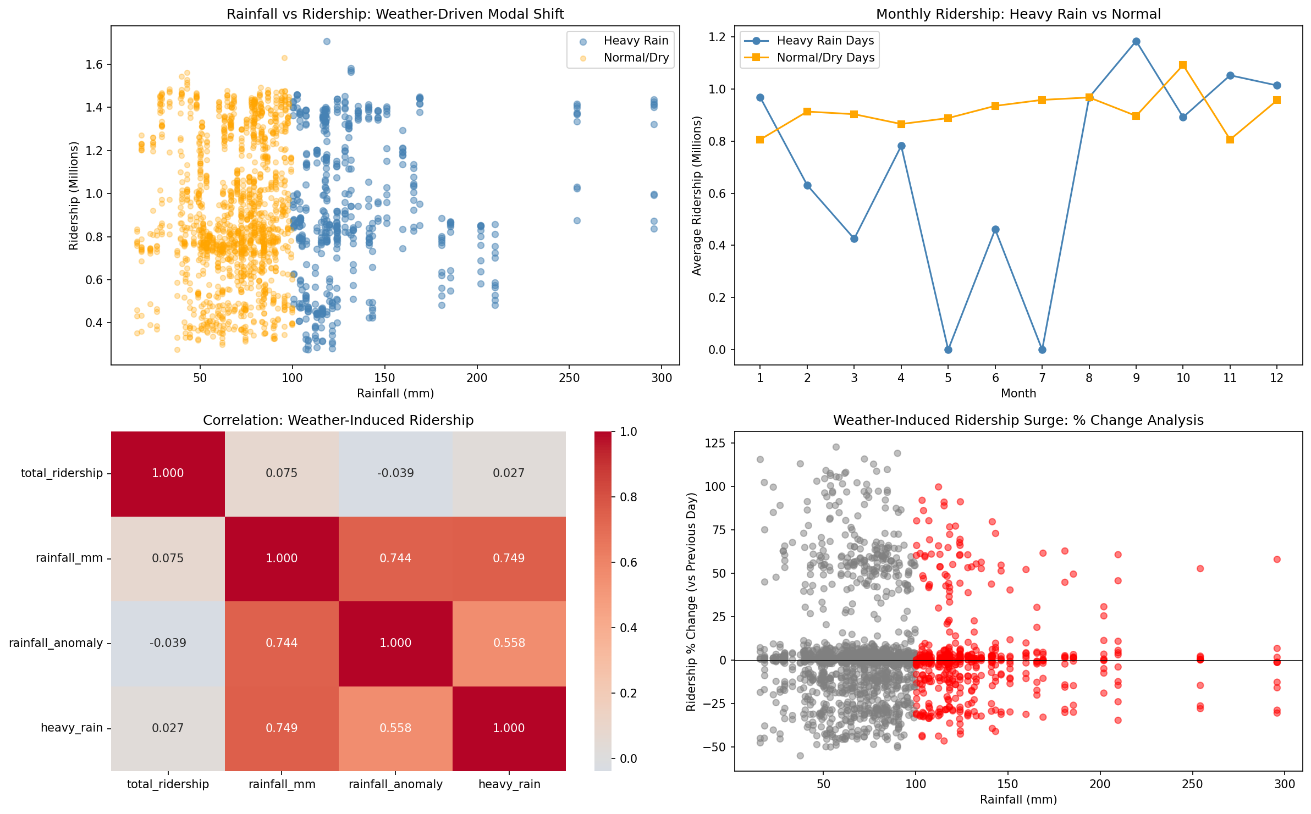
Figure 3.7
Monthly Averages for Daily Rainfall against Total Ridership with Monthly Breakdown of Correlation Coefficients, r, with Corresponding Statistical Significance (p-values)
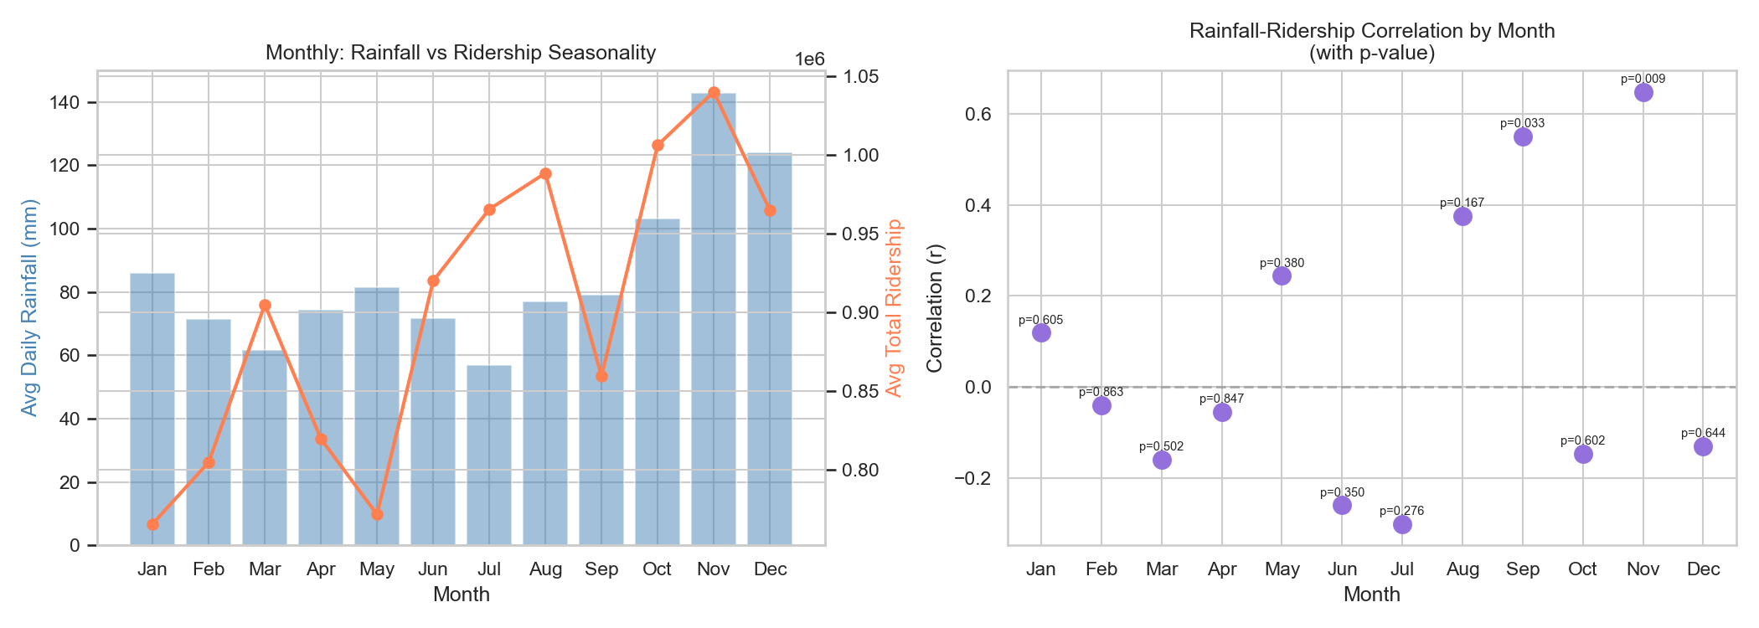
Figure 3.8
Dashboard Analysis on Direct Impact of Wet Weather with Rainfall-vs-Ridership Scatterplot (r = 0.1444), Average Daily Ridership Comparison Bars, Total Rainy Day Sample Count (n = 197), and Historical Rainfall Time Series from 2019 to 2026
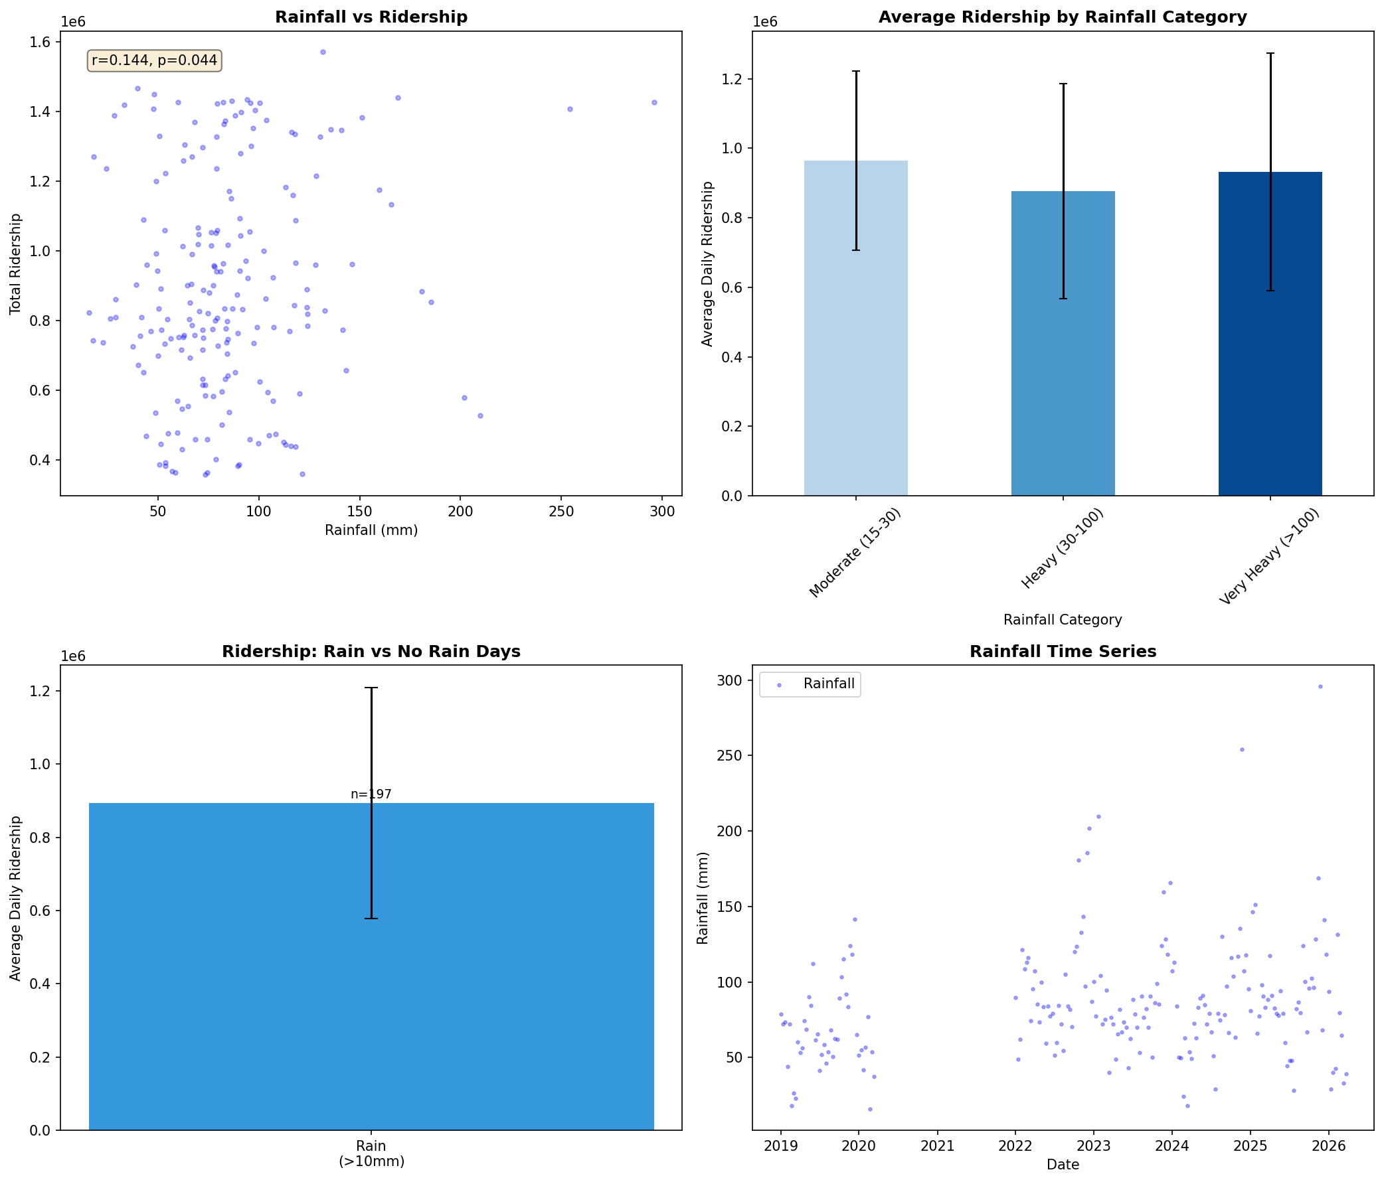

Fuel Price Elasticity and Modal Substitution
Retail fuel price movements exhibit a positive relationship with long-term public transit demand through market-driven modal substitution. Post-MCO analysis reveals a Pearson correlation of ~+0.35 between weekly RON95 prices and total ridership, with non-linear increase occurring above RM2.20/litre and peak lagged responses appearing within 1-3 days (Figures 3.9, 3.10, and 3.11). Two studies show that separating level series from price adjustments prevents models from confusing multi-year trends with sudden policy shocks (Chevance et al., 2024; Pour et al., 2026).
Level features capture long-run demand equilibrium, whereas percent-change variables capture short-run behavioural adjustments to subsidy adjustments, with rail services showing greater sensitivity to long-term price levels. Just as fuel price updates prompt systematic demand adjustments, calendar-based holiday transitions trigger predictable short-term surges and dips.
Figure 3.9
Fuel Price Levels (RON95, RON97, Diesel) in MYR/Litre (top) and Weekly Price Changes for RON95 and Diesel (bottom), both from late 2018 to mid-2026
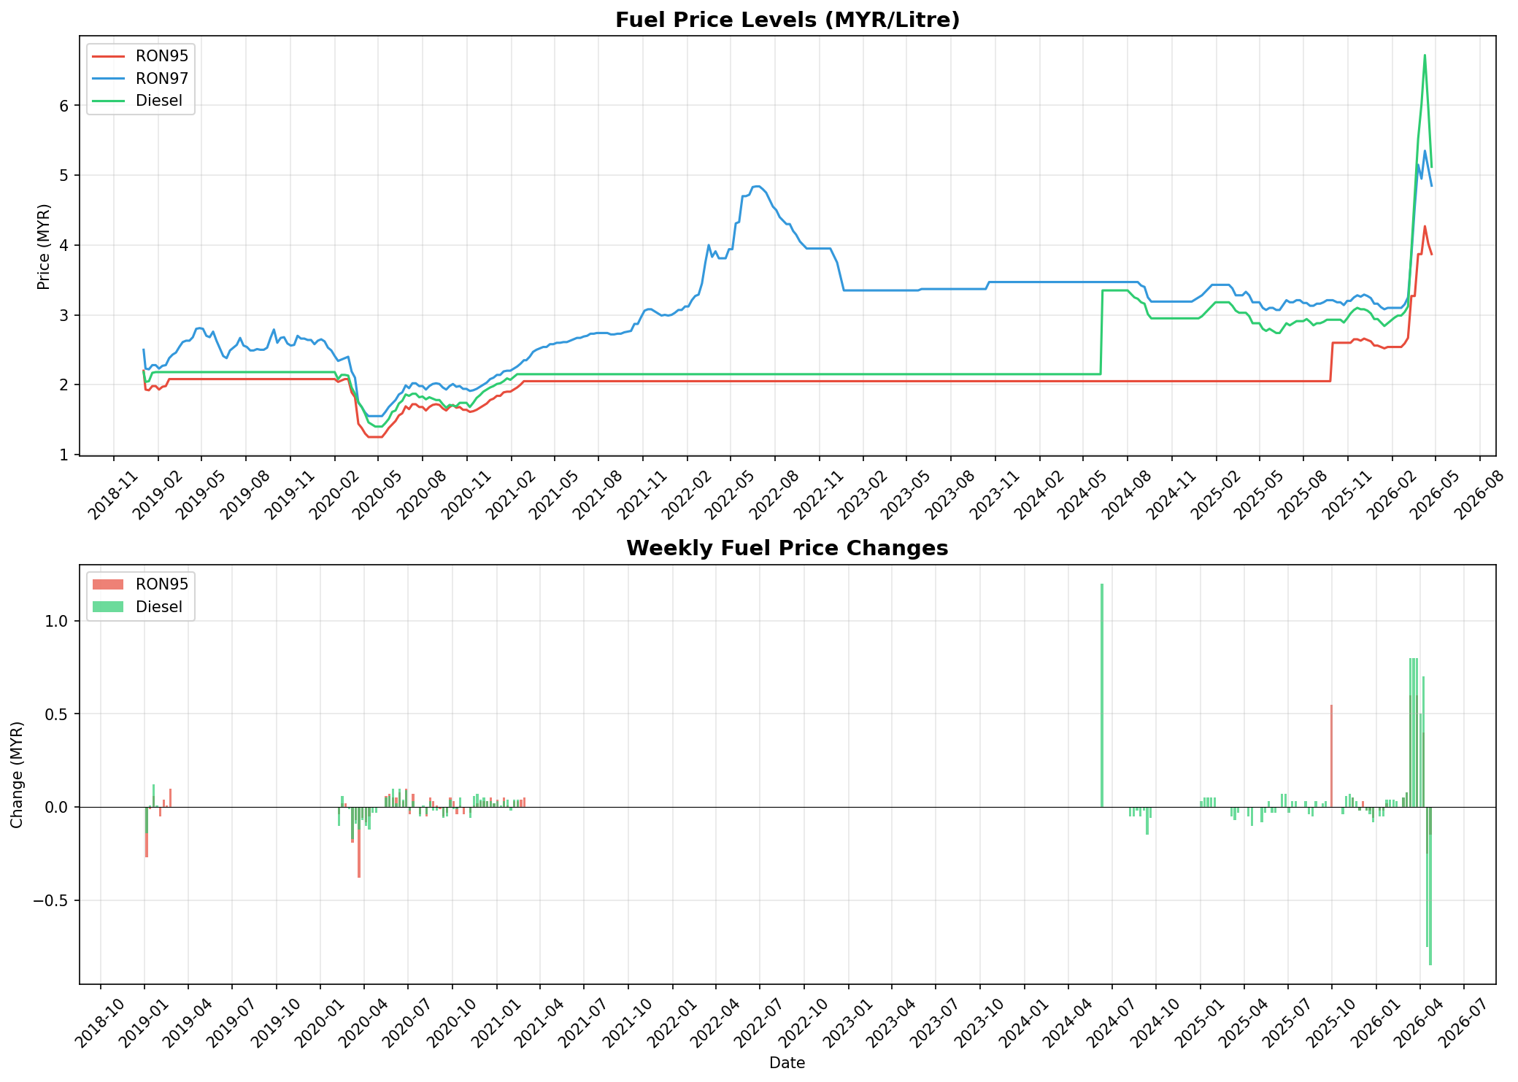
Figure 3.10
Dashboard Analysis on Direct Relationship between Fuel Prices and Public Transit Ridership with Scatterplot with Trend Lines and Weekly Percentage Changes, and Bar Chart of Average Daily Ridership by Price Level
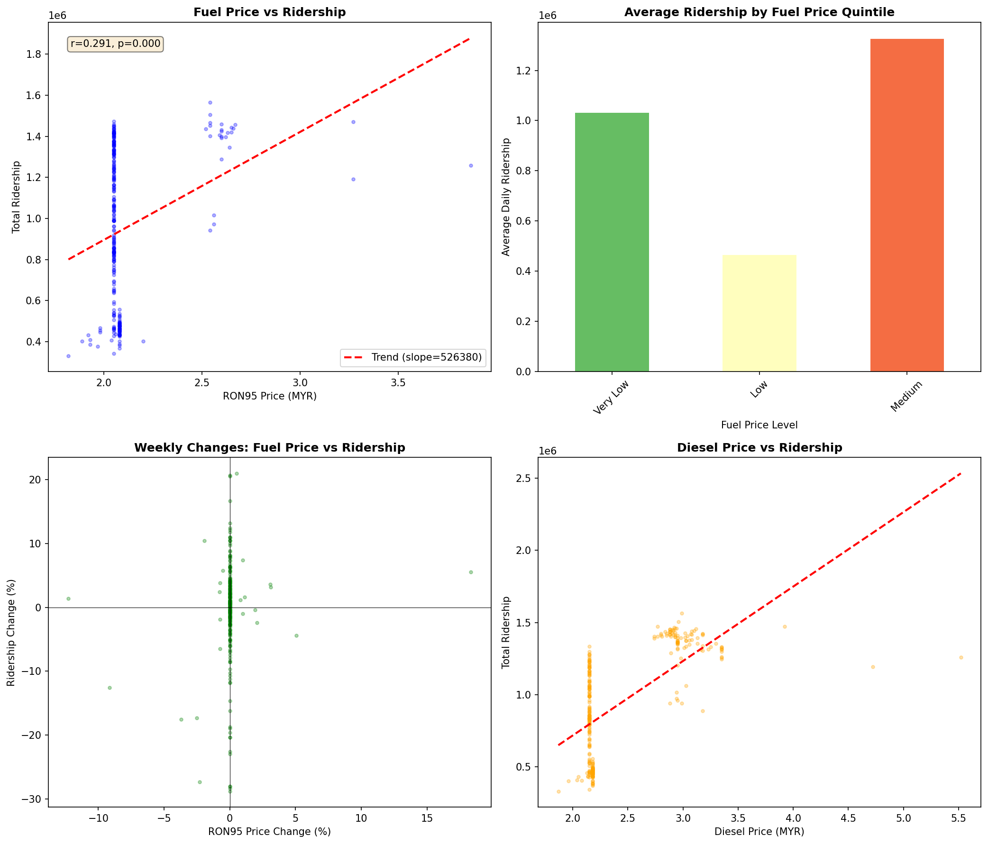
Figure 3.11
Lagged correlation (from 0 to 7 days) between Changes in Fuel Prices (RON95 and Diesel) and Subsequent Changes in Transit Ridership
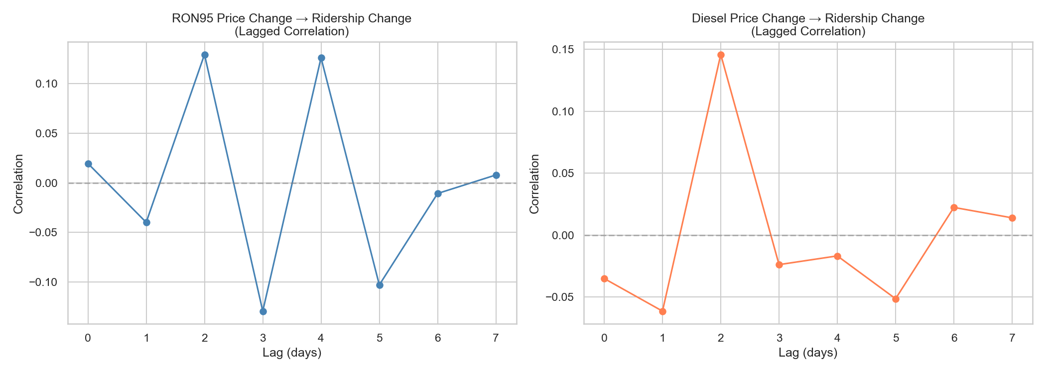

Holiday Anticipation and Return-Surge Effect
Public and academic holidays create systematic demand fluctuations characterized by an anticipatory drop and a subsequent post-holiday return surge. Cross-correlation analysis over a $±7$-day window demonstrates an approximate 18% ridership drop 1-2 days before public holidays, followed by a sharp volume spike on the first post-holiday working day (Figures 3.12, 3.13, 3.14, and 3.15). Proximity features expressing the distance to and from holidays to allow models to learn these demand gradients directly (Wu et al., 2023).
Simple binary holiday flags cannot capture the multi-day spread of these transitions; dedicated lead/lag indicators are required to map the behavioural ramp down and subsequent recovery phases. Evaluating these complex temporal patterns requires analysing how feature types interact across the entire model architecture.
Figure 3.12
Broad Seasonal and Weekly Overview Displaying Average Daily Ridership across Day Types, Monthly Distribution of Public Holidays (peaking in May), Daily Breakdown by Day of the Week, General Ridership Fluctuations across the Months of the Year
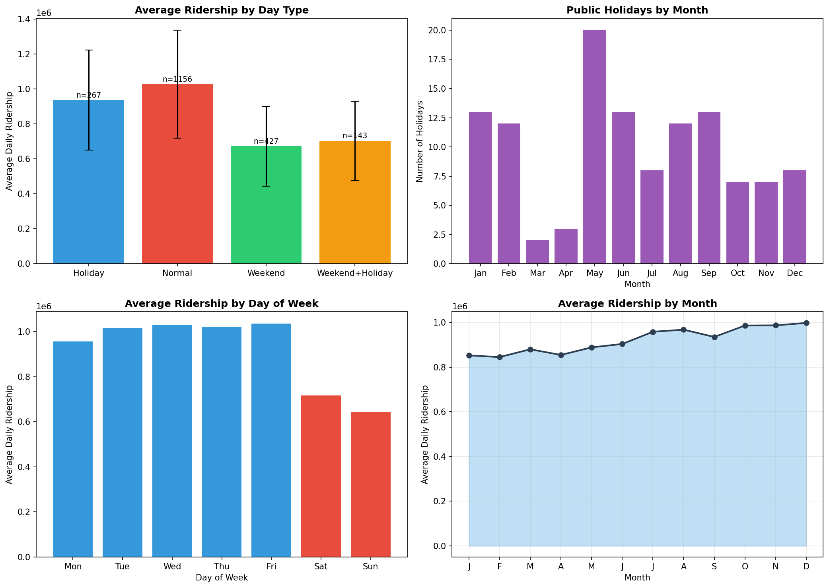
Figure 3.13
Assessing How the Length of Holiday Influences Travel Patterns showing that Short Holidays (less than 3 days) Experience the Most Severe Percentage Dip in Ridership from Normal Levels with Frequency Distribution and Day-of-Week Profile broken down by Holiday Duration

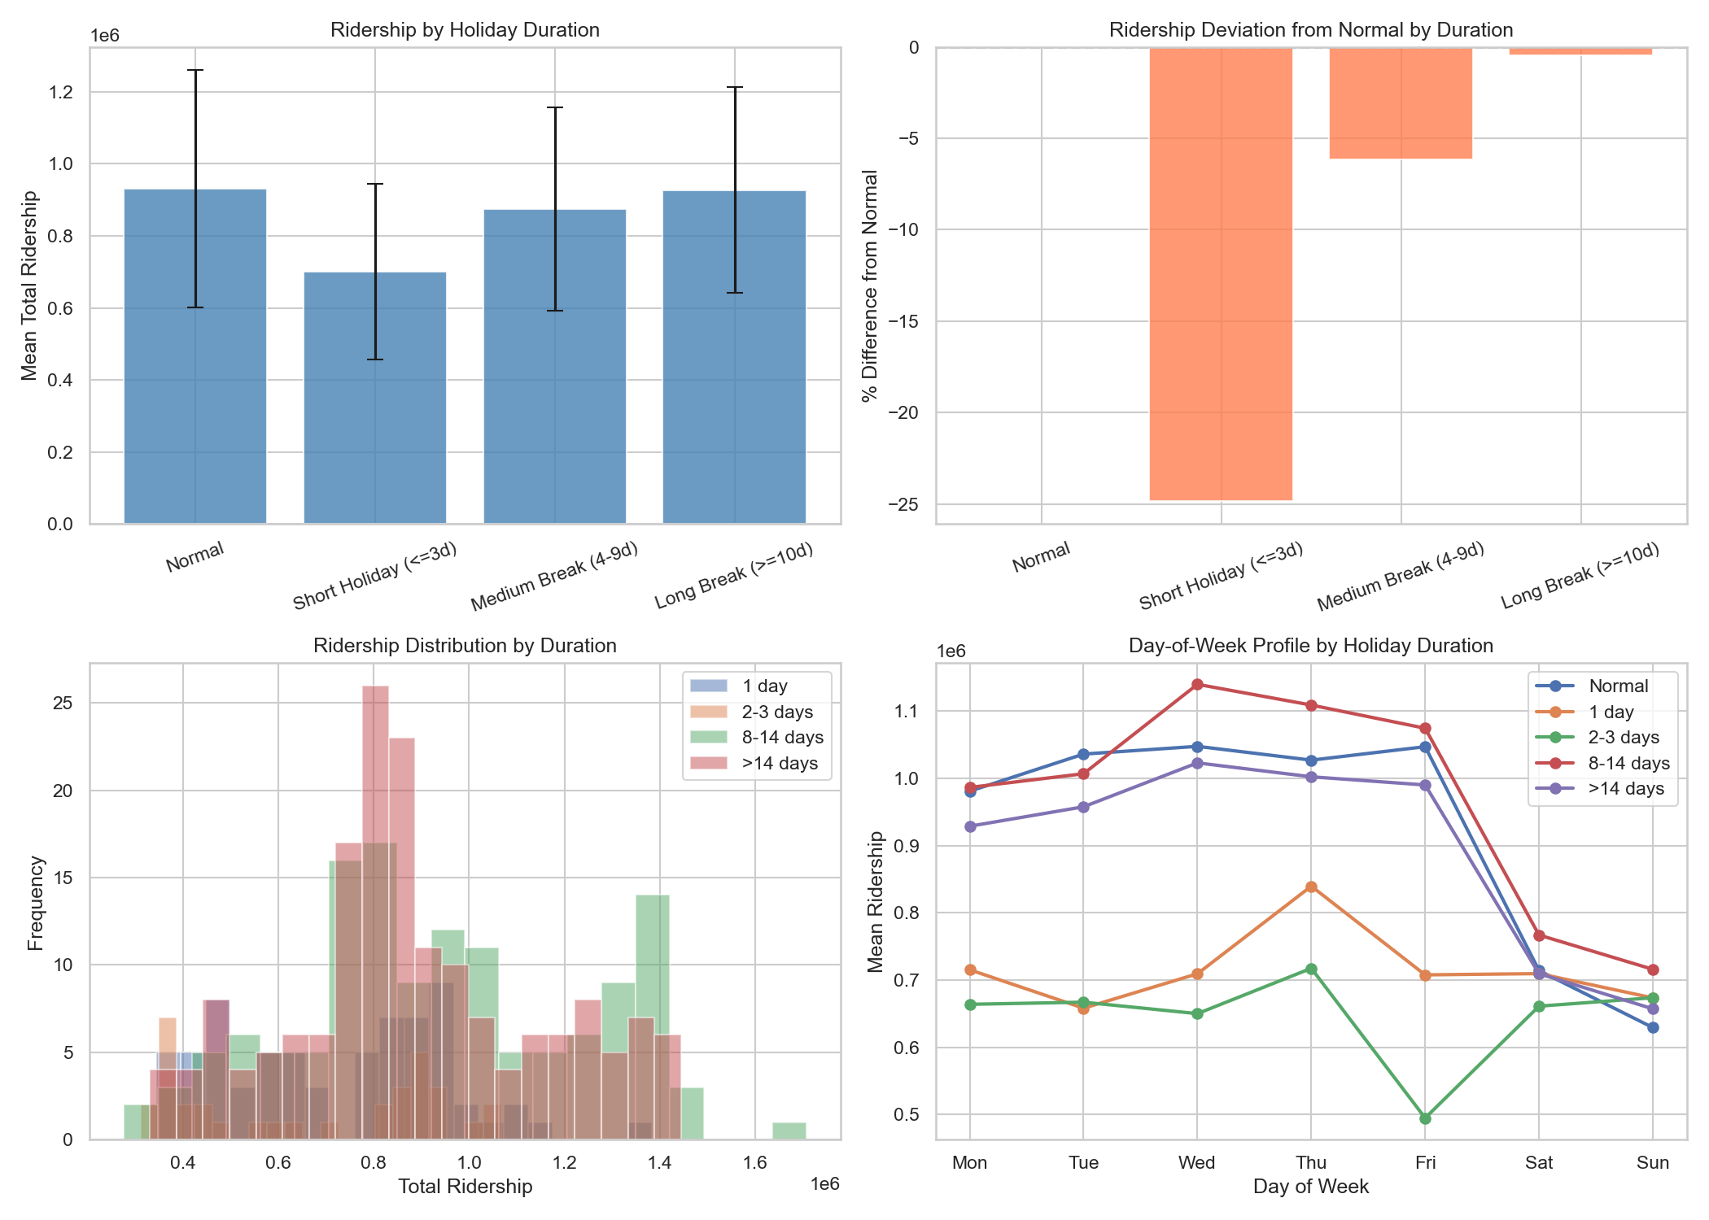
Figure 3.14
Ridership Trends between Academic and Public Holidays highlighting Public Holidays see Sharp Drops in Both Overall Mean Volume and Daily Percentage Change with Breakdown of Mean Ridership across Dozens of Individual Malaysian Calendar Events
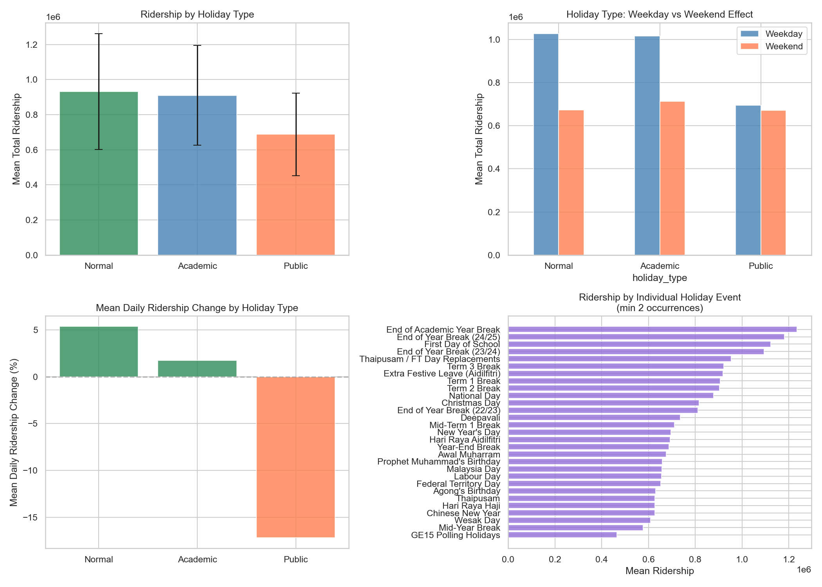
Figure 3.15
Dashboard tracking Transit Demand around Holiday Periods, showing Overall Mean Total Ridership Drops on Holidays, Day-of-Week Demand Dips (Most Pronounced on Tuesdays and Wednesdays), Distinct Weekday vs Weekend Response Gaps, and Percentage of Daily Ridership Change by Holiday Regime

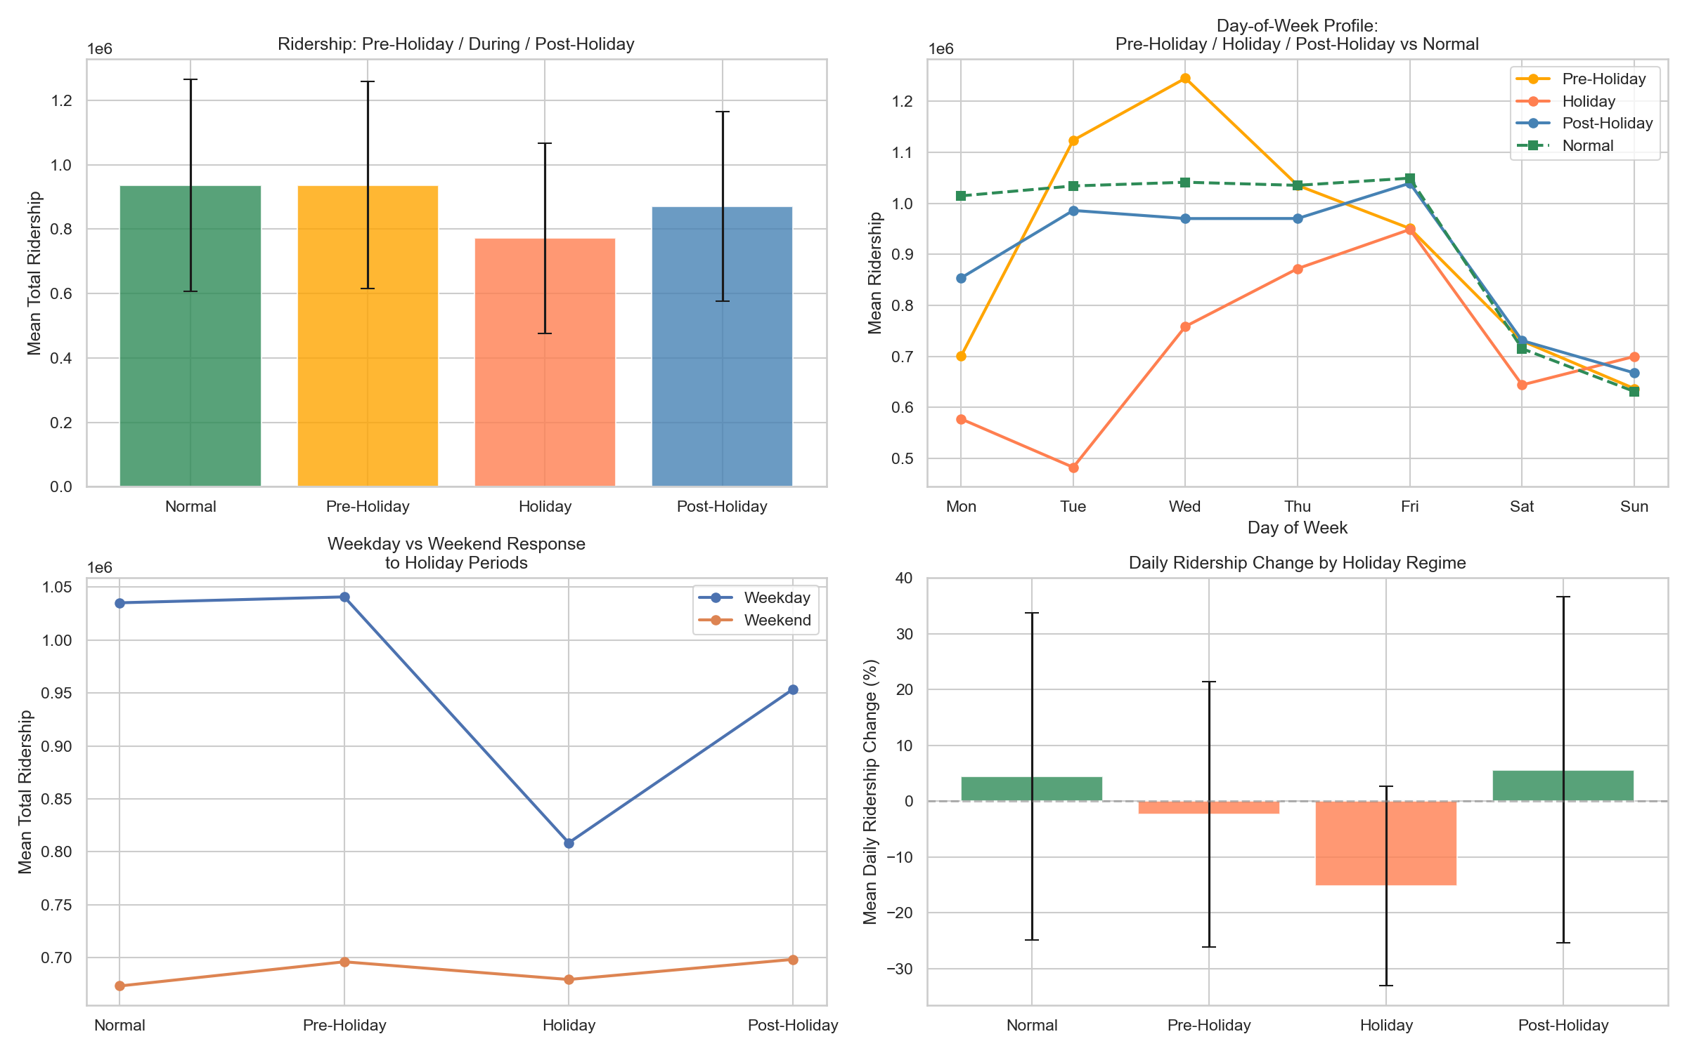

Lag Dominance and Static Near-Zero Signal
Autoregressive historical features dominate linear correlation profiles within the transit demand matric, whereas static parameters exhibit near-zero linear coefficients. Eigenvalue decomposition of the $79×79$ Pearson correlation heatmap (Figures 3.16 and 3.17) confirms that the first principal component accounts for ~72% of total variance and is dominated by ridership lags 7,14, and 28. Autoregressive lag trios consistently rank as the strongest individual predictors within transit feature matrices (Wu et al., 2023).
The dominance of these lags establishes a high-performance floor that models must exceed, while the near-zero linear correlation of static features indicates that DL architectures must employ non-linear techniques to extract value from them. This complex feature landscape justifies the selection and evaluation of various baseline and comparative models.
Figure 3.16
Detailed 6 x 6 Correlation Matrix of Key Demand Forecasting Inputs (left) with Standardized Coefficients of the Dominant Predictors of Ridership (right)
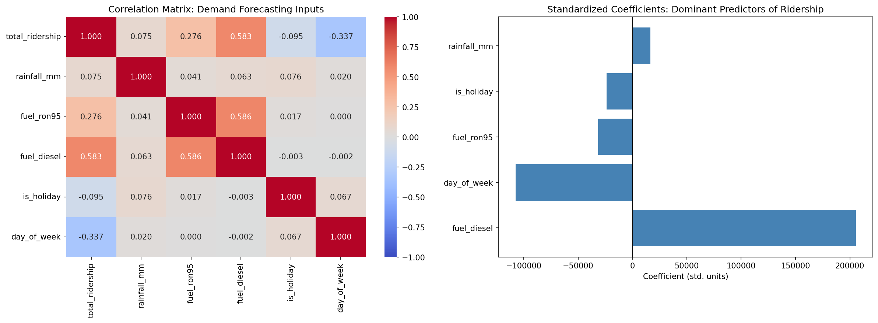
Figure 3.17
Large-scale, Lower-triangular Heatmap visualizing Complex Feature Correlation Matrix (79 x 79) for Full Demand Model
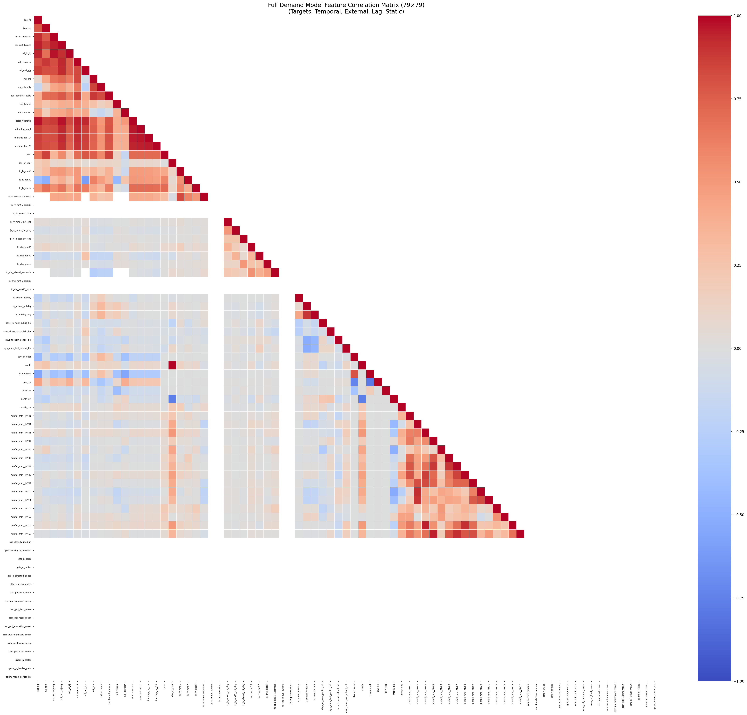

Baseline & Comparative Models
The 14 baseline models are selected progressively which isolates the contribution of each architectural component to transit ridership prediction performance. This design ensures that each model answers a specific architectural question: Does adding bidirectionality helps? Does attention over temporal patterns improve upon bidirectionality? Does encoding cross-feature correlations as a graph surpass implicit spatial encoding? Do FFT-based decompositions outperform graph propagation for periodic ridership signal? The technical details for this study are documented in Appendix for reproducing purposes.

Spatiotemporal Models

LSTM
LSTM is selected as the foundational sequential baseline to establish the minimum performance threshold against which all subsequent architectural innovations are measured. LSTM across diverse time series benchmarks and demostrates that it achieves consistently competitive accuracy as a general-purpose sequential model, confirming its suitability as the primary reference point before specialised architectures are introduced (Barath et al., 2026). In the context of Malaysian transit ridership, where temporal dependencies span daily commuter cycles and strong weekly patterns, LSTM’s gated memory mechanism provides a principled minimum capability for sequential modelling without imposing additional inductive biases such as graph structure or attention. All 14 subsequent models are directly compared against LSTM, allowing each architectural addition such as bidirectionality, pattern attention, graph convolution, series decomposition, to be expressed as a measurable incremental gain over sequential baseline.

BiLSTM
BiLSTM is selected to directly isolate the contribution of bidirectional encoding over the observed look-back window relative to the unidirectional LSTM baseline. BiLSTM achieves measurable improvements over standard LSTM in traffic congestion forecasting by exposing earlier sequence positions to future-within-window context, validating the bidirectional extension for sequential transport demand tasks (Krishnasamy et al., 2025). In Malaysia transit ridership data, mid-window events such as public holidays or major disruptions that fall several days before the forecast horizon may be more accurately encoded when the model can contextualise them against the ridership response that follows – a capability that LSTM’s strictly causal pass precludes by design. BiLSTM isolates precisely this contribution before more complex mechanisms are introduced later.

TPA-LSTM
TPA-LSTM is selected to determine whether pattern-level attention over recurring temporal shapes in the LSTM hidden-state sequence improves upon positional bidirectionality. TPA-LSTM for subway passenger flow forecasting in Shenzhen and demonstrate that the temporal pattern attention mechanism extracts multi-scale periodic signals – daily, weekly, holiday-driven cycles – more effectively than LSTM alone, validating its application to transit demand prediction (Wei et al., 2023). Malaysian transit ridership exhibits pronounced multi-scale periodicity: strict weekday commuter peaks, clear weekday/weekend asymmetry, and sharp holiday suppression events. TPA-LSTM’s 1-D CNN applied over the LSTM hidden-state matrix is designed to detect recurring shapes directly rather than relying on positional proximity, making it architecturally well-matched to periodicity-heavy transit signals. It advances from position-level richness (bidirectionality) to shape-level richness (pattern attention).

CNN-LSTM
CNN-LSTM is selected to test whether hierarchical local feature extraction by a 1-D CNN, prior to recurrent global sequence encoding, improves over attention-augmented recurrence alone. A demostration for a traffic flow prediction study that a CNN-LSTM architecture effectively decomposes the forecasting problem into a local pattern extraction stage (CNN) followed by sequential dependency modelling (LSTM), achieving improvements over purelyy recurrent models (Topilin et al., 2025). In Malaysia transit ridership, short-term local patterns – within-day ridership bursts during morning and evening peaks encoded as consecutive multi-timestep excursions – are more efficiently detected by convolution than by a recurrent cell that must propagate them across the full hidden state. Three independently tested fusion modes (sequential, parallel, augmented) are included to reveal which coupling strategy best suits the flat multivariate feature representation of this dataset, providing additional granularity (Khalil et al., 2021).

CNN-BiLSTM
CNN-BiLSTM is selected to combine the two complementary inductive biases already validated individually – CNN local pattern extraction and BiLSTM bidirectional context – and test whether their combination yields addictive or synergistic gains over either component alone. A study apply CNN-BiLSTM to short-term traffic flow prediction with multi-component sensor inputs and show that bidirectional context over CNN-extracted features reduces prediction errors more than either component in isolation (Zhuang & Cao, 2022). In Malaysian transit ridership, this combination is particularly relevant for mid-window events: a public holiday falling in the middle of the look-back window creates a local pattern that the CNN can detect spatially, and whose temporal position in the window is best contextualised bidirectionally. CNN-BiLSTM is the most expressive LSTM-family model before explicit spatial stream decoupling is introduced via ST-LSTM.

ST-LSTM
ST-LSTM is selected as the canonical bridge model between the LSTM-family and graph-based series, introducing explicit spatial encoding as a separate parallel stream rather than forcing the LSTM to encode both temporal dynamics and feature interactions in a single hidden state. A study applies a multi-stream approach to urban rail passenger flow prediction using multi-source big data and demostrate that decoupling temporal sequence modelling from cross-sensor spatial feature aggregation improves accuracy for datasets spanning structurally heterogeneous sources (Cui et al., 2025). In this study, the 79-features input spans eight structurally distinct sources – ridership, fuel, rainfall, population, GTFS, OSM, GADM, and temporal – and the spatial encoder explicitly captures which feature groups persistently co-activate, a complementary signal to the temporal trajectory captured by the LSTM. ST-LSTM serves as the canonical reference model for the entire codebase: all subsequent model implementations follow its training loop, output structure, and comparison table logic.

Graph Models

STGCN
STGCN is selected as the foundational graph-based baseline because it establishes how much a fixed, pre-computed inter-feature correlation graph contributes over purely sequential or spatially implicit models. A study applies STGCN with a spatiotemporal kernel to traffic flow prediction and confirms that interleaving Chebyshev graph convolution with temporal gated convolution captures relational dependencies that purely recurrent models cannot, even when the graph is static and pre-computed (Deng, 2025). In this study, the 79 features originate from eight structurally different sources whose inter-feature correlations are domain-meaningful: adjacent ridership lines co-vary across the transit network; fuel prices exhibit an inverse correlation with ridership on price-change days; rainfall co-varies with ridership suppression. Encoding these relationships as a Pearson graph allows message passing to propagate signals along correlated feature nodes rather than processing all features uniformly. STGCN marks the transition from implicit spatial encoding (ST-LSTM) to explicit graph-structured encoding.

ASTGCN
ASTGCN is selected to determine whether learnable multi-head attention over both graph nodes (spatial attention) and timesteps (temporal attention) improves upon the fixed gated convolutions of STGCN. A similar study presents ADSTGCN, a dynamic adaptive extension of ASTGCN for multi-step traffic forecasting, and demostrate that dual spatial and temporal attention substantially improves sensitivity to non-stationary input patterns compared to static graph message-passing alone (Cui et al., 2025). In transit ridership forecasting, the most informative subset of features and the most predictive timesteps vary by context: on a normal weekday the commuter-line ridership and day-of-week encoding are most informative, while during a holiday period the holiday-flag features and fuel-trend features dominate. ASTGCN’s per-layer dynamic re-weighting of which nodes and which timesteps to attend to allows the model to adapt this weighting per input sample. It bridges the graph-based and attention-based series by retaining the graph backbone of STGCN while adding attention on spatiotemporal dimensions.

PDR-STGCN
PDR-STGCN is a novel architecture developed in this study within the graph-based series, designed to address two key limitations of STGCN: the static graph’s inability to adapt to sample-specific inter-feature relationships, and the single-channel input’s failure to explicitly encode the periodicity intrinsic to transit ridership. An architecture published demostrates that combining multi-scale periodic fusion with a dynamic relational graph significantly improves traffic forecasting performance over the static-graph STGCN baseline, motivating its adoption for transit ridership which exhibits particularly strong weekly seasonality driven by Malaysian work and school calendars (Hu et al., 2026). The dynamic attention-based adjacency allows the model to construct a different inter-feature graph for each input sample, capturing contextual correlations that a static Pearson graph cannot represent. PDR-STGCN is the most expressive and novel graph model in this research.

STSGCN
STSGCN is selected to test whether fusing spatial and temporal graph operations into a single synchronous adjacency – rather than alternating them in separate blocks as STGCN does – captures joint spatiotemporal correlations more effectively. A research applies STSGCN to expressway traffic flow prediction during holiday periods and demonstrate that the synchronous graph approach better captures simultaneous spatial correlation changes and temporal pattern shifts during anomalous events (Chen et al., 2023). Malaysian transit ridership during public holidays exhibits precisely this behaviour: multiple feature nodes – ridership lines, holiday flags, fuel price indicators – shift simultaneously rather than sequentially, making joint synchronous encoding more naturally aligned with the data generating process. STSGCN tests whether replacing interleaved ST-Conv blocks with a unified 3N x 3N synchronous graph delivers measurable improvement at comparable parameter count.

STFGNN
STFGNN is selected to test whether using two complementary graphs, one capturing cross-feature co-variation at each moment (spatial: $A_{spa}$) and one capturing similarity of intra-window temporal profiles across features (temporal: $A_{tem}$) and fusing them via a learnable gate improves over single-graph models. A related spatiotemporal fusion approach with dynamic sparse graph convolution and demostrate that separating spatiotemporal relational priors captures distinct aspects of the data structure that a single static graph conflates (Chang et al., 2025). In Malaysian ridership data, two features may co-vary strongly at a single point in time (high spatial correlatino in $A_{spa}$) but exhibits different daily profiles across 14-day window (low temporal correlation in $A_{tem}$). For instance, a fuel price series and a rainfall series may both dip on the same days due to coincidence, giving moderate $A_{spa}$ correlation, while their intra-window temporal trajectories are structurally dissimilar in $A_{tem}$. STFGNN is the only model in the study that encodes both types of inter-feature similarity simultaneously via dedicated separate graphs.

MTGNN
MTGNN is selected to test whether learning the inter-feature graph adjacency end-to-end from node embedding matrices instead of deriving it from pre-computed Pearson correlation will produce a more task-specific and expressive relational structure. A study shows a multi-dynamic temporal representation GCN for traffic flow prediction and demonstrates that end-to-end learned adjacency with multi-scale dilated inception outperforms static correlation-based graph models by capturing task-relevant inter-node relationships that correlation alone cannot encode (Wu et al., 2025). In this study, the Pearson graph used by STGCN, STSGCN, STFGNN, and ASTGCN approximates inter-feature relationships derived from training statistics. It may miss non-linear or task-specific dependencies that only become apparent during gradient descent optimisation. MTGNN’s asymmetric learned adjacency ($A≠A^{T}$) additionally allows asymmetric influence – feature i can influence feature j without the reverse – which is suitable for causally asymmetric relationships such as fuel price affecting ridership but not vice versa.

Attention Models

Autoformer
Autoformer is selected to test whether explicit series decomposition into trend and seasonal components, combined with FFT-based autocorrelation attention, outperforms graph-based models for transit ridership, which is a periodic multi-scale signal. A study extends Autoformer with multi-scale feature fusion for time series prediction and demostrate that the decompostion-based approach achieves stable performance on strongly periodic signals by cleanly separating trend recovery from seasonal pattern matching, validating the approach for periodic demand signals (Ma & Zhang, 2025). Malaysian transit ridership in non-MCO periods exhibits largely stationary weekly and daily preiodicity, making the spectral autocorrelation mechanism theoretically well-suited: it can directly discover the 7-day dominant lag from data rather than assuming it. Autoformer introduces the hypothesis that ridership prediction problem is better framed as signal decomposition than as graph-structured feature propagation.

Informer
Informer is selected as the final comparison model, representing efficient long-sequence transformer forecasting. A study applied a graph attention Informer to long-term traffic flow prediction under event impact and demostrate that ProbSparse attention with distilling achieves competitive accuracy while substantially reducing computational cost relative to full self-attention, validating the approach for transport demand forecasting (Song et al., 2024). In this study at $T_{in}=14$, ProbSparse gracefully degenerates to near-full attention (u ~ 13 of 14 queries active), removing approximation error at the cost of no accuracy loss – making the comparison with full-attention models fair. Informer tests whether the generative one-shot decoder, which initialises with recent encoder context and directly produces all $T_{out}=7$ steps with autoregression, provides an advantage over the decomposition-decoder approach of Autoformer for multi-step transit ridership prediction.

Hybrid Multi-scale Temporal Spatio Feature (HMT-TSF) – Proposed Model
HMT-TSF is proposed to address three key limitations identified across 14 baseline models:
- No model captures all three types of structure simultaneously. LSTM family models handle temporal sequences well but have no graph structure and no regime awareness; graph-based models propagate inter-feature correlations but are rigid under distributional shift, attention-based models decompose periodic signals effectively but cannot propagate domain-meaningful feature-to-feature messages.
- No model explicitly handles the MCO regime shift. All graph-based models use static. Pearson graphs computed on training data; the MCO pandemic caused a structural break in ridership patterns that invalidates these learned correlations. Static normalisation strategies compound this problem by applying fixed-scale transformations across data from fundamentally different regimes.
- No model uses domain-aware feature grouping. All 14 baselines treat the 79 features as a flat vector, giving equal initial weight to structurally disparate sources.

Feature Selection
All 79 inputs features are organized into five semantic groups. Two groups (temporal, external) are non-contiguous in the aligned column order, so each group is defined as one or more index segments.
How Features are Used
Step 1 – Semantic Group Embedding: Each group is independently projected by a small to a common per-group embedding dimension d/2:
$$Group g: x_{g} \left(B, T_{in}, F_{g}\right) → Linear\left(F_{g}, d/2\right) → GELU → \left(B, T_{in}, d/2\right)$$
Independent embedding allows each group’s internal structure to be learned without cross-group interference at the first projection stage. This is architecturally analogous to how a domain expert analyses each data source on its own before synthesizing insights across sources.
Step 2 – Gated group fusion with learned softmax weights: All group embeddings are concatenated and passed through a learned softmax group gate, which adaptively weights each group’s contribution at each timestep:
$$h_{concat}=cat\left[h_{1},…,h_{5}\right]→\left(B,T_{in},n_{groups}×d/2\right)$$
$$gate=softmax\left(Linear\left(d_{concat}→n_{groups}\right)\right)→\left(B,T_{in},n_{groups}\right)$$
$$h_{gated}=Σ_{g}\left(gate_{g}·h_{g}\right)→\left(B,T_{in},n_{groups}×d/2\right)$$
The softmax gate forces the model to explicitly allocate attention budget across feature groups at each timestep. On holiday dates, the temporal/cyclical group receives higher weight; on normal weekdays, the target context (recent ridership) and lag groups dominate. The gate learns this allocation from data without manual tuning.
Step 3 – Projection to $d_{model}$: The gated fusion output is projected to $d_{model}$ via:
$Linear\left(d_{concat}→d_{model}\right)→GELU→Dropout→Linear\left(d_{model}→d_{model}\right)→LayerNorm$
This two-stage projection with LayerNorm compresses the fused group embeddings into a unified representation of dimension $d_{model}$ on which all three parallel encoders then operate.

Key Architecture Components

Reversible Instance Normalisation (RevIN)
RevIN is applied to the raw input before feature group embedding (Kim et al., 2023). Each sample’s mean and variance are computed per feature and used to normalise the input:
$$\overset{ˆ}{x}=\left(x-μ_{sample}\right)/σ_{sample}×γ+β$$
where $γ$ and $β$ are learnable per-feature affine parameters. The primary motivation is to reduce within-batch distribution shift caused by the MCO regime change. Without instance-level normalisation, a single minibatch containing samples form multiple regimes causes gradient conflicts that impair convergence. RevIN denormalises predictions after the forecast heads and before loss computation, ensuring the loss is measured in the original MinMax-scaled space where the target scaler was fitted.

Multi-scale Temporal Convolution Network (TCN) – Temporal Encoder
The Multi-scale TCN applies casual dilated convolutions at up to three temporal scales:
- Scale 1 (full $T_{in}$): CausalConv blocks with exponentially increasing dilation capture short-range and medium-range temporal dependencies.
- Scale 2 ($T_{in}//2,\text{ activated for }T_{in}≥28$): CausalConv on the first half of the window; captures medium-range structures.
- Scale 3 ${(T}_{in}//4,\text{ activated for }T_{in}≥56)$: CausalConv on the first quarter; capture long-range structural baselines.
WaveNet-style gated activations ($\tanh{⊙}σ$) regulate information flow within each causal block. DropPath (stochastic depth) stochastically drops entire residual paths during training, with linearly increasing rates from 0 to –drop-path argument. A learned attention pooling mechanism blends outputs across active scales, producing the final temporal summary $h_{t}∈R^{d_{model}}$.

Spatial Graph Encoder
Rather than using the raw temporal sequence as node features (as graph-based baselines do), the Feature Graph Encoder first compresses the time dimension via learned temporal attention:
$$\overset{ˆ}{x}\left(B,T_{in},F\right)→\text{learned time-attn}→\left(B,F,1\right)\text{node feature vectors}$$
A 2-layer GCN then propagates signals across the Pearson-correlation adjacency (|corr| $≥$ 0.1, same construction as STGCN/ASTGCN), with global mean pooling over all F feature nodes producing $h_{s}∈R^{d_{model}}$. This design decouples graph encoding from temporal encoding: the graph branch receives a temporal summary rather than raw sequence, allowing GCN to focus on cross-feature relational patterns without interference from temporal dynamics. Importantly, this encoder and Regime Gating Embedding both receive raw RevIN-normalised input $x$, bypassing the Feature Group Fusion and Temporal Transformer Block, so the graph and regime branches see the unprocessed feature signal rather than the projected $d_{model}$ representation.

Regime Gating Embedding
The MCO period represents a structural break in Malaysia transit ridership – not merely a large shock, but a change in which features predict ridership at all. During lockdown, fuel prices and population density features become irrelevant to transit demand (which was prohibited regardless). The Regime Gating Embedding maintains K=3 learnable embedding vectors representing the three operational regimes:
- Pre-COVID: 2019-01-01 to 2020-03-17
- MCO: 2020-03-18 to 2021-12-31
- Post-MCO: 2022-01-01 to 2025-12-31
At each forward pass, the mean-pooled input is projected to K=3 soft logits via a linear layer and softmax, producing a soft mixture of regime embeddings:
$$h_{r}=Σ_{k}gate_{k}⋅E_{k}, \text{gate}=\text{softmax}\left(\text{Linear}\left(\overset{ˆ}{x}.\text{mean}\left(T\right)\right)\right)$$
This soft gating allows the model to blend adjacent regime characteristics for transitional periods (e.g., early MCO easing in 2021) without hard chronological boundaries. Crucially, no date metadata is required at inference – the regime gate is inferred from the observed feature pattern alone.

Gated Fusion
The three encoder outputs $h_{t}$ (temporal TCN), $h_{s}$ (spatial TCN), and $h_{r}$ (regime gating) are concatenated and passed through a Squeeze-and-Excitation (SE) bottleneck gate:
$$h=cat\left[h_{t},h_{s},h_{r}\right] \left(B,3⋅d_{model}\right)$$
$$g=σ\left(\text{bottleneck}\left(h\right)\right) SE:3d→3d//4→3d,\text{ then sigmoid}$$
$$out=\text{Linear}\left(g⊙h→d_{model}\right)→\text{GELU}→\text{Dropout}→\text{LayerNorm}$$
The SE bottleneck avoid a computationally expensive 3d x 3d weight matrix while still learning to calibrate which of the tree encoder streams contributes most for each input context.

Dual Forecast Heads and Custom Loss
Two forecast heads are applied to the fused embedding:
- Primary head: $h→\text{Linear}\left(d_{model},d_{model}\right)→\text{GELU}→\text{Linear}\left(d_{model},T_{out}\right)$ with highway residual and LayerNorm.
- Boosting head: $h→\text{Linear}\left(d_{model},T_{out}\right)×\text{sigmoid}\left(α\right)$ where $α$ is initialised to -2.0 so sigmoid(-2.0) ~ 0.12 suppresses the boosting contribution early in training; the head gradually activates as training converges
Final prediction: $y=y_{primary}+y_{boost}$
The custom loss penalises both prediction accuracy and smoothness:
$$L=\text{WeightedHuber(step-decay } γ=0.9)+λ⋅\text{TemporalSmoothness}$$
Step 1 (1-day-ahead) has weight 1.0
Step 7 (7-day-ahead) receives weight 0.9⁶ ~ 0.53.
TemporalSmoothness = ${\left|y_{t+1}-y_{t}\right|}^{2}$ across $T_{out}$ prevents oscillatory day-to-day predictions.

Future Temporal Projection – Known-Future Calendar Conditioning
The 16 temporal features are deterministic for any future calendar date, so it was pre-computed for the $T_{out}$ forecast steps of each window as $X_{future}:\left(B,T_{out},16\right)$. A per-step MLP ($n_{t}→\max\left(2⋅n_{t},32\right)→1$, zero-initialised so it starts as a no-op) learns an additive correction from this known-future context – letting the model anticipate weekend dips and holiday effects inside the forecast horizon rather than extrapolating them from the look-back window.

Architecture Diagram
Figure 3.18
HMT-TSF Architectural Flow Diagram
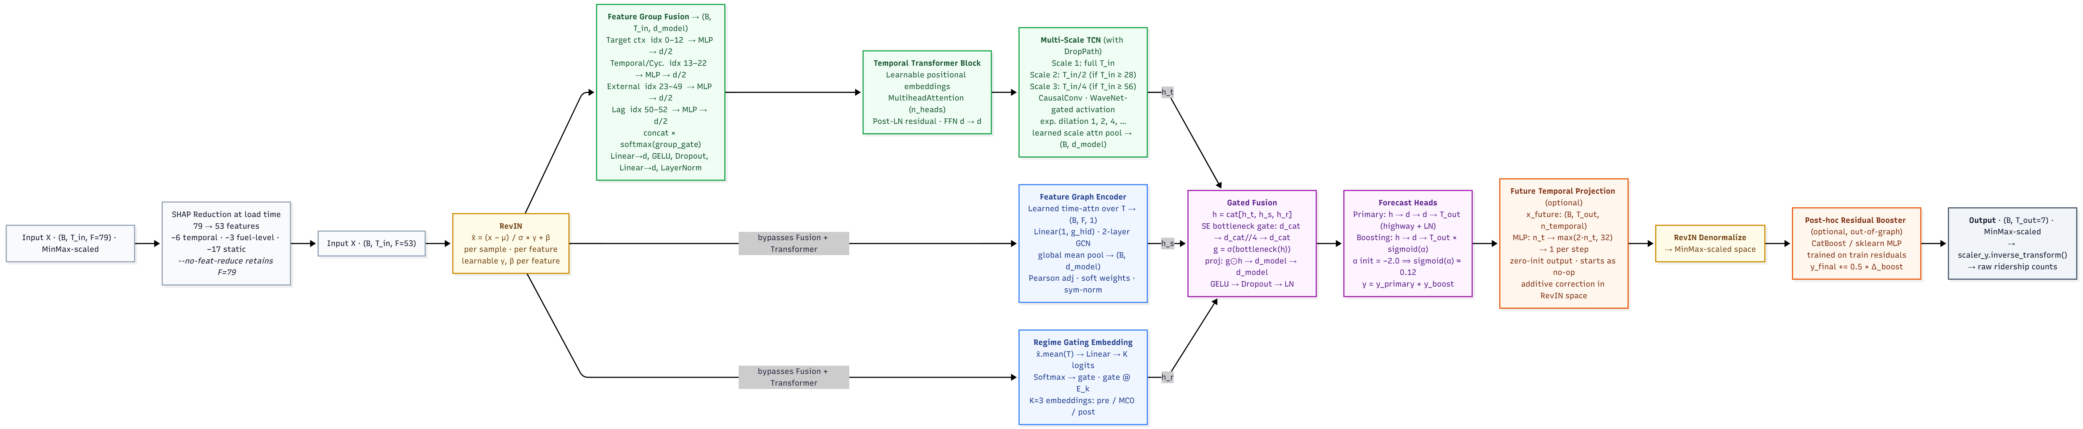
Note. It illustrates a multi-path technical processing pipeline. Begins with sequential initial steps on the far left, splits into 3 distinct parallel processing blocks in the centre (green and blue blocks) and converges back into a single sequence of analytical and output steps on the right. Full training configurations are as listed in Appendix.

Strengths
- Three parallel encoders address all three primary modelling challenges identified from the baseline analysis: temporal dynamics (TCN), inter-feature correlations (GCN), and regime shift (gating).
- Semantic feature group embedding with learned softmax gate provides adaptive feature-source weighting – the model learns which data sources matter most per context.
- RevIN and Regime Gating jointly address the MCO distributional shift from two independent directions: instance-level normalisation removes amplitude drift; explicit regime embeddings adjust the prediction bias for each operational regime.
- Multi-scale TCN with DropPath avoids spectral leakage and sequence-length sensitivity in Autoformer.
- Dual forecast heads with suppressed boosting initialisation ensure stable early training while allowing residual correction to activate progressively.

Weaknesses
- Significantly higher parameter counts and architectural complexity than any single baseline and need careful tuning of RevIN, SE gate, DropPath, and boosting head initialisation.
- Post-hoc CatBoost residual correction adds a second-stage pipeline that is harder to explain and may degrade if neural residuals are not well-structured.
- The k=3 regime embedding boundaries are manually motivated by MCO chronology, a different country or crisis timeline would require re-specification of regime count and boundary dates.
- Static Pearson graph in the Feature Graph Encoder inherits the same MCO-sensitivity limitation as STGCN and ASTGCN, partially offset by RevIN and regime gating but not fully resolved.

Evaluation Metrics

Combined Accuracy Percentage (Combined %)
Combined% serves as a composite index that aggregates absolute, proportional, and squared error metrics to provide a single performance rank for model comparison. The composite value is computed as:
$$\text{Combined\%}=\text{max(0, 100 - MAPE - MAE\% - RMSE\%)}$$
- Higher is better, clipped, cannot be negative
- All three constituent terms are mean-demand-normalized percentages, making them dimensionally homogeneous and directly addable on the same scale.
Equal weighting reflects the operational reality of transit management, where percentage errors relative to daily volume (MAPE), average absolute passenger discrepancies (MAE%), and large individual forecast failures (RMSE%) are equally critical. To understand the specific error characteristics captured by this index, each constituent metric must be analysed independently.

Mean Absolute Percentage Error (MAPE%)
MAPE provides a scale-independent measure of forecast accuracy by expressing average prediction errors relative to actual daily demand. The metric is defined mathematically as:
$$\text{MAPE}=\frac{1}{n}\sum_{i=1}^{n}{\frac{\left|{\overset{ˆ}{y}}_{i}-y_{i}\right|}{\left|y_{i}\right|}}×100$$
- $y_{i}$ = actual ridership, ${\overset{ˆ}{y}}_{i}$ = predicted ridership
- Unit: %, used directly in Combined%
- Lower is better
A study utilizes MAPE to benchmark passenger flow adjustments, demostrating its snestivity for ddetecting incremental accuracy gains in DL comparisons (Wei et al., 2023). Normalizing errors by actual daily volume ensuring that proportional accuracy is weighted equally on low-demand days (weekends, holidays) and high-demand days (weekdays). While MAPE measure proportional error, absolute error magnitude relative to the system throughput is captured via MAE%.

Mean Absolute Error (MAE%)
MAE% normalizes the absolute passenger error by the mean system demand to create a scale-free metric that quantifies average forecast deviations. The calculation is structured as:
$$\text{MAE\%}=\frac{\sum_{i=1}^{n}{\left|{\overset{ˆ}{y}}_{i}-y_{i}\right|}}{\sum_{i=1}^{n}{y_{i}}}×100 = \frac{\text{MAE}}{\overline{y}}×100$$
- $\overline{y}$ = mean actual ridership across all test observations
- Unit: % - scale-free; used directly in Combined%
- Raw MAE (absolute ridership counts) is report separately as an operational diagnostic.
- Lower is better
Pairing normalized absolute metrics with percentage error indicators ensures stable model rankings when datasets contain near-zero observations (Krishnasamy et al., 2025). Including this metric alongside MAPE ensures that models are penalized for both day-specific proportional failures and average absolute variations relative to total network capacity. To complement average absolute errors, worst-cast daily variances are captured using RMSE%.

Root Mean Squared Error (RMSE%)
RMSE% provides a scale-free error measure that penalizes large individual forecast deviations through squaring, capturing tail-error behaviour in the prediction distribution. The metric is computed using the system’s mean demand ($\overline{y}$) denominator:
$$\text{RMSE\%}=\frac{\text{RMSE}}{\overline{y}}×100 \text{where} \text{RMSE}=\sqrt{\frac{1}{n}\sum_{i=1}^{n}{{\left({\overset{ˆ}{y}}_{i}-y_{i}\right)}^{2}}}$$
- Same mean-demand denominator $\overline{y}$ as MAE%
- Unit: % - used directly in Combined%
- Raw RMSE (ridership counts) is reported separately as an operational diagnostic
- Lower is better.
RMSE-based indicators are highly effective for capturing model sensitivity during unexpected peak-period demand spikes (Wu et al., 2025). The squaring operation exponentially penalizes major misjudgements during peak morning or holiday periods, ensuring that models minimizing this metric offer high operational reliability. While these four metrics quantifyy error magnitudes, the model’s overall explanatory power is validated via the Coefficient of Determination.

Coefficient of Determination (R²)
R² measures the proportion of variance in actual ridership explained by the model’s predictions, indicating how well the forecast tracks the direction and shape of transit dynamics. The goodness-of-fit indicator is calculated as:
$$R^{2}=1-\frac{\sum_{i=1}^{n}{{\left(y_{i}-{\overset{ˆ}{y}}_{i}\right)}^{2}}}{\sum_{i=1}^{n}{{\left(y_{i}-\overline{y}\right)}^{2}}}$$
- $y_{i}$ = actual ridership, ${\overset{ˆ}{y}}_{i}$= predicted ridership, $\overline{y}$ = mean of actual values
- Numerator = Residual Sum of Squares (SSR) – unexplained variance
- Denominator = Total Sum of Squares (SST) – total variance in the data
- Range: -∞ to 1; R² < 0, indicates performance worse than predicting the mean.
- Higher is better.
R² provides critical discriminative power when comparing models with similar error magnitudes but different directional tracking capabilities (Zhuang & Cao, 2022). While error percentages evaluate magnitude discrepancies, R² measures explained variance; a negative value indicates that the model performed worse than simply predicting the historical mean. Collectively, these five metrics form a comprehensive validation framework to evaluate the HMT-TSF forecaster against the 14 baseline models under varying look-back horizons and MCO conditions.

REFERENCES
Ahmad, M., Anwer, I., Yousuf, M. I., Javid, M. A., Ali, N., Tesoriere, G., & Campisi, T. (2024, May 23). Investigating the Key Factors Affecting Public Transport Ridership in Developing Countries through Structural Equation Modeling. Sustainability, 16(11), 4426. https://doi.org/10.3390/su16114426
Amir, N. N., Anuar, N. S., Ismail, B., Azreen, N. A., & Ramli, N. A. (2025, December 28). Ridership Prediction System for Rapid Bus Kuantan and Penang using Multi-Feature Analysis. Journal of the Malaysian Institute of Planners, 23(6), 332 - 347. https://doi.org/10.21837/pm.v23i39.1913
Barath, Z., Veres, P., & Banyai, A. (2026, March 1). Beyond Traditional Forecasting Methods: Evaluating LSTM Performance on Diverse Time Series. Mathematics, 14(5), 838. https://doi.org/10.3390/math14050838
Casolaro, A., Capone, V., Iannuzzo, G., & Camastra, F. (2023, November 4). Deep Learning for Time Series Forecasting: Advances and Open Problems. Information, 14(11), 598. https://doi.org/10.3390/info14110598
CCS Global Tech. (2026, March 9). From Reactive to Proactive Decisions: How AI Enablement is Solving Everyday Transit Challenges. CSS Global Tech. https://ccsglobaltech.com/from-reactive-to-proactive-decisions-how-ai-enablement-is-solving-everyday-transit-challenges/
Chang, J., Yin, J., Hao, Y., & Gao, C. (2025, May 30). STFDSGCN: Spatio-Temporal Fusion Graph Neural Network Based on Dynamic Sparse Graph Convolution GRU for Traffic Flow Forecast. Sensors, 25(11), 3446. https://doi.org/10.3390/s25113446
Chen, L., Ren, Q., Zheng, J., Zou, F., Luo, S., Tian, J., & Xing, Y. (2023, April 5). CSFPre: Expressway key sections based on CEEMDAN-STSGCN-FCM during the holidays for traffic flow prediction. (T. A. Rashid, Ed.) PLoS One, 18(4), 1 - 22. https://doi.org/10.1371/journal.pone.0283898
Chen, P., Fu, X., & Wang, X. (2022, July 7). A Graph Convolutional Stacked Bidirectional Unidirectional-LSTM Neural Network for Metro Ridership Prediction. IEEE Transactions on Intelligent Transportation Systems, 23(7), 6950 - 6962. https://doi.org/10.1109/TITS.2021.3065404
Chevance, G., Andrieu, B., Koch, N., Tonne, C., Nieuwenhuyijsen, M., & Bernard, P. (2024, December 30). How gasoline prices influence the effectiveness of interventions targeting sustainable transport modes? Sustainable Mobility and Transport, 1, 1 - 8. https://doi.org/10.1038/s44333-024-00017-1
Cui, H., Si, B., Chi, D., Li, Y., Li, G., & Chen, Y. (2025, October 6). Short-term passenger flow prediction for urban rail systems: A deep learning approach utilizing multi-source big data. (S. Panigrahi, Ed.) PLoS One, 20(10), 1 - 23. https://doi.org/10.1371/journal.pone.0333094
Deng, H. (2025, March 31). Traffic-Forecasting Model with Spatio-Temporal Kernel. Electronics, 14(7), 1410. https://doi.org/10.3390/electronics14071410
Farahmand, Z. H., Gkiotsalitis, K., & Geurs, K. T. (2023, May). Predicting bus ridership based on the weather conditions using deep learning algorithms. Transportation Research Interdisciplinary Perspectives, 19, 100833. https://doi.org/10.1016/j.trip.2023.100833
Ge, L., Sarhani, M., Voss, S., & Xie, L. (2021, October 16). Review of Transit Data Sources: Potentials, Challenges and Complementarity. Sustainability, 13(20), 11450. https://doi.org/10.3390/su132011450
Hashimzai, I. A., & Mohammadi, M. Q. (2024, December). The Integration of Artificial Intelligence in Project Management: A Systematic Literature Review of Emerging Trends and Challenges. TIERS Information Technology Journal, 5(2), 152 - 164. https://doi.org/10.38043/tiers.v5i2.5963
Hassan, M., Mahin, H. D., Ahmed, F., Hassan, M. M., Rahaman, A., & Abdullah, M. (2025, July 4). Assessing Public Transit Network Efficiency and Accessibility in Johor Bahru and Penang, Malaysia: A Data-driven Approach. Results in Engineering, 27, 106126. https://doi.org/10.1016/j.rineng.2025.106126
Hu, J., Tang, B., Zhu, L., Li, Y., Hu, J., & Yang, G. (2026, January 18). PDR-STGCN: An Enhanced STGCN with Multi-Scale Periodic Fusion and a Dynamic Relational Graph for Traffic Forecasting. Systems, 14(1), 102. https://doi.org/10.3390/systems14010102
Huang, S., Li, W., Wen, J., Zhu, M., Lu, Y., & Wu, N. (2022). Spatiotemporal Variations in Shanghai Metro Commuting Flows during Rainfall Events. Weather, Climate and Society, 14(3), 979 - 991. https://doi.org/10.1175/WCAS-D-21-0167.1
Ibrahim, A. N., Borhan, M. N., Osman, M. H., Yazid, M. R., & Rohani, M. M. (2022, June 24). The Influence of Service Quality on User's Perceived Satisfaction with Light Rail Transit Service in Klang Valley, Malaysia. Mathematics, 10, 2213. https://doi.org/10.3390/math10132213
Jevinger, A., Zhao, C., Persson, J. A., & Davidsson, P. (2024, March). Artificial Intelligence for improving public transport: A mapping study. Public Transport, 16, 99 - 158. https://doi.org/10.1007/s12469-023-00334-7
Jiang, R., Yin, D., Wang, Z., Wang, Y., Deng, J., Liu, H., Cai, Z., Deng, J., Song, X., & Shibasaki, R. (2021, October 30). DL-Traff: Survey and Benchmark of Deep Learning Models for Urban Traffic Prediction. Proceedings of the 30th ACM International Conference on Information & Knowledge Management, 4515 - 4525. https://doi.org/10.1145/3459637.3482000
Jiang, S., & Cai, C. (2023, April). The impacts of weather conditions on metro ridership: An empirical study from three mega cities in China. Travel Behaviour and Society, 31, 166 - 177. https://doi.org/10.1016/j.tbs.2022.12.003
Jin, S., Jing, C., Wang, Y., & Lv, X. (2022, June). Spatiotemporal Graph Convolutional Neural Networks for Metro Flow Prediction. The International Archives of the Photogrammetry Remote Sensing and Spatial Information Sciences, XLIII, 403 - 409. https://doi.org/10.5194/isprs-archives-XLIII-B4-2022-403-2022
Keller, C., Gluck, F., Gerlach, C. F., & Schlegel, T. (2022, April 1). Investigating the Potential of Data Science Methods for Sustainable Public Transport. Sustainability, 14, 4211. https://doi.org/10.3390/su14074211
Khalil, S., Amrit, C., Koch, T., & Dugundji, E. R. (2021, May). Forecasting Public Transport Ridership: Management of Information Systems using CNN and LSTM Architectures. Procedia Computer Science, 184, 283 - 290. https://doi.org/10.1016/j.procs.2021.03.037
Kim, T., Kim, J., Tae, Y., Park, C., Choi, J.-H., & Choo, J. (2023, February 14). Reversible Instance Normalization for Accurate Time-Series Forecasting against Distribution Shift . ICLR 2022 Conference, 1 - 25. https://openreview.net/forum?id=cGDAkQo1C0p
Krishnasamy, L., C, S., Dhanaraj, R. K., Al-Khasawneh, M. A., Al-Shehari, T., Alsadhan, N. A., & Selvarajan, S. (2025, May 26). Intelligent traffic congestion forecasting using BiLSTM and adaptive secretary bird optimizer for sustainable urban transportation. Scientific Reports, 15, 18423. https://doi.org/10.1038/s41598-025-02933-9
Levner, A. (2025, March 31). AI-Powered Public Transportation Gains Momentum as Optibus Platform hits One Million Optimizations. Optibus. https://blog.optibus.com/ai-powered-public-transportation-gains-momentum-as-optibus-platform-hits-one-million-optimizations
Liu, C., Xiao, Z., Long, W., Li, T., Jiang, H., & Li, K. (2025, May). Vehicle Trajectory Data Processing, Analytics and Applications: A Survey. ACM Comput. Surv., 57(9), 1 - 36. https://doi.org/10.1145/3715902
Lu, K., Liu, J., Zhou, X., & Han, B. (2020, February 19). A Review of Big Data Applications in Urban Transit Systems. IEEE Transactions on Intelligent Transportation Systems, 22(5), 2535-2552. https://doi.org/10.1109/TITS.2020.2973365
Lv, Z., Li, J., Dong, C., Li, H., & Xu, Z. (2021, June 29). Deep Learning in the COVID-19 epidemic: A deep model for urban traffic revitalization index. Data & Knowledge Engineering, 135, 101912. https://doi.org/10.1016/j.datak.2021.101912
Ma, X., & Zhang, H. (2025, March 29). Time Series Forecasting Method Based on Multi-Scale Feature Fusion and Autoformer. Applied Science, 15(7), 3768. https://doi.org/10.3390/app15073768
Maria-Arribas, D., Pantrigo, J. J., & Cuesta-Infante, A. (2026, February 25). A massive, graph augmented, traffic dataset for machine leraning and deep learning spatio-temporal traffic analysis. Research Square, 1 - 17. https://doi.org/10.21203/rs.3.rs-8670080/v1
Mee, C. K., Subramaniam, G., Ating, R., & Separa, L. A. (2022, September 30). Willingness to use Public Transport in Kuala Lumpur & Manila. Environment-Behaviour Proceedings Journal, 7(21), 1 - 9. https://doi.org/10.21834/ebpj.v7i21.3751
Mohamed, A. H., Adwan, I. A., Ahmeda, A. G., Hrtemih, H., & Al-MSari, H. (2021, April 25). Identification of Affecting Factors on the Travel Time Reliability for Bus Transportation. Knowledge-based Engineering and Science, 2(1), 19 - 30. https://doi.org/10.51526/kbes.2021.2.1.19-30
Mystakidis, A., Koukaras, P., & Tjortjis, C. (2025, February 7). Advances in Traffic Congestion Prediction: An Overview of Emerging Techniques and Methods. Smart Cities, 8(1), 25. https://doi.org/10.3390/smartcities8010025
Ngo, N. S., & Bashar, S. (2024, December). The impacts of extreme weather events on U.S. Public transit ridership. Transportation Research Part D: Transport and Environment, 137, 104504. https://doi.org/10.1016/j.trd.2024.104504
Pour, M. A., Zargari, F., Samimi, A., & Sahebi, S. (2026, March). Analyzing the influence of fuel price shock on urban public transit and interurban automobile travel demand: Evidence from a country with fixed fuel price regulation. Transportation Research Interdisciplinary Perspectives 36, 36, 101829. https://doi.org/10.1016/j.trip.2025.101829
Rahmani, B., Moghaddam, A. M., & Maghrebi, M. (2025, July). Forecasting demand fluctuations of public bus transit during special events and adverse weather conditions through smart card data analysis. Travel Behaviour and Society, 40, 101033. https://doi.org/10.1016/j.tbs.2025.101033
Rezapour, M., & Ferraro, F. R. (2021, June 16). Rail Transport Delay and Its Effects on the Perceived Importance of a Real-time Information. Frontiers in Psychology, 12, 1 - 11. https://doi.org/10.3389/fpsyg.2021.619308
S.K.B, S., Mathivanan, S. K., Rajadurai, H., Cho, J., & Easwaramoorthy, S. V. (2024, December 30). A multi-modal geospatial–temporal LSTM based deep learning framework for predictive modeling of urban mobility patterns. Scientific Reports, 14, 1 - 19. https://doi.org/10.1038/s41598-024-74237-3
Shi, B., Wang, Z., Yan, J., Yang, Q., & Yang, N. (2024, February 27). A Novel Spatial-Temporal Deep Learning Method for Metro Flow Prediction Considering External Factors and Periodicity. Applied Science, 14(5), 1949. https://doi.org/10.3390/app14051949
Sobrie, L., Verschelde, M., Hennebel, V., & Roets, B. (2023, April 1). Capturing complexity over space and time via deep learning: An application to real-time delay prediction in railways. European Journal of Operational Research, 310(3), 1201 - 1217. https://doi.org/10.1016/j.ejor.2023.03.040
Sogbe, E., Susilawati, S., & Tan, C. P. (2024, September 26). Scaling up public transport usage: a systematic literature review of service quality, satisfaction and attitude towards bus transport systems in developing countries. Public Transport, 17, 1 - 44. https://doi.org/10.1007/s12469-024-00367-6
Son, H., Jang, J., Park, J., Balog, A., Ballantyne, P., Kwon, H. R., Singleton, A., & Hwang, J. (2025, March 5). Leveraging Advanced Technologies for (Smart) Transportation Planning: A Systematic Review. Sustainability, 17(5), 2245. https://doi.org/10.3390/su17052245
Song, Y., Luo, R., Zhou, T., Zhou, C., & Su, R. (2024, July 24). Graph Attention Informer for Long-Term Traffic Flow Prediction under the Impact of Sports Events. Sensors, 24(15), 4796. https://doi.org/10.3390/s24154796
Suwaidi, J. A., Aydin, R., & Rashid, H. (2022, July). Investigating Barriers and Challenges to Artificial Intelligence (AI) Implementation in Logistics Operations: A Systematic Review of Literature. Proceedings of the 5th European International Conference on Industrial Engineering and Operations Management, 1600 - 1616. https://doi.org/10.46254/EU05.20220308
Topilin, I., Jiang, J., Feofilova, A., & Beskopylny, N. (2025, September 15). Traffic Flow Prediction via a Hybrid CPO-CNN-LSTM-Attention Architecture. Smart Cities, 8(5), 148. https://doi.org/10.3390/smartcities8050148
Ubaidillah, N. Z., Sa'ad, N. H., Ismail, F., Nordin, N. A., Baharuddin, N., & Hassam, M. K. (2022, June). The Impact of Public Bus Service Quality on the Users’ Satisfaction: Evidence from a Developing Asian City. Review of Applied Socio-Economic Research, 23(1), 83 - 96. https://doi.org/10.54609/reaser.v23i1.185
Vujadinovic, V. L., Damnjanovic, A., Cakic, A., Petkovic, D. R., Prelevic, M., Pantovic, V., Stojanovic, M., Vidojevic, D., Vranjes, D., & Bodolo, I. (2024, September 6). AI-Driven Approach for Enhancing Sustainability in Urban Public Transportation. Sustainability, 16(17), 7763. https://doi.org/10.3390/su16177763
Wang, J., Liu, C., Wu, Z., Liao, R., Li, G., & Lu, H. (2025, March). The Roadmap and Strategy for Prioritizing the Development of Public Transport in China. Multimodal Transportation, 4(1), 100184. https://doi.org/10.1016/j.multra.2024.100184
Wei, L., Guo, D., Chen, Z., Yang, J., & Feng, T. (2023, January 16). Forecasting Short-Term Passenger Flow of Subway Stations Based on the Temporal Pattern Attention Mechanism and the Long Short-Term Memory Network. Geo-Information, 12(1), 25. https://doi.org/10.3390/ijgi12010025
Wu, J.-L., Lu, M., & Wang, C.-Y. (2023, February 2). Forecasting metro rail transit passenger flow with multiple-attention deep neural networks and surrounding vehicle detection devices. Applied Intelligence, 53, 18531 - 18546. https://doi.org/10.1007/s10489-023-04483-x
Wu, Z., Liu, X., & Zhang, X. (2025, May 14). Multi dynamic temporal representation graph convolutional network for traffic flow prediction. Scientific Reports, 15, 16734. https://doi.org/10.1038/s41598-025-01157-1
Yin, X., Wu, G., Wei, J., Shen, Y., Qi, H., & Yin, B. (2022, June). Deep Learning on Traffic Prediction: Methods, Analysis, and Future Directions. IEEE Transactions on Intelligent Transportation Systems, 23(6), 4927 - 4943. https://doi.org/10.1109/TITS.2021.3054840
Yusuf, O., Rasheed, A., & Lindseth, F. (2025, November 3). Data-driven predictive modelling of stop-level public transit patterns. Transportation, 1 - 53. https://doi.org/10.1007/s11116-025-10689-4
Zhao, M., & Lan, C.-L. (2025, Novemeber). Modeling Travel Time Reliability for Non-Interstate National Highway System Routes. Virginia Transportation Research Council, 1 - 68. https://vtrc.virginia.gov/media/vtrc/vtrc-pdf/vtrc-pdf/26-R23.pdf
Zhuang, W., & Cao, Y. (2022, August 30). Short-Term Traffic Flow Prediction Based on CNN-BILSTM with Multicomponent Information. Applied Science, 12(17), 8714. https://doi.org/10.3390/app12178714

APPENDICES

– Hardware Specification
- CPU: 64 cores
- GPU: 1x A100 (UMHPC) – 32GB vRAM
- No hyperthreading

– Data Configuration
- Look-back window ($T_{in}$): 14 / 28 / 56 days for the 14 base models; 7 /14 /28 / 56 / 84 days for HMT-TSF.
- Forecast horizon ($T_{out}$): 7 days
- Data split: 70% train / 15% test / 15% validation (chronological)
- Precision: Sequences stored as float16, cast to float32 before model input
- Scaling: MinMaxScaler fitted on training data only

– Baseline Models Hyperparameters
- Epochs: 150
- Batch size: 32
- LR: 1e-3
- Patience: 15
- Dropout: 0.1
- Weight decay: 1e-4
Some per-model deviations differ from standardized hyperparameters for better comparison according to its architecture:
- STGCN (Dropout: 0.20, Weight decay = 2e-4)
- STSGCN (Epochs: 200, LR: 5e-4, Patience = 25)
- STFGNN (Dropout: 0.20, Weight decay = 3e-4)
- PDR-STGCN (Dropout: 0.15, Weight decay = 2e-4)
- ASTGCN (Dropout: 0.15, Weight decay = 2e-4)
- Autoformer (Dropout: 0.15, Weight decay = 2e-4)

– Baseline Models Training Optimization
- Optimiser: AdamW (decoupled weight decay)
- Loss: HuberLoss (delta = 1.0, default) – robust to ridership outliers
- LR schedule: Linear warmup $→$ ReduceLROnPlateau

– Spatiotemporal Models
LSTM
A stacked LSTM reads the $T_{in}$-step look-back window left-to-right, compressing the entire input sequence into a single final hidden state $h_{T}$. This hidden state is passed directly to a two-layer MLP head to produce $T_{out}$ simultaneous predictions. When layers > 1, dropout is applied between stacked LSTM layers.
Hyperparameter changes for tuned variant:
- hidden $64→128$
- layers $1→2$
- dropout $0.10→0.20$
- weight_decay $1e-4→2e-4$
- Structure unchanged

BiLSTM
Extends LSTM with a reversed recurrent pass over the same look-back window. The forward final hidden state $h_{fwd}$ and backward final hidden state $h_{bwd}$ (both from the last layer) are concatenated before the MLP head, doubling representational capacity.
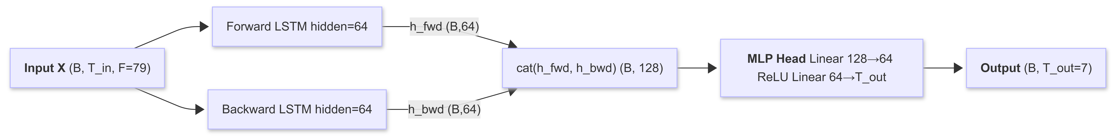
Hyperparameter changes for tuned variant:
- hidden $64→256$
- layers $1→3$
- dropout unchanged
- MLP head input dimension grows to 512 (bidirectional concatenation).
- Structure unchanged

TPA-LSTM
A standard LSTM produces both full hidden-state sequence H and the final hidden state $h_{T}$. The TPA module takes $H_{ctx}=H\left[:,:-1,:\right]$ (all but the last step), transposes it to treat hidden dimensions as channels over time, applies a 1-D CNN to extract temporal pattern filters, adaptive-average-pools across time, scores each filter against $h_{T}$ via a learned scoring matrix $W_{score}$, and softmax-weights the scores to produce a pattern context vector. The concatenation of $h_{T}$ and context is passed to the MLP head.
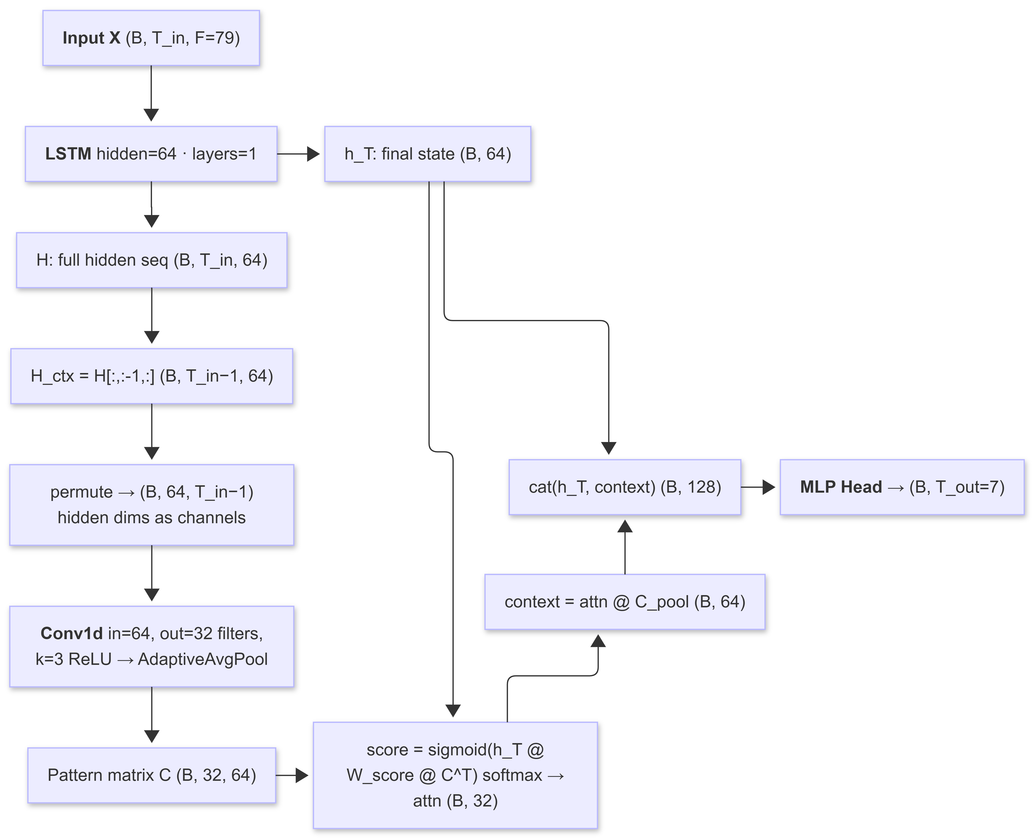
Hyperparameter changes for tuned variant:
- hidden $64→256$
- filters $32→128$
- dropout $0.10→0.15$
- Structure unchanged

CNN-LSTM
Sequential Mode: CNN extracts local temporal features, which the LSTM then processes for global sequential context. LSTM input is CNN output, not raw features.
Parallel Mode: CNN and LSTM process raw input independently; outputs concatenated.
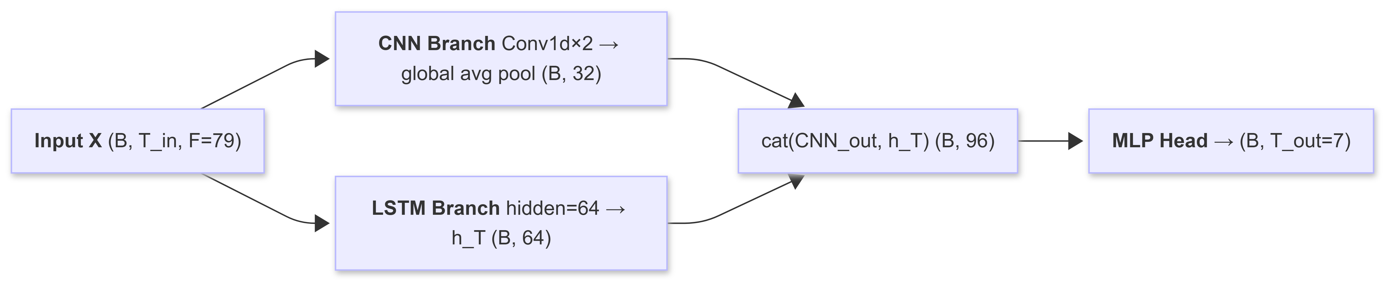
Augmented Mode: Sequential CNN-LSTM with raw-input skip connection to prevent information loss from CNN compression.
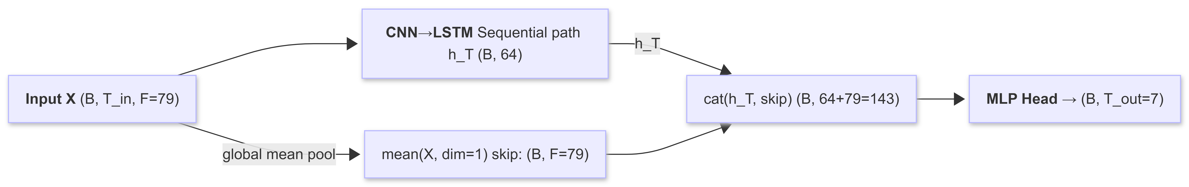
Hyperparameter changes for all three tuned variants:
- cnn_filters $32→64$
- dropout $0.10→0.20$
- Each mode is trained and evaluated independently
- Structure unchanged

CNN-BiLSTM
Hyperparameter changes for tuned variant:
- hidden $64→128$
- cnn_filters $32→64$
- cnn_layers $2→1$
- dropout $0.10→0.25$
- Structure unchanged

ST-LSTM
Two parallel streams are computed independently and concatenated before the MLP head. The spatial MLP is weight-shared across all $T_{in}$ timesteps (time-invariant): it captures which features consistently co-activate in the window rather than when. Mean pooling over the time axis collapses temporal order to product a persistent cross-feature summary.
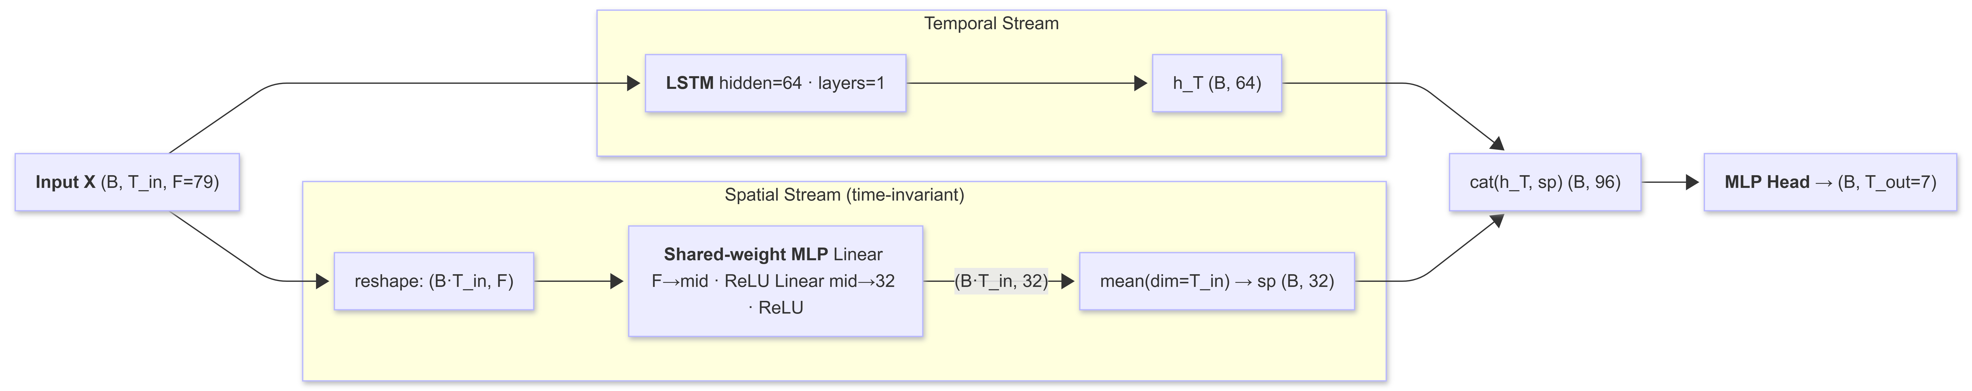
Hyperparameter changes for tuned variant:
- hidden $64→128$
- spatial_hidden $32→128$
- dropout $0.10→0.30$
- Structure unchanged

– Graph Models
STGCN
Input features are treated as N = 79 graph nodes each carrying a scalar temporal signal over $T_{in}$ timesteps. The architecture alternates temporal gated convolutions (GLU) and Chebyshev graph convolutions in stacked ST-Conv blocks, with BatchNorm after each block.
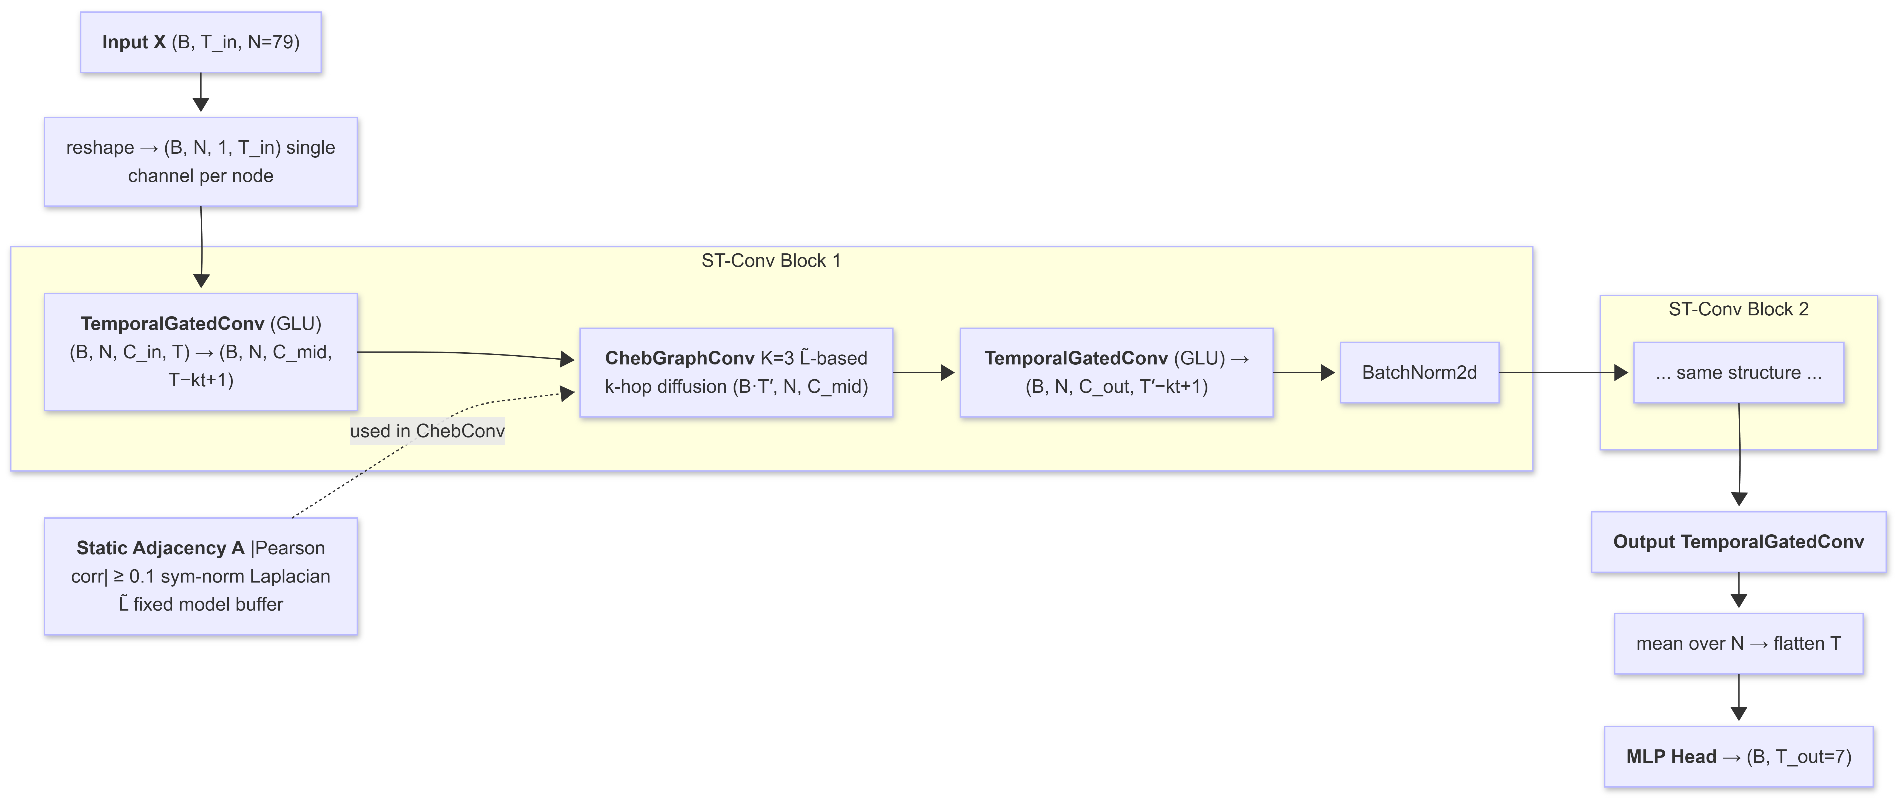
Hyperparameter changes for tuned variant:
- hidden $128→256$
- dropout $0.20→0.25$
- weight_decay $2e-4→3e-4$
- Block depth and temporal kernel unchanged
- Structure unchanged

ASTGCN
Use AMP (fp16 + GradScaler) for memory efficiency.
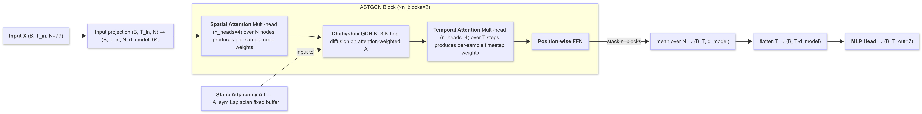
Hyperparameter changes for tuned variant:
- d_model $64→128$
- n_heads $4→8$
- n_blocks $2→3$
- dropout $0.15→0.20$
- weight_decay $2e-4→1e-4$
- Structure unchanged

PDR-STGCN
A two-channel input (original signal + weekly lag-difference) feeds a modified STGCN backbone where each graph convolution replaces the fixed Chebyshev adjacency with a mixed static/dynamic adjacency controlled by a learned scalar $λ$.
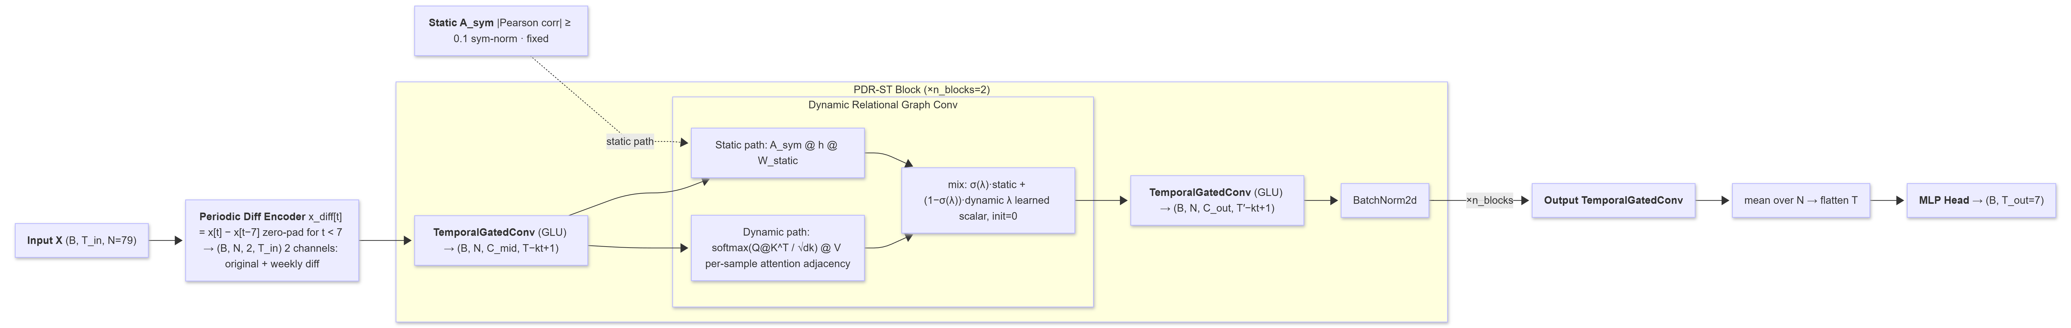
Hyperparameter changes for tuned variant:
- hidden $160→256$
- n_blocks $2→3$
- kt $3→2$
- dk $48→64$
- dropout $0.15→0.25$
- Structure unchanged

STSGCN
The $3N×3N$ synchronous graph (STSG) encodes both spatial adjacency ($A_{spa}$ within each timestep) and temporal adjacency (identity block $I$ linking adjacent timesteps). Each STSGCL layer applies Chebyshev convolution on the full STSG over a sliding 3-timestep window and then extracts the centre N nodes.
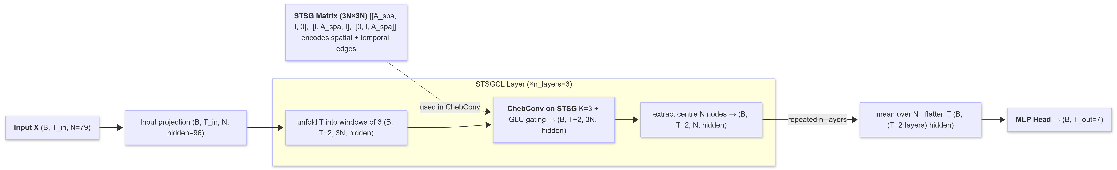
Hyperparameter changes for tuned variant:
- hidden $96→128$
- dropout $0.10→0.25$
- weight_decay $1e-4→2e-4$
- lr $5e-4→1e-3$
- Layer depth unchanged
- Structure unchanged

STFGNN
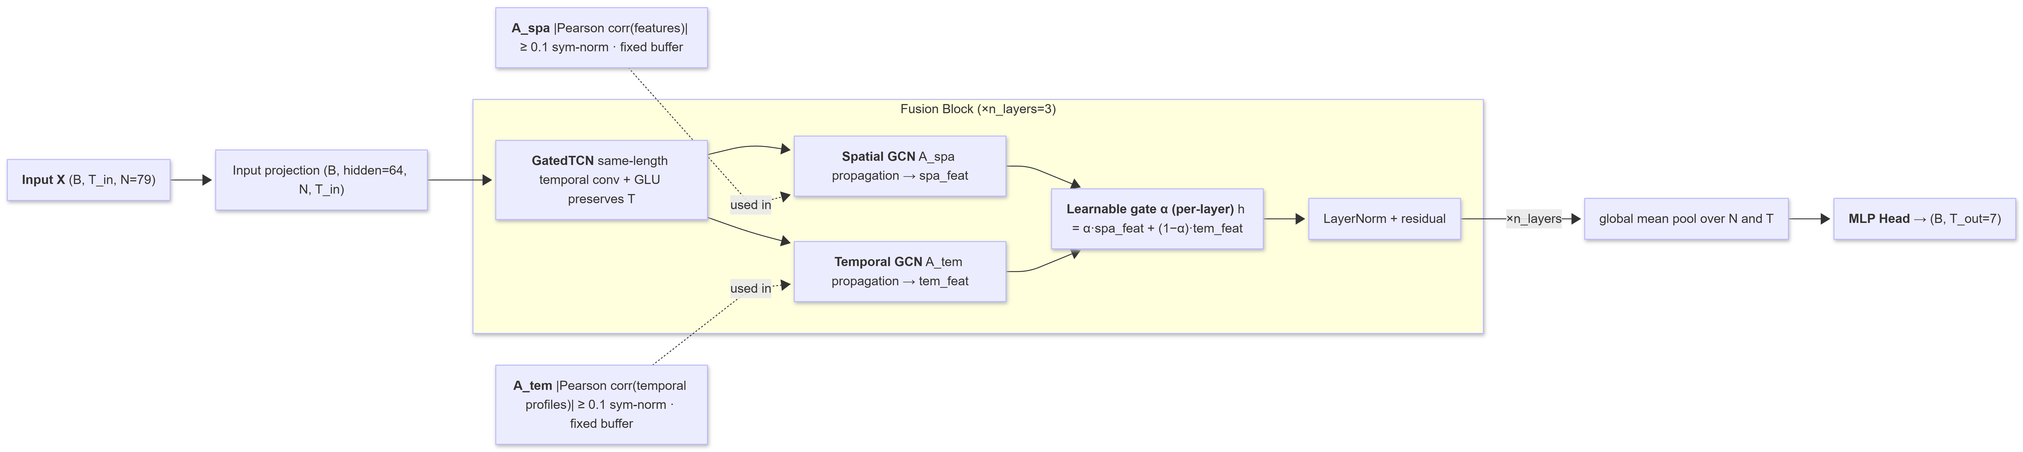
Hyperparameter changes for tuned variant:
- hidden $64→128$
- dropout $0.20→0.35$
- adj_threshold $0.10→0.15$
- Layer depth is unchanged
- Structure unchanged

MTGNN
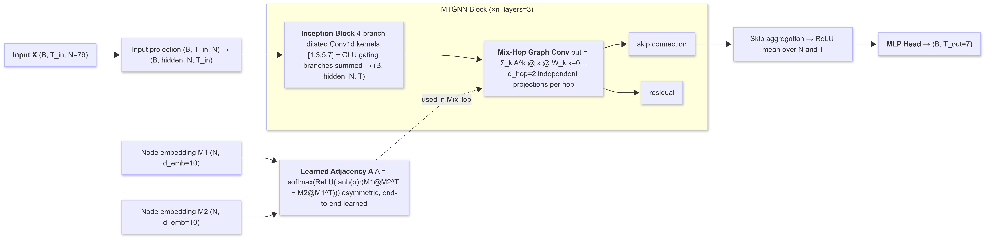
Hyperparameter changes for tuned variant:
- hidden $32→64$
- d_emb $10→7$
- dropout $0.10→0.30$
- weight_decay $1e-4→3e-4$
- Skip channels and layer depth unchanged
- Structure unchanged

– Attention Models
Autoformer
FFT operations are explicitly cast to float32 inside autocast for numerical stability under AMP.
Hyperparameter changes for tuned variant:
- d_model $64→128$
- n_heads $4→8$
- e_layers $2→3$
- d_ff $128→256$
- dropout $0.15→0.25$
- Structure unchanged

Informer
Uses AMP (fp16 + GradScaler). At $T_{in}$ = 14, the single distilling step halves the encoder sequence to length 7, and ProbSparse selects approximately 13 of 14 queries (near-full attention).
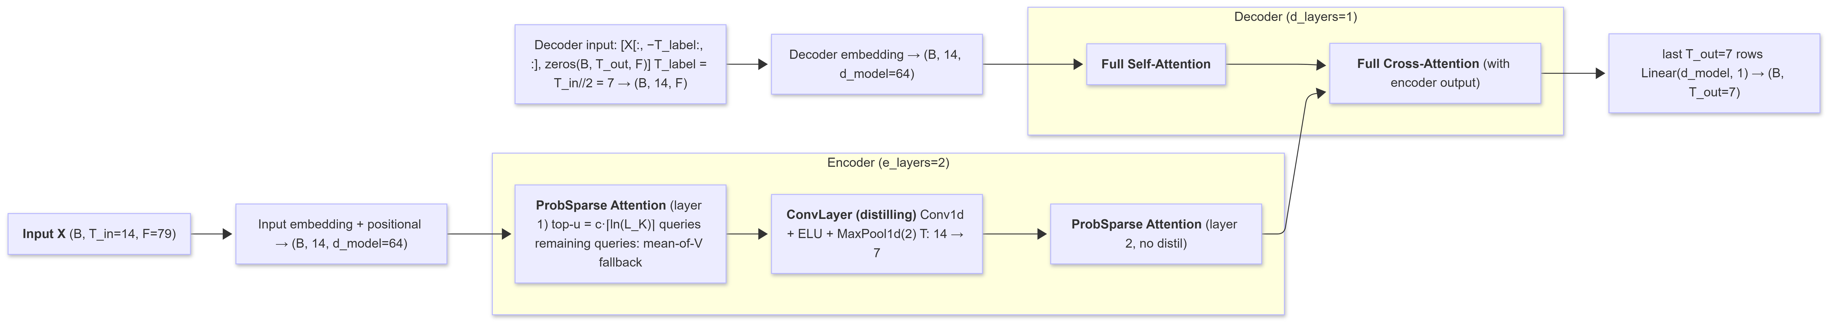
Hyperparameter changes for tuned variant:
- d_model $64→256$
- n_heads $4→16$
- e_layers $2→3$
- d_ff $128→512$
- Dropout unchanged
- Structure unchanged

– HMT-TSF Training Configurations
- Epochs: 150
- Batch size: 32
- Optimiser: AdamW (lr = 1e-3, weight_decay = 1e-3)
- LR schedule: Linear warmup (8 ep) $→$ ReduceLROnPlateau (factor = 0.5, patience = 8)
- Gradient clip: max_norm = 1.0
- Early stopping: patience = 20 (raw val loss)
- Mixed precision: AMP fp16 on CUDA (GradScaler)
- Loss: WeightedHuber (loss_decay = 0.9) + TemporalSmoothness (smooth_weight = 0.01)
- Input noise: Gaussian noise std = 0.02 added to training inputs (data augmentation)
- d_model: 64
- n_tcn_blocks: 3
- tcn_kernel: 3
- graph_hidden: 64
- n_regimes: 3
- n_attn_heads: 4
- adj_threshold: 0.1
- drop_path: 0.2
- dropout: 0.1
- Optional residual boosting: CatBoost or sklearn MLP on train-set residuals; applied at 0.5x weight only if it improves Combined%
- Walk-forward evaluation: test set split into 3 equal blocks; per-block Combined% and R² reported.

