Champlain Regional College at Lennoxville

Computer Science Technology Program

Internet of Things 2 - 420-520-LE

Lab 5 Report

Student’s Name: Murtaza

1. What is the AWS policy allowing us to perform as per defined in the Lab instructions? (3 points)
2. What is the effect on the resources?

Allow

1. Which actions are permitted?

iot:Connect, iot:Publish, iot:Subscribe, iot:Receive

1. On which resources?

*

1. ***Test plan:*** In section 1.5 you were asked to modify your code to collect real data from your sensors. Explain how you tested your application to confirm that the messages arrived in the right format (json) to the broker (aka AWS IoT Core) and include all the evidence here (code, screenshots): (3 points)

I used print statements to verify that the JSON payload containing data was formatted before being send to AWS IoT Core. The on the IoT MQTT client, I subscribed to the topic from the config file and made sure the info getting matched.

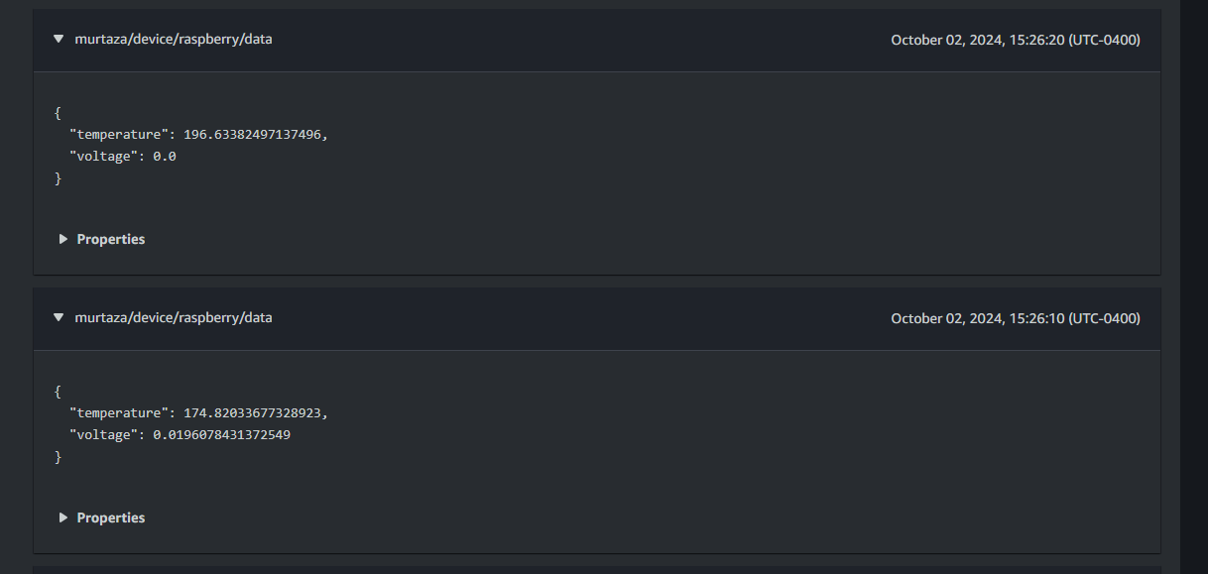

1. ***Submit the link to your repo(4 points):***