**Question 1: Setting up Sensors (15 points)**

You are given two sensors

Write a Python script that:

* Collects data from both sensors every 5 seconds.
* Prints the data in the terminal using the following format:

Temperature: XX.X°C, Humidity: YY.Y%

Proof: screenshot of your terminal

**Question 2: Connecting to AWS IoT Core (15 points)**

Using the Python AWSIoTPythonSDK library, write a script that:

* Connects the Raspberry Pi to AWS IoT Core using your device's Thing certificate and private key.
* Publishes the temperature and humidity data from Question 1 to the topic champlain/sensor/102/data in JSON format, like this:

{

"temperature": XX.X,

"humidity": YY.Y

}

Proof: Screenshot of the AWS MQTT client with messages arriving to the required topic and with the proper format (json)

**Question 3: Storing Data in DynamoDB (15 points)**

You need to store the data from the two sensors in a DynamoDB table using AWS IoT Rules

Write an AWS IoT Rule that:

* Triggers when data is published to the topic.
* Inserts the sensors values and timestamp into the DynamoDB table.
* Include the SQL query used to select the data from the incoming message.

Proof: your SQL statement and data inserted in the Dynamo table

**Question 4: Republish Rule for threshold value (15 Marks)**

Create a separate AWS IoT Rule that:

* Monitor one of your sensors.
* Republishes the data to the topic champlain/republish if the threshold exceeds a given value.
* Write the SQL query for this rule and explain how you would configure it in the AWS Console.

I would set the action to Republish a message to an IoT topic and lab to LabRole and then create the rule. From there, I I would subscribe to the champlain/republish topic in the MQTT test client and then run my code. If everything below 20 temp is excluded from being published in this topic, then it works.

**Proof: Your SQL query and the messages arriving to the RPi only if the threshold exceeded**

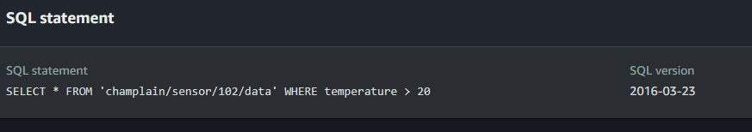

**Question 5: Subscribing to the /republish Topic (15 points)**

Write a Python script for the Raspberry Pi that:

* Subscribes to the champlain/republish topic.
* When a message arrives (temperature > 30°C), the Raspberry Pi turns on an LED connected to a GPIO pin.
* Prints the received message in the terminal

Proof the received message in the terminal and the demo with the LED

At the end of the exam you should demo your result with the teacher and submit the link to your repository with the code.