1. **If we want to use ICA for dimensionality reduction, can we directly pick independent components with larger energy? Explain.**
2. **Use the FA approach to reduce the feature dimension from 4 to 3 for Iris data set. As usual, take 70% of the samples as training set and perform FA. Use 5-NN to classify the test set and then report the average accuracy after 10 trials. For simplicity, you may assume $Ψ=0$ and use the pseudo inverse solution.**  
     
   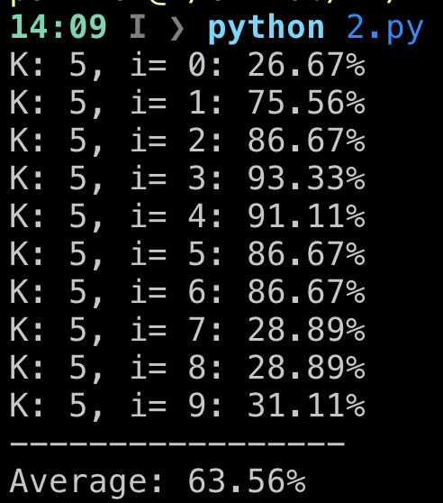
3. Suppose we have two classes of data. The samples in the first class are from $\left[\begin{matrix}x_{1} \\ x_{2}\end{matrix}\right]$ where x1 and x2 are jointly Gaussian with $μ_{x}=\left[\begin{matrix}0 \\ 0\end{matrix}\right]$ and $Σ_{x}=\left[\begin{matrix}1 & 0 \\ 0 & 1\end{matrix}\right]$. The samples in the second class are from $\left[\begin{matrix}y_{1} \\ y_{2}\end{matrix}\right]$ where y1 and y2 are jointly Gaussian with $μ_{y}=\left[\begin{matrix}2 \\ 0\end{matrix}\right]$ and $Σ_{y}=\left[\begin{matrix}1 & 0 \\ 0 & 1\end{matrix}\right]$. Find the $w_{opt}$ (with normalization) and optimal decision value $α_{opt}$.
4. **We have a dataset $S=\left\{\left[\begin{matrix}0 \\ 0\end{matrix}\right],\left[\begin{matrix}2 \\ 2\end{matrix}\right],\left[\begin{matrix}0 \\ 1\end{matrix}\right],\left[\begin{matrix}1 \\ 1\end{matrix}\right]\right\}$ Follow the k-means algorithm to complete the assignment step and the update step for one run. Use $k=2$, initial $μ_{1}=\left[\begin{matrix}-1 \\ -1\end{matrix}\right]$ and $μ_{2}=\left[\begin{matrix}3 \\ 3\end{matrix}\right]$ in the computation.**