Quantization and Adversarial Robustness:
Genuine Robustness or Gradient Masking?
Richard Cai, Cornell University
Quantized models routinely show substantially higher accuracy under standard gradient-based attacks such as FGSM and PGD (Lin et al., 2019; Xiao et al., 2023). However, subsequent work has shown that much of this apparent robustness can arise from the non-differentiable rounding operations introduced by quantization, which obstruct gradient-based optimization rather than fundamentally increasing adversarial robustness (Athalye, Carlini, & Wagner, 2018; Carlini et al., 2019; Croce & Hein, 2020). We present a systematic, multi-architecture, multi-attack empirical study of the interaction between post-deployment quantization and adversarial robustness on CIFAR-10, designed explicitly around the obfuscated-gradients diagnostic framework of Athalye, Carlini, and Wagner (2018), spanning six architectures (ResNet20, ResNet56, MobileNetV2, VGG16_BN, ShuffleNetV2, RepVGG_A0) and four quantization regimes (FP32 baseline, int8 post-training quantization, int4 post-training quantization, int8 quantization-aware training), evaluated with a layered attack suite consisting of white-box FGSM, white-box PGD-20, mixed AutoAttack, black-box transfer attacks from the FP32 source model, white-box gradient-masking-corrected BPDA-PGD, and random-noise placebo, alongside direct diagnostics of the straight-through-estimator (STE) gradient (fraction of near-zero components, gradient norm) and accuracy-vs-ε curves.RIch
Across every architecture we test, int8 quantization (PTQ and QAT alike) produces the textbook signature of obfuscated gradients described by Athalye, Carlini, and Wagner (2018): white-box PGD accuracy is flat or non-monotonic in ε, slightly weaker than Croce & Hein's AutoAttack, and dramatically weaker than both the torchattack black-box transfer and the BPDA-corrected attack, which recover most or all of the apparent robustness gain. This is a consistent, large, and architecture-general gradient-masking signature evident in flat accuracy-vs-ε curves under white-box PGD, a large accuracy gap between white-box PGD and both black-box transfer and BPDA-corrected attacks, and an elevated fraction of near-zero components in the surrogate gradient used to attack it. The apparent robustness gain reported by a naive PGD or FGSM evaluation of an int8-quantized model is, on this evidence, predominantly an artifact of the rounding operator's poorly-behaved backward pass rather than a genuine change in the model's vulnerability. int4 PTQ instead shows substantial clean accuracy collapse, a much smaller fraction of near-zero STE gradient components, and small attack gaps (PGD vs. transfer vs. BPDA) relative to int8, consistent with a mixture of boundary movement and a weaker masking effect. We an infer that int4 pays a much larger clean-accuracy cost since it shows a substantially smaller masking signature by every diagnostic we use and that its surrogate gradient is far closer to being a faithful local model of the true (non-differentiable) loss. We confirm that most intrinsic robustness reported for standard int8 quantization is explainable by gradient masking rather than a real reduction in vulnerability, while aggressive int4 quantization trades accuracy for partial robustness under BPDA and black-box circumvention methods, as previously reported in Lin et al. (2019). Although this study does not produce any novel findings (as previously reported by Xiao et al.), we hope its confirmatory value and inexpensive diagnostic suite assembled are widely reusable in further investigations.
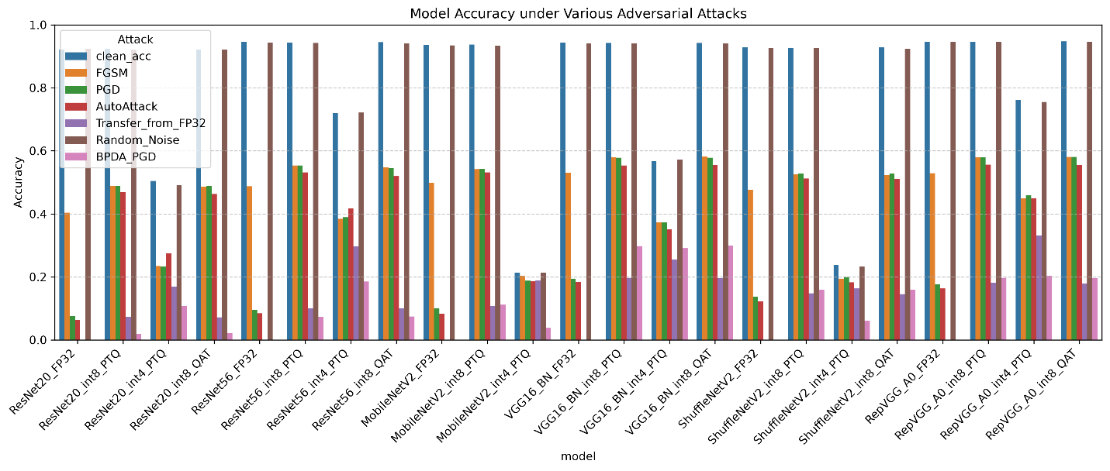
Graph 1. Clean and adversarial accuracy across architectures and quantization regimes. FP32 is the transfer/BPDA reference source, thus it is missing those figures.
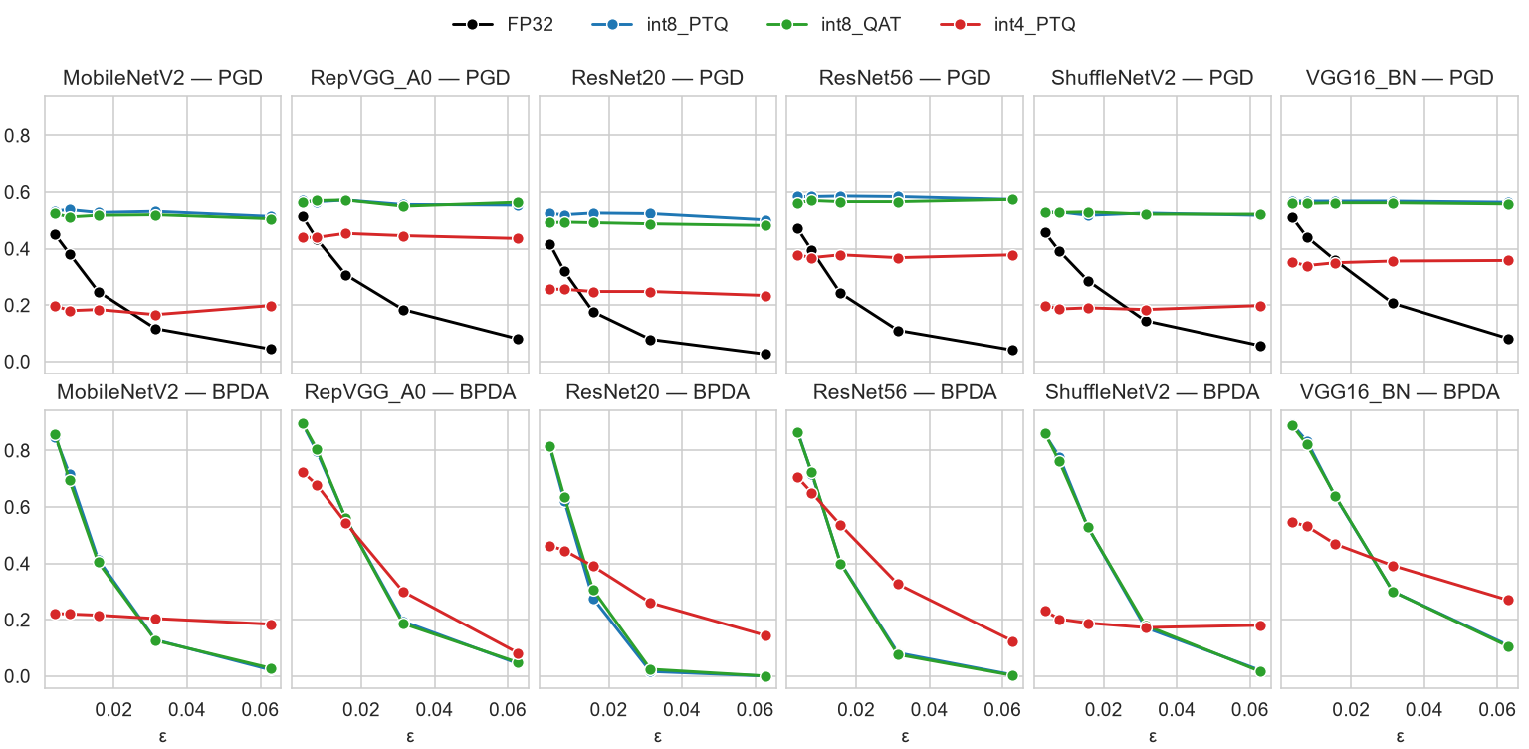
Graph 2. PGD and BPDA accuracy across the perturbation budget sweep.

References
Abomakhelb, A., Abd Jalil, K., Buja, A. G., Alhammadi, A., & Alenezi, A. M. (2025). A comprehensive review of adversarial attacks and defense strategies in deep neural networks. Technologies, 13(5), 202.
Athalye, A., Carlini, N., & Wagner, D. (2018). Obfuscated gradients give a false sense of security: Circumventing defenses to adversarial examples. International Conference on Machine Learning (ICML).
Athalye, A., Engstrom, L., Ilyas, A., & Kwok, K. (2018). Synthesizing robust adversarial examples. International Conference on Machine Learning (ICML).
Barsbey, M., et al. (2020). On the interaction of compressibility and adversarial robustness. arXiv preprint arXiv:2507.17725.
Carlini, N., et al. (2019). On evaluating adversarial robustness. arXiv preprint arXiv:1902.06705.
Cohen, J., Rosenfeld, E., & Kolter, Z. (2019). Certified adversarial robustness via randomized smoothing. International Conference on Machine Learning (ICML).
Croce, F., & Hein, M. (2020). Reliable evaluation of adversarial robustness with an ensemble of diverse parameter-free attacks. International Conference on Machine Learning (ICML).
Goodfellow, I. J., Shlens, J., & Szegedy, C. (2015). Explaining and harnessing adversarial examples. International Conference on Learning Representations (ICLR).
Ilyas, A., et al. (2019). Adversarial examples are not bugs, they are features. Advances in Neural Information Processing Systems (NeurIPS).
Lin, J., Gan, C., & Han, S. (2019). Defensive quantization: When efficiency meets robustness. International Conference on Learning Representations (ICLR).
Madry, A., Makelov, A., Schmidt, L., Tsipras, D., & Vladu, A. (2018). Towards deep learning models resistant to adversarial attacks. International Conference on Learning Representations (ICLR).
Piras, G., et al. (2022). Adversarial pruning: A survey and benchmark of pruning methods for adversarial robustness. arXiv preprint arXiv:2409.01249.
Salman, H., Li, J., Razenshteyn, I., Zhang, P., Zhang, H., Bubeck, S., & Yang, G. (2019). Provably robust deep learning via adversarially trained smoothed classifiers. Advances in Neural Information Processing Systems (NeurIPS 32).
Wong, E., & Kolter, Z. (2018). Provable defenses against adversarial examples via the convex outer adversarial polytope. International Conference on Machine Learning (ICML).
Wong, E., Schmidt, F., & Kolter, Z. (2018). Scaling provable adversarial defenses. arXiv preprint arXiv:1805.12514.
Wong, E., Rice, L., & Kolter, Z. (2020). Fast is better than free: Revisiting adversarial training. International Conference on Learning Representations (ICLR).
Xiao, Zhang, Liu, Qin (2023). RobustMQ: Benchmarking Robustness of Quantized Models. arXiv preprint arXic: 2308.02350.
Xu, C., & Singh, G. (2020). Compression-aware certified training. arXiv preprint arXic: 2506.11992.

