**Arduino Muscle Sensor**

What is the Arduino Muscle Sensor?

The Arduino **EMG** (electromyography) sensor, or a **muscle sensor**, detects tiny electrical signals produced by your muscles when they are used in performing an action (e.g. moving a finger, lifting your arm, etc.).

Link Between Muscles and EMG Sensor

The human brain’s neural activity in a part of the brain called the motor cortex sends signals to the spinal cord. The signal is carried to the muscles through motor neurons and the neurons deliver calcium ions to the muscles, creating a mechanical change. The mechanical change has depolarization (change in electrochemical gradient), which the EMG sensor measures in microvolts.

Surface EMG Sensors (SEMG)

The Surface EMG (SEMG) Sensor is one of two types of EMG sensors (we will be mainly focusing on this type of sensor; the other type of sensor is an Intramuscular EMG Sensor). The SEMG sensor uses electrodes placed on your skin to take measurements. This type is less painful to use as it doesn’t involve any needles being inserted into your muscle (like the Intramuscular sensor does). The trade-off is that you can only use this on surface muscles, and it depends on other factors such as the weight of the user. Applications of the EMG sensor include clinics, sport health, kinesiology research, etc.

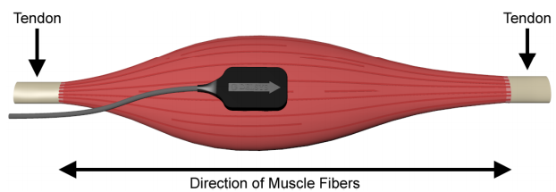The electrodes are placed on the muscle in between the tendons. They catch the electrical signal produced by muscle movement. Normal results include the muscle at rest containing no electrical signals and waveforms. Also, there should be a variety of rates and amplitudes in the data collected when the muscle is contracted. Abnormal results include unordinary data obtained, which, for example, can be caused by muscle or nerve disorders. The stronger the muscle movement is, the more muscles are involved, which results in a greater voltage reading.

How to Use the EMG

Follow these instructions to use your muscle sensor:

1. Take 2 x 9v batteries, and connect the anode of one, and the cathode of the other to the GND pin in between the 2 “V” pins on the EMG Module.
2. Connect the remaining anode to -Vs, and the remaining cathode to +Vs.
3. Connect SIG on the module to Analog pin 0.
4. Connect GND on the module to GND on the Arduino.
5. After setting up the muscle sensor with the Arduino, determine which muscle you want to use for the sensor, and properly clean the skin in that area.
6. Place one electrode in the middle of the muscle and connect it to the red snap connector.
7. Graphical user interface

   Description automatically generatedPlace another electrode at an end of the muscle body and connect it to the green snap connector.
8. Place the third electrode on a bony or non-muscular area near the muscle and connect it to the yellow snap connector.
9. Your setup should look something like the image on the right.
10. Launch the Arduino software (download available at: <https://www.arduino.cc/en/software>) and copy the from “emg.ino”.
11. Upload the program to the Arduino, and observe the results in the serial monitor/plotter when you flex the targeted muscle (remember to set the baud rate to 9600).

How to make a Muscle Controlled Servo

Follow these instructions to use your muscle sensor:

1. Follow the same wiring instructions above.
2. Connect the red (+5V) pin on the servo to the 5V pin on the Arduino.
3. Connect the brown (GND) pin on the servo to a GND pin on the Arduino.
4. Connect the yellow (Signal) pin to pin 9 on the Arduino.
5. Upload the code from “Nervegear.ino” to the Arduino. Run the program.
6. You should notice that if you flex the targeted muscle, the servo will move, and if you relax it, the servo will move back.

Sources

<https://www.seeedstudio.com/blog/2019/12/27/what-is-emg-sensor-myoware-and-how-to-use-with-arduino/>

<https://imotions.com/blog/electromyography-101/>