Lab 1 Exercises

- Download the file 2121_example_dir.tgz and save the file in the Lab1 subfolder of your git repository.
- Open a shell and cd to the Lab1 subfolder. You should see the file you just downloaded when you issue the ls command
- Uncompress the file using the following command:

tar -xzvf 2121_example_dir.tgz

(the tar command stands for Tape Archive – back when data had to be stored on
magnetic tapes, this tool was written to compress whole directory structures, including
files, into a single archive, a bit like zip and gzip and other archiving tools which you might be more familiar with)

- Create a Word document to describe your answers, and take screenshots detailing your progress, and what you’re seeing as you answer the following questions. An answer without context (shown work, and description of how you got it) will get zero credit. Using a mechanism other than shell commands will, likewise, result in zero credit.j

EXERCISES (20 Points each)

Exercise 1: How many directories are contained in this archive? Show in detail how you answered this question, with screenshots. There are 20 directories, because going through each line, the ones that end with / represent directories and those such as owl, wand, and pack are not directories.
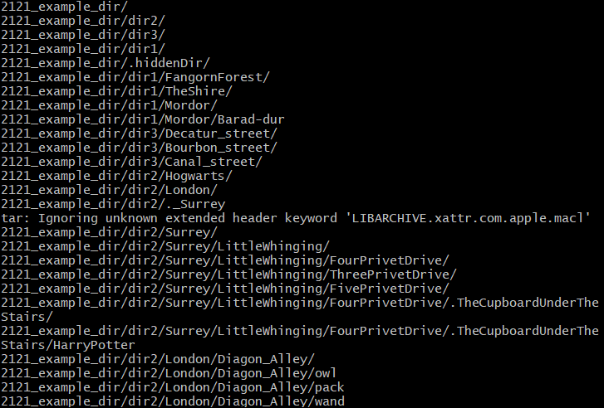
Exercise 2: Are there any hidden directories? If so, where are they located? Show in detail how you answered this question, with screenshots.
Yes .hiddenDir/ is located inside the 2121_example_dir.tgz file by typing ls -a.
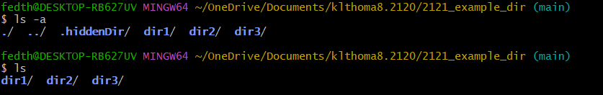
In dir2/ there is also a hidden file called ._Surrey
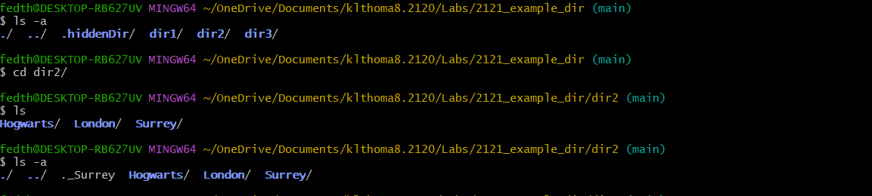
Exercise 3: Issue the printenv command. printenv lists a bunch of things called environment variables, that are specific to this instance of a shell, such as your username, what shell is running, where to find executable files (in the PATH variables), and LOTS of other things. These variables can be modified in real-time in the shell itself, or can be set up so that every new shell you create has a particular environment variable defined in a specific way. Send the output of printenv to a file so that it’s easer to work with, and open that file in your favorite text editor.
- What SHELL are you running, and where it the executable file for this shell?
It is Bash located in the /usr/bin/bash
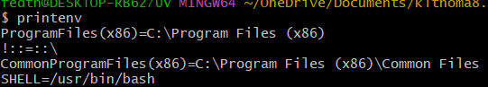
- Where is your HOME directory?
My home directory is in c/Users/fedth
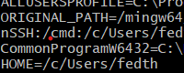
- What is the PWD (the present working directory)?
The PWD is in c/Users/fedth/OneDrive/Documents/klthoma8.2120/Labs/2121_example_dir
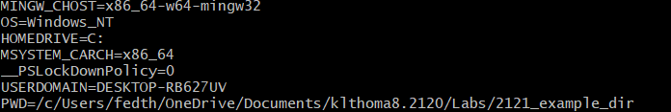
- What directories will the shell go to when looking for a command you issue at the shell prompt? (PATH)
- /mingw64/bin:/usr/local/bin:/usr/bin:/bin:/mingw64/bin:/usr/bin:/c/Users/fedth/bin:/c/Program Files/Java/jdk-22/bin:/c/WINDOWS/system32:/c/WINDOWS:/c/WINDOWS/System32/Wbem:/c/WINDOWS/System32/WindowsPowerShell/v1.0:/c/WINDOWS/System32/OpenSSH:/cmd:/c/Users/fedth/AppData/Local/Microsoft/WindowsApps:/c/Program Files/Java/jdk-22/bin:/c/Users/fedth/AppData/Local/Programs/Microsoft VS Code/bin:/usr/bin/vendor_perl:/usr/bin/core_perl
Show your work, of course….

Exercise 4: ls has another flag, -l , for Long-form listing. (I had hoped to get you to practice using the man pages to figure out how to do this but the bash shell provided by gitbash in Windoze is not full strength and doesn’t have man). Use this version of the ls command to produce a long-form listing of 2121_example_dir, and send the results to a file. Then output the contents of this file to the shell, and copy and paste it as part of your answer to this exercise. Take screenshots showing your process, what commands you are issuing, and explain.
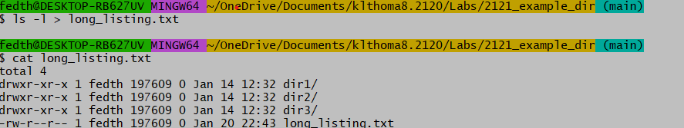
Here my PWD is the example file where I send the command to the SHELL ls -l and then put it into a new text file (within that folder) and then I get the SHELL to show the contents of the file.

Exercise 5:
- Where is Harry Potter? In dir2/Surrey/LittingWhinging/FourPrivetDrive/.TheCupBoardUnderTheStairs
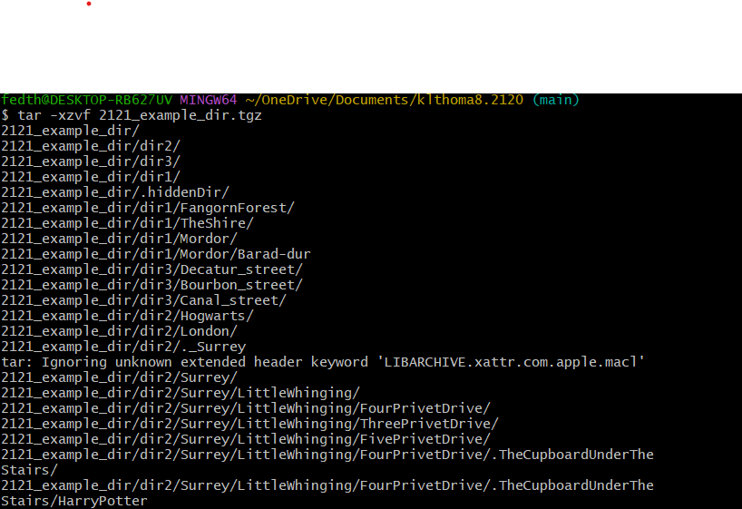Again, screenshots showing your process, and the commands issued. Make a hidden directory in Hogwarts called RoomOfRequirement and move Harry into it. Show that you’ve done this (using ls). (as usual, screenshots and explanation of your process).
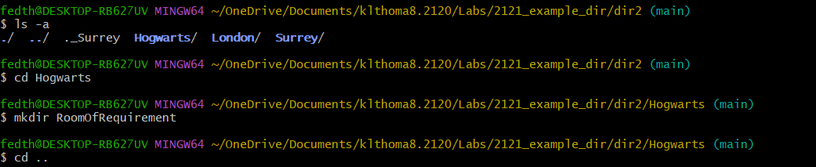
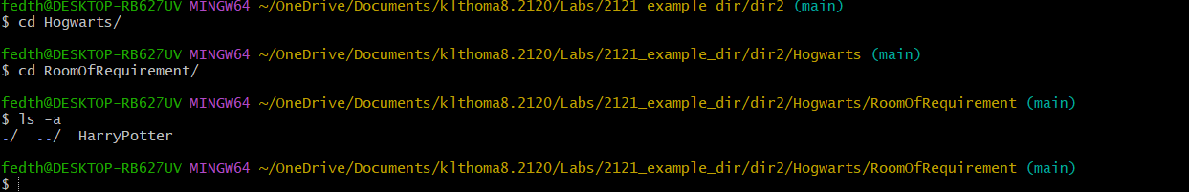
In this series of screenshots I made a new directory using the mkdir command and then moved Harry Potter from where he was in Surrey to here.

- At the end of the Lord of the Rings, Mordor was effectively destroyed when Sauron’s tower, Barad-dur collapsed when the One Ring was thrown into Mount Doom. Remove the Mordor directory. Show that you’ve done this (using ls). (as usual, screenshots and explanation of your process).
In this last screenshot I tried to originally remove the Mordor directory but it had a file in it, so I had to cd into the directory to remove the file first before removing the directory.
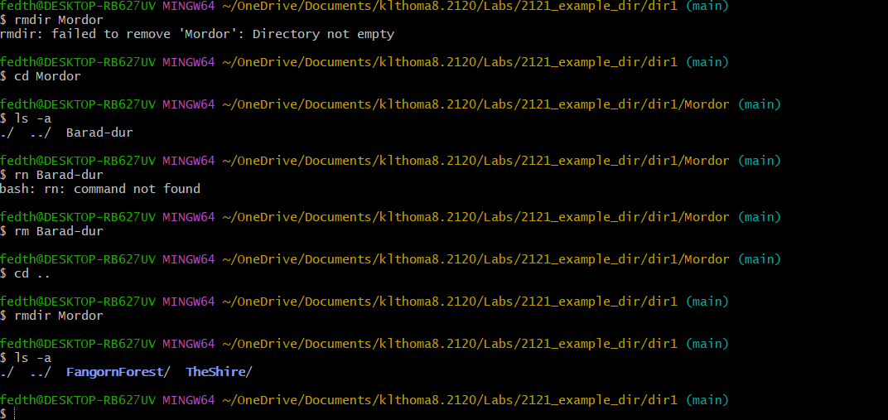

Submission: Place the word document (Lab1Results.docx) into your Lab1 subdirectory, alongside 2121_example_dir. Add everything, commit, and push your results.

