Design Documentation
Motor Driver Base-Board

Revision History
Date | Author | Version | Information/Changes
2025-05-21 | Reisch | V0.1 | Initial Document Draft

Table of Contents
1 Requirements 3
1.1 Hardware 3
1.2 Software 3
2 Hardware Documentation 4
3 Software Documentation 5
4 Referenced Documents 6
5 Abbreviations 7

Requirements
The system shall fulfill the following high level requirements.

Hardware
- Input voltage range 8V-24V
- Input current up to 25A
- Reverse Polarity Protection (RPP)
  - for logic section
  - for power section
- total output power up to 480W
- Motor-driver shall be the TI DRV8334
  - SPI communication
  - Current Sense Amplifier (CSA) outputs
  - INHA/B/C and INLA/B/C wired to Timer outputs of MCU
  - emergency brake/shutdown
  - reset button
- Temperature monitoring
  - 1x per phase (ideal)
  - 1x per bridge (depends on available analog inputs)
- Micro-Controller-Unit (MCU
  - NRF52840 MCU Board
  - 8 analog inputs
    - 3 for current measurement
    - 1-3 for temperature measurement
    - 2-4 for voltage measurements (Input, DCLink, Phase Voltages)
  - wireless connectivity (BLE, WLAN)
  - support different input devices
    - Potentiometer
    - wireless commands (BLE or WLAN) – latency issues?
- TP for different testing

Software

Hardware Documentation
This section shall document all the hardware decision taken during the design of the schematic and layout. This includes calculation for components and the selection process for them and also simulations, where applicable.

Structure of this section
Will be relatively free, based on what makes the most sense. Generally for each section there should be a description of the function and the working principle for the application. After that the component selection can be described either with calculations, logic reasoning or simulations. If this section needs a software implementation to function correctly the relevant information shall be given at the end. A summary can be added optionally at the end of each section. So a simplified example section would look like this:
- functional description
- component selection
- Hardware-Software Interface (if needed for function)
- summary (optional)

Motor Driver

Gate Driver Output
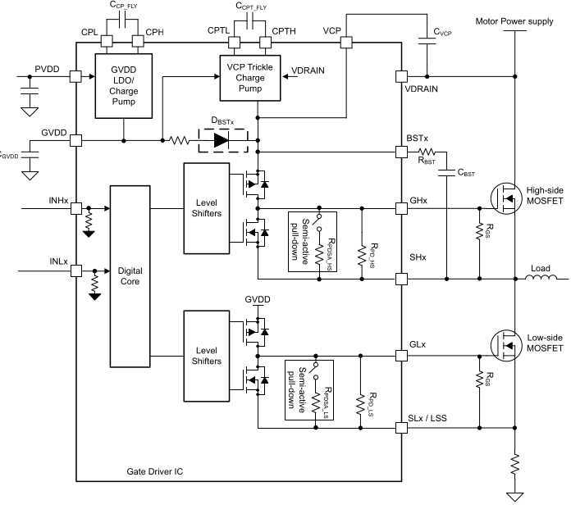

Current Sense Amplifier (CSA)
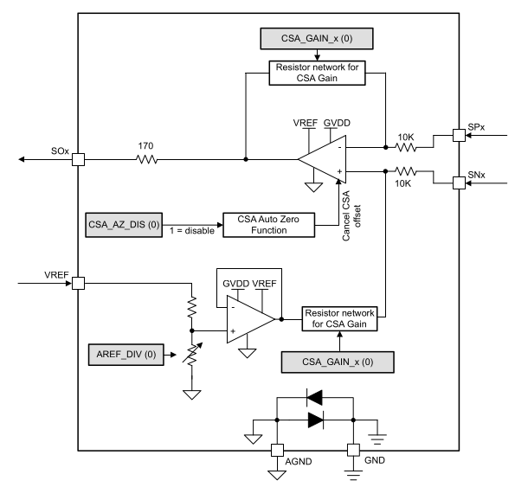

Gate Driver Shutdown

Shutdown Sequence

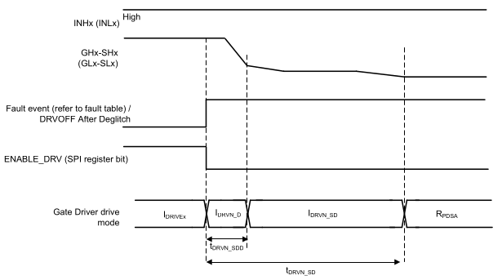
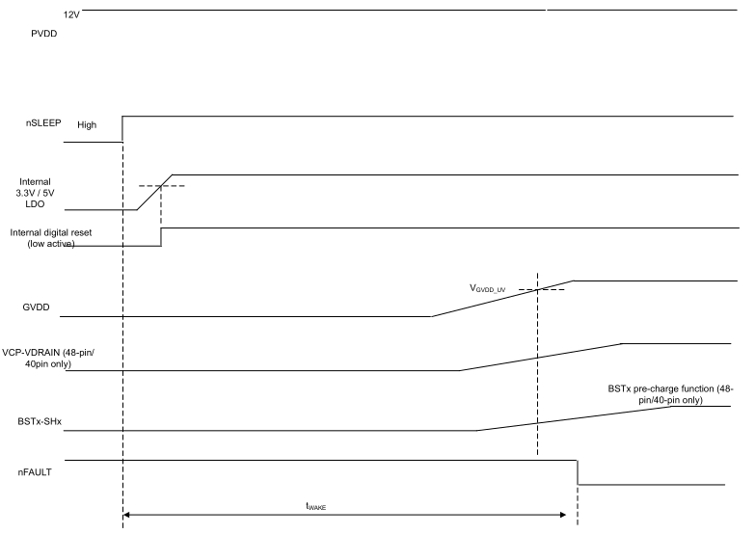

Component Selection
Most of the components for the Gate Drive Unit are based on the datasheet recommendations.

Shunt Resistor

CSA

Shunt Filters

Software Documentation

Motor Driver

SPI

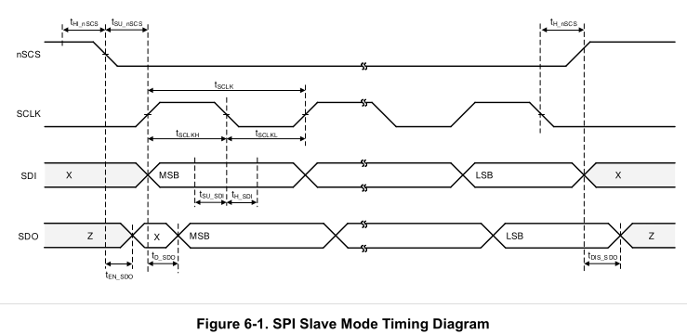
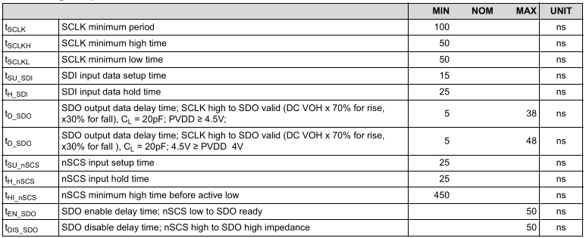
CRC is enabled by default. To disable CRC, transmit "0x0009" to register 0x1C with CRC value
"0x6E" (full SPI frame should be "0x3800096E") after device power-up.
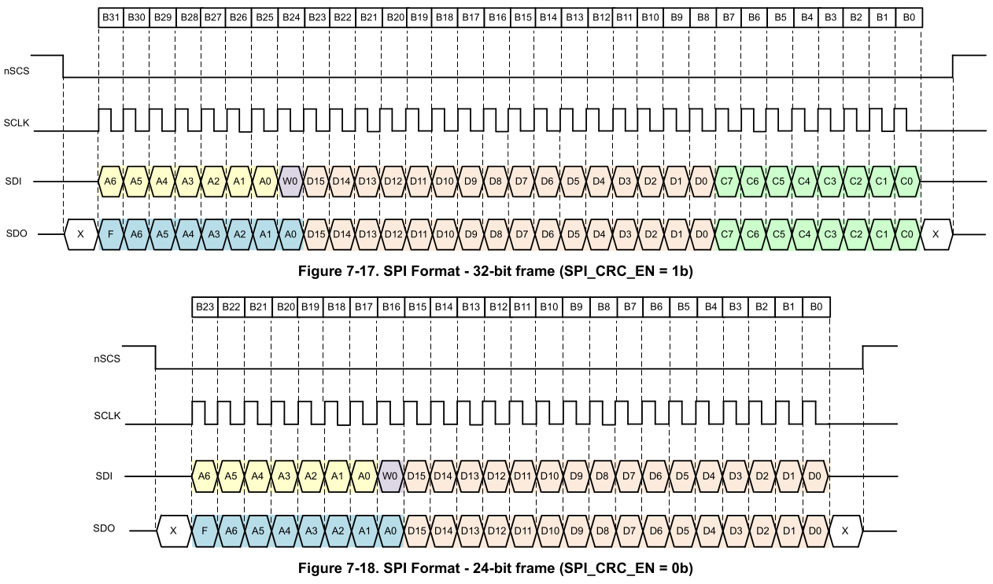

Referenced Documents

Abbreviations
Abbreviations | Full description
MCU | Micro-Controller Unit
CSA | Current Sense Amplifier
RPP | Reverse Polarity Protection
BLE | Bluetooth Low Energy

