Author: Xavier Sanchez A
Date: 6/6/2026
Instructor: Steve Satterfield

IT-230 Final Project Part I – ConsoleRegisterStudent
The ConsoleRegisterStudent program is a C# console application that allows a student to register for courses while enforcing business rules such as preventing duplicate registrations, limiting total credit hours, and validating course selections. The screenshots below demonstrate each required functionality working correctly after debugging and code corrections.

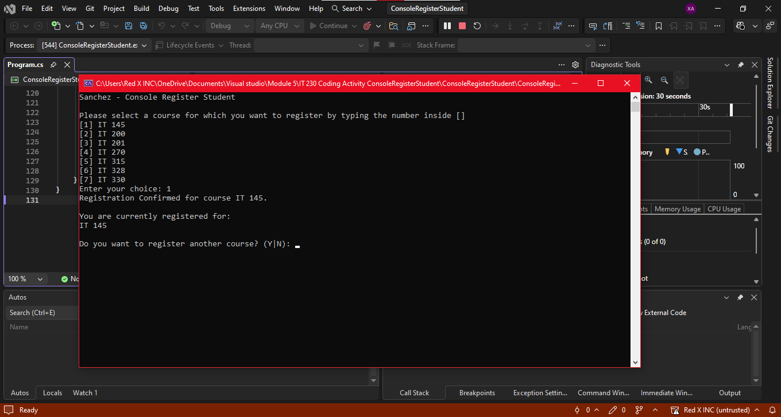
This screenshot shows successful registration for IT 145. The program confirms the course and displays the current registration list.
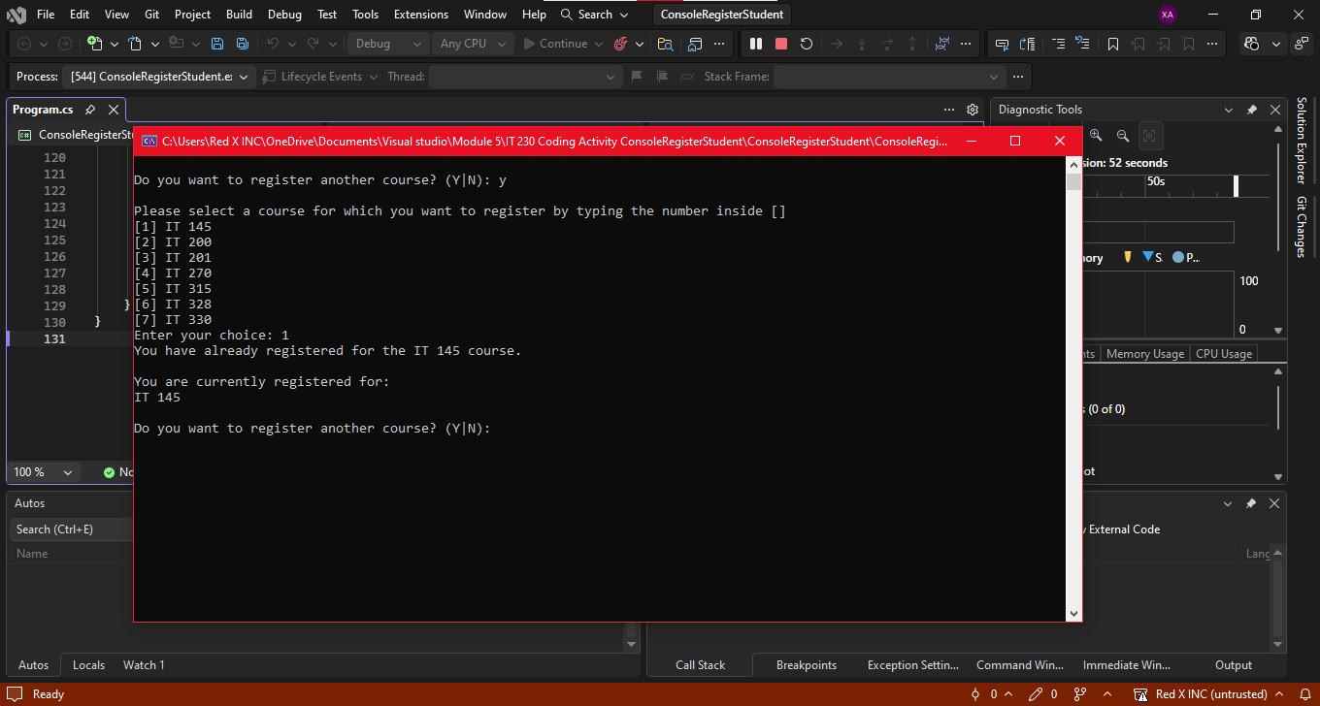
This screenshot demonstrates the program correctly blocking a second registration for the same course. It displays an error message and retains the existing registration list.
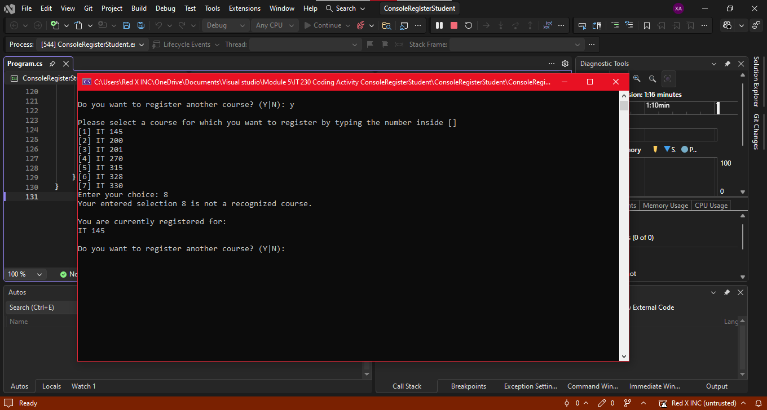
This screenshot shows the error message when an invalid course number (8) is entered. The program validates input and prevents registration for unlisted courses.
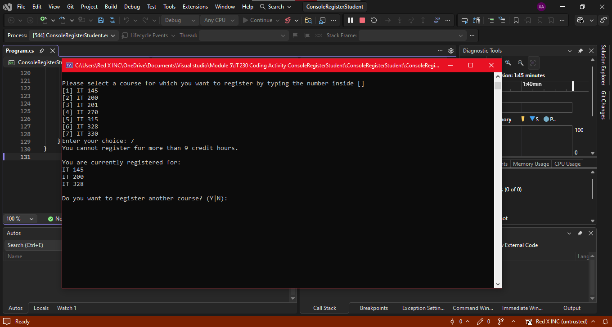
This screenshot displays the message preventing registration beyond nine credit hours after three courses are registered. It confirms that the program enforces the maximum credit limit.

using System;

namespace ConsoleRegisterStudent
{
class Program
{
static void Main(string[] args)
{
(new Program()).run();
}

void run()
{
int choice;
int firstChoice = 0, secondChoice = 0, thirdChoice = 0;
int totalCredit = 0;
string yesOrNo = "";

Console.WriteLine("Sanchez – Console Register Student");

do
{
WritePrompt();
choice = Convert.ToInt32(Console.ReadLine());

int validation = ValidateChoice(choice, firstChoice, secondChoice, thirdChoice, totalCredit);

switch (validation)
{
case -1:
Console.WriteLine("Your entered selection {0} is not a recognized course.", choice);
break;

case -2:
Console.WriteLine("You have already registered for the {0} course.", ChoiceToCourse(choice));
break;

case -3:
Console.WriteLine("You cannot register for more than 9 credit hours.");
break;

case 0:
Console.WriteLine("Registration Confirmed for course {0}.", ChoiceToCourse(choice));
totalCredit += 3;

if (firstChoice == 0)
firstChoice = choice;
else if (secondChoice == 0)
secondChoice = choice;
else if (thirdChoice == 0)
thirdChoice = choice;
break;
}

WriteCurrentRegistration(firstChoice, secondChoice, thirdChoice);

Console.Write("\nDo you want to register another course? (Y|N): ");
yesOrNo = Console.ReadLine().ToUpper();

} while (yesOrNo == "Y");

Console.WriteLine("Thank you for registering with us");
}

void WritePrompt()
{
Console.WriteLine("\nPlease select a course for which you want to register by typing the number inside []");
Console.WriteLine("[1] IT 145");
Console.WriteLine("[2] IT 200");
Console.WriteLine("[3] IT 201");
Console.WriteLine("[4] IT 270");
Console.WriteLine("[5] IT 315");
Console.WriteLine("[6] IT 328");
Console.WriteLine("[7] IT 330");
Console.Write("Enter your choice: ");
}

int ValidateChoice(int choice, int firstChoice, int secondChoice, int thirdChoice, int totalCredit)
{
// Invalid course
if (choice < 1 || choice > 7)
return -1;

// Duplicate course
if (choice == firstChoice || choice == secondChoice || choice == thirdChoice)
return -2;

// Exceeds 9 credits (3 courses)
if (totalCredit >= 9)
return -3;

// Valid
return 0;
}

void WriteCurrentRegistration(int firstChoice, int secondChoice, int thirdChoice)
{
Console.WriteLine("\nYou are currently registered for:");

if (firstChoice == 0)
{
Console.WriteLine("No courses registered yet.");
return;
}

Console.WriteLine(ChoiceToCourse(firstChoice));

if (secondChoice != 0)
Console.WriteLine(ChoiceToCourse(secondChoice));

if (thirdChoice != 0)
Console.WriteLine(ChoiceToCourse(thirdChoice));
}

string ChoiceToCourse(int choice)
{
switch (choice)
{
case 1: return "IT 145";
case 2: return "IT 200";
case 3: return "IT 201";
case 4: return "IT 270";
case 5: return "IT 315";
case 6: return "IT 328";
case 7: return "IT 330";
default: return "";
}
}
}
}

// Through debugging and testing, I corrected logic errors in variable validation, Boolean conditions, and control structures. The final program now meets all software requirements and produces accurate output for every scenario. This process reinforced my understanding of C# syntax, logical flow, and error handling.

