Author: Xavier Sanchez A
Date: 6/18/2026
Instructor: Steve Satterfield

7-2 Final Project Part II Submission (WPFRegisterStudent)

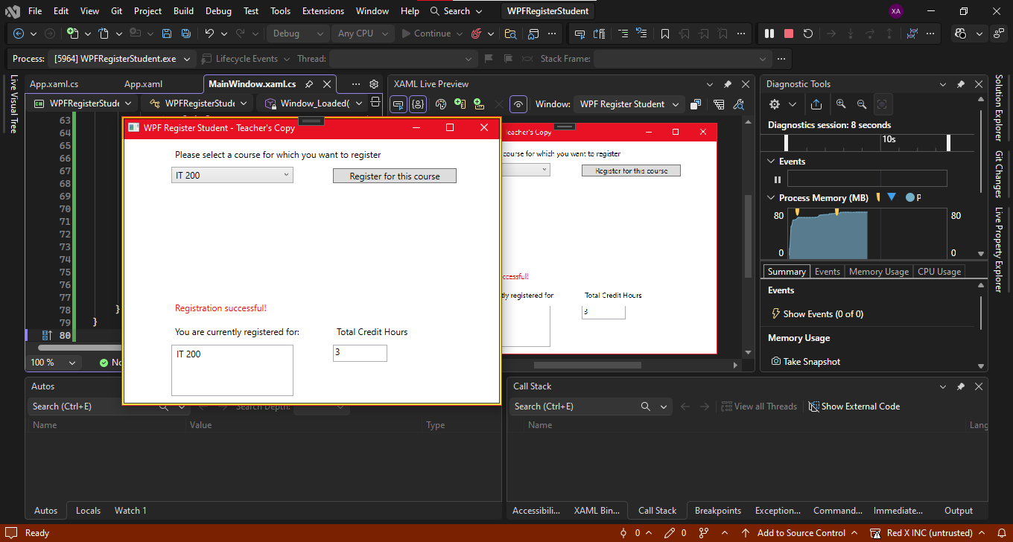
Registration successful message appears after selecting a valid course. The program updates the list of registered courses and total credit hours.
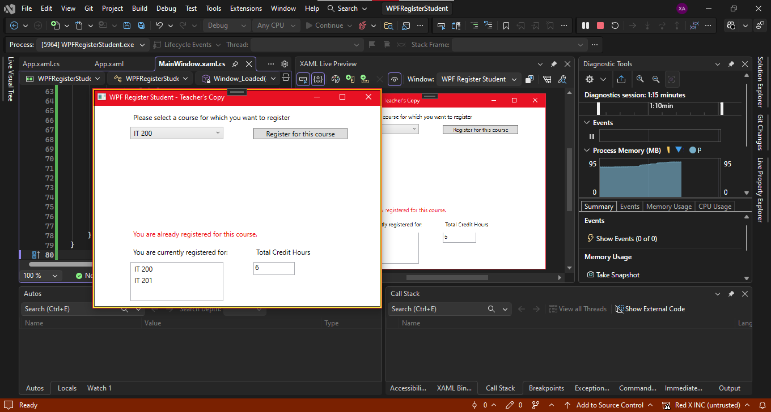
The program prevents duplicate registration and displays error messages. Total credit hours remain unchanged.
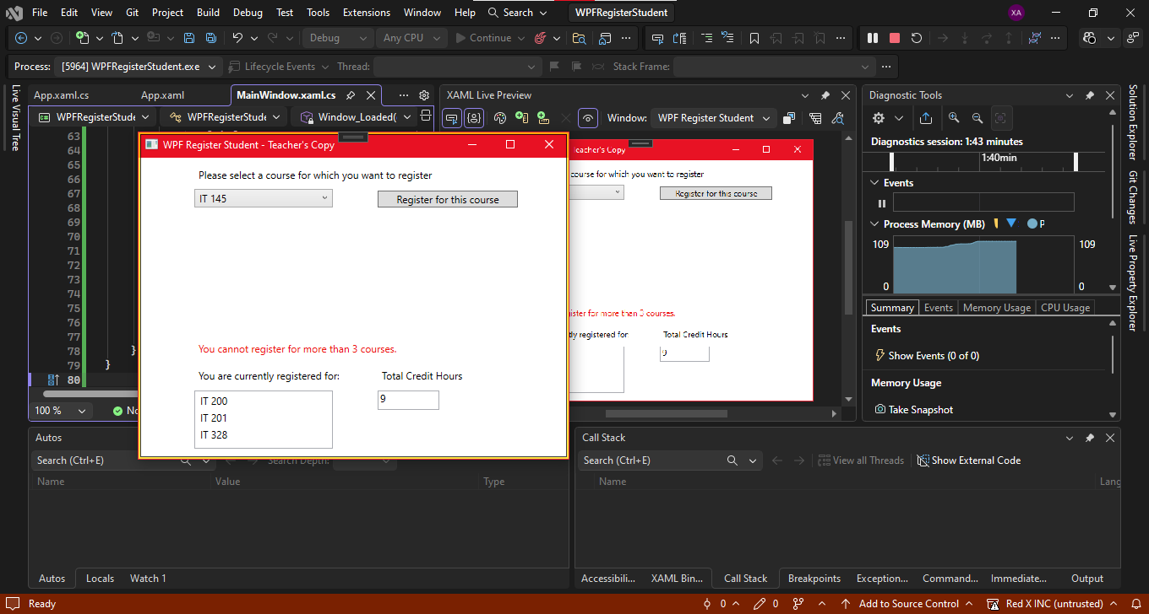
The program enforces the nine-credit-hour limit and displays an error message. The list of registered courses and total credits remain consistent.

MainWindow.xaml.cs code:
using System;
using System.Windows;

namespace WPFRegisterStudent
{
public partial class MainWindow : Window
{
private Course choice;

public MainWindow()
{
InitializeComponent();
}

private void Window_Loaded(object sender, RoutedEventArgs e)
{
// Create course list
Course course1 = new Course("IT 145");
Course course2 = new Course("IT 200");
Course course3 = new Course("IT 201");
Course course4 = new Course("IT 270");
Course course5 = new Course("IT 315");
Course course6 = new Course("IT 328");
Course course7 = new Course("IT 330");

comboBox.Items.Add(course1);
comboBox.Items.Add(course2);
comboBox.Items.Add(course3);
comboBox.Items.Add(course4);
comboBox.Items.Add(course5);
comboBox.Items.Add(course6);
comboBox.Items.Add(course7);

textBox.Text = "0"; // Start with 0 credit hours
}

private void button_Click(object sender, RoutedEventArgs e)
{
label3.Content = ""; // Clear previous messages

// Validate selection
if (comboBox.SelectedItem == null)
{
label3.Content = "Please select a course before registering.";
return;
}

choice = (Course)comboBox.SelectedItem;

// Check if already registered
if (choice.IsRegisteredAlready)
{
label3.Content = "You are already registered for this course.";
return;
}

// Check class limit (max 3 classes = 9 credit hours)
int currentCredits = 0;
int.TryParse(textBox.Text, out currentCredits);

if (currentCredits >= 9)
{
label3.Content = "You cannot register for more than 3 courses.";
return;
}

// Register the course
choice.SetToRegistered();
listBox.Items.Add(choice);

// Update credit hours
currentCredits += 3;
textBox.Text = currentCredits.ToString();

// Confirmation message
label3.Content = "Registration successful!";
}
}
}

Course.cs code:
using System;

namespace WPFRegisterStudent
{
public class Course
{
public string Name { get; private set; }
public bool IsRegisteredAlready { get; private set; }

public Course(string name)
{
Name = name ?? string.Empty;
}

public void SetToRegistered()
{
IsRegisteredAlready = true;
}

public override string ToString()
{
return Name;
}
}
}

