**Goblet Mesh** Christopher McKinney

A goblet of this form can be defined as a 14-tuple $\left\langle w_{g}r_{o}h_{uc}r_{c}h_{lc}r_{s}h_{s}R_{bd}h_{bd}r_{bl}h_{bl}R_{bs}r_{bs}h_{bs}\right\rangle$ (refer to the above diagram for the associated measures). Note that for the purpose of *hs*, the top of the stem is defined as the bottom of the spheroid that defines the exterior of the lower cup, even though the bottom of that spheroid is excluded from the point set. However, for all other purposes, the “stem” extends all the way up to where it meets the lower cup (the intersection on the outer edge). The set of points ***P*** defining the edge of the central cross-section of the material (as displayed in the diagram above) can be defined as follows: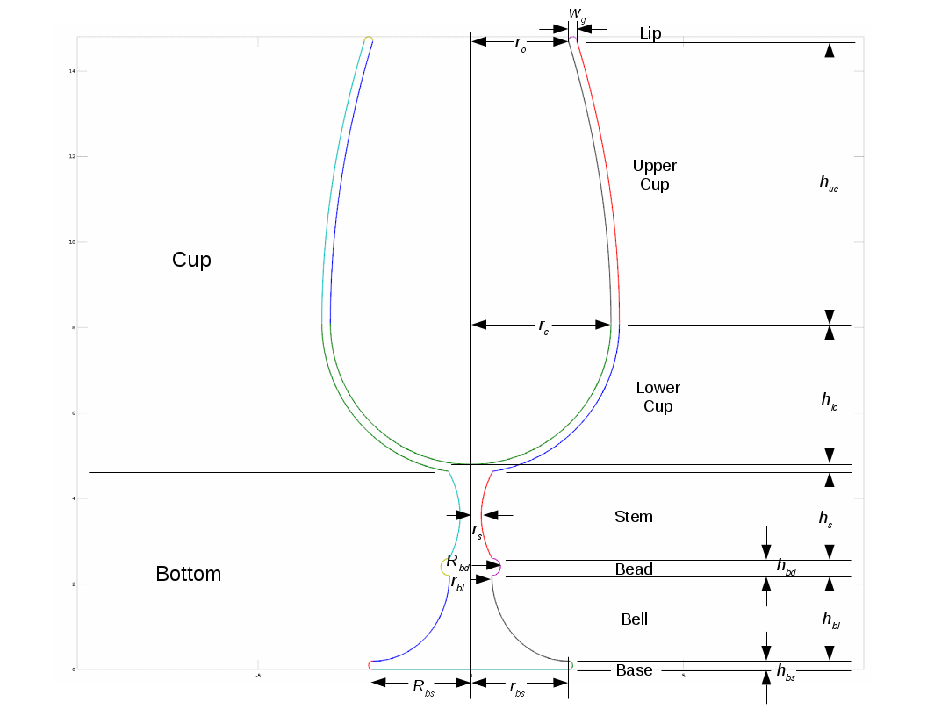

$\begin{aligned}\text{Let}Δ_{uc}=r_{c}−r_{o},R_{c}=r_{c}+w_{g},H_{lc}=h_{c}+w_{g},y_{c}=h_{bs}+h_{bs}+h_{bl}+h_{bd}+h_{s}+H_{lc}, \\ r_{L}=\frac{w_{g}}{2},x_{L}=r_{o}+r_{L},y_{L}=y_{c}+h_{uc},Δ_{s}=r_{bl}−r_{s},v_{s}=\frac{h_{s}}{2},ys=h_{bs}+h_{bl}+h_{bd}+v_{s}, \\ Δ_{bd}=R_{bd}−r_{bl},v_{bd}=\frac{h_{bd}}{2},y_{bd}=h_{bs}+h_{bl}+v_{bd},Δ_{bl}=r_{bs}−r_{bl},Δ_{bs}=R_{bs}−r_{bs}, \\ \text{and}v_{bs}=\frac{h_{bs}}{2}.\end{aligned}$

$\begin{aligned}\text{Let}Ω_{s}=\text{min}a\text{and}θ_{lc}=\text{min}b \\ \text{where}R_{c}cosb−Δ_{s}a^{2}−r_{s}=0,H_{lc}sinb+y_{c}−v_{s}a−y_{s}=0, \\ a≥1,\text{and}−\frac{π}{2}≤b≤0.\end{aligned}$

$\begin{aligned}\text{Let}L=\left\{\left(r_{L}cosa+x_{L},r_{L}sina+y_{L}\right)\text{|}0≤a≤π\right\}, \\ a=\left\{\left(Δ_{uc}a^{2}+r_{c},h_{uc}a+y_{c}\right)\text{|}0≤a≤1\right\},A=\left\{\left(Δ_{uc}a^{2}+R_{c},h_{uc}a+y_{c}\right)\text{|}0≤a≤1\right\}, \\ b=\left\{\left(r_{c}cosa,h_{lc}sina+y_{c}\right)\text{|}−π≤a≤0\right\},B=\left\{\left(R_{c}cosa,H_{lc}sina+y_{c}\right)\text{|}θ_{lc}≤a≤0\right\}, \\ C=\left\{\left(Δ_{s}a^{2}+r_{s},v_{S}a+y_{s}\right)\text{|}−1≤a≤Ω_{s}\right\},D=\left\{\left(−Δ_{bd}sina+r_{bl},v_{bd}cosa+y_{bd}\right)\text{|}−π≤a≤0\right\}, \\ E=\left\{\left(−Δ_{bl}cosa+r_{bs},h_{bl}\left(sina+1\right)+h_{bs}\right)\text{|}−{pi}/2≤a≤0\right\}, \\ F=\left\{\left(Δ_{bs}sina+r_{bs},v_{bs}\left(cosa+1\right)\right)\text{|}−pi≤a≤0\right\},\text{and}G=\left\{\left(r_{bs}a,0\right)\text{|}−1≤a≤1\right\}.\end{aligned}$

$\text{Let}\text{mirror}S:=S∪\left\{\left(−x,y\right)\text{|}\left(x,y\right)∈S\right\}.$

$P=\text{mirror}B∪\text{mirror}A∪\text{mirror}L∪\text{mirror}a∪b∪\text{mirror}C∪\text{mirror}D∪\text{mirror}E∪\text{mirror}F∪G$

The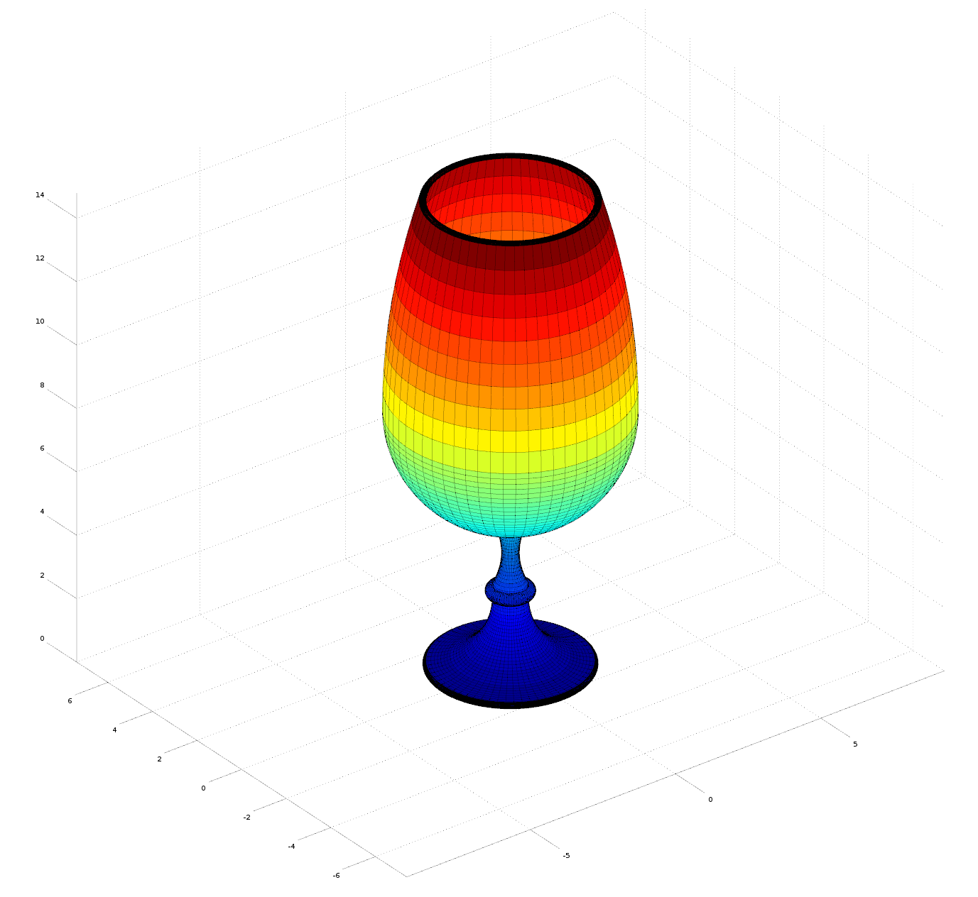 form of the goblet is obtained by rotating the shell defined by ***P*** about the *y*-axis:

The goblet can hold liquid (not touching the lip) of volume *Vhold,* which can be calculated using the integration formula for the volume of the inner wall of the cup:

$V_{hold}=\int_{0}^{h_{uc}}{π}{\left(Δ_{uc}\frac{y^{2}}{h_{uc}^{2}}+r_{c}\right)}^{2}dy+\int_{0}^{h_{lc}}{π}r_{c}^{2}\left(1−\frac{y^{2}}{h_{lc}^{2}}\right)dy$

The volume of glass *Vglass* required to form the goblet can be calculated using the integration formula for the volume of all of the components of the goblet (except for the lip, for which we can use the formula for the volume of a torus):

$\begin{aligned}\text{Let}V_{L}=π^{2}x_{L}r_{L}^{2},V_{uc}=\int_{0}^{h_{uc}}{π}{\left(Δ_{uc}\frac{y^{2}}{h_{uc}^{2}}+R_{c}\right)}^{2}dy−\int_{0}^{h_{uc}}{π}{\left(Δ_{uc}\frac{y^{2}}{h_{uc}^{2}}+r_{c}\right)}^{2}dy, \\ U=H_{lc}−v_{s}\left(Ω_{s}−1\right),V_{lc}=\int_{0}^{U}{π}R_{c}^{2}\left(1−\frac{y^{2}}{H_{lc}^{2}}\right)dy−\int_{0}^{\text{min}\left\{U,h_{lc}\right\}}{π}r_{c}^{2}\left(1−\frac{y^{2}}{h_{lc}^{2}}\right)dy, \\ V_{s}=\int_{−v_{s}}^{Ω_{s}v_{s}}{π}{\left(Δ_{s}\frac{y^{2}}{v_{s}^{2}}+r_{s}\right)}^{2}dy,V_{bd}=\int_{−v_{bd}}^{v_{bd}}{π}{\left(Δ_{bd}sin\left(acos\left(\frac{y}{v_{bd}}\right)\right)+r_{bl}\right)}^{2}dy, \\ V_{bl}=\int_{0}^{h_{bl}}{π}{\left(Δ_{bl}cos\left(asin\left(\frac{y}{h_{bl}}\right)\right)+r_{bs}\right)}^{2}dy,V_{bs}=\int_{−v_{bs}}^{v_{bs}}{π}{\left(Δ_{bs}sin\left(acos\left(\frac{y}{v_{bs}}\right)\right)+r_{bs}\right)}^{2}dy\end{aligned}$

$V_{glass}=V_{L}+V_{uc}+V_{lc}+V_{s}+V_{bd}+V_{bl}+V_{bs}$

The goblet that has been shown in the diagrams has been the goblet defined by the tuple $\left\langle 0.22.36.63.33.30.2520.70.40.522.42.30.2\right\rangle .$ This goblet has a holding volume of approximately 259.60 cm3 and a total glass volume of 132.72 cm3.and the center of mass is known to be in the “bottom” section of the goblet since the glass has (presumably) uniform density and $V_{bottom}=V_{s}+V_{bd}+V_{bl}+V_{bs}≈92.535{\text{cm}}^{3}>V_{cup}=V_{L}+V_{uc}+V_{lc}≈40.186{\text{cm}}^{3},$ and since the height of the bottom section $h_{bottom}=v_{s}\left(Ω_{s}−1\right)+h_{s}+h_{bd}+h_{bl}+h_{bs}≈4.6388\text{cm,}$ the center of mass is known to be below 6.9cm. The thinnest glass is along the walls of the cup, where it has a thickness of 0.2cm (the walls terminate at the lip, which has a minor toroidal diameter of 0.2cm), at the edge of the base, which has a height (and as such a minor toroidal diameter) of 0.2cm, and at the middle of the stem, where it has a diameter of 0.5cm.