English -Name Class

1. What is the velocity of a wave with a frequency of 1.8 Hz and a wavelength 3.6 m? v = λf
2. Label the point with an antinode and node.

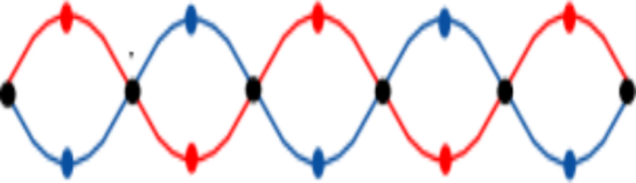

A

B

1. Draw two waves with the SAME amplitude. One has high frequency, and one has low frequency.
2. Match the following definition to the correct explanation.

|  |  |
| --- | --- |
| **Law of Superposition** | Two waves with the same frequency and opposite phase. |
| **Destructive Interference** | The total amplitude of the waves is equal to the sum of the amplitudes of the individual waves. |
| **Constructive Interference** | Two waves with the same frequency and phase. |

1. wave pulse is created in a Slinky. It takes 1.5 seconds to travel the length of the Slinky. If the Slinky is 8 meters long, what is the speed of the wave? v =
2. When the frequency of a wave increases, what happens to the wavelength?
3. A string is clamped at both ends and plucked so it produces a standing wave as shown above. How many nodes and antinodes are there?

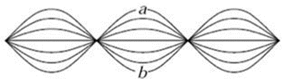

1. 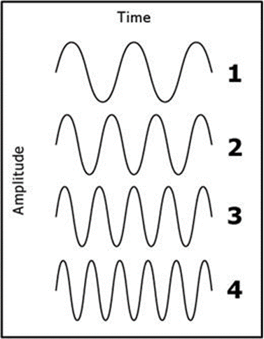Which transverse wave has the highest frequency?
2. 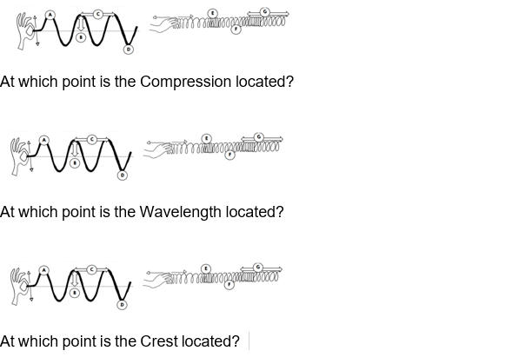
3. 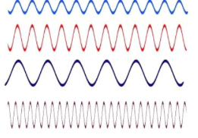Which wave in the diagram has the greatest wavelength?
4. The lowest pitch the average human can hear is about 20.0 Hz. If sound with this frequency travels through air about 300 m/s, What is its wavelength?
5. A sound wave traveling through dry air with a temperature of 45 degrees Celsius will have a wave speed of:
6. Lightening strikes and 10 seconds later you hear the thunder. What is the distance of the storm form you? (speed of sound = 330m/s)
7. Two students are standing 8 meters apart and they used a spring to create a standing wave with 4 antinodes between them. What is the wavelength of that standing wave?