1. System Context Diagram (C4 Level 1)
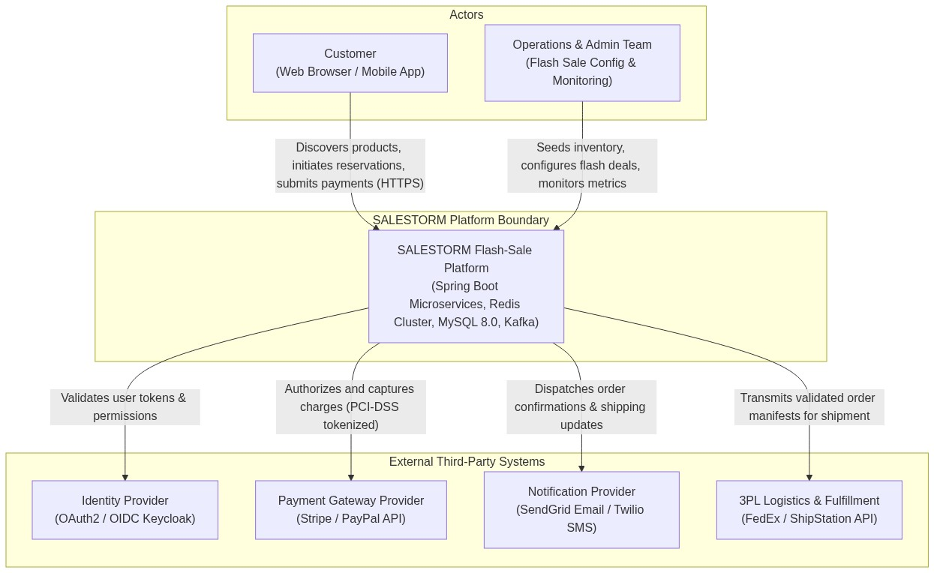
Figure: Diagram 1: flowchart TD

2. Container & Service Architecture Diagram (C4 Level 2)
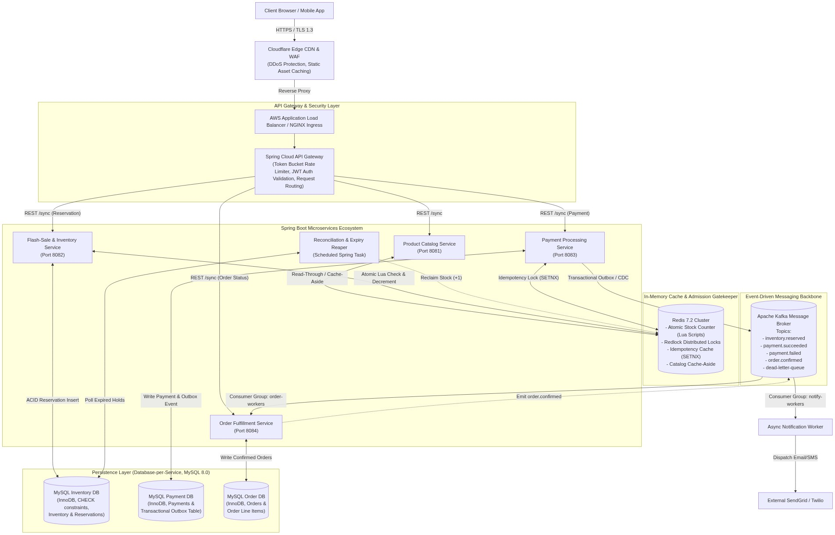
Figure: Diagram 2: flowchart TD

3. Docker-Based Deployment Architecture
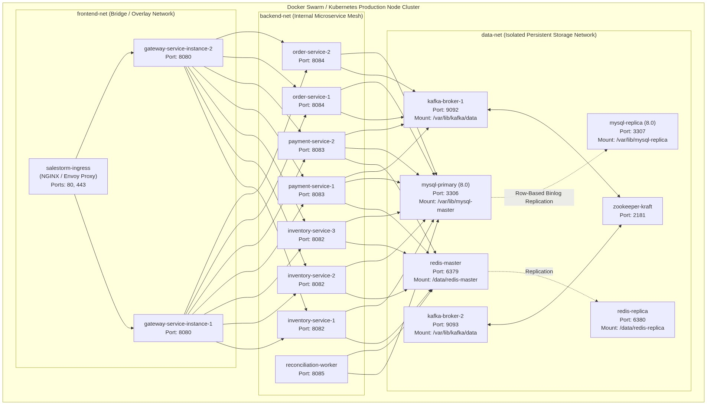
Figure: Diagram 3: flowchart TD

4.1 Domain Class Diagram - Inventory Module
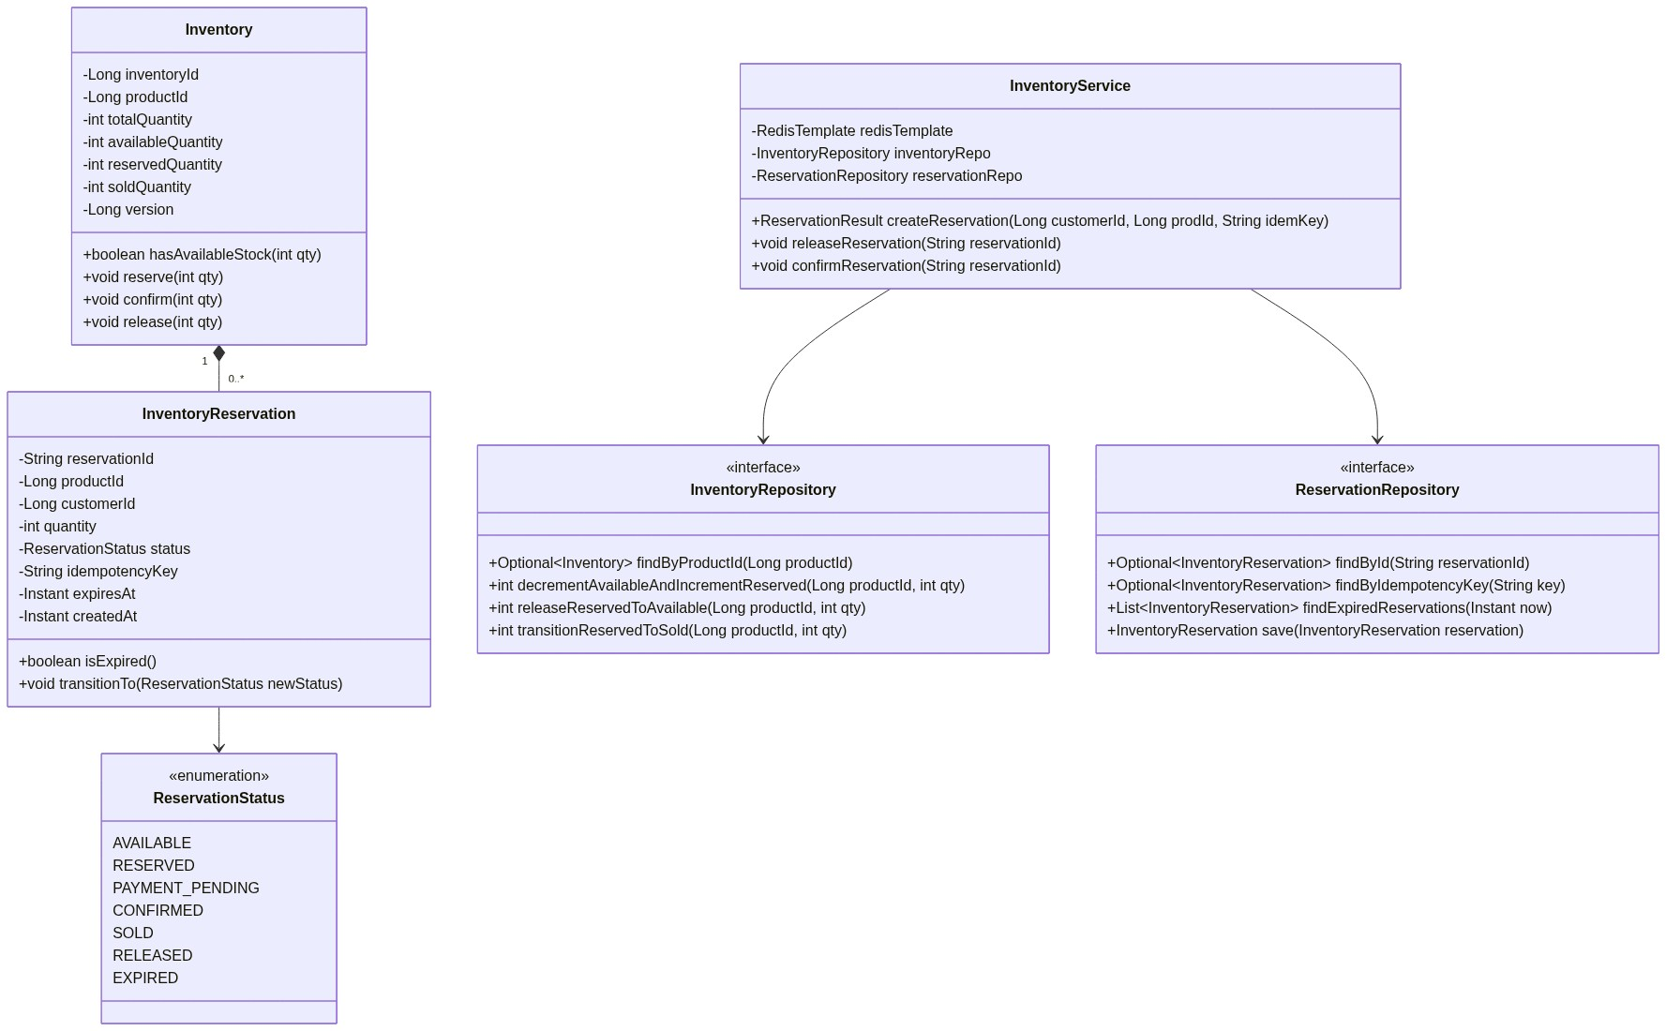
Figure: Diagram 4.1: classDiagram - Inventory Module

4.2 Domain Class Diagram - Payment Module
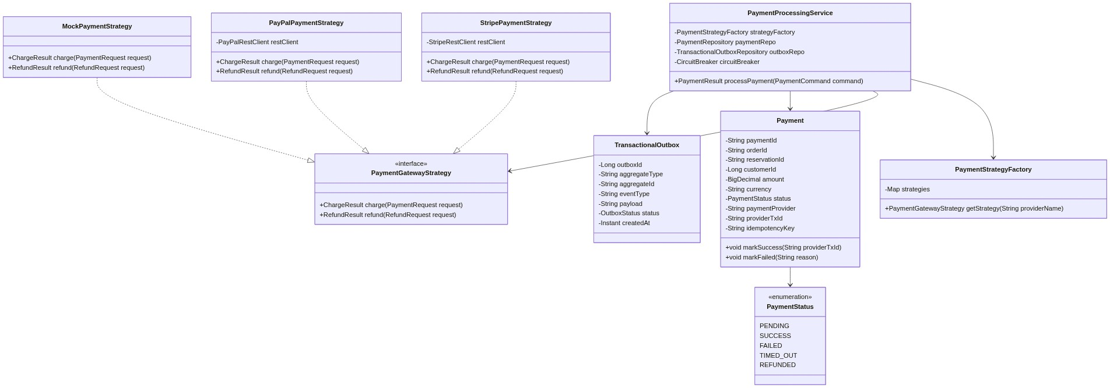
Figure: Diagram 4.2: classDiagram - Payment Module

4.3 Domain Class Diagram - Order Module
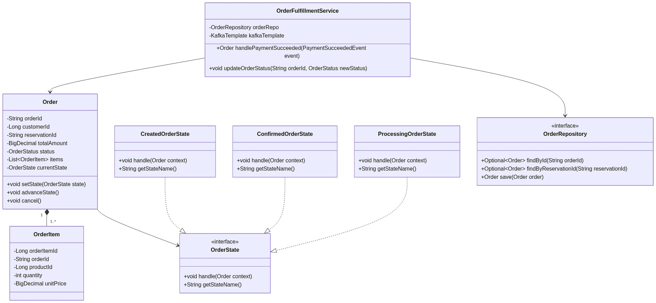
Figure: Diagram 4.3: classDiagram - Order Module

5. Entity-Relationship Diagram (ERD)
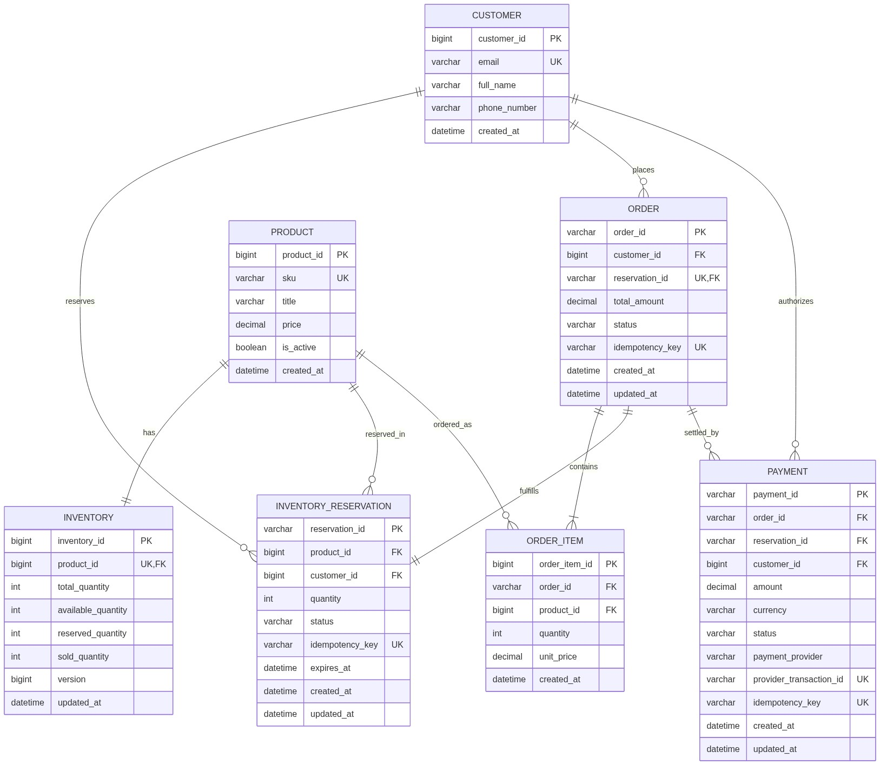
Figure: Diagram 5: erDiagram

6. Transactional Outbox Pattern
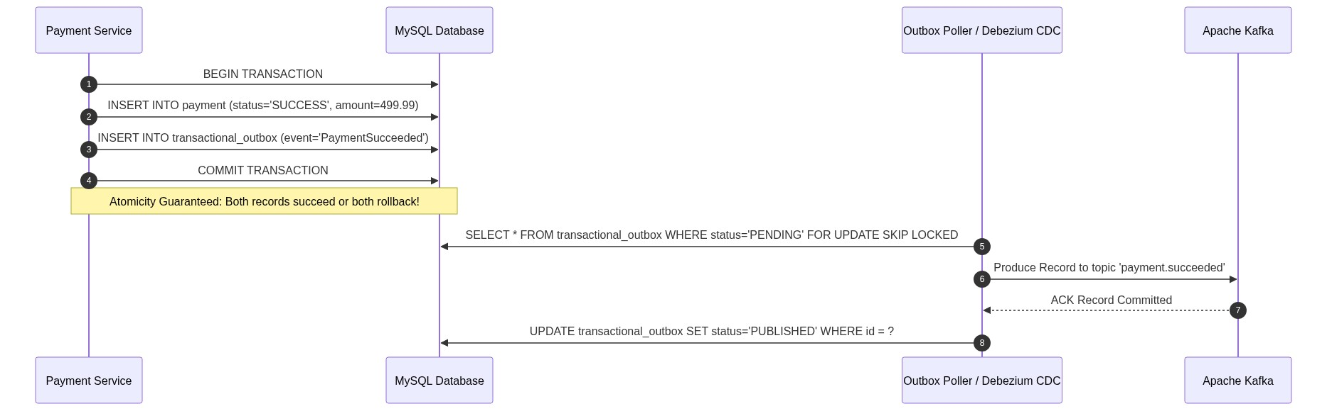
Figure: Diagram 6: sequenceDiagram

7. Complete Reservation & Order State Transition Diagram
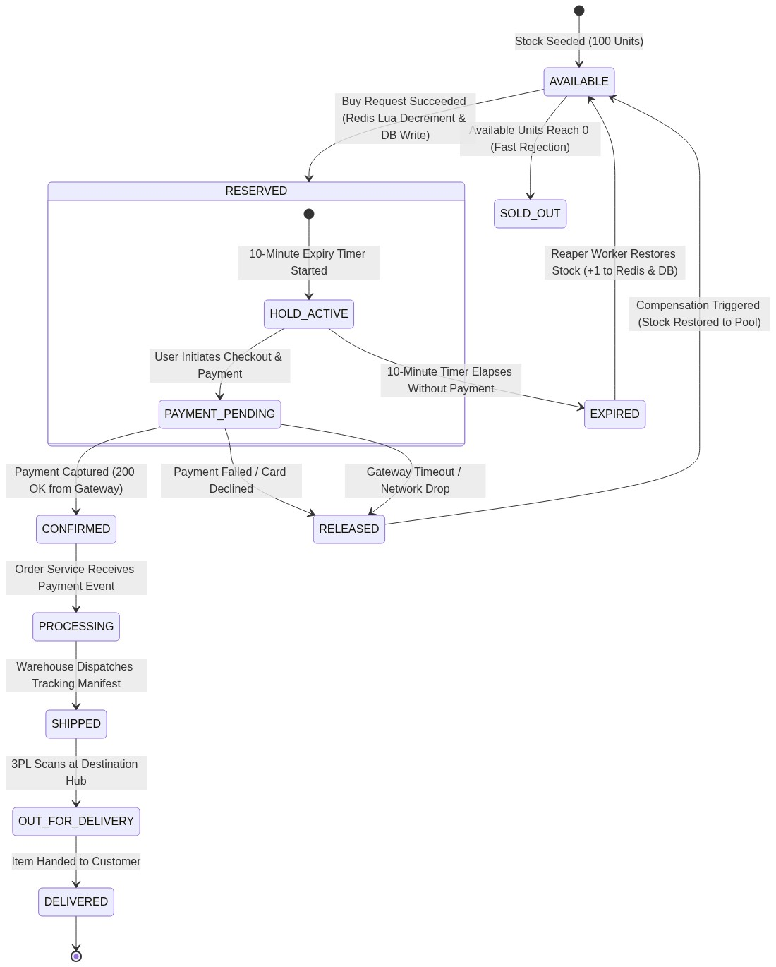
Figure: Diagram 7: stateDiagram-v2

8. Flow 1: Successful Purchase Flow (Request to Order Confirmation)
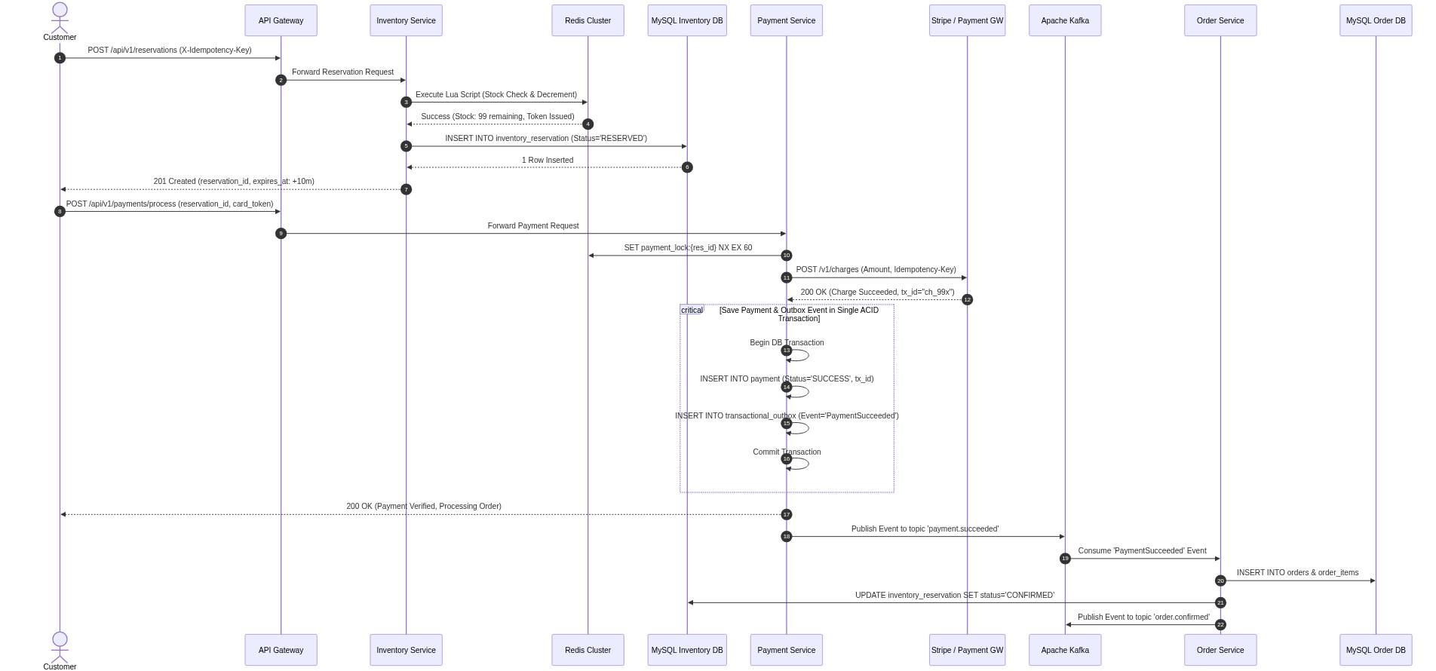
Figure: Diagram 8: sequenceDiagram

9. Flow 2: Payment Failure Triggering Reservation Release
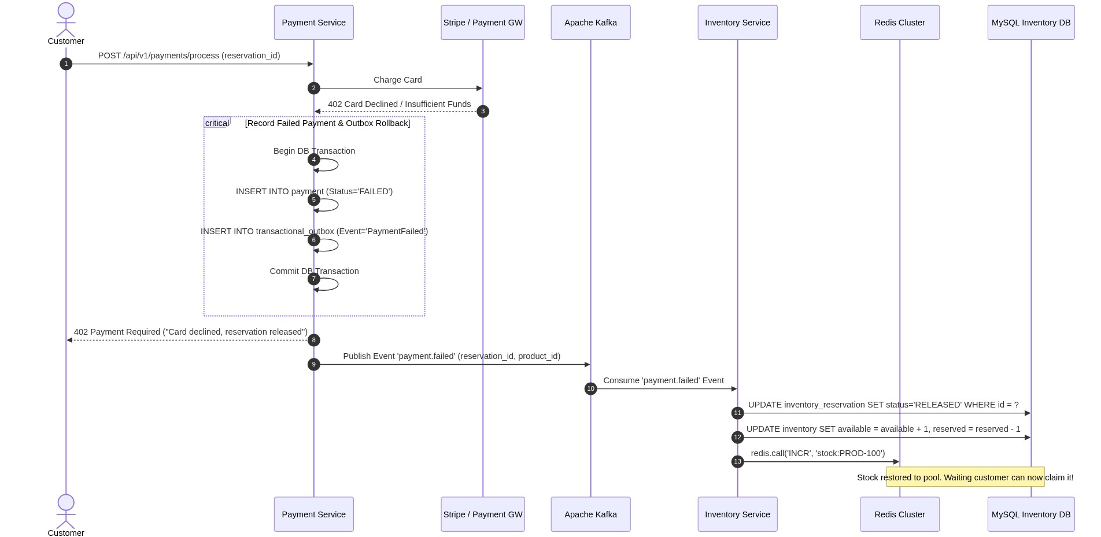
Figure: Diagram 9: sequenceDiagram

10. Flow 3: Payment Success Followed by Temporary Order Service Failure (30s Downtime)
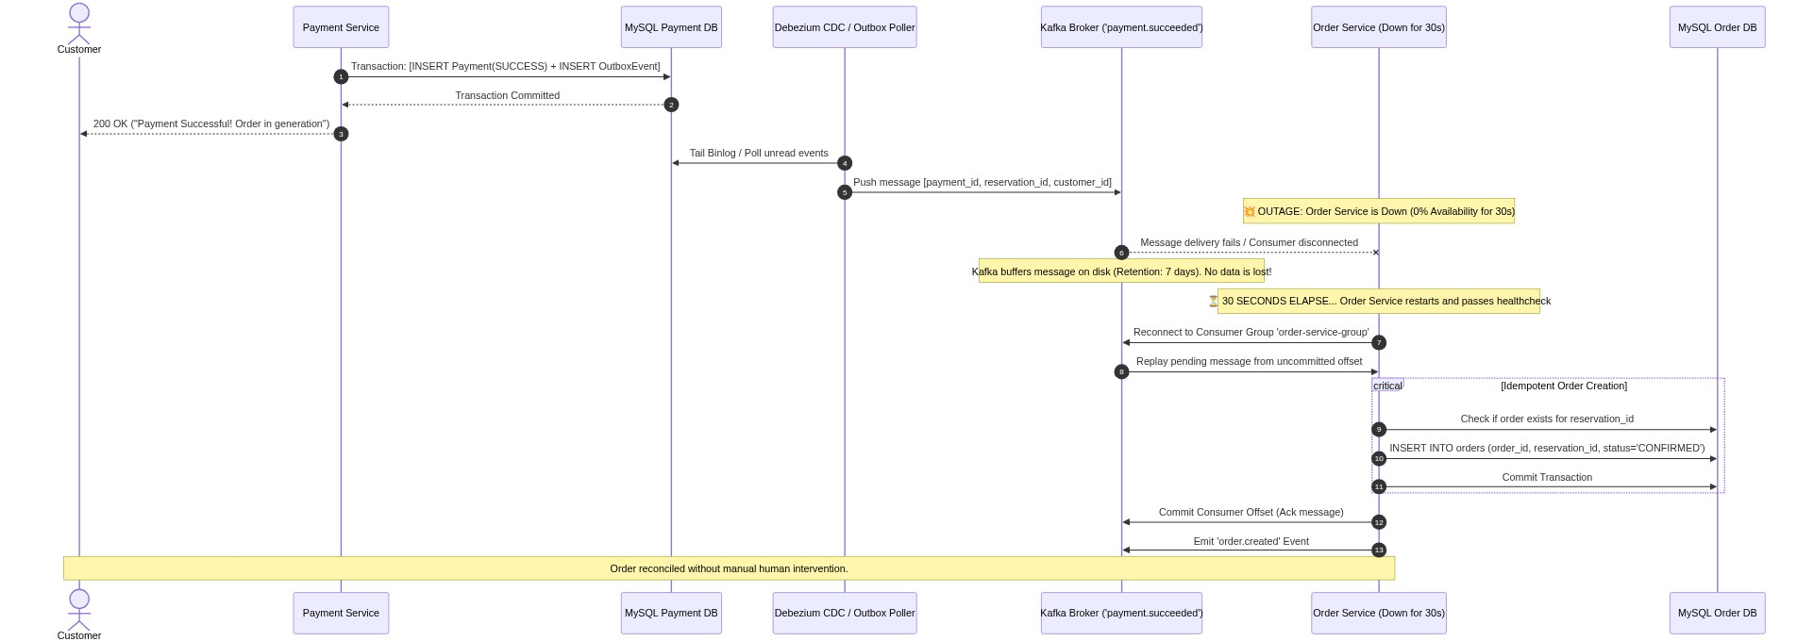
Figure: Diagram 10: sequenceDiagram

11. The Three Pillars of Observability
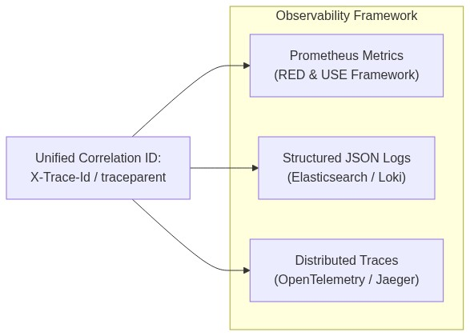
Figure: Diagram 11: flowchart LR

12. Decision Outcome
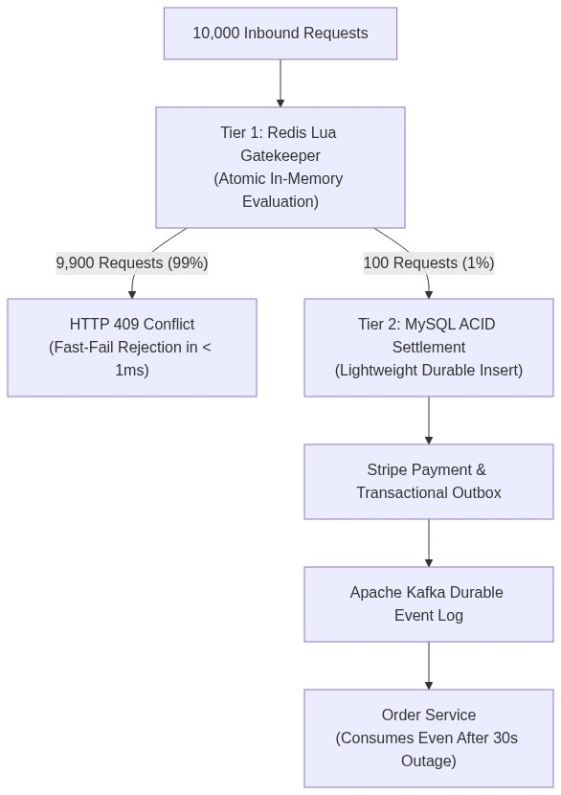
Figure: Diagram 12: flowchart TD

