There are some of my own opinions in the following content, if it is unreasonable, please use the best solution to correct it

The first step is to add an API. The name of the API can define a user ID + API ID for the user in our own panel to distinguish

For example: User ID=uid777, User API ID=NIMXcWSH, the user name for this API is API666 His API name can be uid777#NIMXcWSH#API666 In this way, you can tell which API this API belongs to which user.

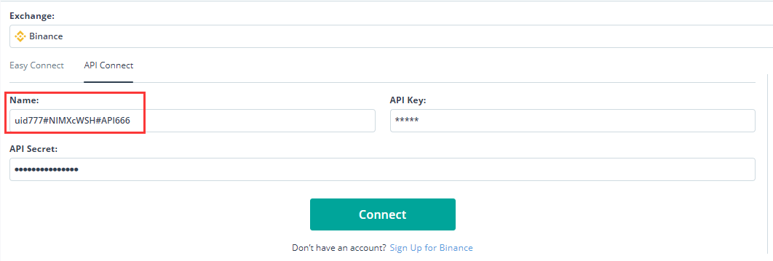

In the background of our own panel, we need to set which exchanges to open, and only the open exchanges can be added by users. If only open, Binance, Huobi, OKEX these three, you can customize the start and stop

The order is that the robot can be copied to trade only after adding the API

In the second step, we need to create a robot managed by the administrator, that is, the strategy displayed to the user. We can define a name for the robot, such as admin#T5LOxJg8 It means that it is a robot added by the administrator. T5LOxJg8 can be used as the number to distinguish this robot. In our own management panel, we can set the name of the robot displayed to the user, and some functions.

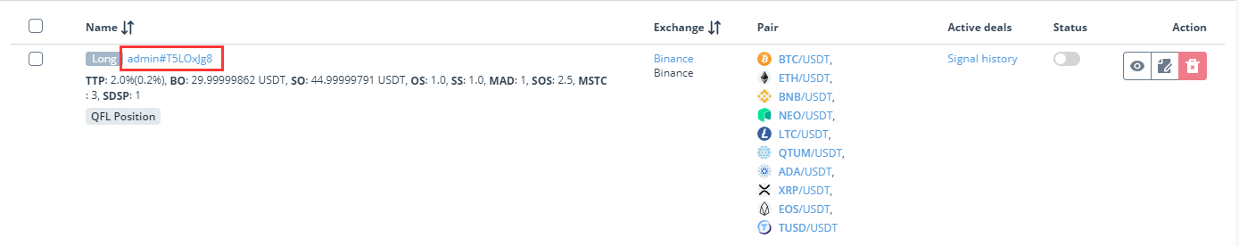

The robot created by the administrator is used as a template, and the user can copy this robot for setting

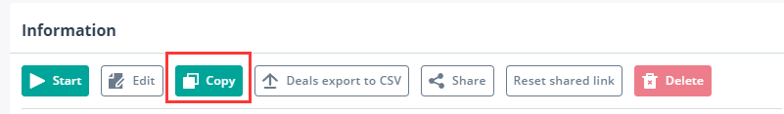

This interface is to copy the robot, you need to set a name and a parameter.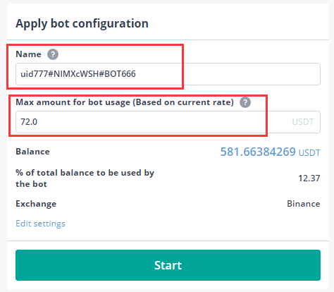https://github.com/3commas-io/3commas-official-api-docs/blob/master/bots_api.md#create-bot-permission-bots_write-security-signed

<https://github.com/3commas-io/3commas-official-api-docs/blob/master/bots_api.md>

https://github.com/rentorm/3commas-api-node