Backend

Frontend

3Commas

3Commas API

DB

Multi User Management system

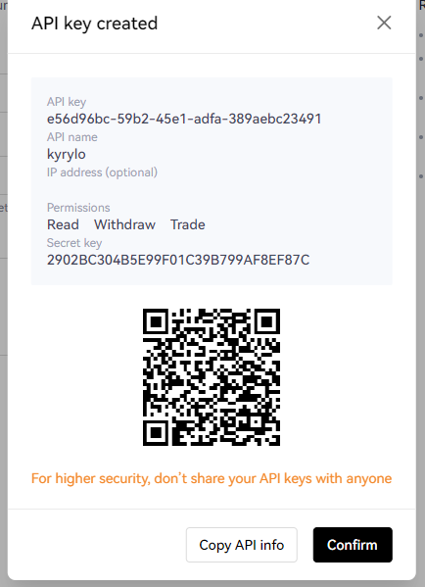

New user

Created by Admin

Robots

Only show Copy Item

Bot Copy

3Commas Copy Action

Copy

Backend Add that bot to User logined

Show Start/Stop, Copy, Edit, Remove items

List Bots