# Lab 2 – Star Schema

# Overview

*TPC* is ready to implement its first data mart. In this lab, you will analyze the user requirements for thisdata mart, design it using dimensional modeling techniques, and implement the schema design in your database.

# After completing this lab exercise, you should be able to:

* Translate user information requirements into a design for a data mart.
* Identify the data needs and potential data sources for a data mart.
* Implement the design for a data mart in a database schema.

# To do this lab you will need the following:

1. Your copies of the *TPC* case study, business rules, and ERD.
2. Access to a computer running MySQL and MySQL Workbench.

# Deliverables

Submit the following to MyCourses as a single .zip file with the following name – *YourLastName_Lab2_211*.zip:

1. Answers to the questions in this lab (MS Word).
2. An ER diagram showing your Star Schema, developed in MySQL Workbench and pasted into a MS Word or .pdf document.
3. A screenshot of your tables from MySQL Workbench.
4. Your MySQL Workbench model *YourLastName_211*.mwb file
5. A *YourLastName_211*.sql file that contains the dumping your database

# Business Scenario

*TPC* management has identified financial control and analysis as their top current issue. After talking with the users in the *TPC* central office in Stratford who are involved with financial control, you find out the following:

* Although each of the three divisions is responsible for financial control (increasing sales and decreasing costs), the Financial Director in Stratford is primarily responsible for overall company performance.
* The three divisions will provide data to the data warehouse in different forms. You will have access to OLTP database for TPC-E. This will provide you with sales data for TPC-E. Since you have access to the developers, they can help you with the data in the OLTP system.
* TPC-W in similar in operation to TPC-E and TPC-W will provide a feed of data for you to use. The data will be similar to that which you have access to for TPC-E. An initial feed will be provided from TPC-W and a monthly feed will be provided with updates each month.
* The data from PEC will be different. There will be a customer and a product feed, but the cost will have to be calculated from manufacturing cost data that will be provided. Formulas for calculation will be provided later.
* Since sales can be made from TPC-E and TPC-W to PEC and from PEC to TPC-E and TPC-W, there will need to be allowances when sales and costs are calculated at the total company level. Sales from one unit to another, although considered as sales for the first unit, are not considered sales for the total company (You can’t count sales to yourself). You will need to identify these customer records.
* There may be overlap in customers among the three company units.
* The company financial performance is measured on an annual, quarterly, monthly and weekly basis. Quarters are based on the normal annual quarters for comparison against other companies. (e.g Quarter 1 is January, February and March …). The company’s fiscal year (financial reporting and tax year), however, goes from May 1 through April 30. The fiscal quarters conform to the fiscal year (e.g., Fiscal quarter 1 is May, June and July …). As an example, fiscal 2011 will extend from May 1, 2011 through April 30, 2012.
* Invoice numbers are not unique across the three divisions, so it will be necessary to keep track of the division responsible for the sale.
* PEC sometimes requires special shipping for the products they manufacture. The options are “Train”, “Truck”, “Air”, “N/A” (not available or applicable). Sales that have no special requirements are coded as 0 on the invoice. The other divisions do not provide this information.
* PEC also provides data on the sales feed about the ordering method. The options are “Internet”, “phone”, “email” or “mail”. The values are stored as text. This information is not provided by the other divisions.
* Since PEC manufactures equipment, in addition to the sale date, there is also an order date. The time between order and sale can be used to measure the performance of the organization’s manufacturing process. The other divisions do not provide this information since they normally ship from stock.
* Payment method is also provided by PEC on the sales feed. The three valid methods are “COD”, “charge” or “cash”. Again, this is stored as text. It is not provided by the other divisions.
* After the initial load feeds, there will be similar feeds for monthly updates.

The company would like a data mart that would allow them to investigate their financial performance at the gross profit (margin) level historically so as to more effectively manage financial performance. They are interested in having a flexible system that will ultimately allow them to optimize sales (to maximize sales) while keeping costs down. In addition, they want to be able to better manage the relationships with their suppliers. Some of the initial queries and reports they would like are:

* A report that shows the sales, and costs associated with each customer or customer type on an annual, quarterly, monthly or weekly basis.
* A similar report showing top customers.
* A similar report as above at the product level / product type/ business unit.
* The average time in days needed to fulfill an order from PEC.
* The number of orders that are not shipped within 10 days of order from PEC.
* The average number of products and sales per invoice (keep in mind that invoice number is not unique across divisions).
* What are the average number / maximum number of different shipping methods on each invoice?
* The average cost of shipping for a particular product by different methods.
* The percentage of invoices that are COD.
* The most frequent method of ordering a product from PEC.
* What is the average number of products supplied by each supplier?
* Show the total cost of products for each supplier.
* Show sales from one division to another.
* Comparisons should be able to be done from year-to-year, quarter-to-quarter, month-to-month, same month or quarter compared to last year, … . This should be able to be done on a calendar year basis or a fiscal year basis.
* Sales by type of customer, by state, by product type, by business unit.
* The sales by supplier state to customer state. This would be useful to see if suppliers should ship directly to customers.
* All reports should be able to report sales, costs and gross profit (sales minus costs).

# Part #1. Requirements Gathering – Fill Out an Information Package

NOTE: Record your answers to the questions below in a separate MS Word or .pdf document that will be submitted for grading.

## Step #1-1: Identify the Process

Remember the focus of a data mart is *one* key business process that is important to company success.

*Question*: Which business process will be the focus of this data mart development?

The data mart development focuses on the sale of the product _________________________________________________________________

*Define*: Write a statement that defines the scope – i.e. universe of discourse – of this data mart.

The scope of this data mart is to ensure the financial performance of the company. The performance measures that are suitable for manufacturing and sales in order to increase the sales of the company and ensuring that the manufacturing cost remains as low as possible.

*Question*: Assuming that the *TPC-E* ERD and other data sources cover various business activities and data systems within the company, what are the source data system(s) that are relevant to this development? Fill out **Table 1** with the details.

*Table 1*. Business Activities & Relevant ERD Tables

|  |  |
| --- | --- |
| **Business Activity** | **Relevant ERD Table(s) or other data source(s)** |
| Internal Operations | Invoice, TCP-W sales, TCP- sales |
| Sales | Invoice , TCP_ E sales, TCP – W sales , |
| Cost of Manufacturing | PCE manufacturing cost data |
|  | Customer, Customer Type |
|  | Product, Product Type |
|  | Business_unit |

## Step #1-2: Choose the Grain

*Question*: What grain options do you see in the scenario?

Time taken by the supplier to manufacture the product ,

Day-to-day orders that are made by the customers,

Time needed for a product to reach customer,

Sale of the product manufactured by the supplier and which is purchased by each customer

*Question*: What level of detail do you propose for this data mart? Why?

The total amount of product manufactured by the supplier

The total amount of sales made.

## Step #1-3: Identify the Dimensions

*Question*: What business dimensions are relevant to the scenario?

The business dimensions relevant to this scenario are as follow:

Customer, Sales Date, Product, Supplier, Shipping Date

Junk dimensions are as follows:

Ordering method , Shipping method, Payment method.

*Question*: Will you have any degenerate dimensions in your model? Explain.

Yes, we will have invoice id as a degenerate dimension. This is because it does not have a dimension table of its own. Invoice id will be kept in the fact table and this is done to reference back to the transactional database

*Question*: Will you have any role-playing dimensions in your model? Explain.

Yes, we will have role playing dimensions which are sales date.

*Question*: Will you have any junk dimensions in your model? Explain.

The junk dimensions in our model will be payment method, shipping method and ordering method included in PEC. The collection of transaction flag is considered to be junk dimension, when we add such dimensions to the fact table, they occupy extra space. So, they are considered as Junk Dimension.

## Step #1-4: Identify the Facts

*Question*: What are the key performance metrics needed by the users?

Days it takes to confirm an order , total profit and loss of each supplier who manufactures products for particular customer, days required to ship a particular product to the customer

*Question*: What *type* of fact table schema will this be? (Refer to the Week #4 lecture discussion of schema types.) Explain your reasoning.

The fact table schema will be accumulating fact table as the model will be requiring to perform roll up data which is possible with the help of package

Fill in **Table 2** with the information about the facts that are relevant to this process. Include in your description the reason *why* a given fact is included (i.e. for what will it be used?).

*Table 2*. Data Mart Fact Group Details

|  |  |  |
| --- | --- | --- |
| Fact Group: Sales Fact Table | | |
| **Fact Name** | **Fact Description** | **Default Aggregation Rule** |
| Quantity | Number of products purchased by customer | Fully Additive |
| Days to ship | The number of days it takes to ship a particular order to customer | Semi Additive |
| Amount | Total sales for an order | Fully Additive |
| Days to confirm | Days required to confirm an order | Fully Additive |
| Discounted | Boolean to show discounted products | Non- Additive |

## Step #1-5: Complete the Process Information Package

Fill in the Information Package chart in **Appendix A** for this process.

*Question*: Did you identify any hierarchies within the dimensions? If so, list them here.

1. Customer:

Customer_Type 🡪 Customer_State 🡪Customer_City🡪Customer_Zip🡪 Address1,Address2🡪Customer_Name1

1. Supplier:

Supplier_State🡪Supplier_City🡪Supplier_Zip🡪 Address1,Address2🡪Supplier_Name

1. Sales_Date

Sales_year🡪Sales_quarter🡪Sales_month🡪Sales_week🡪Sales_day

Fiscal_sales_year🡪_fiscal_sales_quarter🡪_fiscal_Sales_month🡪fiscal_sales_week🡪fiscal_sales_day.

1. Shipping_Date

Shipping_year🡪Shipping_Quarter🡪Shipping_month🡪Shipping_week🡪Shipping_day

Fiscal_year🡪Fiscal_quarter🡪Fiscal_month🡪Fiscal_week🡪Shipping_day

1. Product

Business_unit_name/BU Abbrev🡪Product_type_desc🡪Product_desc🡪price1,price2,unit_cost

1. Order_date

Order_year🡪Order_quarter🡪Order_month🡪Order_week🡪Order_day

Fiscal_order_year🡪Fiscal_order_qaurter🡪Fiscal_quarter_month🡪Fiscal_order_week🡪Fiscal_order_day

Draw a dimensional table detail diagram (refer to Week #4/5 Practice Exercise #3) for your dimension(s). Put the attribute for the lowest grain level at the bottom. Surround it with the other time items (attributes) and show relationships with arrows. Clearly delineate any hierarchies.

Customer: Supplier:

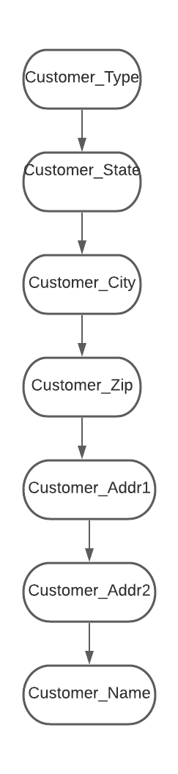 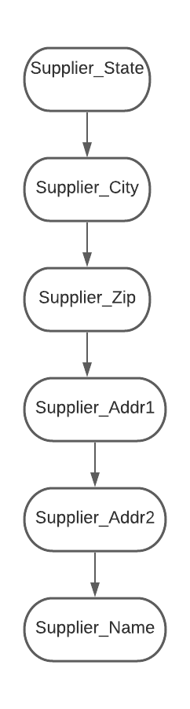

Sales_date:

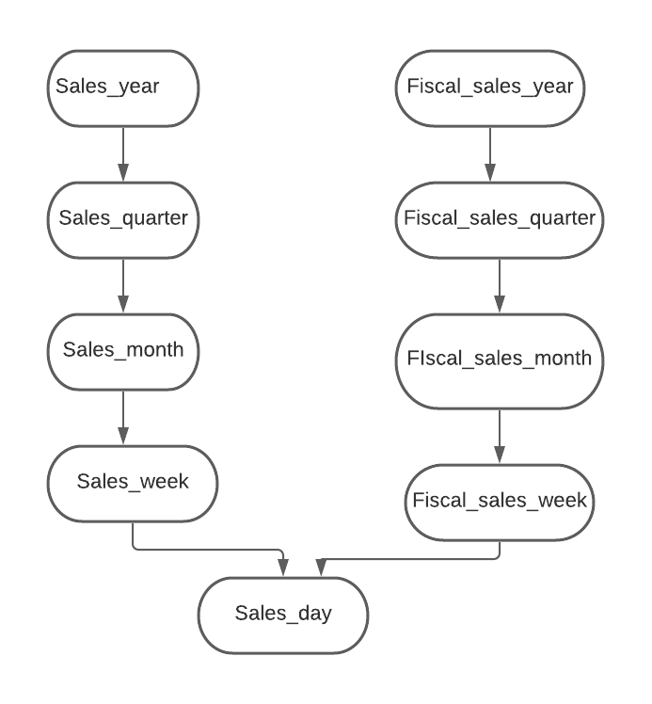

Shipping_Date

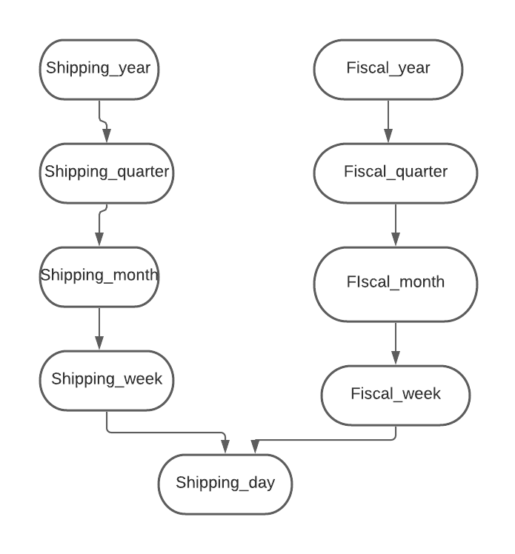

Product:

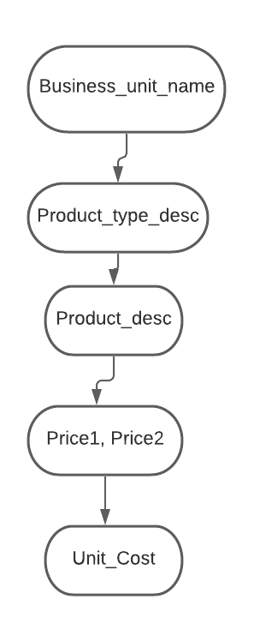

Order_Date:

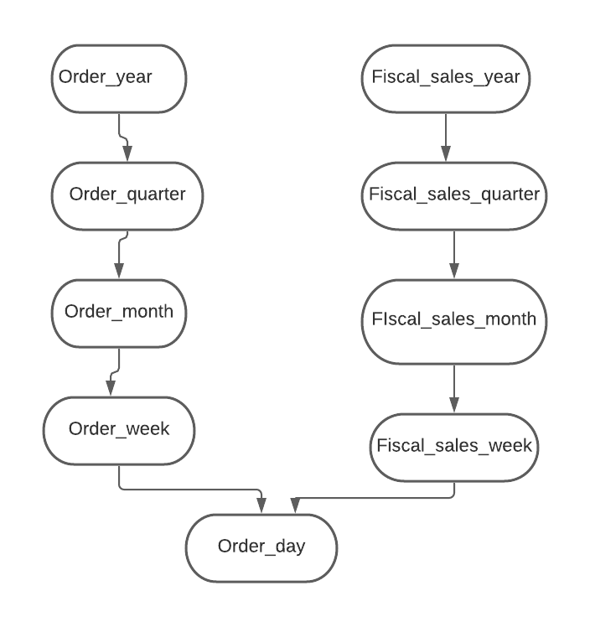

PEC:

Shipping_method

Pyemnt_method

Order_method

# Part #2. Dimensional Modeling

## Step #2-1: Design Your STAR Schema

Using the information that you have gathered, design a STAR schema for this process. Use MySQL Workbench to formally draw your model. Define tables, attributes, attribute data types, and relationships (with cardinality and participation). Save (paste) your STAR schema in an MS Word or .pdf document and save it to the MyCourse dropbox.

## Step #2-2: Implement the STAR Schema

Create a MySQL database called YourLastName_FinancialDM that will contain your data mart. This will be similar to what you did in Lab #1 using MySQL Workbench.

Implement your STAR schema in your YourLastName_FinancialDM data mart. You should save your SQL generated from MySQL Workbench.

You may define your constraints (PK, FK, etc.) and indexes in your model now but you can wait to implement them in your database until after you’ve loaded the data.

Question: Why would you want to wait?

Conforming the model with attributes and tables is important. It is not recommended to load the primary keys and the foreign keys before we load the data. If the loading is done before hand , then when we try to load the data in the database. All these constraints will be checked every time a new row is added to the database. This will impact the performance and the constraints of the primary and the foreign key after we load the data. It will affect the overall performance of the system. So, it is recommended to wait.

Fill in **Table 3** for the tables that you defined.

*Table 3:* Data Mart Tables

|  |  |
| --- | --- |
| **Table Name** | **Fact or Dimension?** |
| Customer | Dimension |
| Supplier | Dimension |
| Sales_date | Dimension |
| Shipping_Date | Dimension |
| Order_date | Dimension |
| Product | Dimension |
| Sales_fact | Fact |
| PEC Junk | Dimension |

**Appendix A: Information Package**

Process Name: Sale of the product

|  |  |  |  |  |  |  |  |
| --- | --- | --- | --- | --- | --- | --- | --- |
| **Customer** | **Supplier** | **Product** | **Order_date** | **Sales_date** | **Shipping_date** | **PEC Junk** |  |
| Customer_type | Supplier_State | Business_unit_name | Order_year | Sales_year | Shipping_year | Payment_method |  |
| Customer_State | Supplier_City | Business_abbrev | Order_quarter | Sales_quarter | Shipping_month | Shipping_method |  |
| Customer_city | Supplier_zip | Product_Desc | Order_month | Sales_month | Shipping_week | Ordering_method |  |
| Customer_zip | Supplier_addr1 | Product_Type_Desc | Order_week | Sales_week | Fiscal_year | PEC_Sk |  |
| Customer_addr1 | Supplier_addr2 | Unit_Cost | Order_fiscal_year | Fiscal_sales_year | Fiscal_month |  |  |
| Customer_addr2 | Supplier_name | Price1 | Order_fiscal_quarter | Fiscal_sales_quarter | Fiscal_week |  |  |
| Customer_name | Supplier_SK | Price2 | Order_fiscal_month | Fiscal_sales_month | Shipping_day |  |  |
| Customer_SK | Supplier_ID(NK) | Product_SK | Order_fiscal_week | Fiscal_sales_week | Shipping_quarter |  |  |
| Customer_ID(NK) |  | Product_ID(NK) | Order_day | Sales_day | Fiscal_quarter |  |  |
|  |  |  | Order_date_SK | Sales_date_SK | Shipping_Date_SK |  |  |
| **Measured Facts :** Days to ship, days to confirm, amount, discounted, quantity, ________________________________________________________________________________________________ | | | | | | | |

ISTE-DW Lab #2 Grade Sheet Name: ________________________________________

|  |  |  |  |  |
| --- | --- | --- | --- | --- |
| Part/Step | Q# | Max Pts. | Pts. Earned | Comments |
| 1-1 | 1 | 5 |  |  |
|  | 2 | 5 |  |  |
|  | Table 1 | 10 |  |  |
| 1-2 | 1 | 5 |  |  |
|  | 2 | 5 |  |  |
| 1-3 | 1 | 5 |  |  |
|  | 2 | 5 |  |  |
|  | 3 | 5 |  |  |
|  | 4 | 5 |  |  |
| 1-4 | 1 | 5 |  |  |
|  | 2 | 5 |  |  |
|  | Table 2 | 10 |  |  |
| 1-5 | 1 | 5 |  |  |
|  | 2 | 5 |  |  |
| 2-1 | 1 | 15 |  |  |
|  | 2 | 5 |  |  |
|  | 3 | 5 |  |  |
| 2-2 | 1 | 15 |  |  |
|  | 2 | 10 |  |  |
|  | 3 | 5 |  |  |
|  | Table 3 | 5 |  |  |
| Appendix | Info Package | 10 |  |  |
|  | **Total** | 150 |  |  |