  Name: Mithila Nigudkar _________________________ | Rochester Institute of Technology  Golisano College of Computing and Information Sciences  School of Information

Practice Exercise #2 (PE02)
Information Packages
Overview
In this exercise, you will have an opportunity to investigate the information package approach to requirements gathering that is proposed by your textbook author for designing data warehouses and data marts.

After completing this exercise, you should be able to:
- Show how the information-package approach can be used to determine the schema for a data mart.
- Design and explain the components of a STAR schema, justifying component placement.
- Discuss the importance of careful, schema design for data warehouse/mart performance.

Business Scenario
The XYZ Indemnity Corporation is a large insurance enterprise that sells insurance policies, annuities, and other financial vehicles. They would like to design a data mart that will allow them to monitor the sale of insurance policies through their sales and marketing organizations.

In talking with them, you find out the following:
- Insurance policies are sold by company agents to clients nationwide.
- For a policy, it is important to know the policy category (individual, group, industry), type (home owners, auto, life, casualty, disability, health, etc), the face value (coverage level) of the policy, the sale and effective dates of the policy, whether or not the policy is currently in force, and the deductible level. Each policy is identified by a 10-digit policy identification number.
- For this portion of the business, it is important to know the names and hire dates of agents. Agents are identified by the standard company employee identifier, their social security number.
- Each agent sells in a given sales territory. Each territory has an identifier and relates to a given zip code. They also keep track of the date that the territory was last redistricted (the zip code was added or deleted). Territories are grouped into sales districts.
- The company keeps extensive information about their clients. However, the information most relevant to policy sales is the policy holder’s name and address (street, city, state, and zip code). Customers are identified by a twelve-character, alphanumeric customer ID.

Sales and marketing managers are interested in viewing sales data by territory (or district), effective date, policy category, and face value. They also want to be able to get individual reports on their agents that cover policy sale amounts. Information on sales territories is also important here. Some of the queries and reports they would like are:
- Total number of policy sales per month by territory (district) by type (category) of policy
- Total number of policy sales per quarter by territory (district) by type (category) of policy
- Total number of policy sales per month by agent by type (or category) of policy
- …
- Total face value of all policies by month of effective date
- Total face value of all policies by year of effective date
- …
- Total number of policies in force/not in force by agent
- Total face value of all policies sold by an individual agent
- …
- Total number of policy sales per month by agent territory (or district) and client zip code
- Top selling agent by territory (or district) by month
- …

In addition to their internal company data, the company purchased a master zip code table from the US Postal Service and tables of various other national actuarial and risk assessment statistics.

Part #1. Requirements Gathering – Fill Out an Information Package
Step #1-1: Identify the Process
Remember: the focus of a data mart is one key business process that is important to company success.
Question: What are the user department(s) that are relevant to this development?
Sales and Marketing
____________________________________________________________________
Choose: Business department(s) [ are] [are not] the same as the process under investigation.
Business department are not the same as the process under investigation.
Question: What would be the source operational system(s) that are relevant to this development? These are not specifically discussed in the above Business Scenario.

Policy , Agent , Client , Territory _____________________________________________________________
Define: Write a statement that defines the scope – i.e., universe of discourse – of this data mart.
A data mart that is built to observe and analyze the performance of sales in a company by looking at the sales that is made monthly, yearly and quarterly. ________________________________________________________________________________________________________________________________________
Step #1-2: Choose the Grain
Question: What information is grain selection based upon

Grain selection is mainly based on users need. But we can also describe it has how do we want to model a single row in the fact table. ___________________________________________________________________
Question: What grain options do you see in the scenario?
Grain options available in the scenario are state, city, street, year,month,quarter, policy type and category.

____________________________________________________________________
Question: What “best practice” applies to the determination of grain? Why?

The best way it to keep the granularity at the lowest level of detail. By doing this it becomes easier to add dimensions to the fact table. Also, it becomes easy to perform the roll up and drill down operations. ___________________________________________________________________
____________________________________________________________________
____________________________________________________________________
Question: What level of detail – i.e., grain – do you propose for this data mart?

Policies sold by the company _______________________________________________________________
Step #1-3: Identify the Dimensions
Fill in: Dimensions are single-valued entitles that describe the important business measurements that the user wants to track.
Question: What business dimensions are relevant to the scenario?
Agent, time, client , policy
____________________________________________________________________
Question: Do any of the dimensions include hierarchies? If so, list hierarchies in each dimension.

Yes, the dimensions include hierarchies such as Policy category, time and territory.

Policycateogry(individual,group,industry) time(year,month,quarter) territory(state,city,street).

____________________________________________________________________

Step #1-4: Identify the Facts
Fill in: Facts are the important numeric values that the user wants to monitor to determine business success or failure.
Explain: “Facts are typically additive” means that …

Facts are typically additive, that means we can use fact tables for analyzing how our business is doing. Additive facts help us to summarize all the dimensions that are in the fact table. Also, aggregation operation such as min , max is easy to perform in all directions ____________________________________________________________________________________________________________________________________
Questions: a) What are the key performance metrics needed by the users?
The key performance metrics needed by the user are Number of policies sold with respect to date, month, Categories, total sales amount with respect to agents. _____________________________________________________________________________________________________________________________________
b) What attributes do these facts imply will be needed in the fact table?

Inforce and facevalue _________________________________________________________________

Fill in the Information Package below.

Subject: Insurance policy sales
Policy | Agent | Client | Territory | Sales Date
policyNo | agentName | clientName | territoryName | Year
typename | dateOfHire | Street | districtName | Month
typeDesc | territoryID | City | lastRedistrictName | Quarter
Facevalue |  | State | zipcode | Day
cateogryName |  | zip
Inforce
agentNo
Deductible

Measured Facts: Policy, Facevalue, Deductible Inforce,Sales__________________________________________________________
____________________________________________________________

Part #2. Dimensional Modeling – Create the STAR Schema

Step #2-1: Model the STAR Schema

Use the ERD in Figure 1 below as the data definition source for modeling your STAR schema.

Figure 1. Insurance Policy Sales ERD
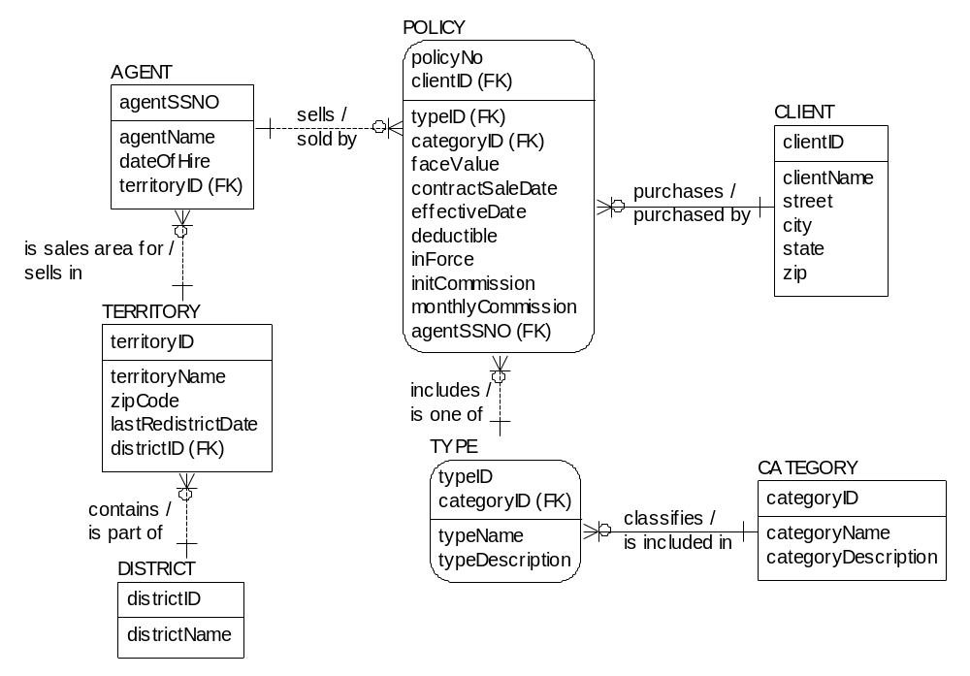
Question: Hierarchies are included as dimension attributes in the key dimensions in a dimensional model. Does a dimensional table usually have hierarchies? [yes][no]

Justify your answer:

Yes, a dimension table has hierarchy. Correctly modelled hierarchies will improve the query performance. And make the drill down and roll up operations convenient. ________________________________________________
____________________________________________________________________
Question: Most of the dimensional attributes are defined as [ text values] [ integer values].
Why?
Most of the dimensional attributes are defined as text values as they are more meaningful and it becomes easy to understand as compared to the numeric values__________________________________________________________
Step #2-2 Create your Dimensional Model using MySQL Workbench, save it as a pdf file, and submit it to MyCourses PE02 Drop Box.
DW-PE02 Gradesheet Name: ____________________
Requirements | Grade | Grade Earned | Comments
Part #1 – Step #1-1: Identify the Process  - Question: User department(s)  - Choose:  - Question: Source data system(s)  - Define: Universe of discourse  Part #1 – Step #1-2: Choose the grain  - Question: Grain selection  - Question: Grain options  - Question: Best practice & Why?  - Question: level of detail  Part #1 – Step #1-3: Identify dimensions  - Fill in  - Question: Business dimensions  - Question: Hierarchies  Part #1 – Step #1-4: Identify dimensions  - Fill in  - Explain: Facts  - Question: Key performance metrics  - Question: Attributes  Information Package  - Has subject  - At least five dimensions (must have two date dimensions)  - Measured Facts | 2  2  2  2  2  2  10  2  2  2  2  2  2  2  2  2  8  4
Part #2 – Step #2-1: Model the star schema  - Question  - Question  Part #2 – Step #2-2: Draw dimensional model  - Has all dimensions in the Information Package  - Facts mentioned in the Information Package  - Role playing dimensions  - Relationships between fact and dimensions including cardinalities | 4  4  15  5  10  10
Total Grade: | 100

Top-selling means? Number of policies sold? Highest total face value? Assume: # policies.

