**IGME:771: Week 3- LAB 2**

For lab 2 the state I selected to work with is California and the city is Los Angles. My dataset is Race and Ethnicity. As being an Asian student in the United States I was very eager to know how much percent of Los Angles population is Asian. By looking at the figure1 we can see that the z-score is very high. Because of randomness we reject the hypothesis. As from the figure it is evident that the Asian population is very highly scattered. And the z-score which is 37.86 is high. Because of which we can say that the Asian population in Los Angles is clustered.

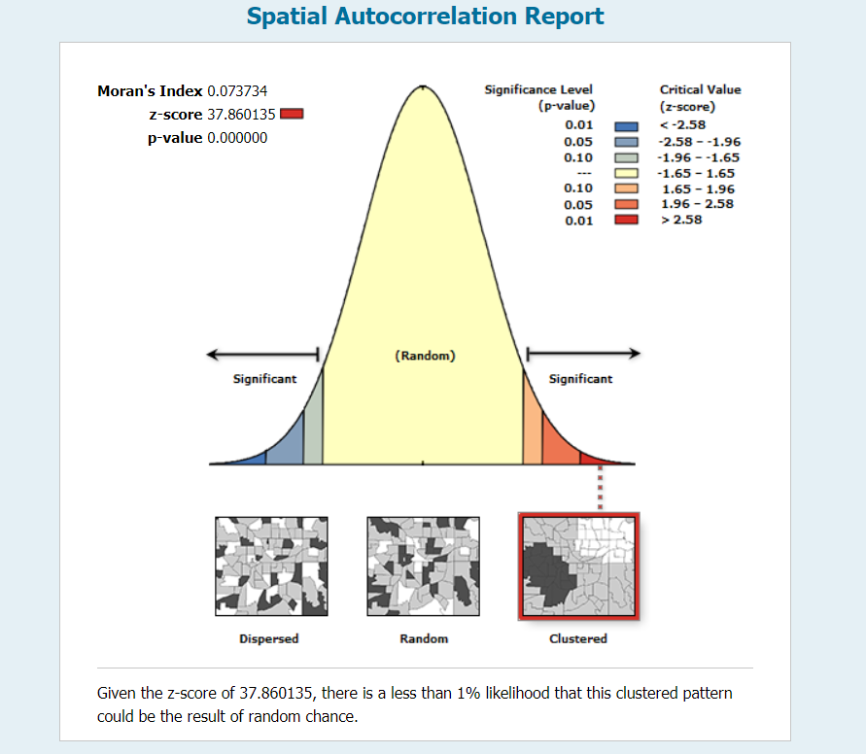 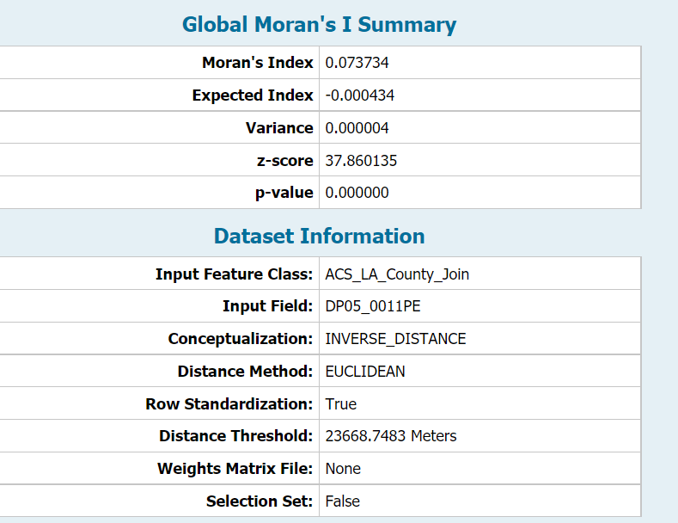

**Figure 1: Spatial Autocorrelation Report**

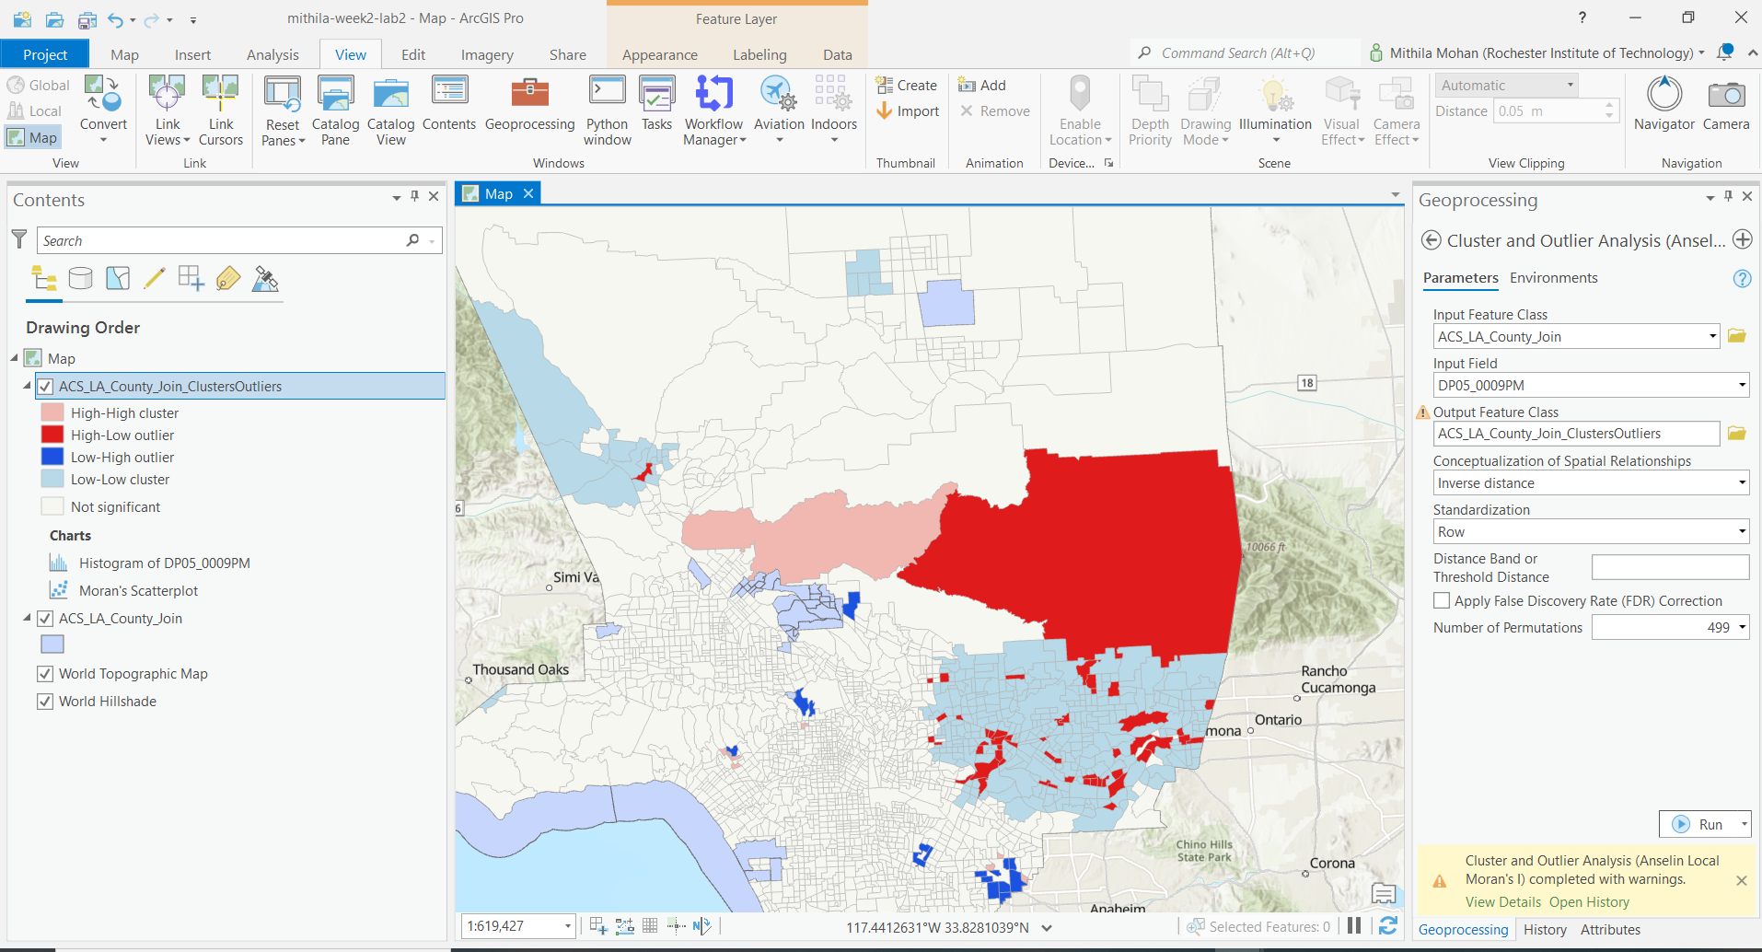

**Figure 2: Clustered Analysis**

From the figure 2 it can be noticed that the area coloured with red shows high cluster, similarly areas with pink shows high cluster as well. On the other hand, areas with dark and light blue represent areas with low cluster. And white represents that there is no significance.