**IGME 771: GIS: LAB 5**

**Task 4 final classification map product.**

**Part 1**

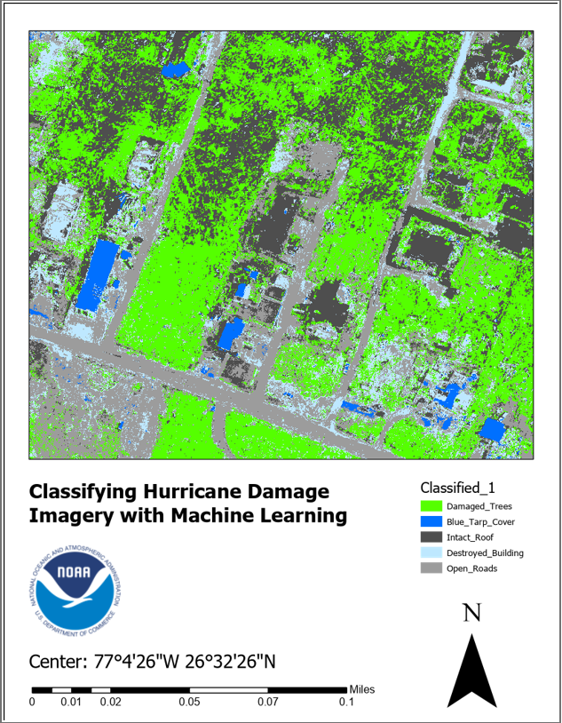

**Part 2**

**Confusion matrix table created in Task 6 and a brief (50-75 word) discussion of your final results**

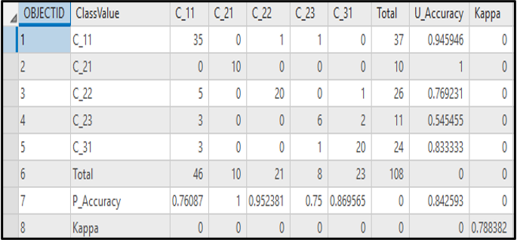

**Figure 2: Confusion Table Matrix**

In the above figure we can see that, C_31(Open Roads), C_23(Destroyed Building) and C_22(Intact Roof) is misinterpreted because there is a similarity of the grey color between them. C_21(Blue Trap) indicates complete agreement because it received U_Accuracy and P_Accuracy. C_11(Trees) was identified as C_22, C_23, C-31 which is incorrect and it leads to false negative and which in turn reduced the P_Accuracy (~76). According to the “Almost Perfect Agreement” the Kappa Value ~79 can be considered as “substantial agreement”. The results are moderately fair according to the requirement that is mentioned.

**Part 3**

1. **What other classification classes might you have included in the schema that was loaded In Task 3, Step 1? For example, open grass? What other classes could help a team in a disaster.**

**Answer:**

Porch, Debris and Cars are the other classification classes that we can use. So that we can build a strategy in advance to identify areas where people are trapped. So, in such case we can focus more clearly on the areas that are affected and avoid sending emergency help where it is not needed. In this way we can prioritize the areas that need help.

1. **The overall accuracy of the classification based on the Kappa value   
   discussed in Task 6 was “substantial agreement” between ground truth data and machine data. Although this was good, it was by no means perfect. How might these types of errors potentially produce problems when using the outputs of this analysis for Disaster Response? For example, if developing damage assessment maps based on machine learning algorithm outputs, what problems might occur with the use of these maps in terms of inaccuracy?**

**Answer:**

Although the agreement was good considering disaster response it will mislead by incorrectly identifying the areas and will not help in finding the correct areas or regions. This will eventually create a lot of problems and misleading because we will depend on analysis thinking that it will provide correct solutions so that we know where to look for. Also, we need to remember that these results can be useful unless we are not completely dependent on it. We need to use them with extra care and be aware in case of disaster management.