**ISTE-782 Assignment 2 - Data Scavenger Hunt**

To begin with I computed 5 instances for each of the three features that were given such as MLA, ALA, PLA, MRV, ARV, PRV, MRA, ARA, PRA. Out of these 9 features computed, by looking at all the three plots we can see that ALA, ARA, ARV does have much difference. The highest values go up to 22.5 and the lowest goes to 1.0. Which is same for all the three plots. There is no significant variation that can be used to determine the differences. Similarly, by glancing at MLA, MRV, MRA it enables us to notice that they all have the same plot which is 0.00. On the other hand, PRA, PLA, PRV were the three features that were remarkably different their highest value goes up to 140 and the lowest is 5 and all the remaining values are between 20 to 80 for all the three plots. Moving on, by considering the 5 instances for each of the three features available and by returning the 5 largest values of PLA, PRV, PRA. The two features that were most helpful in determining the five instances that were different are PLA and PRV. PLA and PRV have exactly the same number of instances. So likewise, the feature that is different is PRA. And the top 5 instances of PRA are 34 11 60 9 8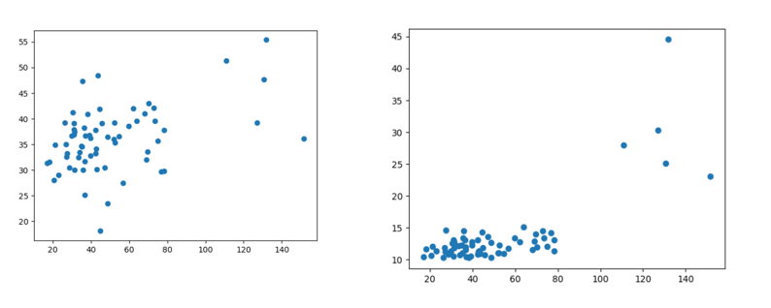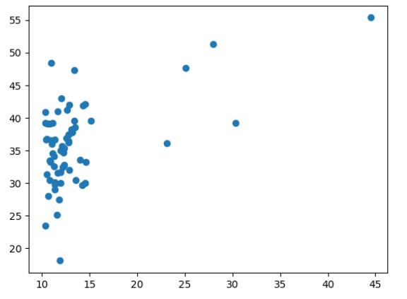 **Figure1: PLA vs PRV Figure 2: PLA vs PRA Figure 3: PRA vs PR 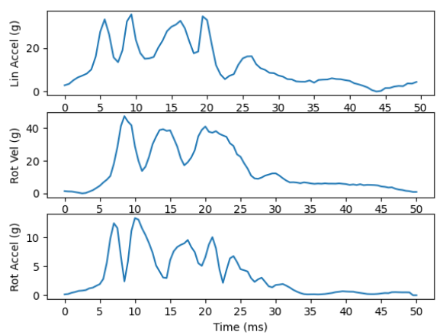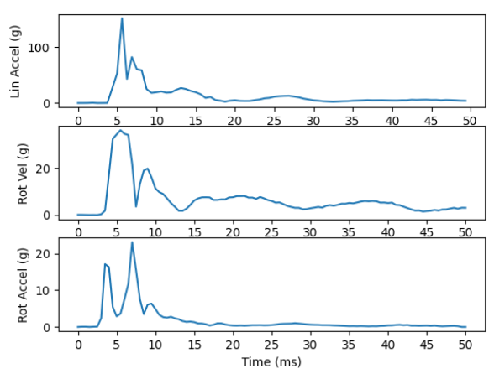 Plot 1: Normal data instance Plot 2: Different data instance**

By comparing normal data instance and different data instance as shown in the above figure we can tell that in plot 1 Linear acceleration, Rotational velocity and Rotational acceleration is varying from 0 being the lowest and 40 being the highest similarly for the different data instance 0 is the lowest and highest is 120 approximately. And it remains constant between 0 to 5. Normal data instances show a varying waveform whereas different data instance has persistent waveform form from 5-50 ms. The difference in their waveforms makes it distinct.