**ISTE 782: Visual Analytics: Assignment 4**

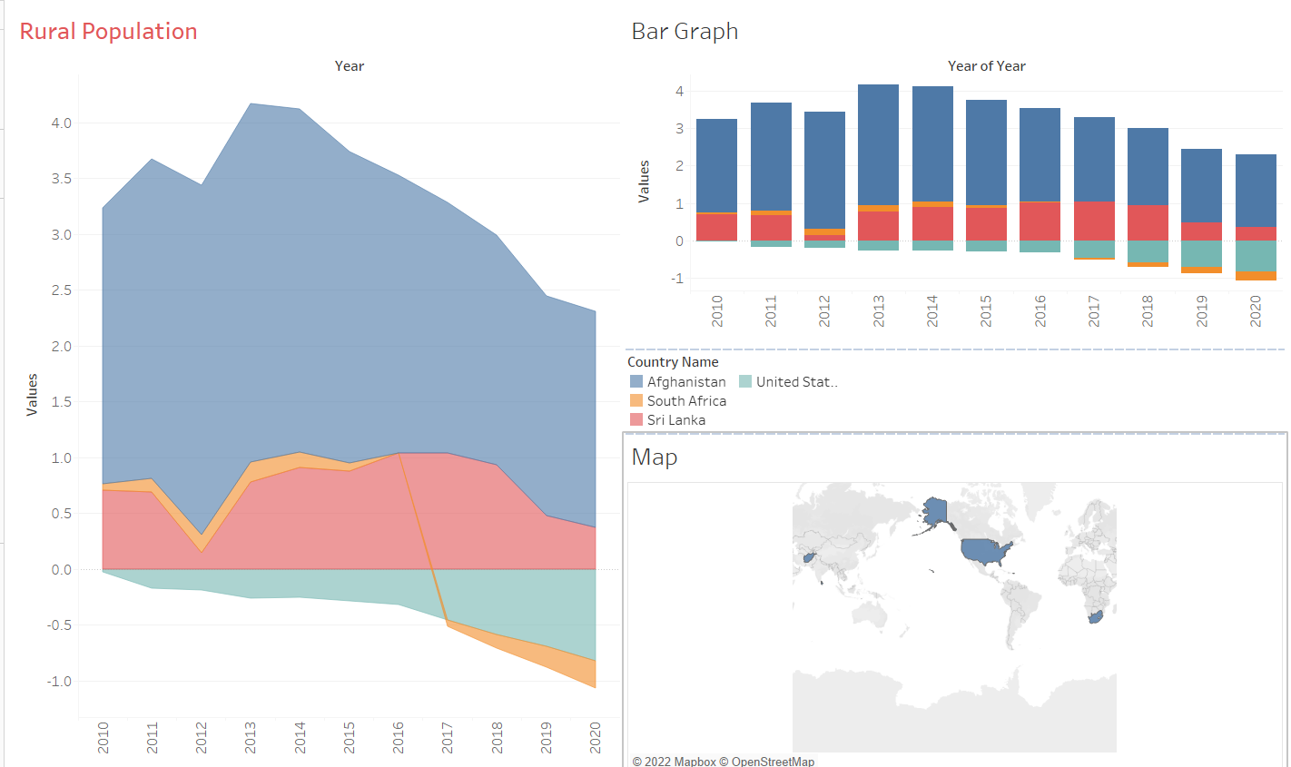

**Figure 1: Tableau Dashboard**

**Comparison Analysis:** As we can see from figure 1 there are four countries which are being compared across an indicator which is Rural Population. The four countries such as Afghanistan, Sri Lanka, South Africa and United States of America are selected based on income groups such as Low-income economies, Lower-middle-income economies, Upper-middle-income economies and High-income economies respectively. The indicator chosen gives an idea about how is the rural population in respected countries. As countries with high-income economies have less rural population as compared to the one with low-income economies. As it can be noticed form the above figure that the comparison is done based on last ten years which is 2010-2020. The reason behind choosing these years is, few years ago, a lot of rural population has moved to the city side as there were developments and advancements in the way of living where a low-income economy group of people could afford to stay in the city. This comparison analysis tells us the percent of rural population 10 years ago (2010) vs how it has been recently (2020).

**Tableau interactive capabilities reflection:** From the figure above three different views have been used which are Area Chart, Map and Bar Graph. Where in the orange color represents South Africa, Dark Blue is Afghanistan, Light Blue is United States and Pink is Sri Lanka respectively. As it can be noticed Afghanistan had the highest percent of rural population in the past ten years. There was a constant increment within the percentage of rural population in that country respectively. Whereas on the other hand, [1] United States had the least percent of rural population from 2010-2018. However, there was a rise in the population in rural areas in 2020. Similarly, from 2013-2018 Sri Lanka showed the same percent of rural population which declined in the year 2019-2020. The country that showed the least percent of rural population among all the four countries is South Africa. 2015-2017 it can be seen that there was 0 rural population which increased by 0.5% in 2019 and remained constant till 2020.

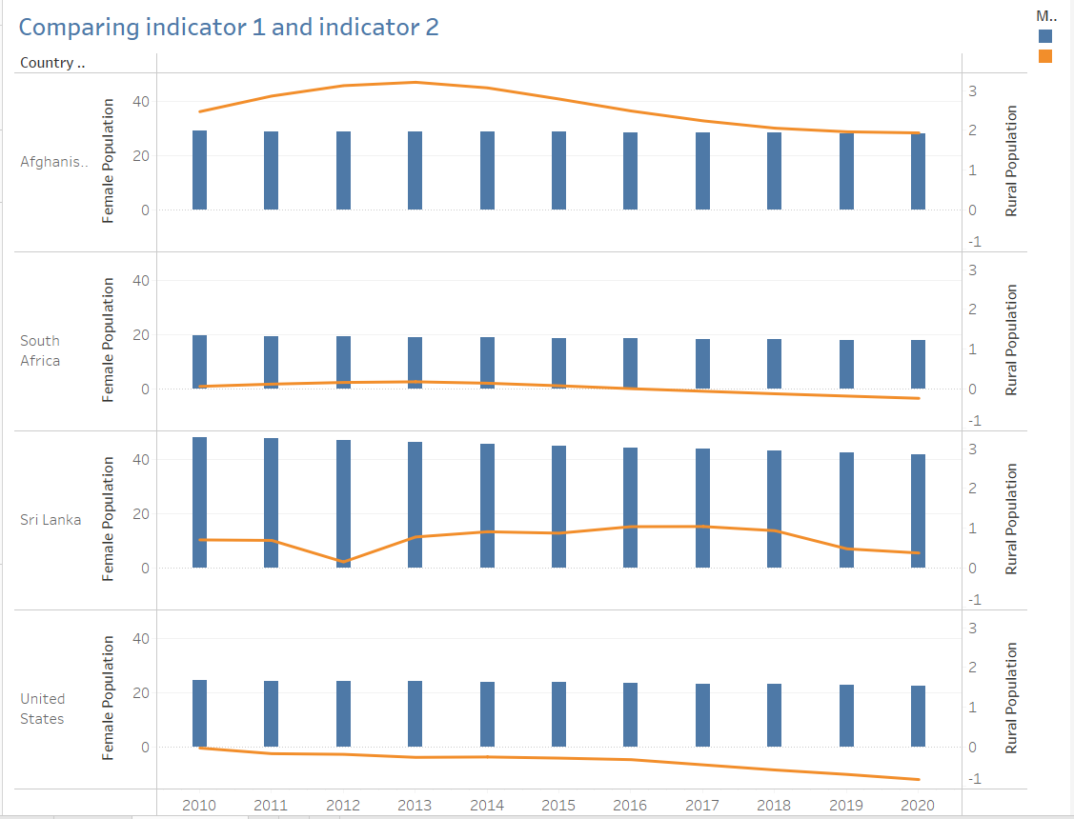

**Figure 2: Comparing indicator 1 and indicator 2**

In figure 2, two indicators used are Rural population and the second one is Female population. The second indicator chosen gives us an idea of what is the percent of female population living in the rural areas across the 4 Low, Lower, Upper and High economy countries. The bar graph shows the percent of Female population similarly the orange curve represents Rural population belonging to that particular country. [1] United States which fall into the high economy category has the 20-25% of females present whereas rural population in United States is almost negligible. In comparison to South Africa which is almost 18% of the overall population but there is no rural population in that country from the figure 2 we can see that rural population curve is a straight line which is 0.003%. Sri Lanka has the highest percent of female population among the four countries which is approximately 47% although there is an upward and downward curve considering the rural population. On the other hand, Afghanistan has the highest percent of rural population moreover the female population is on an average 28% for the ten years. It can be concluded form the figure that there are countries which have higher percent of rural population but the female population in that country is an average such as Afghanistan. South Africa has both the rural and female population very less. Sri Lanka has highest female but the rural population is not a stable curve. Not much difference can be spotted between South Africa and United States. South Africa has 18% while on the other hand United States has 23% of female population.

**References**

|  |  |
| --- | --- |
| [1] | D. Farquhar, “Rural Population,” *National Conference of State Legislatures,* vol. 27, p. 32, 2019. |