**ISTE: 782: Visual Analytics: Assignment 5**

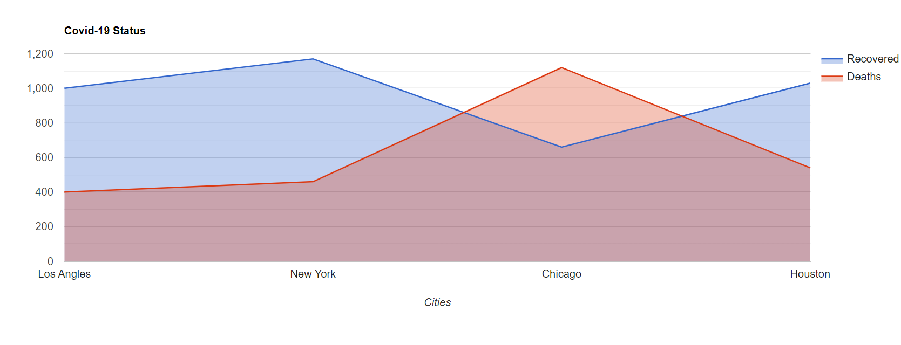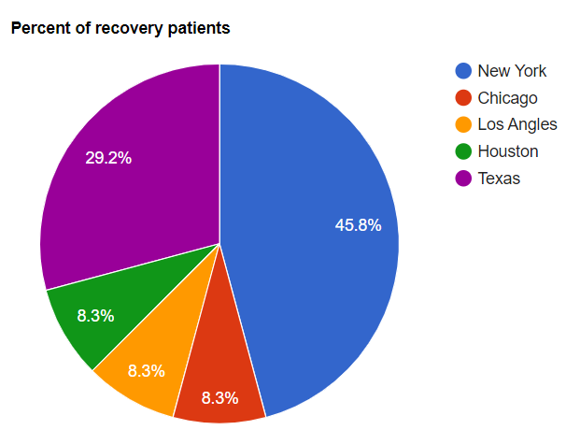

**Figure 1: Area Chart Figure 2: Pie Chart**

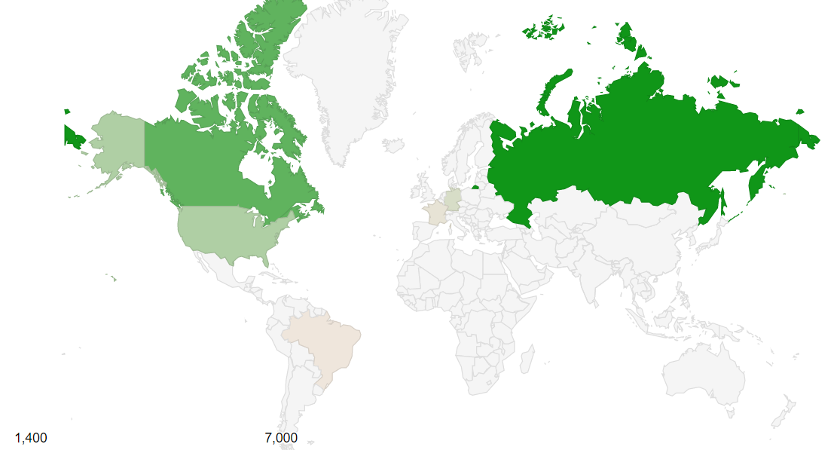

**Figure 3: Geo Map**

For this assignment, I have used the Covid-19 dataset. The dataset is downloaded from Kaggle and it contains the information of covid-19 till February 2021. There are different attributes such as Recovered cases, Active cases, Deaths, Status of patients by different countries and different cities. The figure 1 Area chart shows0 the recovered and deaths for different cities in the United States. As we can see Los Angles has the highest number of recovered cases where as Chicago on the other hand has the maximum number of deaths. The second visualization tool used is the pie chart. It shows the percent of recovered patients. As it can be noticed from the figure 2 New York has highest number of recovered patients which is about 45.8% followed by Texas which is 29.2%. Similarly, Los Angles, Chicago and Houston has only 8.3% of the recovered patients. The third visualization tool used is the Geo Map. The geo map tells us the percent of the recovered patients across different countries. The dark green color represents the country with has the topmost number of recuperated patients as from figure 3 it is obvious that in Russia the covid-19 cases are dropping and experiencing a growth in patients recovery. Followed by Canada and United States. The algorithm that I have used from the Ware Chapter 11 is brushing. The area chart shows the recovered and deaths cases which aided in the correlation of data on cases in each city, indicating which city was mostly affected by the virus. Another algorithm that I would like to add is Algorithm 6: Small Pattern Comparisons in a Large Information Space. As data visualization on a small scale is probably easy however the problems arise when we have to need to see the different patterns of data on a large scale. [1] One alternative is to zoom in and zoom out depending on the data found and to see if there are new patterns and if a pattern does exist and then one has to repeat the process again to confirm the details.

LINK: <https://people.rit.edu/mn7646/Assignment%205/output.html>

|  |  |
| --- | --- |
| [1] | W. Colin, “Visual Thinking Processes,” *Perception for Design, Elsevier Science & Technology,* p. 50, 2019. |