PYTHON

🐍 What Python is
Python is a very popular general-purpose interpreted, interactive, object-oriented, and high-level programming language. Python is dynamically-typed and garbage-collected programming language.
Dynamically-typed : you don’t need to declare variable types manually. The language figures out the type while the program runs.
Garbage collection means the language automatically cleans up unused memory.
print ("Hello World")
How Python interpreter works
Source code(.py file) -> Translator stage(syntax check) -> Bytecode creation(stored in pychache) -> python vm execute byte code
2 modes of python interpreter –
Interactive Mode: In this mode, you type Python commands one by one, and the interpreter executes them immediately.
Example >>> print("Hello")
Hello
Script Mode: In this mode, you write code in a file and run the whole program.
File – app.py run by give command “python app.py”
REPL stands for:Read → Evaluate → Print → Loop
It is a feature of Python that lets you interact with the interpreter directly.
Advantage of python interpreter is it is cross platform compatible and allow code to run on various operating systems
Basic:
Input in python : input() or input("Enter something: ")
Exampels
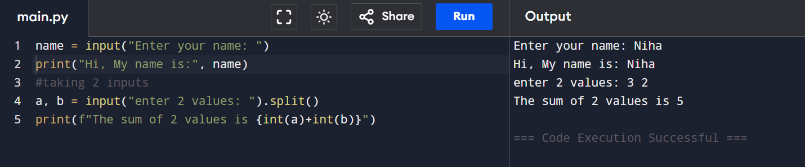

Data Types
Primitive data types fundamental types that hold only one value at a time. (int , float, bool, None type)
Collection data types: that store multiple values in a single variable. ( str, list, tuple, set, dict)
Check data type by “type()” function:
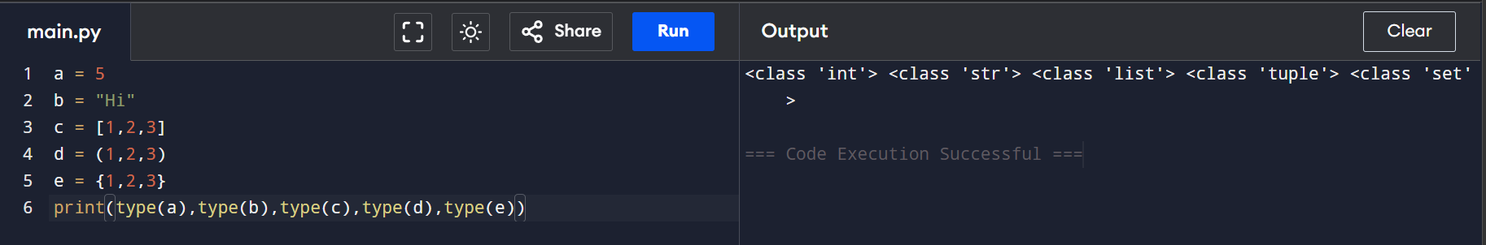
We can check if a value is an instance of particular type by using “isinstance()”
Eg : print(isinstance(c,list)) , output: True
Numbers:
Python has 3 built in numeric types: int, float, complex
In Python, precision refers to how accurately numbers are represented and calculated. Python supports arbitrary precision for integers, meaning whole numbers can grow as large as memory allows without overflow. However, floating-point numbers have limited precision because they are stored in binary format, which can lead to small rounding errors (for example, 0.1 + 0.2 not exactly equaling 0.3). For high-accuracy decimal calculations, Python provides the Decimal module, which avoids floating-point errors.
Arthemetic operations
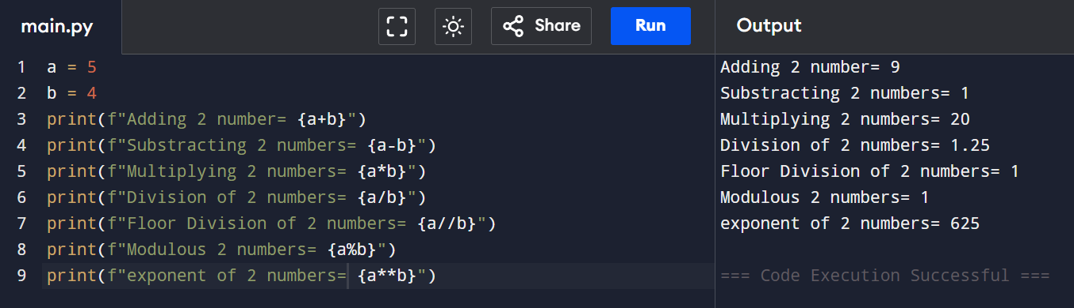
Math functions
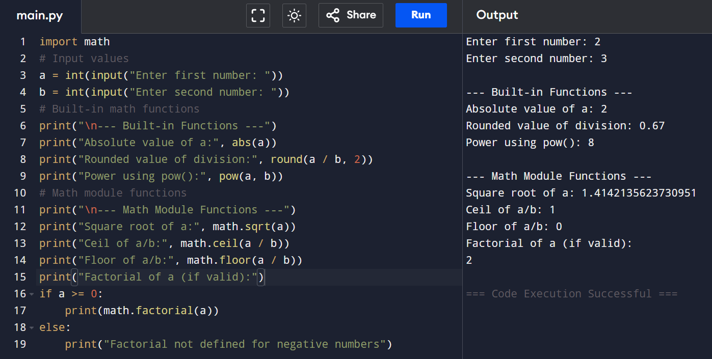
Type conversion: Type conversion in Python is the process of changing one data type into another (like int to float or string to int).
It is used to make data compatible for operations and is done using functions like int(), float(), and str().
Identity operators (is, is not) check whether two variables refer to the same memory object
Membership operators (in, not in) check whether a value exists inside a sequence like list or string.
The walrus operator (:=) is used to assign a value to a variable inside an expression, making code shorter and more efficient.
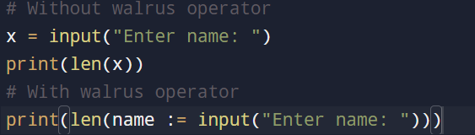
Bool is a subtype of int in python
Truthy and falsy values:
In Python, Truthy and Falsy values refer to how different values behave when they are evaluated in a Boolean context (like in if statements). A value is considered Falsy if it behaves like False in conditions. Common falsy values include 0, 0.0, "" (empty string), [] (empty list), {} (empty dictionary), () (empty tuple), and None.
On the other hand, Truthy values are all values that are not falsy, meaning they behave like True in conditions. Examples include any non-zero numbers (like 5, -1), non-empty strings (like "Python"), and non-empty collections (like [1, 2], {1: "a"}). These concepts are commonly used in decision-making statements such as if and while to control program flow.
Small Integer caching

In Python, small integer caching is an optimization technique where Python reuses already created integer objects instead of creating new ones again and again. It means that small integers (usually from -5 to 256) are stored in memory once and reused whenever needed to improve performance and save memory.
For example, if you assign a = 100 and b = 100, both variables will point to the same memory location because 100 is in the cached range. But for larger numbers like 1000, Python creates separate objects. You can verify this using the is operator, which checks object identity.
Logical Operators:
In Python, logical operators are used to combine conditional statements and return a Boolean result (True or False). They are mainly used in decision-making like if and while statements.
Short circuit behaviour: In Python, short-circuit behavior happens in logical operators when the expression stops evaluating as soon as the final result is known. In and, if the first condition is False, Python does not check the second one because the whole result will already be False. In or, if the first condition is True, Python stops immediately because the result will already be True.
Loops:
For : Iterate over iterable
range()- range(start, stop, step)
enumerate() – get index and value together
zip() – iterate over multiple iterables
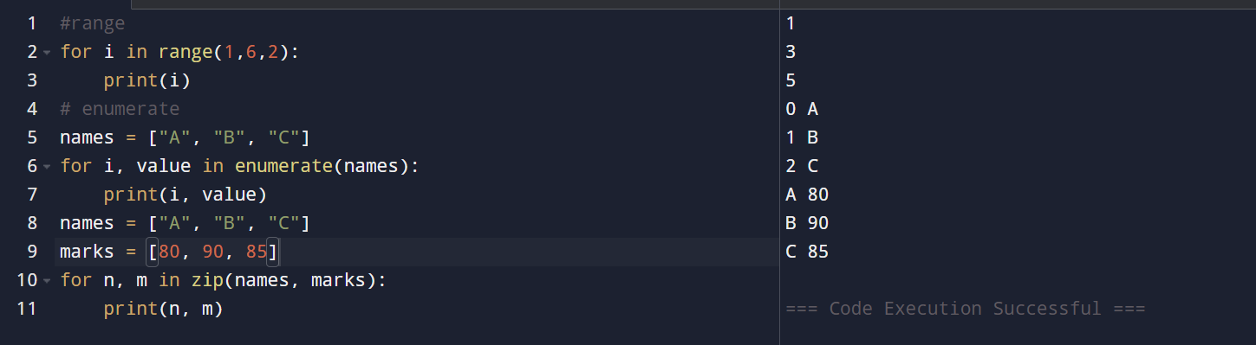
While: A while loop repeats as long as condition is true. Use it when you don’t know in advance how many iterations you need.
Break , continue, for -else: break → stops loop , continue → skips current step , for-else → runs else if no break happens, The else block runs only if the loop is NOT stopped by break.
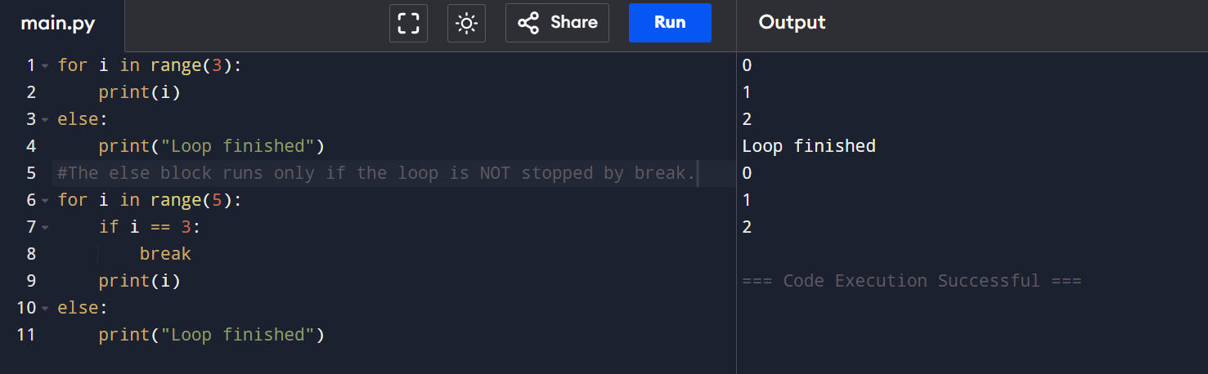

Strings
Strings in python are immutable sequence of Unicode characters. You can use single, double and triple quotes
a byte string is a sequence of bytes (used to store binary data) written with a b prefix like b"hello" instead of normal text strings. This stroes ASCII values if that value
a raw string is a string prefixed with r (like r"...") where backslashes are treated as literal characters instead of escape sequences. Eg : print(r"C:\new\folder\test")
You cannot change individual character in a string you must create a new string
string indexing and slicing:
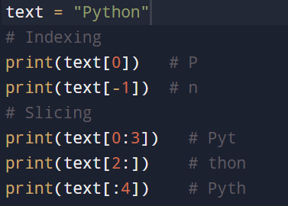
String methods:
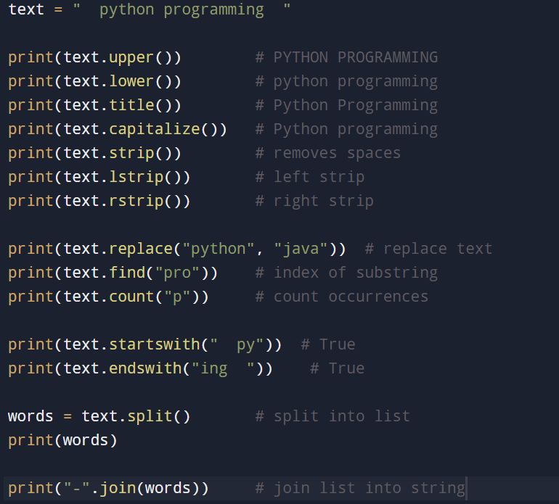
We cannot concatenate a string and an integer directly. We should convert the integer to string first
Length of string – len(s)
List
A list is an ordered, mutable, dynamic array that can hold elements of any type. Lists are most versatile and commonly used collectios
using slicing (list[:]) creates a shallow copy, not a deep copy.
List methods:
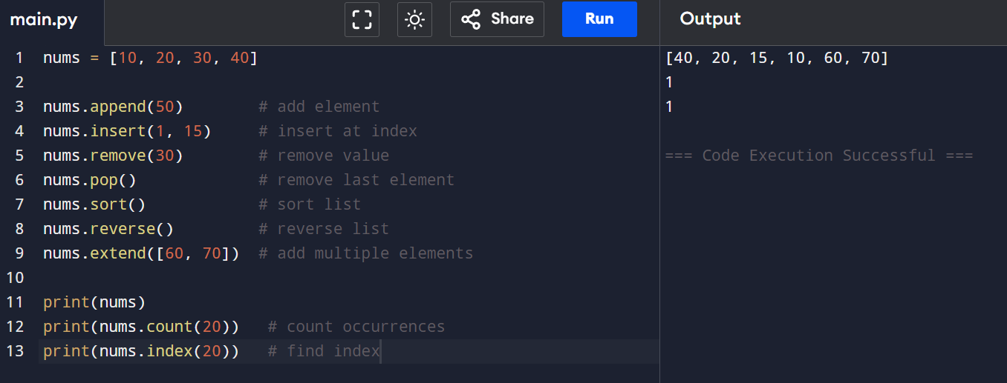
Sort vs sorted: sort() and sorted() are used to arrange elements in order, but they work differently. The sort() method modifies the original list in place and does not return a new list, while sorted() returns a new sorted list and keeps the original data unchanged. For example, nums.sort() changes the same list, whereas sorted(nums) creates a separate sorted copy, making it useful when you want to preserve the original list.
shallow vs deep copy: A shallow copy creates a new outer object but still references the same inner objects, so changes in nested (inner) data affect both copies; it can be created using slicing (list[:]) or copy.copy(). A deep copy, created using copy.deepcopy(), makes a completely independent copy of both the outer and inner objects, so changes in one do not affect the other at any level.
Append vs extend: append() and extend() are list methods used to add elements, but they work differently. append() adds a single element (even if it is another list) as one item at the end of the list, while extend() adds each element of an iterable separately to the list.
# append vs extend
a = [1, 2]
a.append([3, 4])
print("After append:", a) #[1, 2, [3, 4]]
b = [1, 2]
b.extend([3, 4])
print("After extend:", b) # [1, 2, 3, 4]

Tuples
a tuple is an ordered collection of elements that is immutable (cannot be changed after creation). It allows duplicate values and is written using parentheses ()
In Python, a tuple with one element must include a trailing comma to be recognized as a tuple; for example (5,) is a tuple, while (5) is not a tuple and is treated as an integer. The comma is what tells Python that it is a tuple, even if it contains only one value.
Tuple methods:
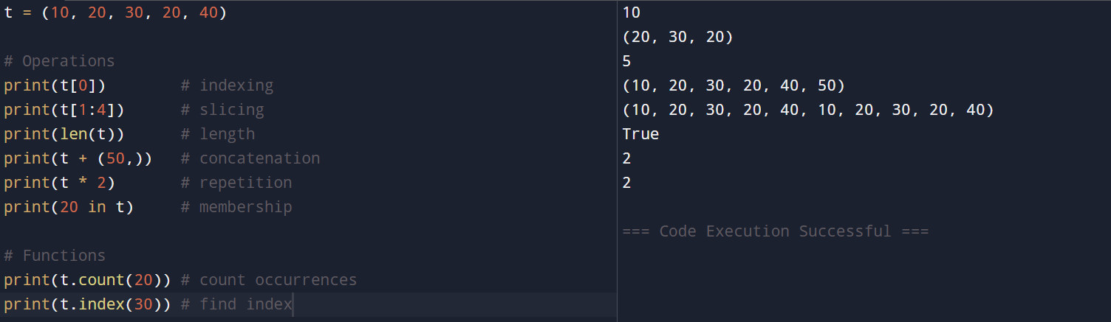

Tuple packing and unpacking: tuple packing means assigning multiple values into a single tuple like t = 10, 20, 30, while tuple unpacking means extracting those values back into individual variables such as a, b, c = t, where each variable gets one value from the tuple in order.
Named Tuple: a named tuple is a special type of tuple where each value can be accessed using a name (attribute) instead of only index positions. It is created using the collections.namedtuple() function and provides more readable and structured code compared to normal tuples.
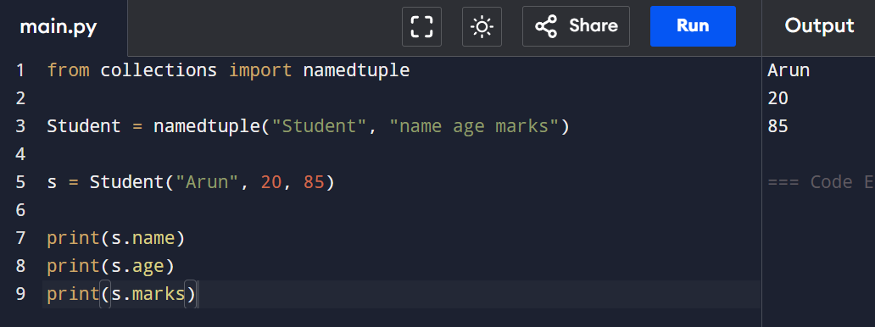
Set
A set is another collection data type in Python. Sets are mutable and dynamic like lists. But they are unordered, duplicates are not allowed, and can contain only hashable objects. What a hashable object means will be reviewed in the next section below.
To create a set, you should use the special built-in function set(<iterable>): my_set = set((1, 113.5, True, "Some string"))
If we initialize empty curly braces we get dictionary
my_set = {}
print(type(my_set)) # <class 'dict'>
Sets are iterable but no access to elements
Ser methods:
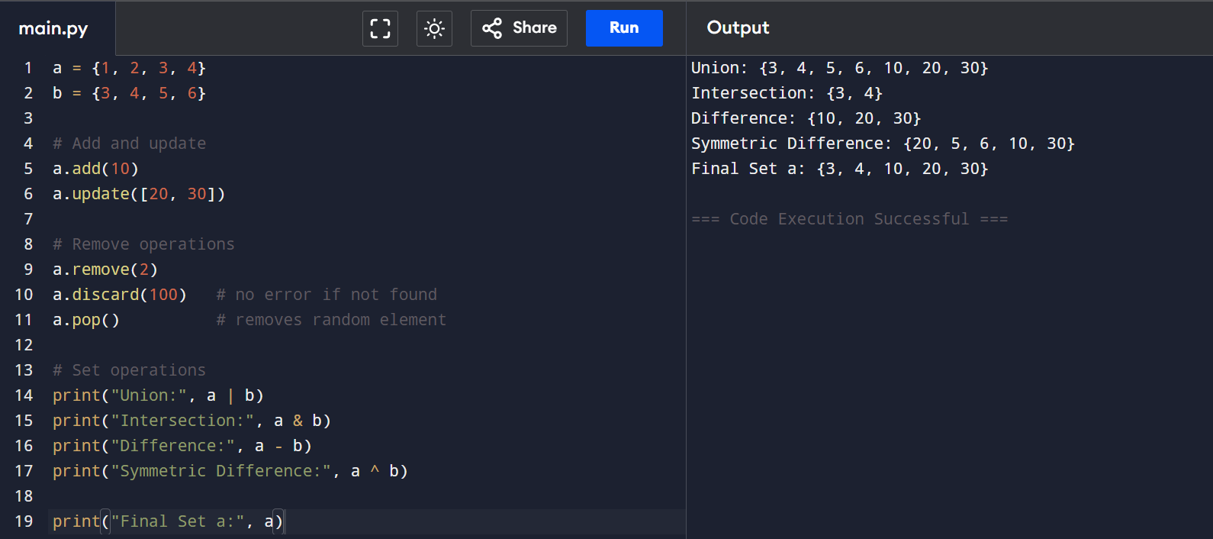
Sets are mutable, but elements must be immutable means cannot store list or dict inside a set
pop() removes random element, Sets are faster for membership check, s = {True, 1, 2} True == 1, so one gets removed.,
Dictionary:
A dictionary is a collection that stores data in key-value pairs, where each key is unique and used to access its value.
Methods in dictionary:
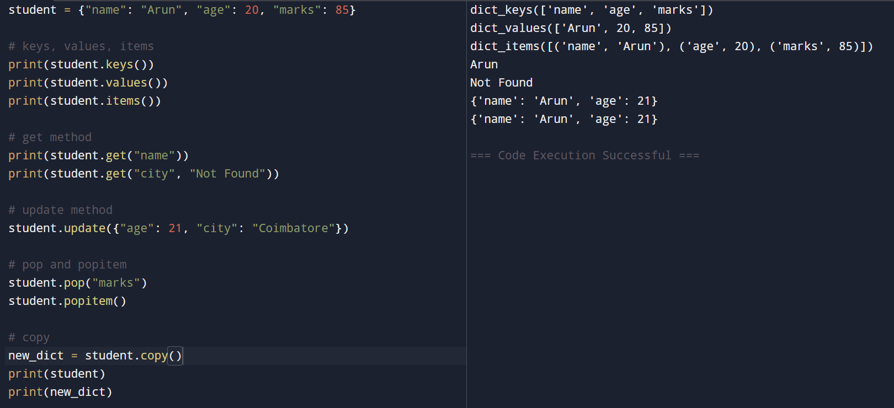
Copying dictionary: copying a dictionary means creating a new dictionary with the same key-value pairs using the copy() method, which performs a shallow copy; this means the new dictionary is separate from the original at the top level, so changes to simple values do not affect the original, but if the dictionary contains nested objects like lists or other dictionaries, those inner objects are still shared between both copies. For a completely independent copy where even nested objects are duplicated, copy.deepcopy() is used.
Keys must be immutable- Dictionary keys must be hashable, meaning they must not change during their lifetime., True, 1, and 1.0 are treated as the same key, Dictionary insertion order is preserved, in checks keys, not values,
setdefault(): If key exists → return its value or If key missing → insert default value and return it
setdefault() method in a dictionary is used to get the value of a key if it already exists, or add the key with a default value if it does not exist. It helps avoid checking manually with if key not in dict. The syntax is dict.setdefault(key, default_value). If the key is present, it returns the existing value; otherwise, it inserts the key with the given default value and returns that default. This is especially useful for grouping data or counting values.
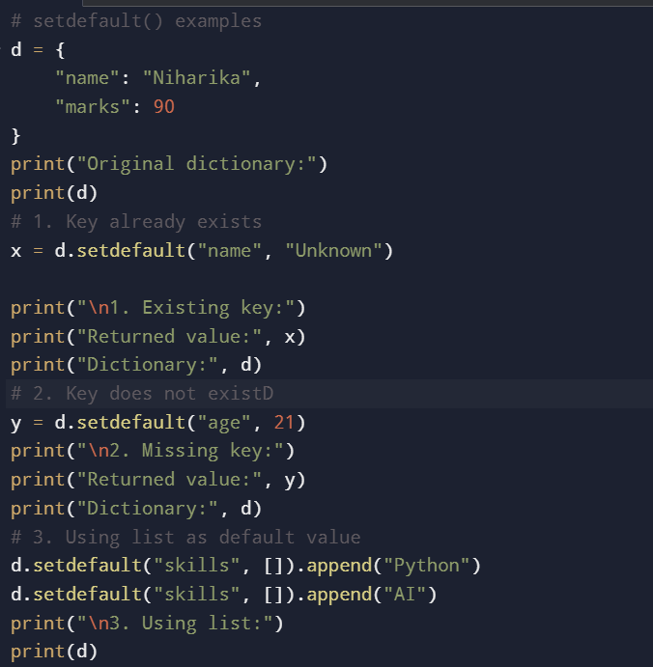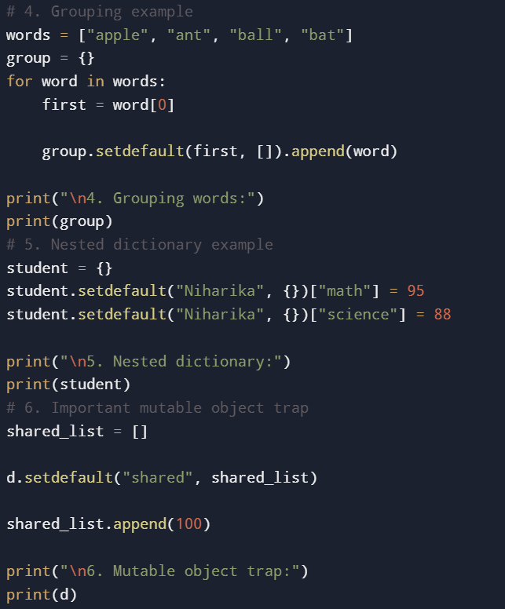
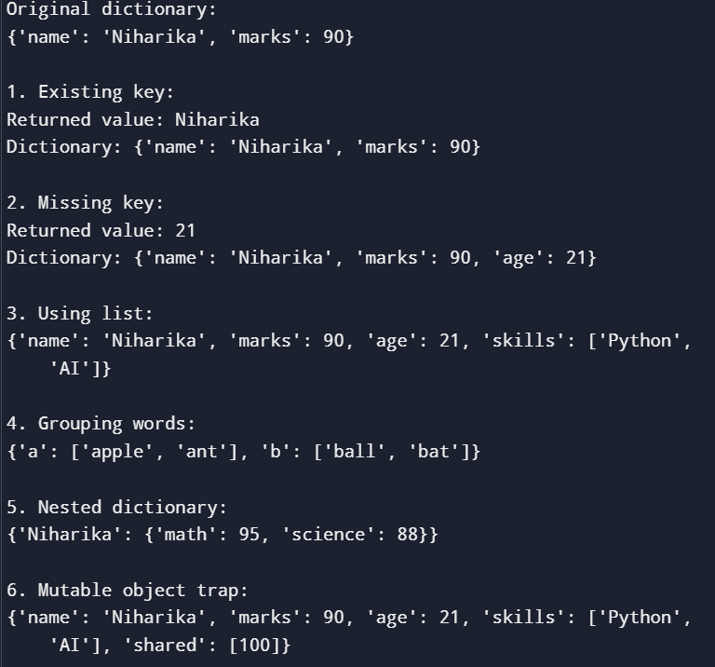
Defaultdict : defaultdict is a dictionary that automatically assigns a default value to a missing key instead of raising KeyError.
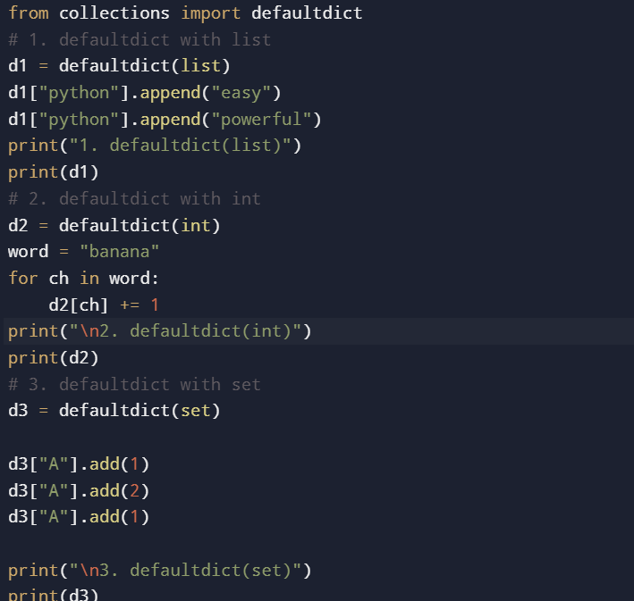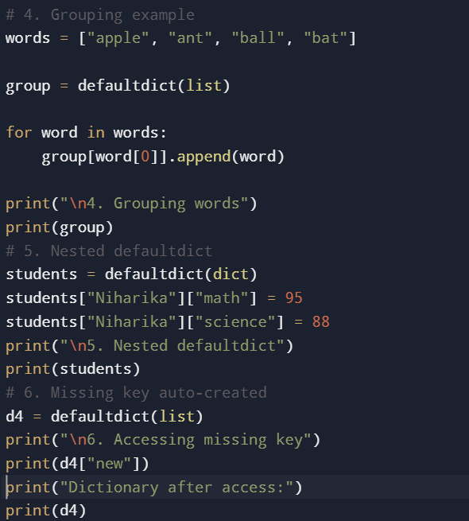
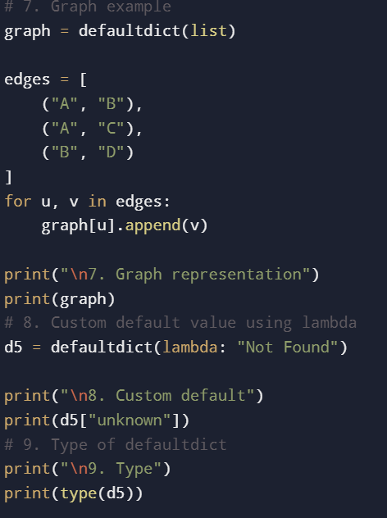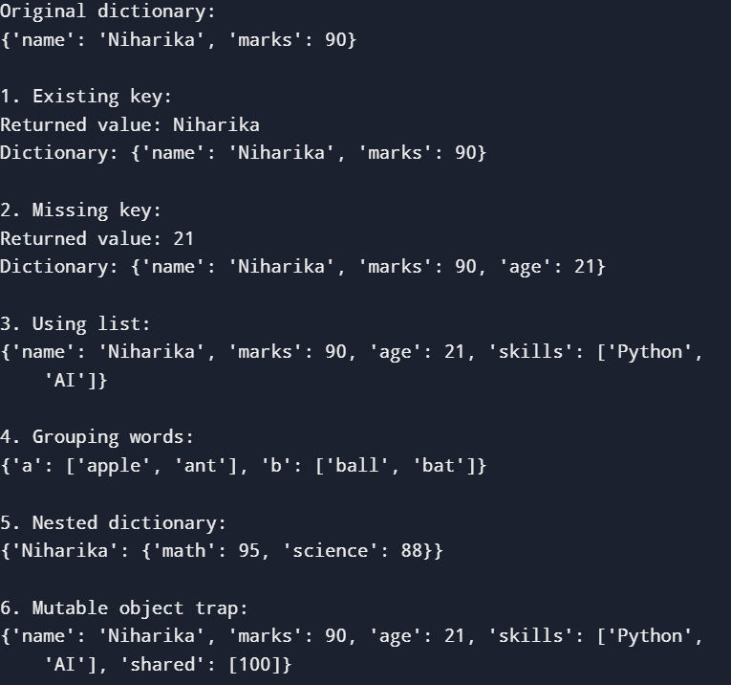

Functions
A function in Python is a reusable block of code that performs a specific task and runs only when it is called. Functions help make programs organized, reduce repeated code, and improve readability. A function is created using the def keyword followed by the function name and parentheses. It can take inputs called parameters and can also return a value using the return statement.
Default argument: Default arguments are function parameters that already have a default value assigned. If the user does not pass a value while calling the function, Python uses the default value automatically. Eg: def function_name(parameter = default_value):
Important rule - Non-default arguments must come first
Keyword argument: Keyword arguments are arguments passed to a function using the parameter name (key = value format). Instead of passing values by position, we pass them using parameter names. Eg : student(name="Niharika", age=21)
args in Python refers to arbitrary positional arguments. It is used in a function definition with *args to allow the function to accept any number of positional arguments. Inside the function, args is stored as a tuple.
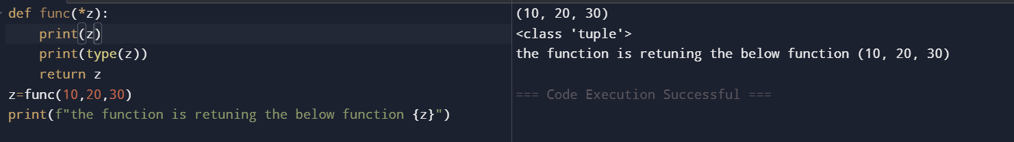
kwargs in Python refers to arbitrary keyword arguments. It is used in a function definition with **kwargs to allow the function to accept any number of keyword (named) arguments. Inside the function, kwargs is stored as a dictionary.
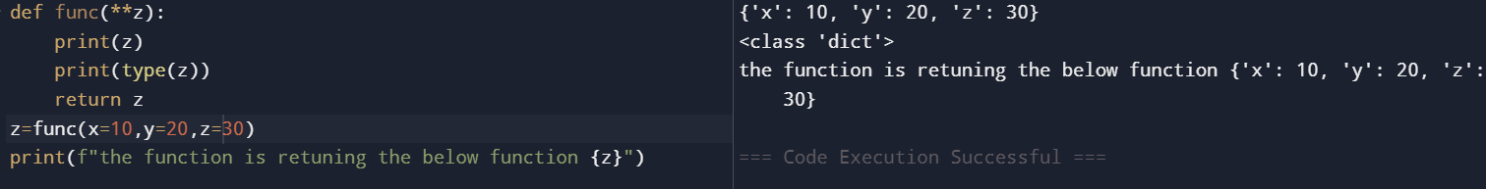
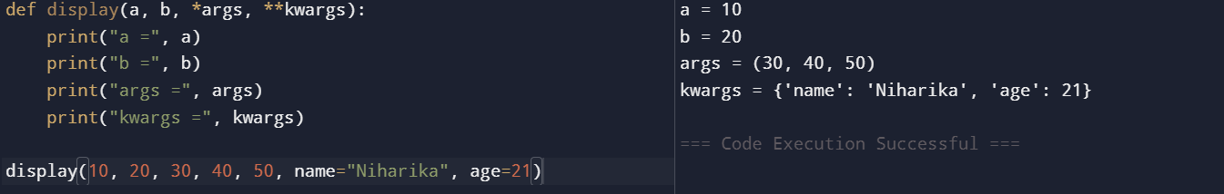
Lambda function
A lambda function in Python is a small anonymous function written in a single line using the lambda keyword. It can take any number of arguments but can contain only one expression. Lambda functions are mainly used for short, temporary operations where defining a full function with def is unnecessary.
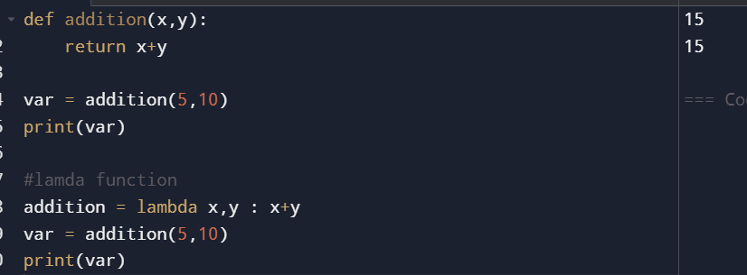
The map() function in Python is used to apply a function to every item in an iterable (like a list, tuple, etc.) and returns a map object containing the transformed values. map(function, iterable)
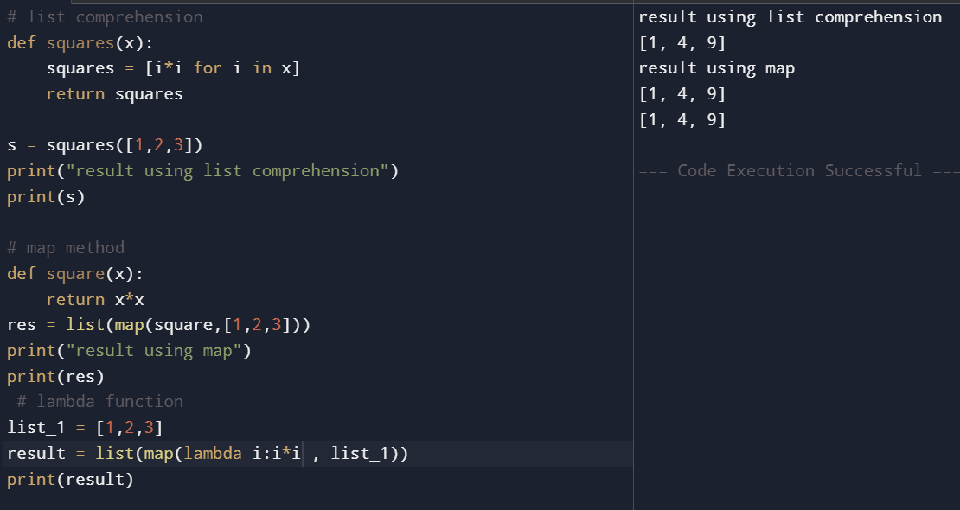
The filter() function in Python is used to select elements from an iterable based on a condition. It applies a function to each element and returns only the elements for which the function evaluates to True. The result is returned as a filter object, which is usually converted into a list, tuple, or set.
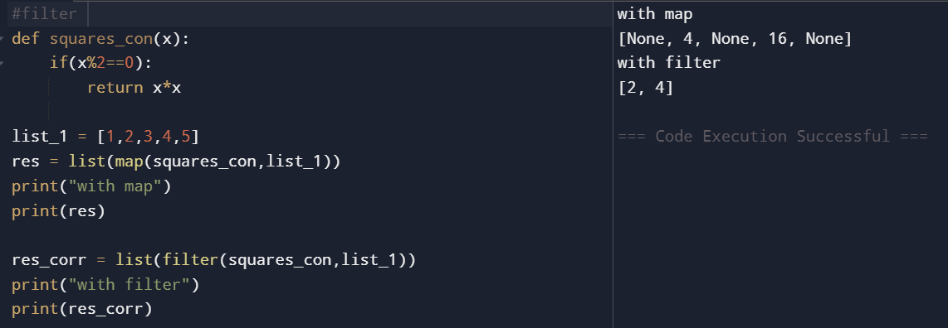
The reduce() function in Python is used to combine all elements of an iterable into a single value by repeatedly applying a function to the elements. It processes the iterable from left to right and returns one final result. The reduce() function is available in the functools module.
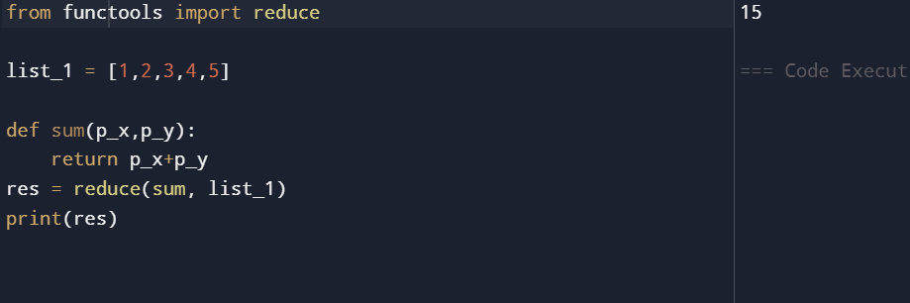
Exception handling:
Exception handling in Python is used to handle runtime errors without stopping the program execution. The main keywords used are try and except.
- try → contains code that may cause an error
- except → handles the error if it occurs
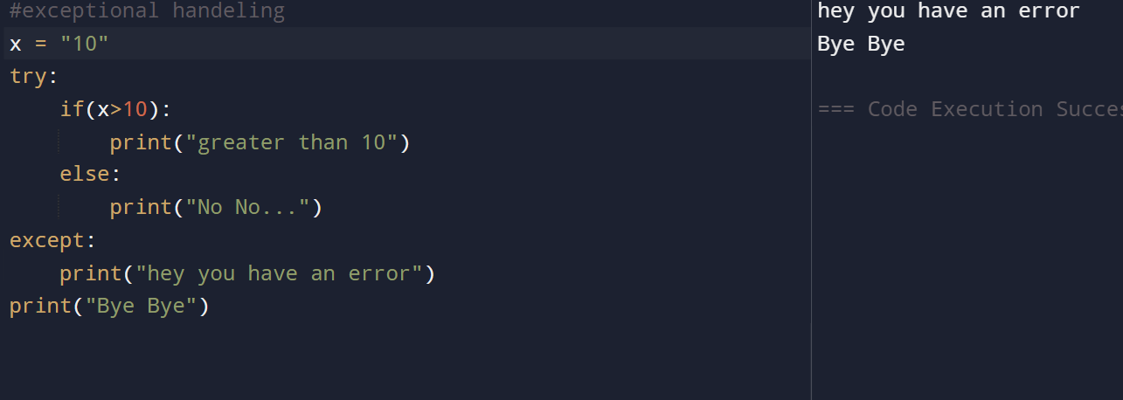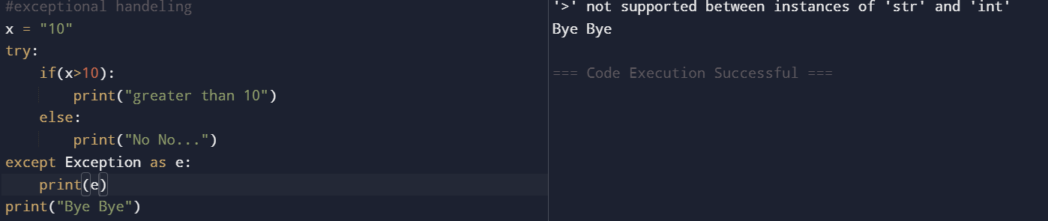
The finally block in Python exception handling is used to execute code that must run whether an exception occurs or not. It is commonly used for cleanup operations like closing files, database connections, or releasing resources.
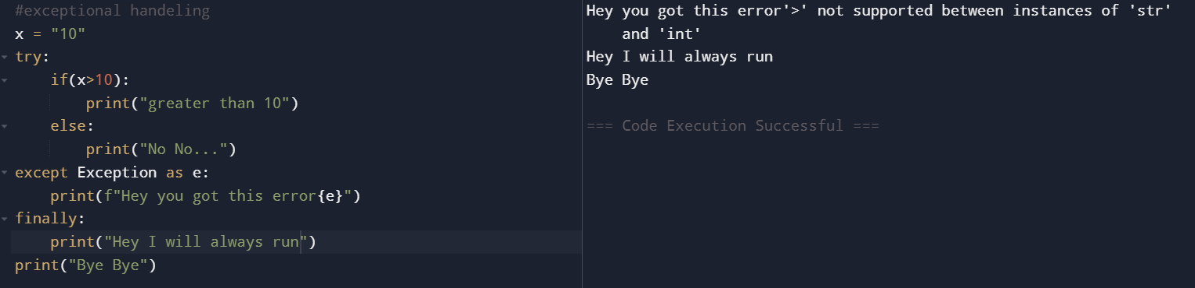
Raising a value error
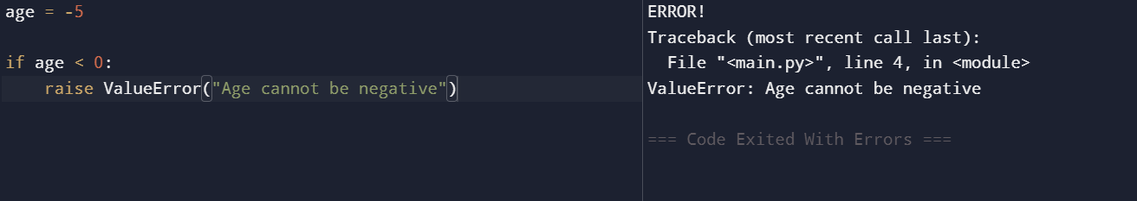
OOPS IN PYTHON:
OOPS (Object-Oriented Programming System) in Python is used to organize code into objects and classes, making programs more structured, reusable, and easier to manage. It helps in modeling real-world entities like students, cars, bank accounts, etc., using objects that contain both data and functions. OOPS improves code reusability through inheritance, provides security using encapsulation, reduces code duplication, and makes large applications easier to maintain and scale.
Main goals – reusability, sacalability , Readability
A class in Python is a blueprint for creating objects. It defines the data (variables) and behavior (functions/methods) that an object will have.
An object in Python is an instance of a class. It is a real thing created from the class blueprint.
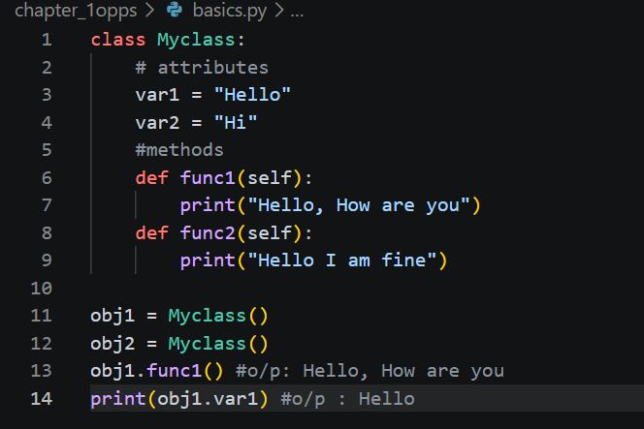
Self : self is a reference to the current object of a class. It is used to access the object’s variables and methods inside the class.
A constructor in Python is a special method that automatically runs when an object is created. It is used to initialize object variables and is written using __init__().
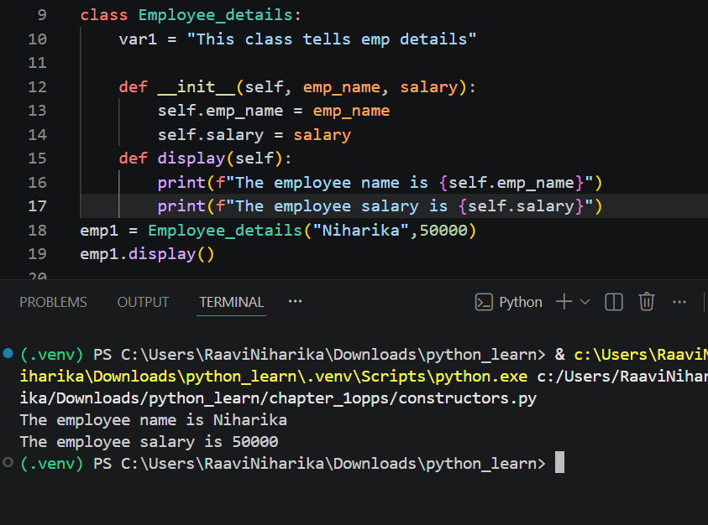
Encapsulation:
Encapsulation in Python is the process of: Binding data (variables) and methods (functions) together inside a class and restricting direct access to some data.
Encapsulation is the concept of hiding data and allowing access through methods inside a class.
Public → Accessible from anywhere. (name)
Protected → Accessible inside class and child class. (_name)
Private → Accessible only inside the class. (__name)
Types of methods
Instance method: An instance method is a method inside a class that operates on object data using self. It is called using an object of the class.
Instance Variable → A variable unique to each object and defined using self.
Class Variable → A variable shared by all objects of a class.
A class method is a method that works with class-level data instead of object data.
It uses cls as the first parameter and is defined using @classmethod.
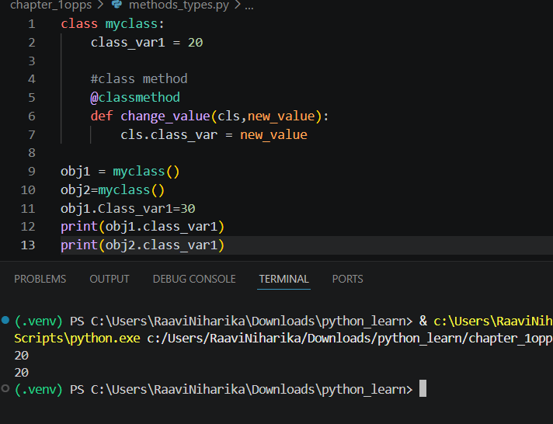
Static method: A static method is a method that does not use self or cls.
It is defined using @staticmethod and works like a normal function inside a class.
• Uses @staticmethod
• Does not access object or class data
• Called using class name or object
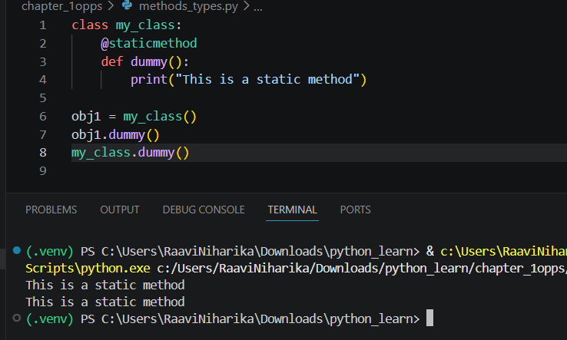
Dunder method: A dunder (magic) method is a special method in Python with double underscores before and after its name, like __init__().
These methods automatically provide special behavior to objects.
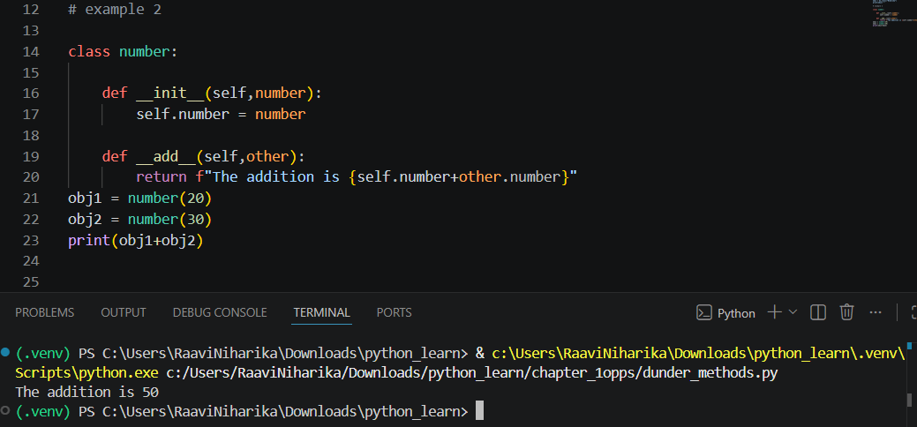
Inheritance in python:
Inheritance in OOP is a feature where one class acquires the properties and methods of another class.
It helps in code reusability and creating parent-child relationships between classes.
Type hint: Type hint is a way to specify the expected data type of a variable, function parameter, or return value in Python. It improves code readability and helps in error checking.
super() is used to access methods or constructors of the parent class inside a child class.
Single level inheritance:
Single-level inheritance means: A child class inherits properties and methods from only one parent class.
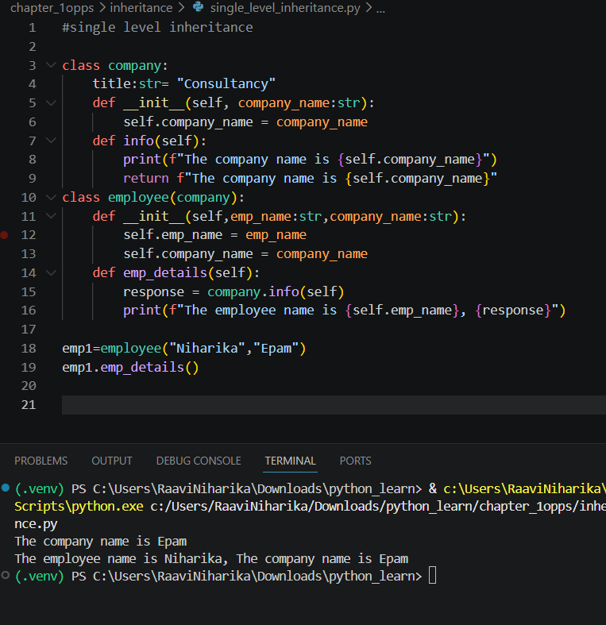
Multiple inheritance : Multiple inheritance is a feature where one child class inherits properties and methods from more than one parent class.

