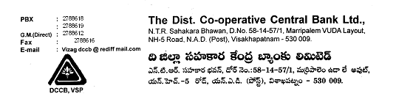

REF: IT/UPS -AMC/2024-25 26/06/2024

# Short Tender Notice

Sealed quotations are called from eligible Firms/Company for providing the AMC to UPS Batteries for **“The District Cooperative Central Bank Ltd.,Visakhapatnam” (including Head office and** Branches)

# The details of the scope of work are mentioned below:

|  |  |  |
| --- | --- | --- |
| **S.No** | **AMC for the ITEM Described below** | **Qty** |
| 1 | 3 KVA Online UPS system | 34 |
| 2 | 10 KVA Online UPS System | 1 |
| 3 | 1 KVA Online UPS System | 2 |

**Work Location: For all the Branches and H.O of “The District Cooperative Central Bank Ltd. Visakhapatnam”**

# Terms and Condition:

1. Preventive Maintenance of UPS system will be done at least once in Three Months during AMC Period.
2. During Preventive maintenance checkup, the systems should be cleaned and general performance should be checked, cleaning equipment should be carried out.
3. Apart from Preventive maintenance visits, all Breakdown calls on the systems should be covered.
4. Cost of all spares that are replaced in the UPS systems will be covered under the comprehensive Annual Maintenance.
5. Replacement of UPS spare parts with the same model and same company spare parts as the old one.
6. Complaint should be attended within 24 hours of the call log.
7. Standby should be provided, if the repair of the device would take more than 24 hours.
8. All the prices shall be as per the estimates furnished.
9. The indicated item of the work is not exhaustive it may differ based on the work site scenario.
10. The Bank has the right to cancel the L1, if the work/service is not satisfactory and work is not completed within time.

# Tender Schedule:

Starting date: 02.07.2024

Last date for receipt of bids:09.07.2024

# Award of Contract:

The contract will be awarded to the bidder with the Lowest price quoted. Bank reserves the right to accept or reject any or all bids without providing any reasons.

Sealed quotations should be handed over directly to the address mentioned below :

To

The Chief Executive Office,

**The District Co operative Central Bank Ltd.,Visakhapatnam .**

**N.T.R Sahakara Bhavan,**

**D.No:55-14/57/1,**

**Marripalem VUDA Layout,**

**NH-16,N.A.D ,**

**Visakhapatnam-530009**

Sd/-

Chief Executive Officer