**SANGAM SKM COLLEGE -NADI**

**AGRICULTURAL SCIENCE**

**YEAR 10- WORKSHEET**

**WEEK 4**

1. Differentiate between a primary tillage implement and a secondary tillage implement.

1. i.Label the parts of a mouldboard plough. ( 1 – 7 )

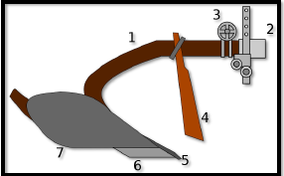

iiState the function of part 7.

3. The type of wheel shown below, is commonly found in a disc harrow.



1. State the name of the wheel.
2. Explain its function.

4. State the name and function of the machine given below.

|  |  |  |
| --- | --- | --- |
|  | Name | Function |
|  |  |  |