**Sangam SKM College Nadi – 2021**

**Year 10 Social Science**

**Worksheet 2 – Week 3**

1. Define the following terms:
2. Totalitarian

________________________________________________________________________________________________________________________________________________

1. Constitutional Monarchy

________________________________________________________________________________________________________________________________________________

Use the resource given below to answer question numbers 2 and 3.

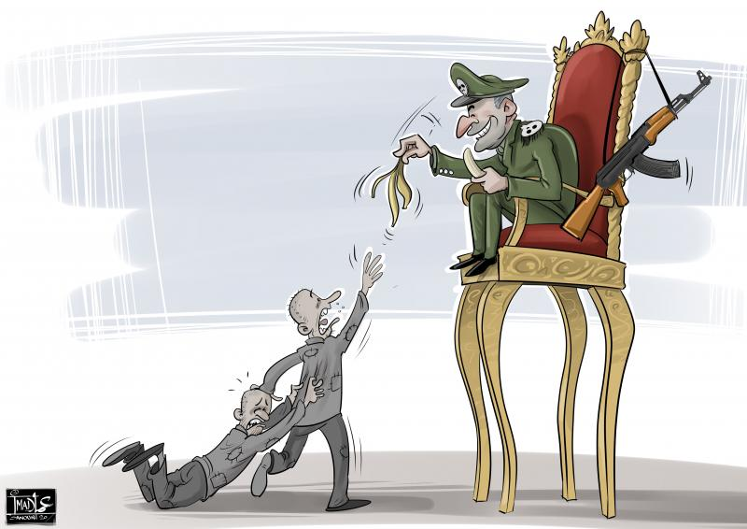

1. Identify the type of government depicted above.

_______________________________________________________________________

1. Name a country which has the above type of government in the world today.

_______________________________________________________________________

1. What does the acronym WHO stands for and state a way in which it has assisted in the current global pandemic?

________________________________________________________________________________________________________________________________________________________________________________________________________________________