**SANGAM SKM COLLEGE - NADI**

**YEAR 11 ECONOMICS WORKSHEET- 2021**

**WEEK 2 (31.05.21 – 04.06.21)**

**QUESTION 1**

(a) Define the following economic concepts:

(i) Economizing Resources

(ii) Opportunity Cost

(b)Complete the following table in your Answer Book by briefly stating how each Economist defined Economics

|  |  |
| --- | --- |
| **Economist** | **Definition** |
| J.M.Keynes |  |
| Alfred Marshall |  |
| Adam Smith |  |
| P.A.Samuelson |  |

(i) Economics is regarded as a Social Science as it deals with Human Behavior, Human Problems and Human Organization System. Discuss these three aspects.

(ii) Explain the relationship between scarcity, choice and opportunity cost.

(iii) Describe two roles of an Economist.

(c) (i) Identify and explain the fundamental economic problem faced by the societies in

the economy.

(ii) Discuss one reason as to why economics is regarded as a social science.

(d) Study the photographs given below and answer the following question

i. ii

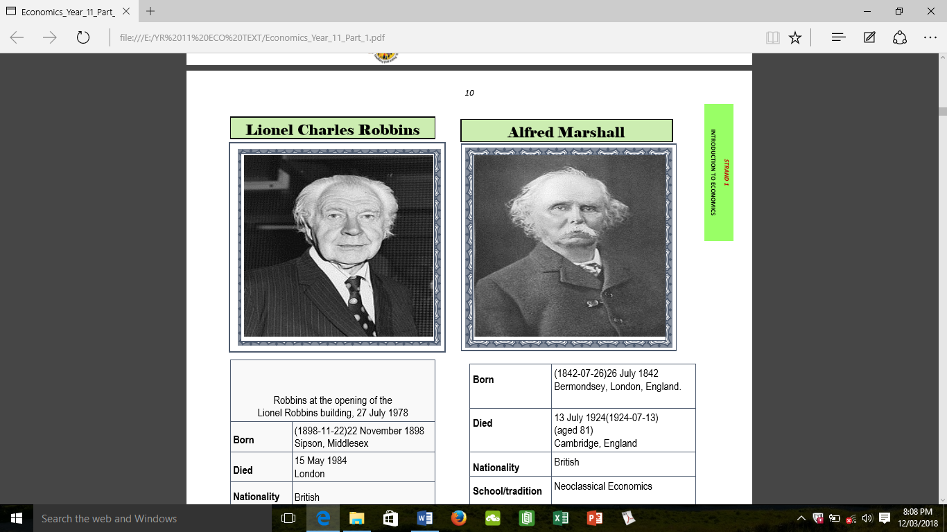 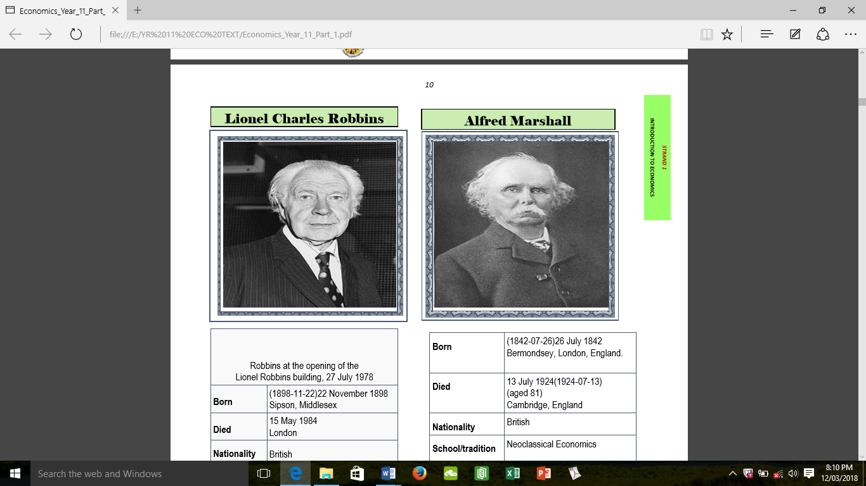

Source: *A Direct Approach Year 11 Economics Textbook (CDU)*

Identify the economists above and explain their definition of economics.

**WEEK 3 – (07.06.21 – 11.06.21)**

**QUESTION 2**

(a) Study the extract given below and your knowledge to answer questions (i) and (ii).

The material needs of such communities are typically provided for through hunting and gathering or through agriculture. Questions about which members of the community get which portions of what has been killed, gathered, or harvested are solved according to rules derived from the individual society’s traditions.

Source:

[*http://www.encyclopedia.com/finance*](http://www.encyclopedia.com/finance)

(i) Name the economic system which is elaborated in the above article.

(ii) Identify an example of an economic question from the above article.

(iii). Differentiate between Planned Economy and Subsistence Economy.

(iv). What does the phrase laissez faire mean?

(b) Study the graph given below and your knowledge to answer the question that follows. 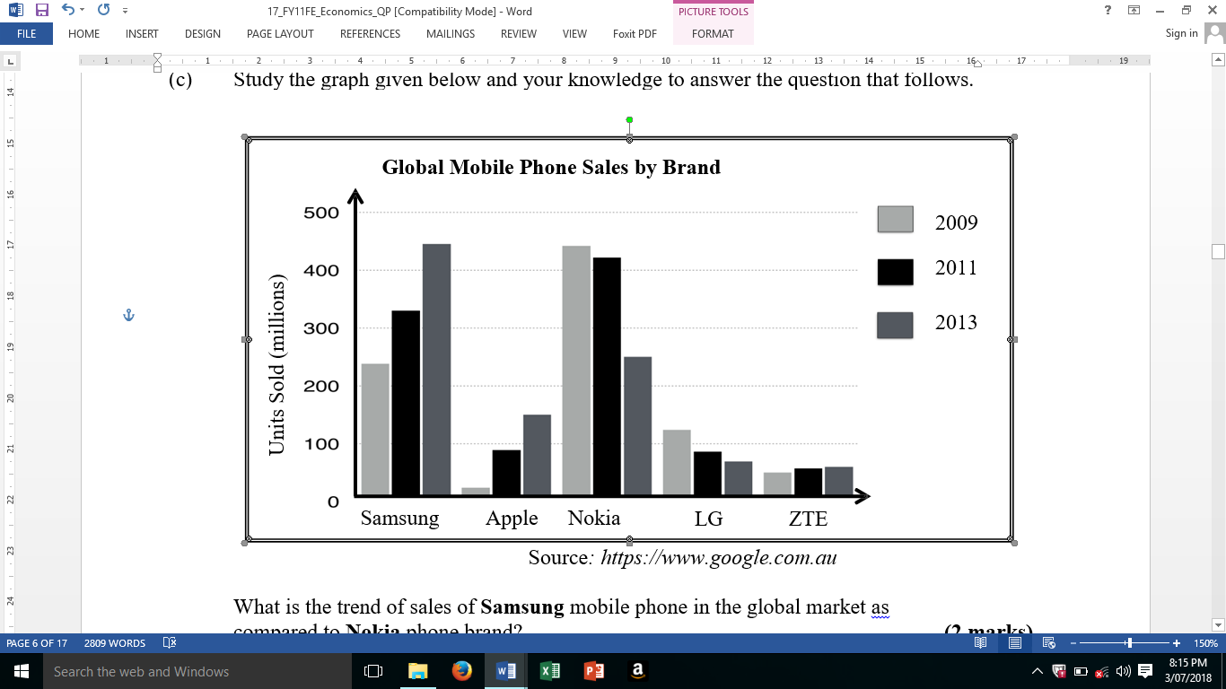

(i) Name the type of graph shown above**.**

(ii)What is the trend of sales of Samsungmobile phone in the global market as compared to Nokiaphone brand?

(c) Use the following information to answer the questions that follow.



(i) What does the above graph show?

(ii) Give two importance of having a graphs in economics?

(iii) Name any two types of graph you have studied in economics?