**Sangam SKM College Nadi – 2021**

**Year 11 Geography**

**Worksheet 1 – Week 2**

1. Use the resource given below and your knowledge to answer the questions that follow.

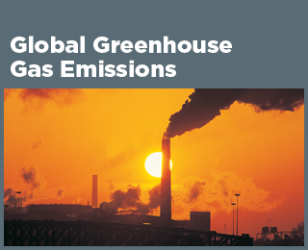

1. State two major causes of global warming.

__________________________________________________________________________________________________________________________________________________________________________________________________________________________________________________________________

1. State two ways of reducing the effects of global warming.

__________________________________________________________________________________________________________________________________________________________________________________________________________________________________________________________________

1. Define the following terms:
2. Climate

__________________________________________________________________________________________________________________________________________

1. Solar Radiation

_____________________________________________________________________

_____________________________________________________________________

1. Temperature

_____________________________________________________________________

_____________________________________________________________________

1. Insolation

__________________________________________________________________________________________________________________________________________

1. Weather

__________________________________________________________________________________________________________________________________________

1. Explain why the southerly winds reaching New-Zealand are generally cool and northerlies are usually warm.

________________________________________________________________________________________________________________________________________________________________________________________________________________________

1. State the two elements of climate.

________________________________________________________________________________________________________________________________________________________________________________________________________________________

1. Briefly discuss how the fohn winds are formed.

________________________________________________________________________________________________________________________________________________________________________________________________________________________

1. With reference to either Fiji or New-Zealand, identify one climate control and explain how it affects the climate of a specific region.

________________________________________________________________________________________________________________________________________________________________________________________________________________________________________________________________________________________________________________________________________________________________________________________________________________________________________________________________________________________________________________________________________________________________________________________________________________________________________________________________________________________________________________________________________________________________________________________________________________________________________________________________________________________________________________________________________________________________________________________________________________________________________________________________________________________________________________________________________________________________________________________________