**SAGAM SKM COLLEGE**

**YEAR 11 WEEK 4 WORKSHEET**

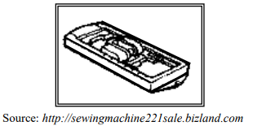**DEPARTMENT OF HMOE ECOOMICS**

1. The machine part shown on the right is used for
2. Attaching zips.
3. Making button holes.
4. Making a rolled hem.
5. Making decorative stitches.
6. State one basic requirement to achieving a perfect fit in a garment.
7. Explain the process pattern layout in garment construction.
8. Study the picture below to answer the questions that follow.

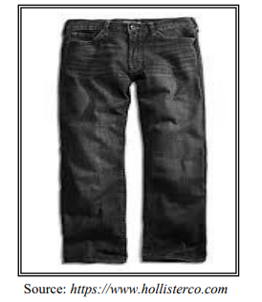

1. Identify a suitable side seam for the garment.
2. Explain the steps involved in making the seam.