**SANGAM SKM COLLEGE- NADI**

**YEAR 11 OFFICE TECHNOLOGY-2021**

**WORKSHEET WK-2**

**QUESTION 1**

1. Define the following terms:

a) Office layout chart

b) Data projector

1. Study the equation given below and answer the questions:

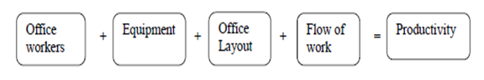

1. State **one** reason why we have the above equation related?
2. What will be the outcome of the equation if one of its components is removed?
3. Briefly explain the following in terms of modern office:
4. Greenpower
5. Binder**)**
6. Ergonomics

**QUESTION 2**

1. Define the following terms:

i) Slide sorter

ii)Transition

1. List the steps to add transitions between slides in PowerPoint Presentation
2. What is the purpose of using the Animations ribbon?

**ESSAY WRITING**

**To carry out the operations effectively in an office, every worker needs to be trained on specific areas of the job.**

With reference to the above statement, discuss **three** ways of managing office functions in relation to:

▪Using of office equipment

▪Understanding the processes involved

▪Communicating within the office and with customers and suppliers

**SANGAM SKM COLLEGE- NADI**

**YEAR 11 OFFICE TECHNOLOGY-2021**

**WORKSHEET WK-3**

(a) Define the following terms:

(i) laptop

(ii) ergonomic

(b) Describe how the use of green power contributes to the effectiveness of an organisation.

(c) Explain how the flow process chart is used by specific people in an organisation.

(d) Differentiate between solid fill and gradient fill in relation to formatting the background of a power point presentation.

(e) State the purpose of inserting Clip Art in the power point presentation.

(f) Name the menu that will display the audio and video icons in power point

or word.

(g) Differentiate between Save as and Save command in relation to saving

a document.

(h) Study the power point toolbar below and answer the questions that follow.

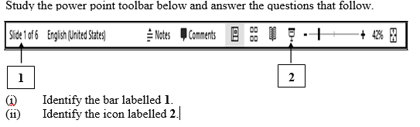

(i) **Define the following terms**

(a) browsing

(b) privacy

**ESSAY WRITING**

**When an office is planned or reorganised, it is important to consider the relationship between people, equipment and the flow of work.**

With reference to the above statement, discuss **two** factors of each of the following that enable an office to function successfully.

▪ privacy

▪ office layout

▪ arrangement of furniture

▪ accessibility to documents and equipment

THANK YOU