**SANGAM S K M COLLEGE-NADI**

**YEAR 12 BIOLOGY WORKSHEET**

**WEEK 2**

1. The diagram below shows the image of a specimen viewed at 40 x magnification.

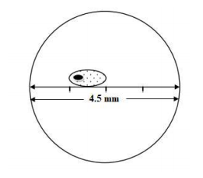

1. Calculate the length of the specimen in micrometers (µm).

(Diameter of field of view = 4.5 mm)

1. If the diameter of the field of view at 40x magnification is 4.5 mm, what would be the diameter of field of view at 400x magnification?
2. Explain the difference between magnification and resolution.
3. In one of your practical activities, you were asked to observe the letter ‘e’ at low power under the microscope. If the letter ‘b’ was used instead of ‘e’, draw the image that you would observe.
4. The diagram given below shows a filamentous alga viewed under a compound microscope. It is magnified 40x and the field of view diameter is 1.5mm (40x magnification).

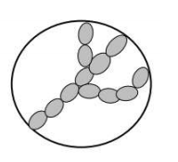

Estimate the size of one cell. Give your answer in microns.

1. A microscope has three objective lenses and a 10X eye piece. An object viewed under this microscope has a total magnification of 400X. State the magnification of the objective lens.
2. 16 cells were observed under 400X magnification. Calculate the number of cells observed under 40X.
3. The diagrams below represent stages in the development of a vertebrate. Use the diagram to answer that follow.

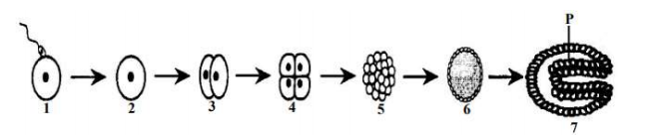

1. Name and describe the stages 5 and 6.
2. Name a structure which will develop from tissue layer P?
3. Describe how the above process differs from mitosis.
4. Name three examples of structures that will develop from the following layers:
5. Ectoderm
6. Mesoderm
7. Endoderm
8. Differentiate between Prokaryotes and Eukaryotes.
9. List the **three** types of changes the cells experience in gastrulation.