**SANGAM S K M COLLEGE-NADI**

**YEAR 12 BIOLOGY WORKSHEET**

**WEEK 3**

1. The diagram given below is of a chloroplast. Label structures a-d.

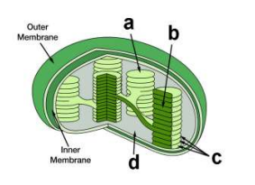

1. Write the word and balanced chemical equation for photosynthesis?
2. Identify two importance of sunlight in light reaction of photosynthesis?
3. Complete the table given below.

|  |  |  |  |
| --- | --- | --- | --- |
| Reaction | Where does it take place in the chloroplast | Reactants | Products |
| Light Reaction |  |  |  |
| Dark Reaction |  |  |  |

1. Explain how ATP is different from ADP.
2. Explain how an increase in carbondioxide increases the rate of photosynthesis.
3. Label the diagram to the right with the following: water, oxygen, carbon dioxide, glucose, ATP, NADP,sunlight

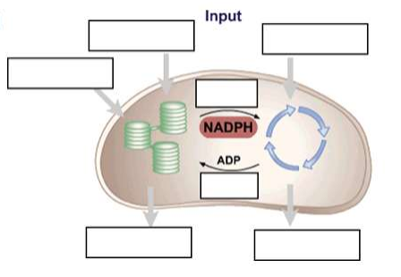

1. Identify the role of NADP+ .
2. Identify the parts of the mitochondria label **1, 2, 3 & 4.**

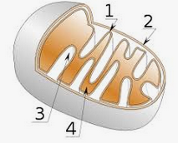

1. Write the correct chemical equation for **anaerobic respiration** in Humans.
2. Name **two** products formed during anaerobic respiration in yeast.
3. Explain how the numerous folding of the inner membrane (cristae) of mitochondria is advantageous.