**SANGAM SKM COLLEGE- NADI**

**CHEMISTRY**

**YEAR12**

**WORKSHEET 1**

**WEEK :2**

**STRAND: GENERAL CHEMISTRY**

* **Please wash your hands before you start the worksheet. Remember Hygiene is very important. Stay Safe. Do take care of yourself.**
* **Spend 30 minutes completing the questions. Summary notes and hints are given for completion of the questions.**

**Summary notes**

* **Whenever you are answering questions from uncertainty you have to look the smallest division and then use the 1/ 10 rule.**
* **Measuring cylinder has the 1ml smallest division when you use the rule, hence divide by 10 will give you ± 0.1**
* **Burette has 0.1 smallest division so when you divide by 10, the uncertainty will be ± 0.01**

**EXAMPLE** **BURETTE READING MEASURING CYLINDER**

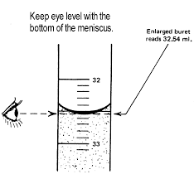

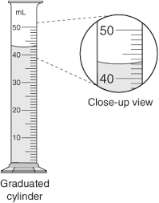

**ANSWER: 32.54 ± 0.01 ml ANSWER: 43.0 ± 0.1 ml**

**RULER**

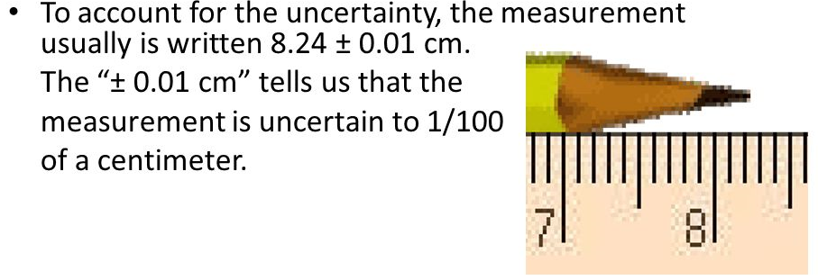

**QUESTIONS**

**Write the measurement with uncertainty for the following apparatus:**

**1. 2.**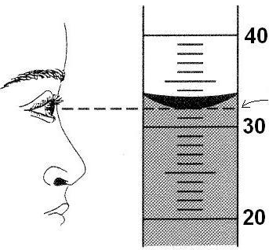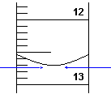

.

**1. Answer: _________________________**

**2. Answer: _________________________**

**3.**

A:___________________________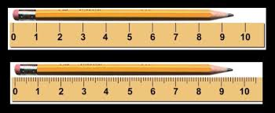

B:______________________________

**SANGAM SKM COLLEGE- NADI**

**CHEMISTRY**

**YEAR12**

**WORKSHEET :2**

**WEEK :3**

**STRAND: GENERAL CHEMISTRY**

**DEFINITION WORKSHEET**

**1.Define the following:**

**(a) Accuracy:__________________________________________________________________**

**(b)Precision** :__________________________________________________________________

(c) **Systematic Error**:____________________________________________________________

(d) **Random Error**:_____________________________________________________________

2.During the game of golf a person shows the skills of accuracy and precision. The following result was obtained.

A B C

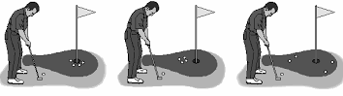

Which one of the following

(i) High precision and low accuracy:______________________

(ii) High precision and high accuracy:_____________________

(iii) Low precision and low accuracy:______________________

3. State if the following example is a random or systematic error :

(i) Forgetting to tare or zero a balance produces mass measurements

________________________________________________

(ii) Not reading the meniscus at eye level for a volume measurement.

________________________________________________

(iii) Measuring length with a metal ruler will give a different result at a cold temperature than at a hot temperature, due to thermal expansion of the material.

__________________________________________________

(iv) An improperly calibrated thermometer may give accurate readings within a certain temperature range, but become inaccurate at higher or lower temperatures.

__________________________________________________