**Year 12 Economics Worksheet Week 2**

**Strand One: Introduction to Economics**

**1.Define**

**a.Production Possibility Curve**_________________________________________________

__________________________________________________________________________

**2. State the 5 Assumptions of a PPC**

a.______________________________________________________________

b.______________________________________________________________

c.______________________________________________________________

d.______________________________________________________________

e._________________________________________________________________

**3.List the Concepts Illustrated by the PPC**

a._________________________________________________________________

b.________________________________________________________________

c._________________________________________________________________

d._______________________________________________________________

e.______________________________________________________________

**4.Define**

**a. Production Efficiency**_______________________________________________________

_________________________________________________________________________

**b. Allocative Efficiency**__________________________________________________________

_______________________________________________________________________________________________________________________________________________________

c.**Marginal Rate of Transformation________________________________________________**

**____________________________________________________________________________**

**5.Use the graph to answer the question.**

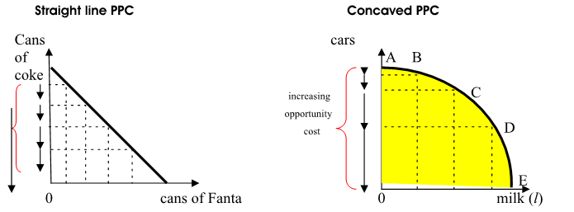

a.State the reasons for the shapes above

i.Straight Line__________________________________________________________________

___________________________________________________________________________

ii.Concaved_________________________________________________________________________________________________________________________________________________

6.

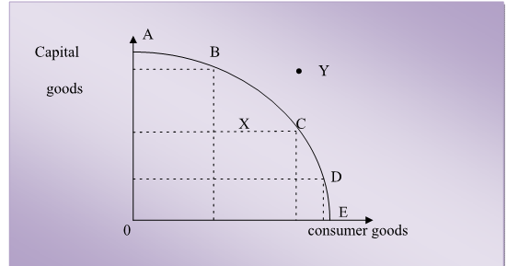

Explain what the Points of the PPC show

Points A-E_____________________________

______________________________________

Point X________________________________  
______________________________________

Point Y-________________________________

______________________________________  
7.

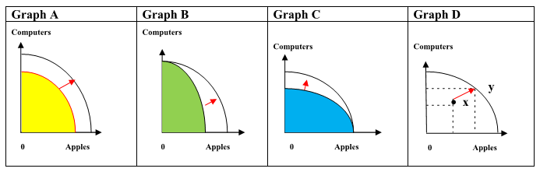

What each graph shows

a.**Graph A**-___________________________________________________________

__________________________________________________________________

b.**Graph B**___________________________________________________________

___________________________________________________________________

c.**Graph C**-___________________________________________________________

_________________________________________________________________

d.**Graph D**-______________________________________________________________

_____________________________________________________________________

8. Use the diagram below to answer question(i) and (ii)

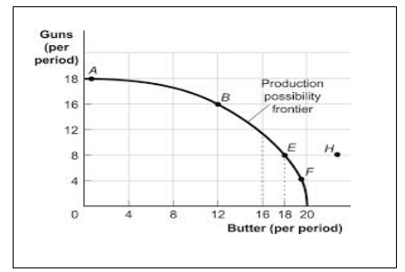(i)Calculate the opportunity cost if the economy moved from Point E to B on the graph.

(ii)Calculate the MRT if the economy increased its butter production from 0 units to 12 units.

**Year 12 Economics Worksheet Week 3**

**Strand Two: Microeconomics**

1. Label the curves given below**.**

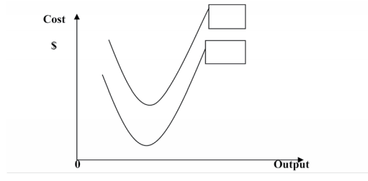

2. Use the information given below and your knowledge to answer the questions (i) and (ii).

The schedule given below shows the cost value for a firms output.

|  |  |  |  |  |
| --- | --- | --- | --- | --- |
| Output | Average Variable Cost | Total Cost | Average Cost | Marginal Cost |
| 1 | 2 | (a) | 6.0 | - |
| 2 | 3.5 | (b) | (e) | 5.0 |
| 3 | 4.0 | 16 | (f) | (h) |
| 4 | 6.5 | (c) | 7.5 | (i) |
| 5 | 6.8 | (d) | (g) | 8.0 |
| 6 | 6.0 | 40.0 | 6.7 | (j) |

i. Calculate the missing figures for (a)-(j).

ii. Differentiate between fixed cost and variable cost.

___________________________________________________________________________________________________________________________________________________________

3. Define the term **productivity.**

_________________________________________________________________________________________________________________________________________________________

4. List 2 factors that increases productivity.

____________________________________________________________________________________________________________________________________________________

5. What is the Law of Diminishing Returns?

__________________________________________________________________________________________________________________________________________________________________________________________________________________________________________

ii. The following table shows production data for tomatoes grown on a 1000 hectares farm

6) Complete the table given below and answer the questions that follow

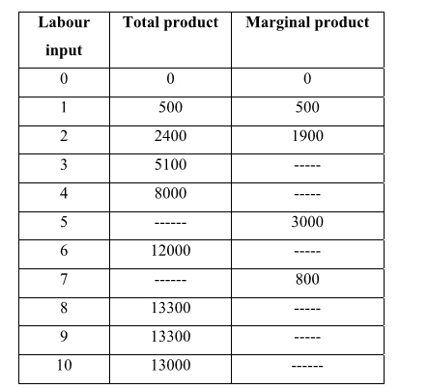

i. Which factor is fixed? Which is variable?

ii. What is the marginal product of 3rd worker?

iii. What is total product of 7th worker?

vi. Complete the Statement: ‘the law of diminishing returns sets in with the employment of the __________________ worker.

7. Definitions

a. **Economies of Scale**________________________________________________________

______________________________________________________________________

b. **Internal Economies**_______________________________________________________

________________________________________________________________________

c. **External Economies**________________________________________________________

________________________________________________________________________

d. **Diseconomies of scale**________________________________________________________

__________________________________________________________________________

8. Show graphical illustration of Economies and Diseconomies of Scale