**SANGAM SKM COLLEGE - NADI**

**YEAR 12 Economics WORKSHEET- 2021**

**Week 4**

**Strand Two: Microeconomics Elasticity**

**1.** Define the different types of elasticity and write down the formulas in the table given below.

|  |
| --- |
| Definition Formula    1.Price Elasticity of Demand  2.Income Elasticity of Demand  3.Cross Elasticity of Demand |

**2. Fill in the Blanks**

Use the words in the box given below to answer the questions given.

**downward; minus; positive , Elasticity; percentage , quantity demanded; price , elastic;1**

**income ; quantity demanded**

1.____________________is the general concept of measuring the responsiveness of one

economic variable to another in _______________________terms.

2. The price elasticity of demand measures how _____________________________

changes in response to a change in ____________________.

3. Since the demand curve slopes _________________, elasticity of demand has

a(an)______________________sign. However, economist ignore this, and treat it as

________________number

4. Demand is said to be ________________when the elasticity of demand is greater

than _________________.

5. The ______________ elasticity of demand measures the responsiveness of

__________________________to changes in consumer income, holding other things equal.

3.Complete the given crossword on the topic Elasticity

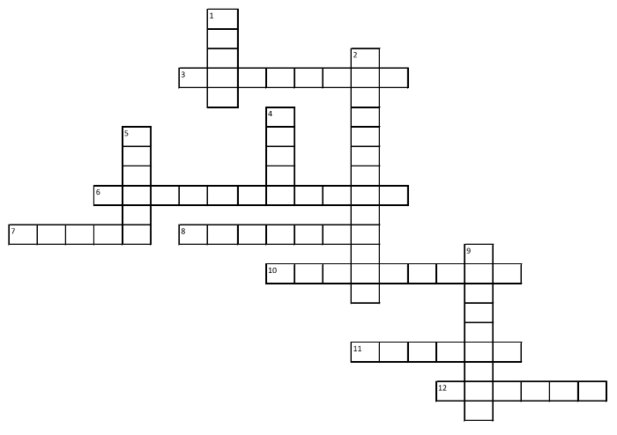

**Across**

3. As income increases, the demand for this type of good decreases.

6. Goods that can replace one another, such as butter and margarine.

7. The law of demand states that quantity demanded increases as _____________decreases.

8.______________demanded is the amount of a good or service demanded at a particular

price.

10. Expanding into foreign markets____________ both the number of buyers and the demand

for goods and services

11.As income increases, the demand for this type of good increases.

12.Being able and willing to buy a good or service.

**Down**

1. Movements ______________the demand curve illustrate the law of demand.

2. Goods that go together, like tennis rackets and tennis balls.

4. A ______________in the demand curve can result from the changes in consumer preference,

income, prices of related goods, number of buyers, and beliefs about the future.

5.____________expectations of price and income can affect the present demand for goods and

services.

9. An outbreak of mad cow disease _____________the demand for beef, because consumers

bought less meat.

*(Reference copyright-Council for Economic Education)*