SANGAM SKM COLLEGE-NADI

GEOGRAPHY YEAR 12 REVISIONAL WORKSHEET 3-WEEK 4

TOPIC- TOURISM

A: **CROSS WORD**

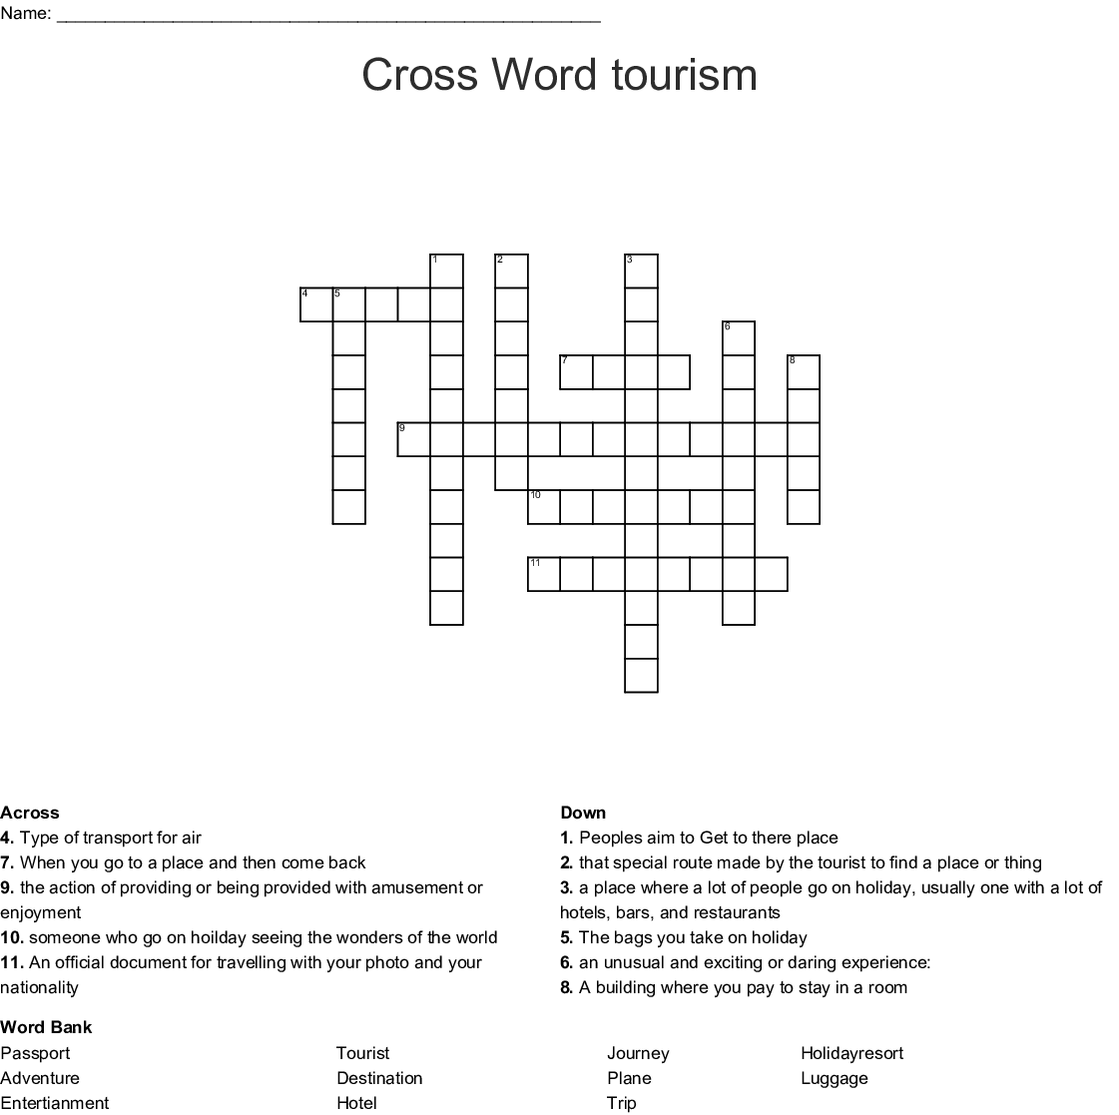

B**: MAPPING - FIJI**

On the outline map of Fiji, name and locate the following features; (Students can draw an outline map)

1.) Fiji’s first hotel.

2.) The island group west of Viti Levu famous for tourism activity.

3.) The privately owned resort in Lomaiviti Group.

4.) The island known for Sanctuary of Crested Iguana.

5.) The resort where the first natives of Fiji landed.

6.) An eco-tourism village

7.) Fiji’s heritage town

8.) Island home to Shark Reef Marine Reserve

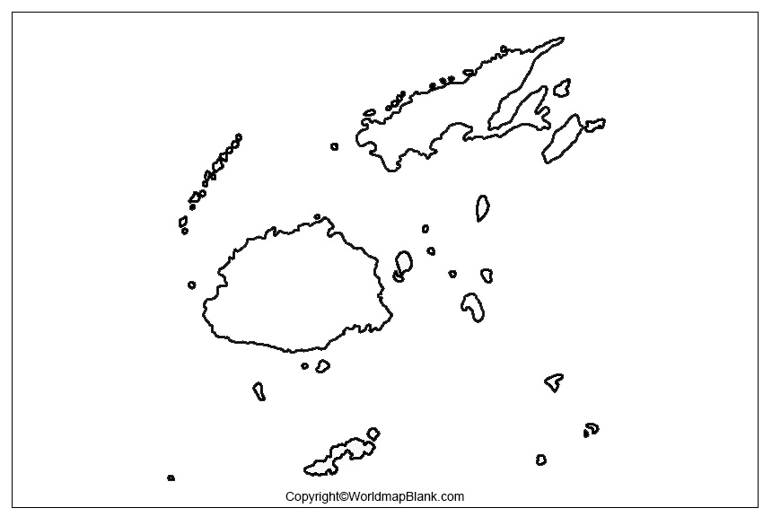

C. AUSTRALIA- MAJOR ATTRACTION SITES

Use the images numbered to identify the attraction sites

