**SANGAM SKM COLLEGE – NADI**

**HOME ECONOMICS DEPARTMENT**

**WORKSHEET – WEEK 4 – YEAR 12A/F/E**

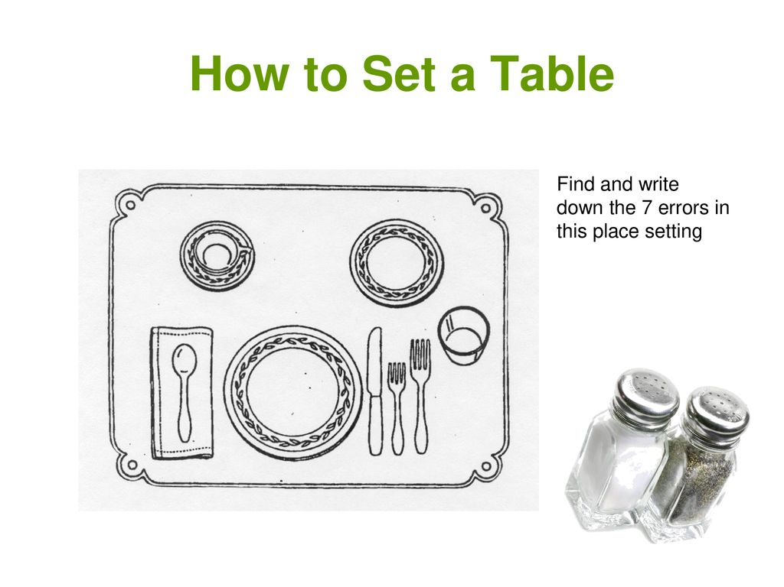

1. __________________________________________________________________________________

2. __________________________________________________________________________________

3. __________________________________________________________________________________

4. __________________________________________________________________________________

5. __________________________________________________________________________________

6.________________________________________________________________________________

7.________________________________________________________________________________

**THE END**