**SANGAM SKM COLLEGE- NADI**

**YEAR 12 OFFICE TECHNOLOGY-2021**

**WORKSHEET WEEK-2**

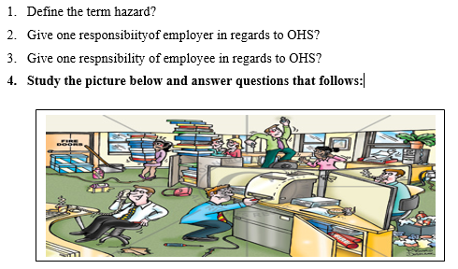

1. Identify two risks in the pictures?
2. Identify the remedial action of the above risk?
3. Name the hazards of the risk identified in your answer in (a)?
4. Describe the occupational overuse syndrome (OOS) and how it is caused?
5. Define mechanization?
6. Two objective of mechanization are improving quality of work and **reduction of fraud**. Explain the underline objective?
7. List one advantage and one disadvantage of mechanization?
8. Explain the **functions** of the following office equipments below:
9. Binding machine
10. Multimedia projector
11. How can **paper waste** be reduced in the office. Give two(2) ways?
12. Explain ways **to maintain** these following equipments below:
13. Photocopier -
14. Laminationg Machines -
15. Two features of computer are speed and accuracy. What does **accuracy** mean in this statement?
16. After using office equipment, it is important thay you leave the area of work exactly as you found. Explain and give **two** reasons why this should be done?

**SANGAM SKM COLLEGE- NADI**

**YEAR 12 OFFICE TECHNOLOGY-2021**

**WORKSHEET WEEK-3**

1. What is DATA INTEGRITY?
2. Explain the two threats to the integrity of data below:
3. Virus Attack ii) Natural Disaster
4. Explain the term “BACK UP”?
5. Differentiate between USB flash drive and an optical disk?
6. A **incremental Backup** provides a back up or files that have changed or are new since the last incremental backup. Give one advantage and disadvantage of this kind of file?
7. Name the two types of storing back up devices below?
8. b)

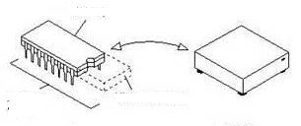

**ESSAY WRITING**

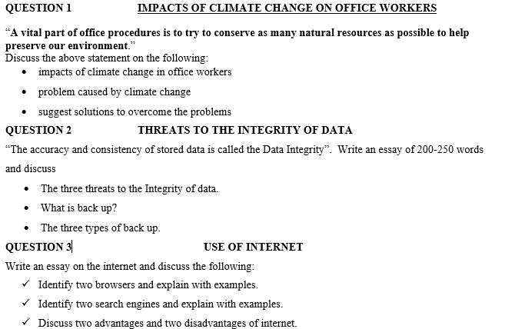

Thank you