**SANGAM SKM COLLEGE - NADI**

**YEAR 13 ACCOUNTING WORKSHEET- 2021**

**Week 4**

Instruction

* Hope you had completed worksheet 1 and 2 based on Nature of Accounting and partnership

**Let’s watch a video on partnership**

**Click on the following link**

[**https://youtu.be/4CaXGEgTPe8**](https://youtu.be/4CaXGEgTPe8)

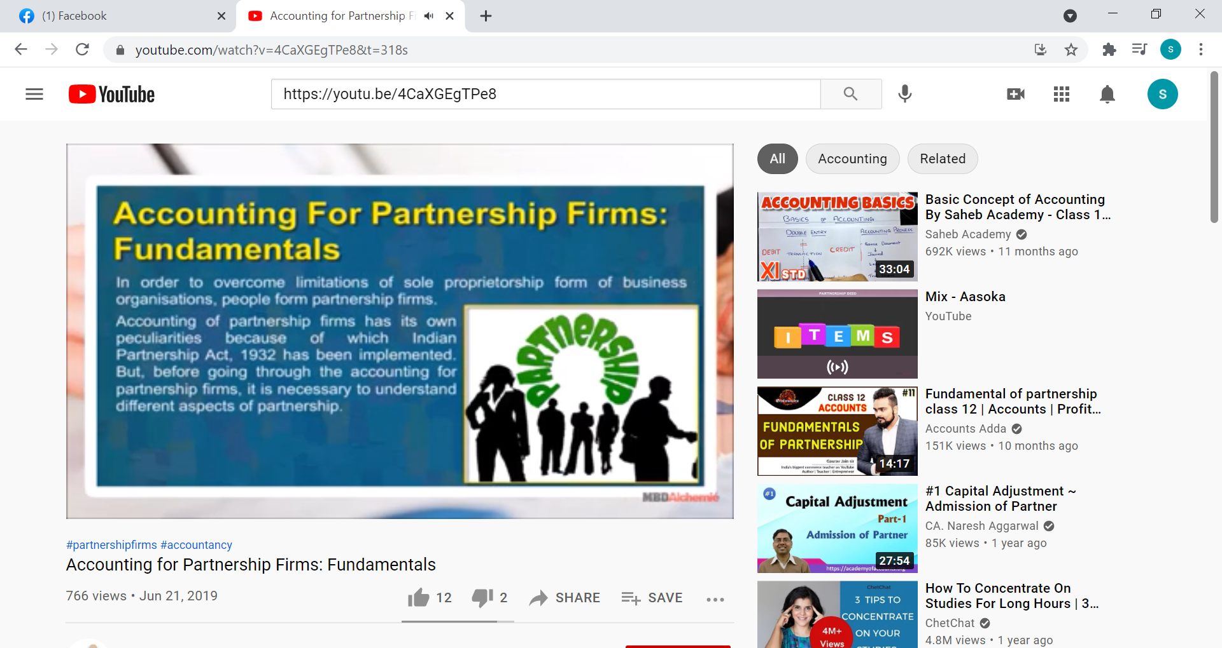

**After watching the video, answer the following question.**

**1. Identify the important document that is needed while forming a partnership**

**2. Explain the type of Accounts for the following:**

1. **Interest on capital**
2. **Interest on drawing**

**3. Complete the following closing journal entry**

1. **Salary paid to the partners**
2. **Interest on drawing**
3. **Interest in capital**

**4. Prepare a summary by noting down the important points from the video**