**SANGAM SKM COLLEGE- NADI**

**YEAR 13 BIOLOGY**

**HBESP** (Home Based Educational Support Programme-2021) **ACTIVITIES - WEEK 2**

***INSTRUCTIONS***

*Students can either print the worksheets and answer on them or copy the questions at the back of their books and answer them.*

**LESSON 1 Proteins/Genetics**

1.Identify which of the diagram below represents a protein:

**a. Primary structure c. Tertiary structure**

**b. Secondary structure d. Quaternary structure**

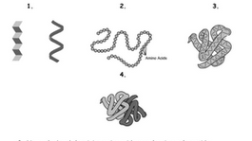

2. Explain why the shape of globular proteins (e.g. enzymes, hormones) essential for its role.

3. The leading strand of a DNA molecule has the following sequence:

**5’-CGCATGTAGCGA-3’**

Which of the following sequences is complementary to the leading strand shown above?

A. 5'-AGCGATGTACGC-3'B. 3’-AGCGATGTACGC-5

C.5’-GCGTACATCGCT-3D. 3’-GCGTACATCGCT-5’

4. Decide if each of the following statements about DNA is   
**true** or **false**

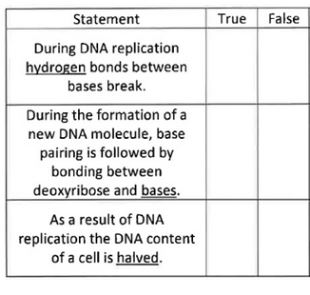

5. The diagram below represents part of deoxyribonucleic acid (DNA) molecule. The letter ‘A’ represents adenine and ‘G’ represents guanine

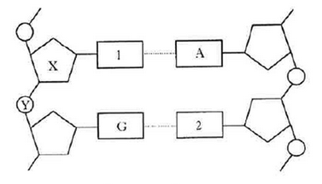

i) State the letters that represents bases 1 and 2

ii) Name the two components represented X and Y on the diagram

iii) After the double stranded DNA molecule unwinds, what is the next event in the process of DNA replication?

6. The diagram given below shows the flow of information from the nucleus to the cytoplasm during protein synthesis.

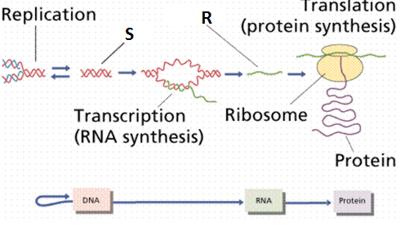

1. What molecules do **R** and **S** represent?

1. Give two reasons why the molecule S has to replicate.

1. Briefly explain the role of tRNA in protein synthesis.

**ACTIVITIES - WEEK 3   
HBESP** (Home Based Educational Support Programme-2021)

**LESSON 2 Genetics**

1. A **gene mutation** that occurs in a gamete-producing cell may be inherited and enter the **gene pool** of a population.

(a) Define the terms:

(i) Gene mutation

(ii) Gene pool

(b) Explain why gene mutations are essential for evolution to occur.

2.Down’s Syndrome is an example of aneuploidy. Most people who have this syndrome have trisomy 21.

i. Define aneuploidy

ii. Explain how a trisomy at the 21st pair arises.

3. **Distinguish** between the following

a. Continuous and Discontinuous variation   
b. Somatic and Germinal mutations   
c. Disjunction and Non- disjunction  
d. Autopolyploidy and Allopolyploidy

4. The following chart shows the crossover frequencies for genes on an autosome of the Armor Plated Squirtlesaur.

**Construct a chromosome map**.

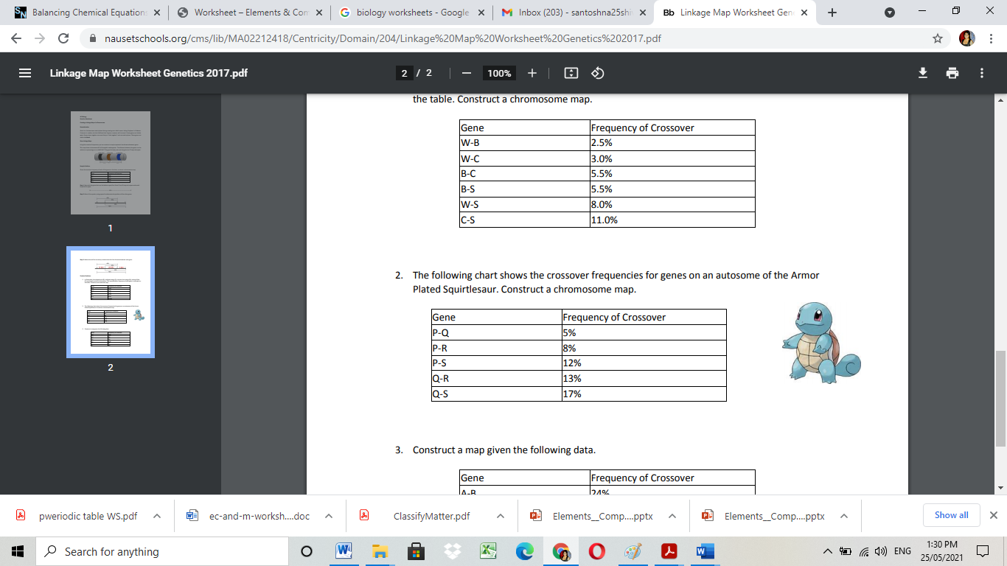

5. The diagram given below shows the initial stages of genetically engineering bacteria to produce insulin hormone**.**

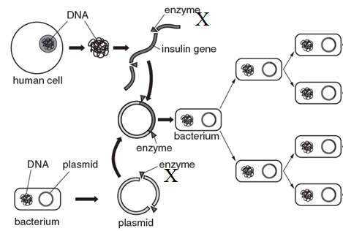

i).Name enzyme **X**.

ii). When genetically engineering bacteria is used to produce human insulin, it is important that the same enzyme is used to cut both the human DNA and the plasmid.

Explain why the same enzyme has to be used.

6. In a certain population of 3000 people, 2520 were found to have wavy hair, the dominant phenotype **(W).** The remainder of the population have straight hair, the recessive phenotype **(w).**

Show your working in calculating the following:

(i) Frequency of the recessive allele **(w)**.

(ii) Number of individuals who are homozygous dominant for this trait.

(iii)State 3 assumptions of Hardy Weinberg’s principle.

7.Genetic drift operates through population bottle neck and founders effect. Explain the terms.

Population bottleneck-

Founders Effect-