**SANGAM SKM COLLEGE – NADI** 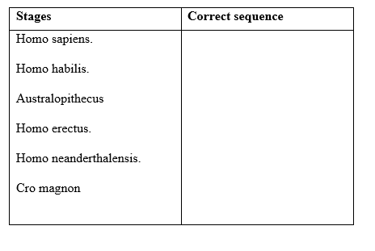

**YEAR 13 BIOLOGY**

**ACTIVITIES- WEEK 4**

***INSTRUCTIONS***

*Students can either print the worksheets and answer on them or copy the questions at the back of their books and answer them.*

Q1. Directions: Find/Name **six** animals that belong to the order primate from the word puzzle given below**.**



Q2**.** Write all the correct stages of human evolution in   
their correct sequence

Q3. Name the **first** genus of hominid that was truly   
bipedal.

Q4. Discuss two advantage of bipedalism over   
quadrupedalism.

Q5. Explain the term ‘**Arboreal**’.

Q6. Who was **Java Man**, and why is **Java Man**  
considered important?