**SANGAM SKM COLLEGE – NADI**

**YEAR 13 ECONOMICS**

**SUPPLEMENTARY WORKSHEET 2- 2021**

**QUESTION 1**

1. Jack is in Year 13 and receives a pocket expense of $20.00 and she spends on can of coke and packet of bean. The price of coke is $4 and the price of a packet of bean is $2. Coke will be on y-axis and packet of bean on x-axis.
2. Complete Jack’s consumption possibilities schedule given below

|  |  |  |
| --- | --- | --- |
| Consumptions possibilities | Coke | Packets of Bean |
| **A** |  |  |
| **B** |  |  |
| **C** |  |  |
| **D** |  |  |
| **E** |  |  |

**(5 marks)**

1. Write an equation for the budget constraint. **(1 mark)**
2. Calculate the slope of the budget line. **(1 mark)**
3. Draw the budget line graph on the pair of axis. **(2 marks)**
4. On the pair of axis, sketch the budget line and the indifference curve to illustrate the point of consumer equilibrium. **(3 marks)**
5. List the three conditions for the stable consumer equilibrium. **(3 marks)**

**QUESTION 2**

Study the table below and answer questions that follow:

Supply schedule for cans of coke

|  |  |
| --- | --- |
| **Price (cents)** | **Quantity (000)** |
| **80** | 6 |
| **90** | 8 |
| **100** | 10 |
| **110** | 12 |
| **120** | 16 |
| **130** | 18 |

Calculate PES for the following price range:

(i) price increases from $0.80 to $1.00

(ii) price decreases from$1.30 to $1.20 **(4 marks)**

**QUESTION 3**

|  |
| --- |
| Tourism in Fiji is believed to be the major source of income and helps revitalize the local economies. However tourism also has its own share of problems. |

* + - 1. State two importance of tourism sector in Fiji’s economy. **(2 marks)**
      2. Identify two problems caused by tourism industry in Fiji. **(1 mark)**
      3. Explain the concept of eco-tourism. **(1 mark)**
      4. Explain the linkage of tourism industry to other sectorial development. **(1mark)**

**QUESTION 4**

1. **Study the diagram given below and your knowledge to answer the questions that follow.**

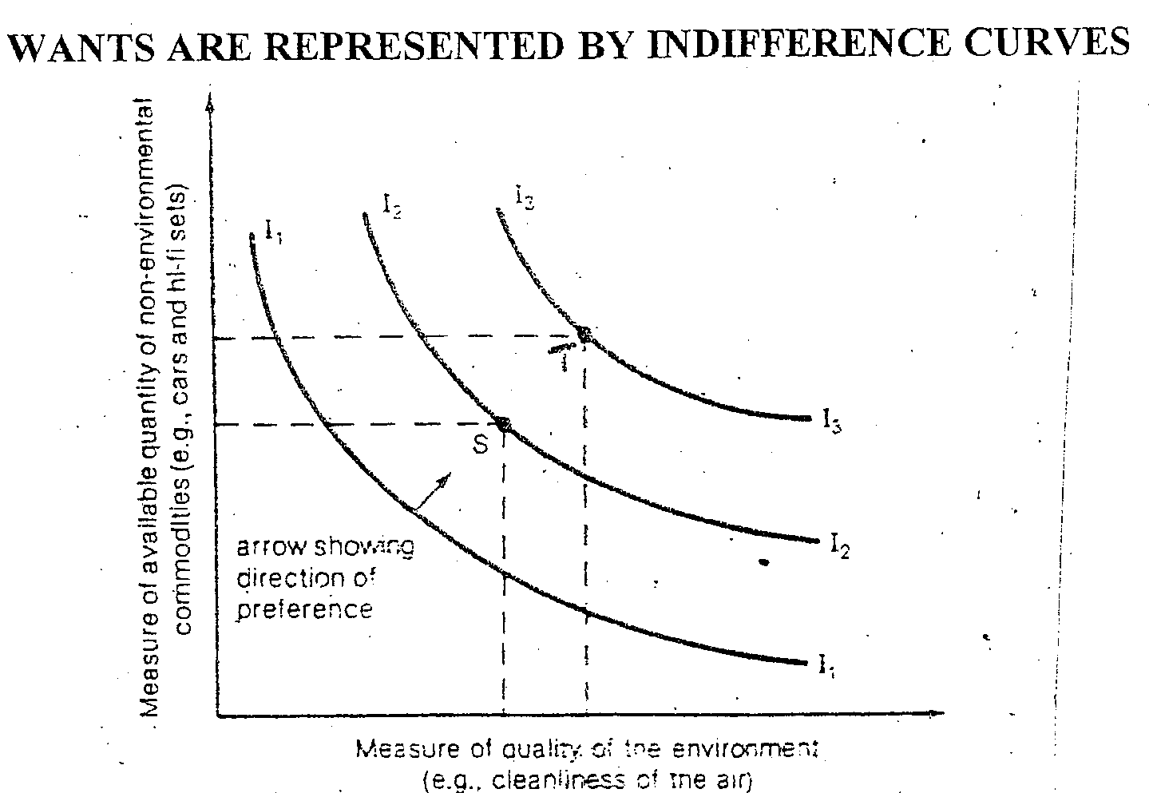

* + 1. Name a factor responsible for the amount of commodities that can be produced or made available to satisfy wants. **(1 mark)**
    2. Explain why consumer would prefer choice of point T than point S to satisfy his wants. **(1 mark)**
    3. Differentiate between indifference curve and indifference map. **(2 marks)**

1. Study the graph below and answer the following questions.

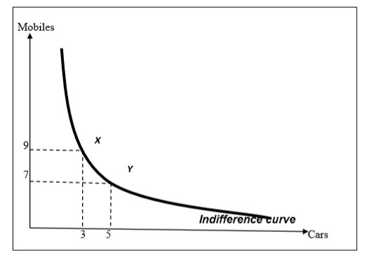

i. Explain the shape of indifference curve given above? **(2 marks)**

ii. State one feature of indifference curve. **(1 mark)**

iii. What is the utility level at point X? **(1 mark**)

**THE END**