**SANGAM SKM COLLEGE-NADI**

**GEOGRAPHY YEAR 13 –REVISIONAL WORKSHEET 2- Week 3**

**TOPIC: PLATE TECTONICS: PROCESSES AND LANDFORMS**

**PART A**

**DEFINITIONS**

In your own words, state clearly the meaning of the following terms:

1. Continental Drift Theory

________________________________________________________________________________________________________________________________________________

1. Convection currents

________________________________________________________________________________________________________________________________________________

1. Conservative margins

________________________________________________________________________________________________________________________________________________

1. Anticline

________________________________________________________________________________________________________________________________________________

1. Weathering

________________________________________________________________________________________________________________________________________________

1. Asthenosphere

________________________________________________________________________________________________________________________________________________

1. Batholiths

________________________________________________________________________________________________________________________________________________

1. Crust

________________________________________________________________________________________________________________________________________________

1. Delta

________________________________________________________________________________________________________________________________________________

1. Solifluction

________________________________________________________________________________________________________________________________________________

k.) Lava plug

____________________________________________________________________________________________________________________________________________________________

**PART B RESOURCE INTERPRETATION**

Use the resource given below and your knowledge to answer the questions that follow.

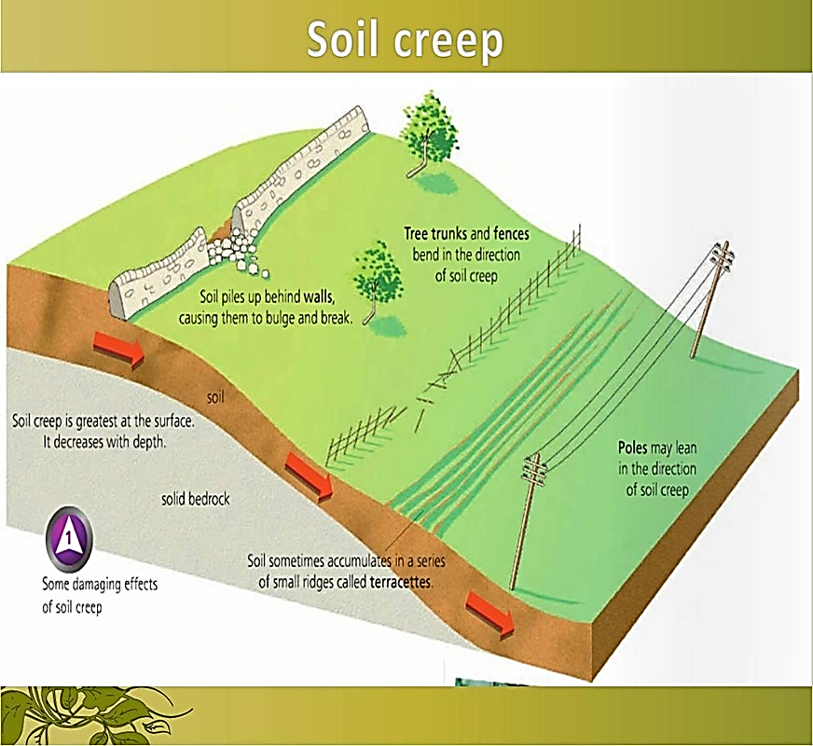*<https://www.google.com/search?rlz=1C1GCEU_enFJ831FJ831&biw=996&bih=624&tbm=isch&sa=1&ei=EX9XXICwGtO2rQH_sJuICQ&q=soil+creep+mass+movement>*

1. Identify the type of mass movement shown above.

_____________________________________________________________________

1. Briefly explain this process of mass movement.

__________________________________________________________________________________________________________________________________________

1. How is this type of movement different from earthflow? Give 2 reasons to explain your answer.

__________________________________________________________________________________________________________________________________________ _____________________________________________________________________

1. Explain how development has increased the risk of mass movement.

_________________________________________________________________________________________________________________________________________ ____________________________________________________________________

**PART C ESSAY**

Write an essay of 180-200 words on the given question. (To be written in the geography essay book or in the geography note book)

**With reference to specific case studies, discuss two advantages and two disadvantages of volcanism.**