**SANGAM SKM COLLEGE-NADI**

**GEOGRAPHY YEAR 13 –REVISIONAL WORKSHEET 3- Week 4**

**TOPIC: PLATE TECTONICS: PROCESSES AND LANDFORMS**

1. **Word Search (Find the words given in the words list)**

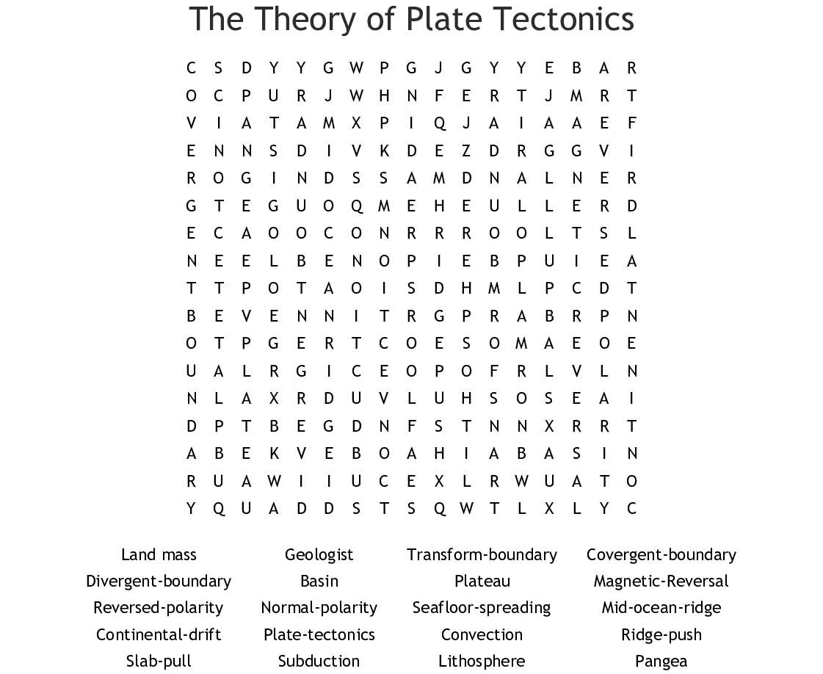

1. **Resource Interpretation**

Use the resource given below and your knowledge to answer the questions that follow.

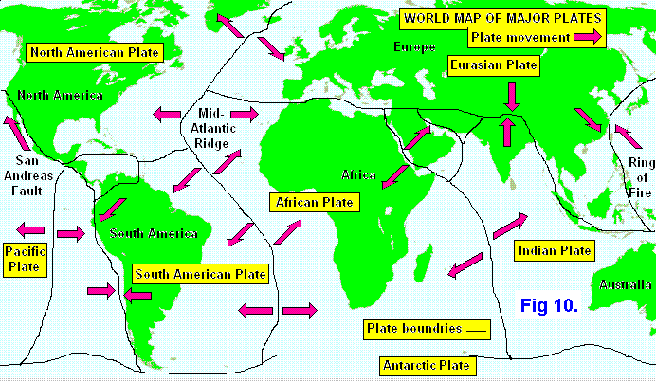

[*https://www.google.com/search?q=plate+movement&rlz=1C1GCEU_enFJ831FJ831&oq=plate+movement&aqs=chrome..69i57j0l5.12943j0j7&sourceid=chrome&ie=UTF-8*](https://www.google.com/search?q=plate+movement&rlz=1C1GCEU_enFJ831FJ831&oq=plate+movement&aqs=chrome..69i57j0l5.12943j0j7&sourceid=chrome&ie=UTF-8)

1. Identify two plates at constructive plate boundary.

__________________________________________________________________

1. What kind of boundary is the San Andreas Fault?

__________________________________________________________________________________________________________________________________________

1. Differentiate between a destructive margin and a collision zone?

__________________________________________________________________________________________________________________________________________

**PLATE TECTONICS QUIZ**

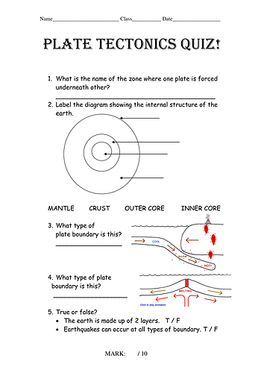

**Short Answer Questions**

1. State a difference between the Basaltic lava and Andesitic lava.

________________________________________________________________________________________________________________________________________________

1. Define the term **caldera**? Explain how it is formed?

________________________________________________________________________________________________________________________________________________

1. Differentiate between physical and biological weathering.

________________________________________________________________________________________________________________________________________________________________________________________________________________________

1. Describe the formation of a lava plug.

________________________________________________________________________________________________________________________________________________ _______________________________________________________________________

1. Explain how composite cones are formed.

_______________________________________________________________________________________________________________________________________________________________________________________________________________________