**SANGAM SKM COLLEGE NADI**

**DEPARTMENT OF HOME ECONOMICS**

**YEAR 13-WEEK 2 WORKSHEET**

**Food Supply**

**1.**

1. Define the term household food security.

**__________________________________________________________________________________________________________________________________________**

1. State**one** effect of climate change on food supply.

**__________________________________________________________________________________________________________________________________________**

(c) Discuss one impact of natural disasters on fisheries.

**________________________________________________________________________________________________________________________________________________________________________________________________________________________**

**Milk**

2. Define the following:

1. Caramelization - ________________________________________________________________________________________________________________________________________________
2. Millard reaction - ________________________________________________________________________________________________________________________________________________
3. Fermentation - ________________________________________________________________________________________________________________________________________________

3.

1. Identify the protein which forms scum when milk is heated and state the effect of scum formation. _________________________________________________________________________________________________________________________________________
2. State one way of preventing film formation when heating milk. __________________________________________________________________________________________________________________________________________

4. Discuss the action of lactic acid producing bacteria on casein. ______________________________________________________________________________________________________________________________________________________

5. State the difference between homogenization and pasteurization. ________________________________________________________________________________________________________________________________________________________________________________________________________________________________________________________________________________________________________________________

6. Define the termhygroscopic.

____________________________________________________________________________________________________________________________________________________________

**Cereal**

7. Differentiate between gelatinization and dextrinization with examples.

________________________________________________________________________________________________________________________________________________________________________________________________________________________________________________________________________________________________________________________

8. State **one** reason for spoilage of whole meal flourduringstorage.

____________________________________________________________________________________________________________________________________________________________

**W SANGAM SKM COLLEGE NADI**

**DEPARTMENT OF HOME ECONOMICS**

**YEAR 13-WEEK 3 WORKSHEET**

**Meat**

1. Explain the difference between wet aging and dry aging. Also state which process is better and why. ________________________________________________________________________________________________________________________________________________________________________________________________________________________________________________________________________________________________________________________________________________________________________
2. How can you prevent cross contamination of meat? ________________________________________________________________________________________________________________________________________________
3. State the effect of marbling on meat

________________________________________________________________________________________________________________________________________________

1. Name the pigment which gives meat bright red colour

________________________________________________________________________

1. State the effect of moist heat on proteins. ________________________________________________________________________________________________________________________________________________
2. List two ways of tenderizing meat. ________________________________________________________________________________________________________________________________________________
3. Explain Non – enzymatic browning in meat. ________________________________________________________________________________________________________________________________________________________________________________________________________________________

8. Discuss one reason for adding nitrate to processed meat. ______________________________________________________________________________________________________________________________________________________

**Fruits and Vegetables**

9. a) Fleshy fruits have three classifications. Identify the two classifications of fruits given below

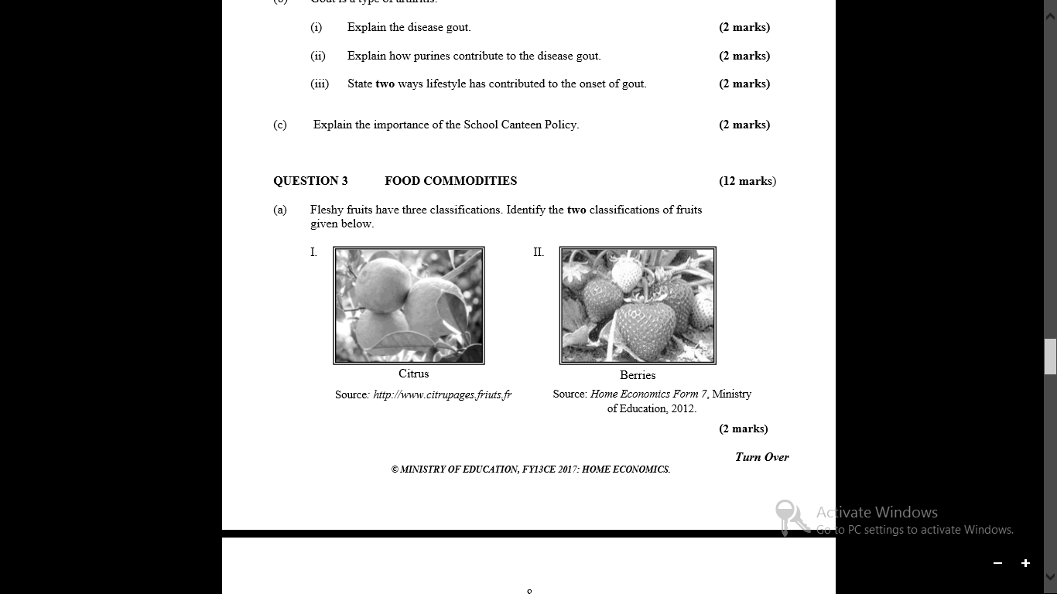

b) Cut fruits and vegetables undergo discolouration during food preparation.

i) Explain **one** reason for the discolouration. **(2 marks)**

__________________________________________________________________________________________________________________________________________________________________________________________________________________________________________

ii) Mention one way of preventing this discolouration. **(1 mark)**

**____________________________________________________________________________________________________________________________________________________________**

c) Explain the function of pectin in juice processing. **(2 marks)**

**____________________________________________________________________________________________________________________________________________________________**