**SAGAM SKM COLLEGE**

**YEAR 13 WEEK 4 WORKSHEET**

**DEPARTMENT OF HMOE ECOOMICS**

1. Study the pictures given below and answer the question that follow.

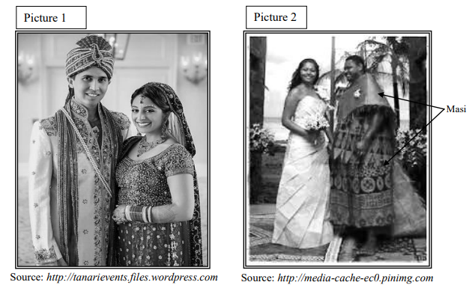

1. Evaluate the two special attires in Pictures 1 and 2 with regards to the following textile requirements that determine their end uses

Discuss their:

1. Aesthetics
2. Functional
3. Label the outfit with the following designed features and explain the features
4. Rhythm
5. Emphasis
6. Line