**SANGAM SKM COLLEGE**

**WEEK 4 -** YEAR 13 PHYICS PUZZLE

You don’t have to write the question for this week instead attempt and record the solution.

**Off to the races.** A standard physics problem (and demo) races cylinders rolling down an inclined plane. The cylinders are constructed to have the same mass and the same outer radius, but one is solid wood and the other is a metal hoop. The hoop, having the greater moment of inertia, accelerates less under the gravitational force, and loses the race.

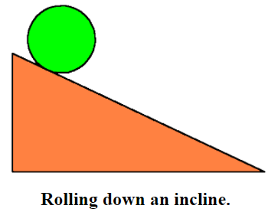

But what if we handicap this race differently. Make two **solid** cylinders of the same length and radius, but of materials of very different density. They will have very unequal masses. Now which one will win, and why?

**Answer:**

Now race two spherical balls of the same radius but different masses, say one of steel, one of wood. Which will win?

**Answer:**