**SANGAM SKM COLLEGE- NADI**

**YEAR 9 ENGLISH Home-Based Learning 2021**

**WEEK 2 MASS-MEDIA, DICTIONARY AND LIBRARY**

**MASS MEDIA**

1. Discuss **one** advantage that television has over radio.
2. Give a disadvantage of magazine.
3. Why is radio the most reliable form of media used in times of natural disasters?

***Study the advertisement below to answer questions that follow.***

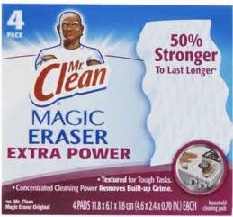

1. Name the product which is advertised above.
2. State how the above advertisement is attracting the attention of the people.
3. Philip wants to express his views in the newspaper on increasing road accidents in Fiji. Which section of the newspaper should he refer to?

**DICTIONARY**

1. Why do people use a dictionary?

1. What is a guideword?

1. Give the abbreviation of the following words as used in a dictionary:
2. Preposition
3. Adverb
4. Arrange the following words in alphabetical order.

Crack, Crock, Cake, Cast

**LIBRARY**

1. How are fiction books arranged in a library?
2. Explain the difference between an autobiography and a biography.
3. Give a reason why reference books are not issued on loan to library users.
4. List **some** important library rules that every student in your school must abide by while in the library.