WORKSHEET 4

PHYSICAL EDUCATION YEAR 9 & 10

Objective : students to understand the types of muscle and how it works

Sub-strand: Exercise Physiology

Types of muscles:

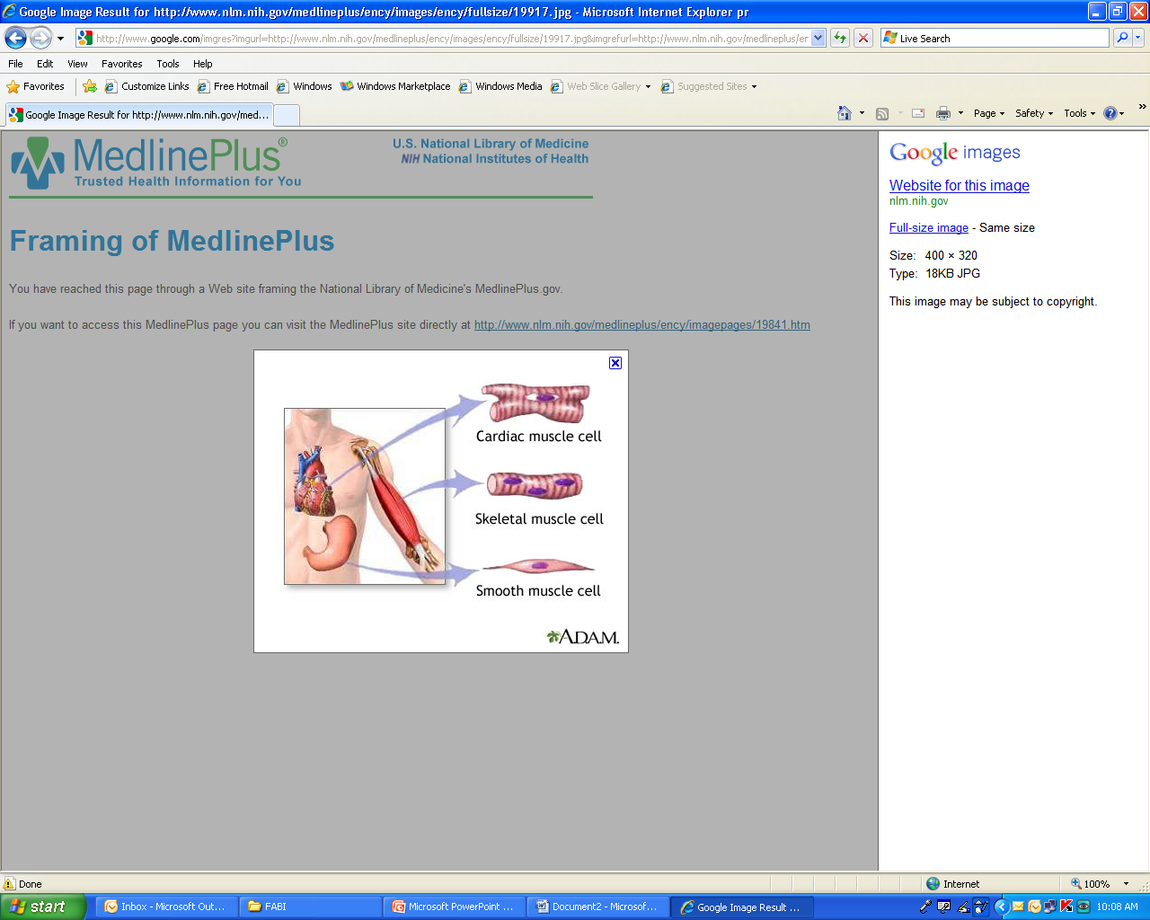

Types of muscles:

* **Smooth /Involuntary**

This type of muscle is located in the lining of the stomach and gut, the walls of blood vessels and inside our eyes. It performs a number of different functions, each of which takes place without our conscious control.

* **Skeletal / Voluntary**

This type of muscle is what we normally think of when we talk about muscles. Skeletal muscles forms approximately 40% of our body weight, and is responsible for bodily movement, posture, facial expressions and many other movements. Since these muscles are under our conscious control.

* **Cardiac Muscle**

This type of muscle is found only in the heart. Its function is to force the blood around the body. This is a special kind of involuntary muscle: as well as working automatically, cardiac muscle does not get tired.

**Activities for Worksheet 4**

1. Name two examples of skeletal muscles found in our hands and legs?

__________________________________________________________________________________________________________________________________________

1. Which type of muscle helps us to move from one place to another?

__________________________________________________________________________________________________________________________________________

1. List and explain any two functions of muscles?

__________________________________________________________________________________________________________________________________________

1. Which type of muscles is not under our control?

__________________________________________________________________________________________________________________________________________

WORKSHEET 5

PHYSICAL EDUCATION YEAR 9 & 10

Objective : Students to understand the importance of blood, its circulation and how blood pressure is measured

Sub-strand: Cardio Respiratory System

* Heart – It pumps blood to all parts of the body

**3 types of blood vessels**

1. Arteries – carries blood away from the heart
2. Capillaries – network of small vessels through which blood passes
3. Veins- carries blood back to the heart

**Blood pressure**

* the pressure of the blood in the circulatory system, often measured for diagnosis since it is closely related to the force and rate of the heartbeat and the diameter and elasticity of the arterial walls

There are 2 figures placed in blood pressure Reading:

1. **Systolic** – is the upper figure in the reading

* It reveals the amount of pressure on the arteries while the heart beats

1. **Diastolic** - is the bottom number.

* It is always lower and tells us the pressure on the arteries between heartbeats. This is the time when the heart refills with blood.

- Example - systolic and diastolic blood pressure reading would be 120/80 mm Hg (normal blood pressure).

Hypotension (too low): Below 90/60 mm Hg

Normal: Below 120/80 mm Hg

Prehypertension: 120/80 to 139/89 mm Hg

Hypertension stage 1: 140/90 to 159/99 mm Hg

Hypertension stage 2: Over 160/100 mm Hg

Hypertension crisis: 180/110 mm Hg – immediate medical attention is required.

**Activities for Worksheet 5**

Find and Circle the given words

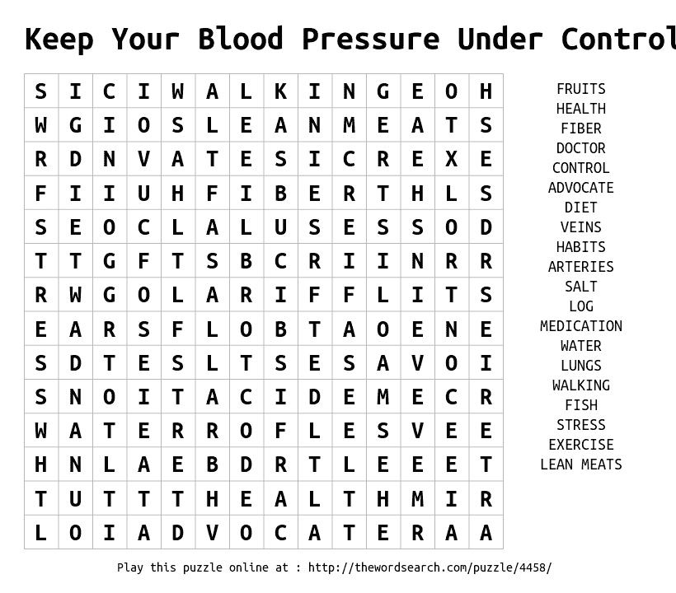

WORKSHEET 6

PHYSICAL EDUCATION YEAR 9 & 10

Objective : Students to understand the importance of training with safety

Sub-strand: safety

With any outdoor activities, safety and guidance are really important factor

1. Should maintain proper footwear
2. Should maintain proper uniform
3. Should always consider the environment
4. Ground condition should be free from injuries
5. Always hydrate yourself ( carry water bottle)
6. Should have first aid on the side

**Activities for worksheet 6**

**Exercise**

1. Jog for 5 minutes
2. Stretching body from leg to head
3. 5 minutes running in the compound
4. Take 3 minutes break ( drink water)
5. 10 press up
6. 5 high knees
7. Drink water- 30 seconds
8. Jog for 5 minutes
9. Cool down from head to toes
10. Drink water