**SANGAM SKM COLLEGE-NADI**

**WEEK 2 AGRICULTURAL SCIENCE -YEAR 9 WORKSHEET**

Short Answers Questions

1. Explain how agriculture began.
2. State items that were brought by the following:

* Missionaries
* Explorers
* Indentured labourers

1. Explain one way in which commercial farmers cater for the large number of people.
2. Explain at least two importance of :

* First Aid Kit
* OHS
* Agriculture

1. Explain a solution to the following challenges faced in Agricultural development.

* Climate
* Expensive Labour
* Lack of finance
* Geography

1. Explain three advantages and two advantages of backyard farm.
2. Discuss how commercial agriculture affects the environment,
3. Explain the importance treating an injury.
4. State at least three items that can be found in a first aid kit
5. Explain why Agriculture Science First Aid Kit does not contain any medication.

11.Use the OHS sign to answer questions given below.



* + 1. Who is responsible for making this sign on a farm?
    2. Who is the sign meant for?
    3. Are the rules instructing or informing?
    4. Explain why the rules can be easily seen.
    5. Which word will warn the audience?
    6. What may occur if rules are not followed?

**SANGAM SKM COLLEGE-NADI**

**WEEK 3 AGRICULTURAL SCIENCE -YEAR 9 WORKSHEET**

Short Answer Questions

1. Match the items **List A** to the correct description from **List B**

|  |  |  |  |  |
| --- | --- | --- | --- | --- |
| **Answer List A** | | | **List B** | |
|  | 1. | Cart |  | A. axe |
|  | 2. | Irrigate |  | B. overgrown branch |
|  | 3. | Fell |  | C. wheelbarrow |
|  | 4. | Prune |  | D. watering can |

1. Differentiate between the usage of a hoof knife and a hoof nipper in trimming the goat hoofs.
2. Briefly explain what a dairy cattle farmer would use the following tools for.

(i) branding iron

(ii) hot iron

(iii) Drench gun

4. State one reason why teachers‟ are encourage gardening tools a bright orange-red colour.

5. State the function of the tools from A- D

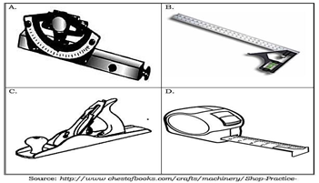

6. Study the diagram below to answer the following question

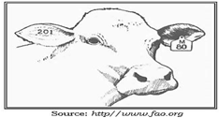

1. State the identification method.
2. State the best tool a farmer can use when applying the identification method show above.

7. Explain one purpose of a burdizzo.